1. *Executive Summary from “Western Wind and Solar Integration Study" (May 2010 report)*
   1. *What changes to balancing areas in Western Electricity Coordinating Council are expected?*There are three key benefits of balancing area cooperation: 1) aggregating diverse renewable resources over larger geographic areas reduces the overall variability of the renewables, 2) aggregating the load reduces the overall variability of the load, and 3) aggregating the non-renewable balance of generation provides access to more balancing (and more flexible) resources. (p.17)
   2. *Describe the three scenarios studied. Under what scenario does Wyoming have the largest wind generation installed capacity? Which scenario costs the least?*  
      The 3 scenarios studied are: In-Area, where each state generates and consumes all of its new wind capacity; Local Priority, where plants are installed strategically in the West, and 10% of all power is shipped to different states; Mega Project, where only the best wind resources are developed and power is shipped across the entire West. (p.10)
   3. *Describe the effect of wind on other generation sources. Why are nuclear and coal fired generation challenging from a load management perspective when renewables are incorporated into the system?*Wind and solar generation primarily displace gas resources nearly all hours of the year, given the fuel prices and carbon tax assumed for this study ($2/MBTU coal, $9.50/MBTU gas, $30/ton CO2). Since gas-fired generation is typically more flexible than coal generation, the natural economic displacement of gas generation by wind and solar generation makes the balance of dispatchable generation on-line less flexible (fewer gas units, more coal units). (p.16)
   4. *Under what conditions does wind primarily displace coal in comparison to the scenario where no renewables are developed? What is the effect on emissions in this case?*At a $3.50/MBTU gas price, wind and solar primarily displace coal generation, leaving the more flexible gas generation resources to operate together with the wind and solar generation. With lower gas price assumptions, operating costs are reduced by about 40%, to $46/MWh ($39/MWh in 2009$), but emissions reductions are higher. (p.17)
   5. *Under what scenario does pumped-hydro energy storage become economically viable?*WWSIS finds that at higher (30% case) penetration levels, decreased flexibility of either the coal or hydro facilities made operation more difficult and increased the costs of integrating the renewable generation. (p.29)
2. *Executive Summary section ES.4 (The Wind Vision Roadmap: A Pathway Forward) from Wind Vision*
   1. *List 5 areas that are a focus for increasing development of wind energy.*Wind Power Resources and Site Characterization  
      Wind Plant Technology Advancement  
      Supply Chain, Manufacturing, and Logistics  
      Wind Electricity Delivery and Integration  
      Wind Siting and Permitting  
      Collaboration, Education, and Outreach  
      Policy Analysis (p.53)
   2. *Who are the primary stakeholders in the continued improvement of wind energy technologies? What is a stakeholder?*The industry, policymakers, and the public are the primary stakeholders. (p.52)
   3. *What are the action areas for the Economic Value theme?*Supply Chain, Manufacturing, and Logistics  
      Collaboration, Education, and Outreach  
      Workforce Development  
      Policy Analysis (p.53)
   4. *Why is it important to continue reduction of wind energy costs?*Continuing declines in wind power costs and improved reliability are needed to improve market competition with other electricity sources.  
      Levelized cost of electricity reduction trajectory of 24% by 2020, 33% by 2030, and 37% by 2050 for land-based wind power technology and 22% by 2020, 43% by 2030, and 51% by 2050 for offshore wind power technology to substantially reduce or eliminate the near- and mid-term incremental costs of the Study Scenario. (p.53)
   5. *What are the potential consequences of not pursuing the proposed roadmap?*Without actions to improve wind’s competitive position in the market, such as those described in the roadmap and summarized in Text Box ES.4-1, the nation risks losing its existing wind manufacturing infrastructure and a range of public benefits as illustrated in the Wind Vision. (p.56)

3. *Using the blade element momentum approach (with and without the Prandtl correction) and dividing the blade into nine 2m segments as suggested above, consider the turbine operating at sea level ($ρ$ =1.23 kg/m3) with a 10 m/s wind.*

An iterative BEM method was written in Python 2.7 using Numpy and Matlibplot. The following outlines the procedure for one pass of one segment of the blade:

1. Guess values for a and a’

2. Calculate the total angle between the tangential direction and the wind vector, :

3. Calculate the angle of attack, $α$, as the difference between $φ$ and the pitch angle of the blade, :

4. Passing the data file name and $α$ into a function, it returns the coefficients of lift and drag for the section:

CLCD = getCLCD(currentfile,alpha_deg[i])

5. Calculate the coefficients of force in the normal and tangential directions:

6. Calculate a new a and a’:

7. Calculate the forces the blade section experiences in the normal and tangential directions:

$$F_{N}=C_{N}\frac{1}{2}ρw^{2}c \\ F_{T}=C_{T}\frac{1}{2}ρw^{2}c$$

Steps 2 through 6 were placed in a while loop with a tolerance criterion based on the change in a for each iteration. Once converged to the tolerance, the while loop ends and a *Prandtl Tip Correction* factor, $F$, is calculated, as shown below. This correction affects the angle of attack, the force coefficients and thus the forces in both the normal and tangential directions. This while loop is placed in a for loop to iterate over each blade section. In effect: for each blade section, iterate a solution for a and a’, then calculate forces and corrections.

$$f=\frac{N_{blades}}{2}*\frac{R-r}{r\sin{φ}}$$ $F=\frac{2}{π}\cos^{-1}\left(e^{-f}\right)$

(a)

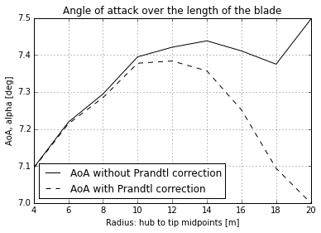

As shown above, the angle of attack varies only slightly along the length of the blade: $α=7.23$ on average. This confirms the design of the blade, as the sectional blade pitch should be such as to provide a near-constant angle of attack. This allows a more consistent force to develop along the blade.

(b)

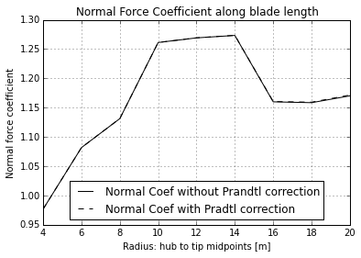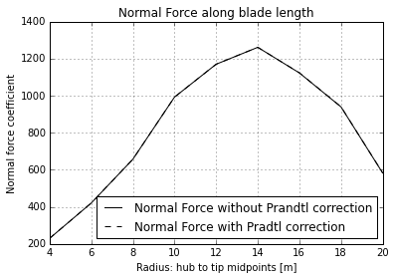

The above graphs show the normal force coefficient and the normal force over the length of the blade, respectively. The discontinuous bump in the middle of the plot in the force coefficient is caused by the discontinuous change in airfoil properties; specifically, in the data from the

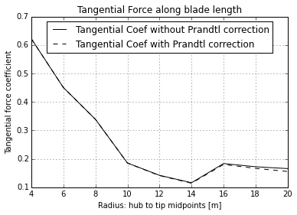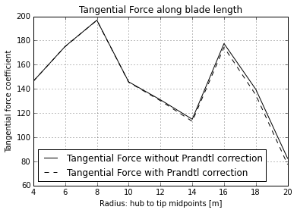

In the tangential direction, the plots again appear discontinuous, and again for the same reason: the blade section data for sections 4, 5 and 6 have a coefficient of drag 10 times higher than either of the other sections. This affects the corresponding data points in the above graphs.

(c)

Total Thrust: **44.26 kN**

Total Torque: **87.48 kN m**

Total Power: **274.82 kW**

Thrust was calculated by the following method: For each section, defined by its radius, the thrust is the sum of the normal forces times their corresponding section length (2 m). Since the section length is constant it is calculated only once, based on the first interval. Finally, the thrust is multiplied by the number of blades.

sectionlength = r[1] - r[0]

for i,section in enumerate(r):

thrust += F_N_corr[i] * sectionlength

thrust *= N_blades

Torque was calculated in a nearly identical manner. At each section from hub to tip, the torque is the sum of the tangential force per unit length time the section length times the radius. Again, the torque is multiplied by the number of blades for a total.

for i,section in enumerate(r):

    torque += F_T_corr[i]*r[i] * sectionlength

torque *= N_blades

With the total torque, the power is simply calculated:

power = torque * omega