BCS/16/21/005/TZ - ABDILLAH TALIB ALI

ASSIGNMENT 1

**Part 1: HTML Structure and Tags**

<!DOCTYPE html>

<html lang="en">

<head>

    <meta charset="UTF-8">

    <title>My Web Page</title>

    <link rel="icon" href="favicon.ico" type="image/x-icon">

</head>

<body>

    <h1>Welcome to My Web Page</h1>

    <img src="me.jpg" alt="A photo of me" width="200">

    <h2>This is an H2 Heading</h2>

    <h3>This is an H3 Heading</h3>

    <h4>This is an H4 Heading</h4>

    <h5>This is an H5 Heading</h5>

    <h6>This is an H6 Heading</h6>

    <p>I am a passionate learner and aspiring tech professional who enjoys exploring books, playing football, coding, and expanding knowledge through university studies and self-improvement.</p>

    <hr>

    <p>This is a second paragraph.<br>

        And this line starts after a line break.</p>

    <h2>My Top 5 Favorite Books</h2>

    <ol>

        <li>The Alchemist</li>

        <li>Atomic Habits</li>

        <li>Sapiens</li>

        <li>1984</li>

        <li>Clean Code</li>

    </ol>

    <h2>My Top 5 Hobbies</h2>

    <ul>

        <li>Reading</li>

        <li>Photography</li>

        <li>Traveling</li>

        <li>Playing Guitar</li>

        <li>Learning New Skills</li>

    </ul>

    <h2>My Favorite Image</h2>

<img src="https://images.pexels.com/photos/4974912/pexels-photo-4974912.jpeg" alt="Person coding on a MacBook Pro at desk" width="250">

    <h2>Useful Links</h2>

    <p>

        Visit <a href="https://www.wikipedia.org" target="_blank">Wikipedia</a><br>

        Watch videos on <a href="https://www.youtube.com" target="_blank">YouTube</a><br>

        Learn code at <a href="https://www.freecodecamp.org" target="_blank">freeCodeCamp</a>

    </p>

    <h2>My Weekly Schedule (Mon–Fri)</h2>

    <table border="1" cellpadding="8" cellspacing="0">

        <tr>

            <th>Day</th>

            <th>Morning</th>

            <th>Afternoon</th>

        </tr>

        <tr>

            <td>Monday</td>

            <td>University</td>

            <td>Studying, Coding</td>

        </tr>

        <tr>

            <td>Wednesday</td>

            <td>University</td>

            <td>Football, Coding</td>

        </tr>

        <tr>

            <td>Friday</td>

            <td>Studying</td>

            <td>Playing Football, Learning</td>

        </tr>

    </table>

</body>

</html>

OUTPUT

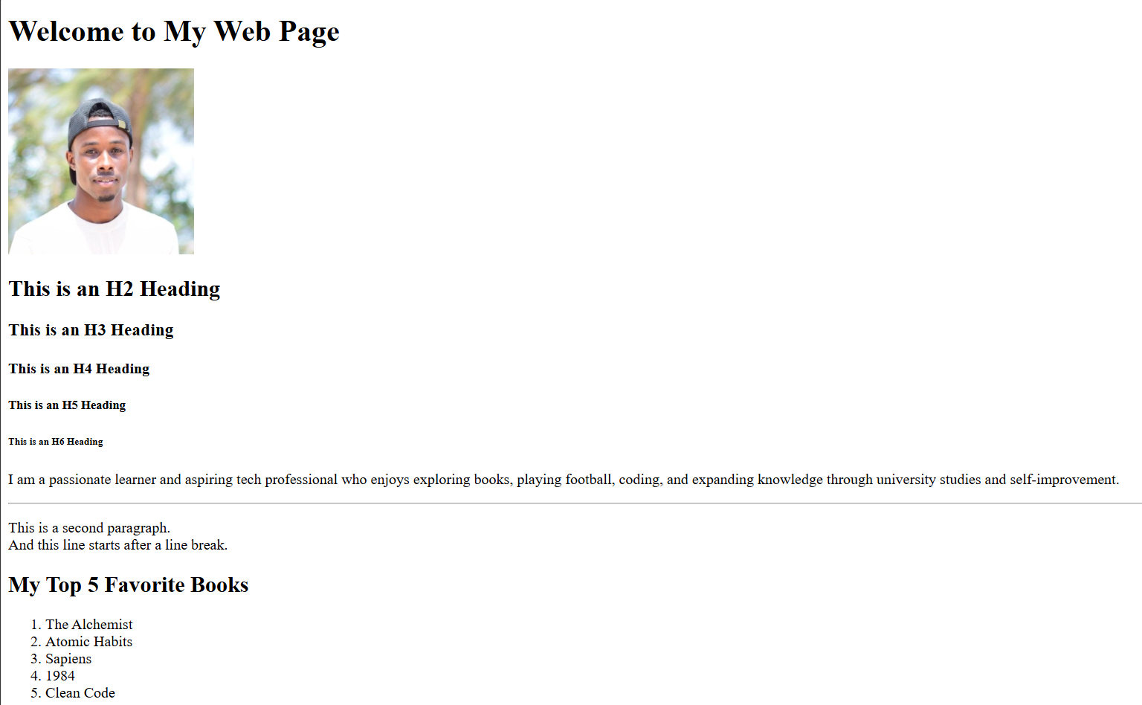

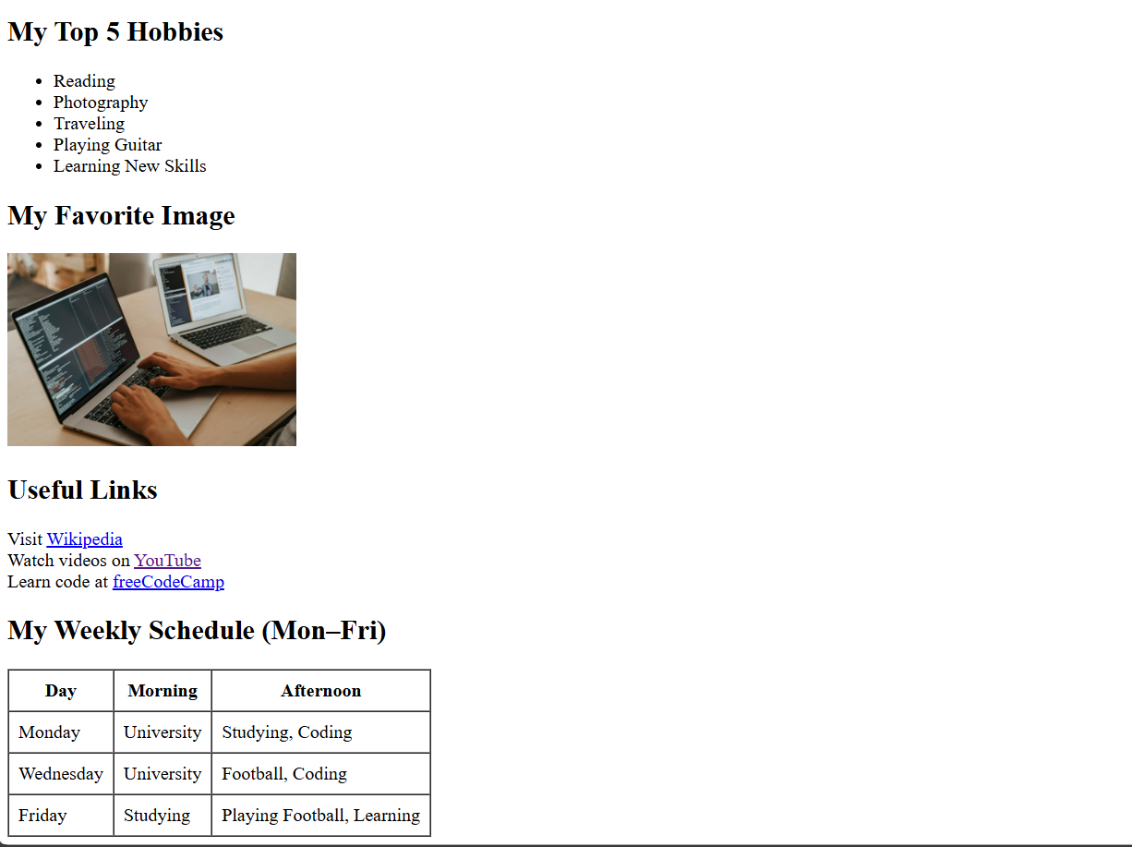

Q1: What is the purpose of the <head>section in HTML?   
A: The <head>section contains meta-information about the HTML document that is not displayed directly on the web page. It includes elements like the page title, character encoding, links to stylesheets, scripts, and favicons. This information helps browsers understand how to load and display the content correctly.

Q2: Why do we use semantic tags like <section>, <article>, and <footer>?  
A: Semantic tags give meaning to the structure of a webpage. They help both developers and browsers understand the role of different parts of the content. For example, <section> defines a thematic grouping of content, <article> represents a self-contained piece of content, and <footer> typically contains information like contact details or copyright. Semantic tags improve accessibility, SEO, and code readability.

**Part 2: Understanding and Exploring the DOM**

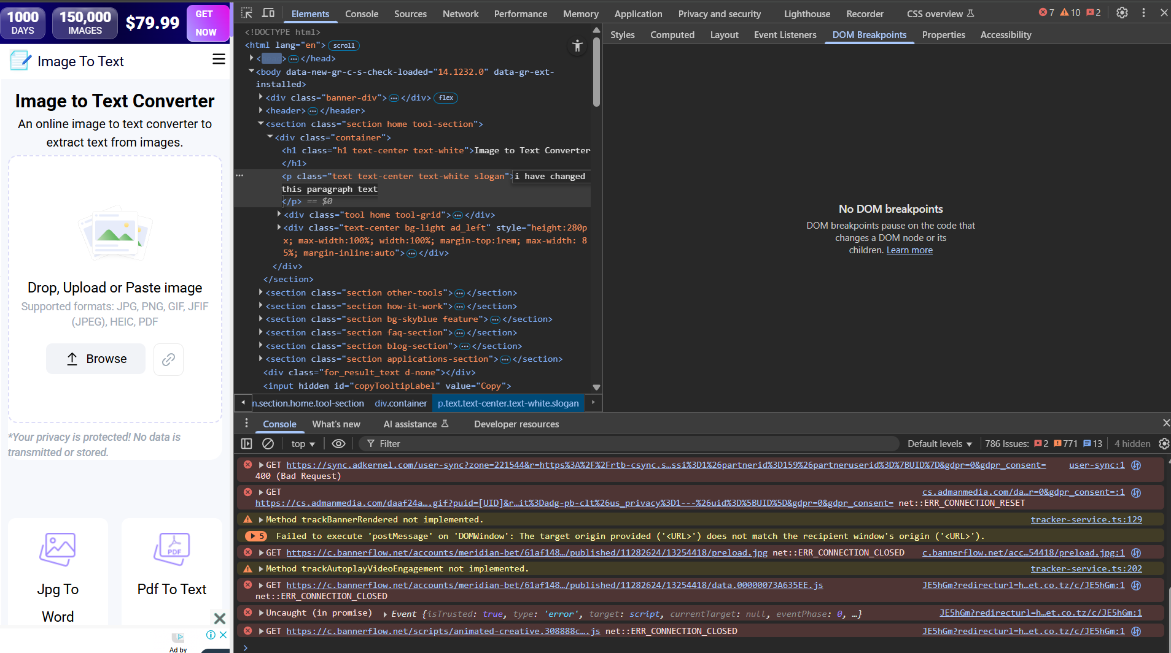

**Q1: How is the DOM different from the HTML file?**  
**A:**The **HTML file** is the source code written by the developer, while the **DOM (Document Object Model)** is a live, in-memory representation of that HTML structure created by the browser. The DOM can change dynamically through JavaScript or developer tools, while the original HTML file remains unchanged unless you edit and save it manually.

**Q2: What happens in the browser when you add or delete nodes in the dev tools?**  
**B:**When you add or delete nodes in the browser’s developer tools, it updates the **DOM in real-time**, and you can immediately see the changes on the web page. However, these changes are **temporary** and will disappear when the page is refreshed because they don’t affect the original HTML file saved on disk.