**Protocol data downloading Imaris (download to Excel)**



1. **A screenshot of a computer

   Description automatically generated**Select the cells you want to include in the analysis.
2. Click on “New Plot”.



1. Following screen appears. Click on detailed (blue circle). Select the type you are interested in on the left (red circle). And click on save icon on the right (yellow circle). Safe the file in a folder as an excel document. Do this step for all the ‘data type’ you are interested (12 in total).

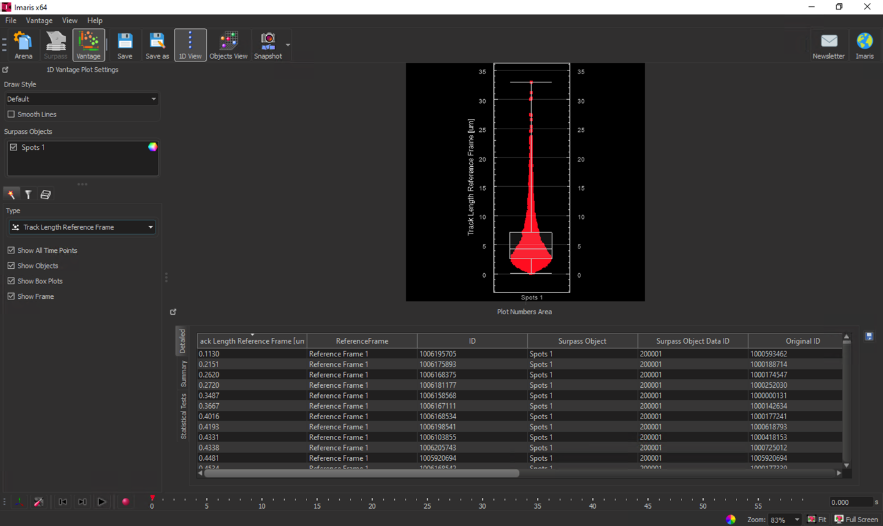



If the required parameters cannot be selected (e.g., “Track Displacement x Reference Frame”), they have to be enabled in preferences – statistics – spots.

For individual cell export:  
1) check that reference frame is set at 0 time point

2) make sure spots are calculated against the reference frame  
