**2012年硅产业重点企业报告**

本内部报告主要包含三个部分：工业硅产业，有机硅上下游，多晶硅产业及它们的相关产业。

工业硅部分介绍了工业硅相关概述、目前市场经济运行环境等，接着分析了工业硅重点企业运行的现状，行业市场竞争格局。最后概述了行业发展趋势，国家政策，市场消费容量，现有产量预测，及行业投资建议。

采用数据主要来自于各类市场监测网站和企业网站。

**目录**

第一部分 工业硅行业重点企业 4

一、 西班牙Ferroatlantica C:\Users\Administrator\AppData\Roaming\Tencent\Users\32329357\QQ\WinTemp\RichOle\)$WKC{DA@UYMUGVVINZ@OTP.jpg 6

1. 公司组织架构、主要业务 6

2. 生产基地、主营业务、装置规模、产品类别、销售市场 7

3. 生产经营情况 32

[二、 挪威埃肯C:\Users\Administrator\AppData\Roaming\Tencent\Users\32329357\QQ\WinTemp\RichOle\N[27A{F$HPY7V[4]56%2]EB.jpg 36](#_Toc334171918)

1. 埃肯业务情况 36

2. 埃肯工业硅 37

3. 埃肯财务情况 38

三、 全球冶金（Globe Metallurgical） 38

1. 业务部门构成 39

2. 工业硅 41

3. 财务情况 42

四、 巴西瑞玛 45

五、 湖北三新 46

六、 芒市卓信 47

七、 云南永昌 48

八、 四川潘达尔 48

# 第一部分 工业硅行业重点企业

去年下半年以来，整个硅产业链的各级产品价格均大幅走低，受汽车、多晶硅等下游不振影响，工业硅也快速步入下行通道。今年国内工业硅需求和出口需求将出现一降一升局面，由于综合成本增幅较快，工业硅企业的利润将进一步被蚕食。

据中国有色金属工业协会硅业分会统计，去年我国工业硅消费量同比增长了27.1%。随着多晶硅行业快速扩张，其对工业硅的需求从9.5万吨增至18万吨，增幅接近90%，同铝合金、有机硅等下游基本持平。

去年我国工业硅已建产能320万吨，还有100万吨在建产能，2011年产量为136万吨，同比增长15.2%。不过随着今年6300KVA以下小炉逐渐被淘汰，据中国有色金属工业协会硅业分会预计2013年国内工业硅产能在400万吨左右。

国内市场方面，今年工业硅产量增速将接近甚至超过需求的增速。随着湖北三新硅业、潘达尔硅业等大炉企业投产，今年国内工业硅产量将大幅增加；同时考虑到下游汽车、化工以及太阳能行业的整体回落，工业硅终端市场需求会出现减速。

国际市场方面，多家机构认为，今年汽车行业和光伏业前景仍不容乐观。有分析预测欧洲汽车业下滑幅度将达到10%左右，且各国仍在削减光伏补贴，因此国际工业硅的价格将延续2011年下半年以来的疲软态势。

工业硅下游消费比例

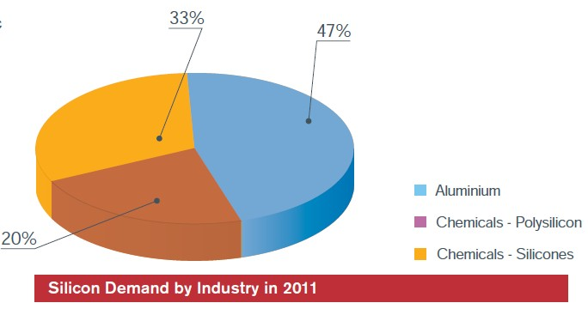

全球工业硅市场占有情况 (2012 year)

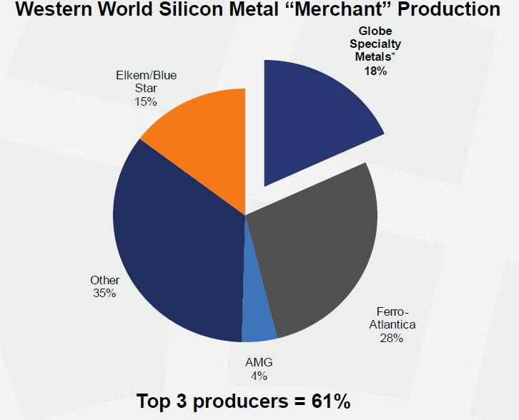

## 西班牙Ferroatlantica C:\Users\Administrator\AppData\Roaming\Tencent\Users\32329357\QQ\WinTemp\RichOle\)$WKC{DA@UYMUGVVINZ@OTP.jpg

西班牙Ferroatlantica（大西洋铁合金）隶属维拉米尔集团。维拉米尔集团现已成为全球知名的大型跨国企业集团，同时也是西班牙最大的工业集团之一，在中国拥有多个投资项目。公司旗下的大西洋铁合金有限公司在金属硅项目上占据全球领先的地位，拥有世界上最先进的技术，在西班牙、法国、委内瑞拉和南非建有15个一流的工厂。‘

#### 公司组织架构、主要业务

公司主要有4大块业务：

电冶金

能源

矿业

光伏太阳能

公司在生产工业硅方面占有全球的14%产能。铁合金也是在欧盟地区处于领先地位。公司拥有46台炉子，总计装置容量1024MW。集团产量超过1百万吨每年，分别如下：

Si Metal .............................. 292.000 t year

SiMn .................................. 254.000 t year

FeMn................................... 121.000 t year

FeMn Af ............................... 92.000 t year

FeSi ................................... 250.000 t year

此外，公司年产171000吨微硅粉，42000吨Söderberg 电极糊。有能力生产太阳能级硅，这将是未来几年最大市场潜力的业务板块。

FerroAtlántica集团, S. A. 的整个业务组成如下图1：

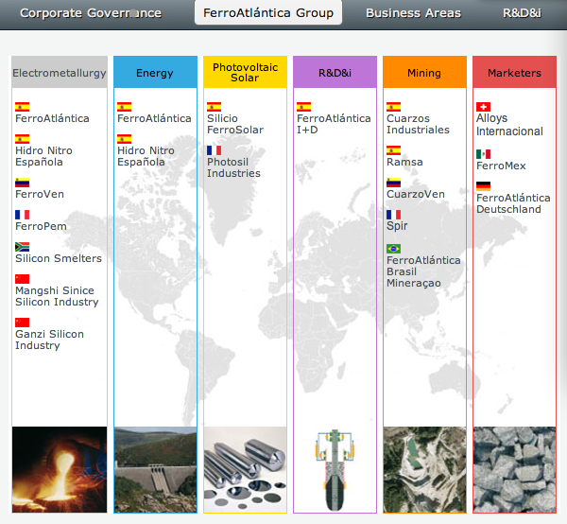

图1. FerroAtlántica集团业务组成

#### 生产基地、主营业务、装置规模、产品类别、销售市场

1). FerroAtlántica S.A. 目前运营4家铁合金工厂和6座水电站。

Two of the factories are situated in the area of A Costa da Morte, A Coruña Province, in the Municipalities of Cee and Dumbría, at a distance of 10 km from each other. The third factory is located in the Sabón – Arteixo Industrial Estate, in the Northeast of Galicia, at a distance of 12 Km from A Coruña. The fourth factory is situated in Boo, Cantabria, in the municipalities of Astillero and Camargo.

FerroAtlántica operates a total of 13 furnaces, with a combined power of 273 MW, annually producing 40,000 t of Silicon, 79,000 t of FeSi, 33,000 t of Microsilica, 155,000 t of FeMn, 147,000 t of SiMn, 15,000 t of FeMn Af and 6,000 t of Electrode Paste. The resulting annual production of ferroalloys is approximately 475,000 tonnes per year.

The hydroelectric plants generate the power from various rivers near the factories. Five of these plants are situated on the banks of River Xallas (Dumbría municipality), and one on the banks of the River Grande del Puerto (Vimianzo municipality). The plants manage the whole process of power production, transportation and transformation. The plants function automatically.

Quality

FerroAtlántica is guided by the philosophy of Total Quality. This philosophy means not only guaranteeing that the products manufactured fulfil their specifications but also ensuring that every aspect involved in its industrial and commercial activities fulfils the highest quality standards.

FerroAtlántica encourages the active participation of all its employees in the Total Quality programme.

Its factories are all ISO 9001 and OSHAS certified. All of them also is attached to the Eco-Management and Audit Regulation EMAS (Environmental Management and Audit System).

In order to fulfil the obligations deriving from the REACH regulations (Registration, Evaluation, Authorization and Restriction of Chemicals Substances) enforced by the European Union, FerroAtlántica has carried out all necessary procedures to ensure that each and every one of the substances that are produced and commercialised, are duly registered.

Environment

FerroAtlántica is fully committed to becoming the most competitive company in all areas of its business, by ensuring that all the environmental and energy resources are used efficiently, by protecting the health and safety of its employees and preventing all potential risks in the workplace and by respecting and improving the environment. All activities that contribute to reducing the environmental effects of all its processes are given the highest priority and are part of a continuous and ongoing process.

All FerroAtlántica factories are ISO 14001 certified and fulfil the EMAS (Environmental Management and Audit System) Regulations.

Environmental audits are performed regularly in all factories to ensure that they continue to fulfil the environmental regulations.

Prevention of Risks in the Workplace Policy.

Health and Safety of all employees in the Workplace is an essential factor in the production and sale of ferroalloys, and as such, is the responsibility of all persons working for the Company.

FerroAtlántica is very aware of this principle and is therefore committed to ongoing improvement aimed at increasing health and safety levels as well as the commitment to preventing risks and deterioration of employees' health in the workplace. The company has implemented a Prevention of Risks in the Workplace Management System based on the achievement of annual objectives, the identification of dangers and the evaluation and control of risks and preventive actions.

In order to guarantee the continuous improvement of the system, FerroAtlántica will ensure that all employees participate and receive information on the subject and their right to enquire about it, as well as sufficient and appropriate theoretical and practical training on the risks that specifically apply to their positions and the general risks in the Factory to which they may be exposed. This will be applied to the existing Employees as well as recent recruitments and to subcontractors' employees and the corresponding material and organisational resources are provided in order to reduce the rates of accidents, incidents and professional illnesses as much as possible, within the available technological limits, whilst fulfilling the existing laws and regulations and others that the company voluntarily establishes.

FerroAtlánntica will ensure that this Prevention Policy is understood and accepted by all Employees and will regularly revise and adapt the policy and the established annual objectives.

A．**Cee factory**

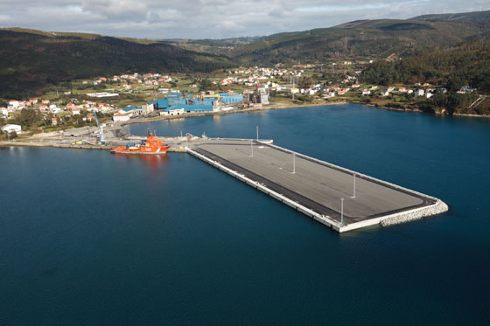

The **Cee factory** is the oldest and most emblematic factory on the Cee-Dumbría industrial complex. Its annual production capacity is 18,000 tonnes of Ferrosilicon, 37,000 tonnes of Silicomanganese, 55,000 of Ferromanganese, 6,000 of Electrode Paste and 3,000 tonnes of Microsilica.

**Installations**

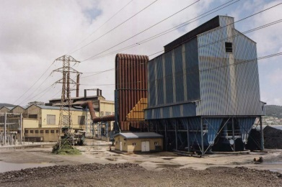

Three submerged electric arc furnaces, one with a power rating of 24 MVA for producing Ferrosilicon, one with 39 MVA that can produce Ferromanganese or Silicomanganese, and one with 28 MVA for producing Silicomanganese.

**Auxiliary installations**

* A plant that produces Söderberg type Electrode Paste, with a 600 KW single-phase furnace.
* Two fume treatment filters in the FeSi furnace, which produce Microsilica.

There is also a fume treatment filter for the FeMn and SiMn furnaces.

B．**Boo factory**

The **Boo factory**, founded in 1913, is situated in Cantabria, more specifically in the municipalities of Astillero and Camargo.

The Boo factory has an annual production capacity of 45,000 tonnes of standard Ferromanganese (HC), 115,000 tonnes of Silicomanganese and 12,000 tonnes of Refined Ferromanganese (MC).

The factory has a surface area of 174,000 m2. Originally, it was designed to manufacture Calcium Carbide and, having undergone various modifications and extensions, it currently produces ferroalloys, specifically Ferromanganese, Silicomanganese and Refined FeMn.

The factory is fully committed to becoming the most competitive factory in all areas of its business, by ensuring that all the environmental and energy resources are used efficiently, by protecting the health and safety of its employees and preventing all potential risks in the workplace and by respecting and improving the environment. All activities that contribute to reducing the environmental effects of all its processes are given the highest priority and are part of a continuous and ongoing process.

**Installations**

|  |  |
| --- | --- |
|  | * Four electric submerged arc furnaces with ratings of 20, 30and 2x35 MVA, for the production of both FeMn and SiMn, indistinctly. * One 3 MVA tilting furnace used to manufacture FeMn MC. * One crushing and classification facility for all the products, with a capacity of 150 t/h. * A cogeneration plant with a rating of 6 MW. * One plant for making briquettes from fine materials. |

C．**Dumbría factory**

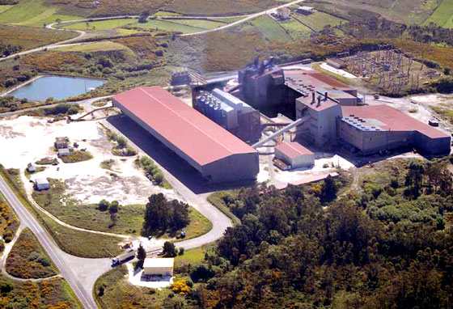

The **Dumbría factory** was built in 1975 and it is part of the industrial complex situated in the county of A Costa da Morte, in A Coruña Province. It is owned by FerroAtlántica Group.

Its annual production capacity is 61,000 tonnes of Ferrosilicon, 6,000 tonnes of Refined Ferrosilicon, 6,000 of High Purity Ferrosilicon (HP) and 13,000 tonnes of Microsilica.

**Installations**

* The factory has 2 submerged electric arc furnaces for producing Ferrosilicon in standard, refined and high purity qualities, with power ratings of 72 MVA and 39 MVA.

As is the case in the Cee Factory, this Factory has fume filters in the furnaces used to create the Microsilica.

**D．Sabón**

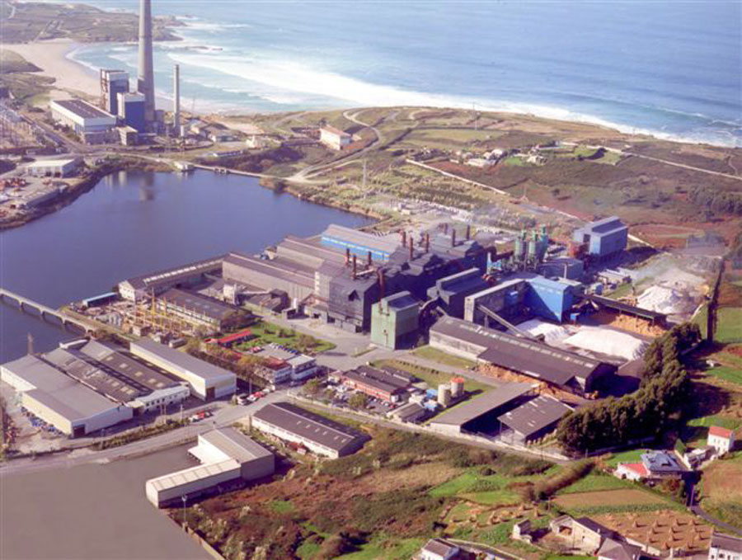

The factory is situated in Northeast Galicia, on the **Sabón – Arteixo** Industrial Estate, at a distance of 12 Km from A Coruña.

In 1992 **FerroAtlántica, S.A.** acquired the Division and boosted its business significantly, recovering productive resources and making new and important investments in the expansion and improvement of the existing installations as well as the construction of new facilities.

The factory has built-up surface of 124,600 m2 and an installed filtering area of 59,550 m2.

Its production capacity is 40,000t/year of Silicon and 17,00 t/year of Microsilica.

**Main installations**

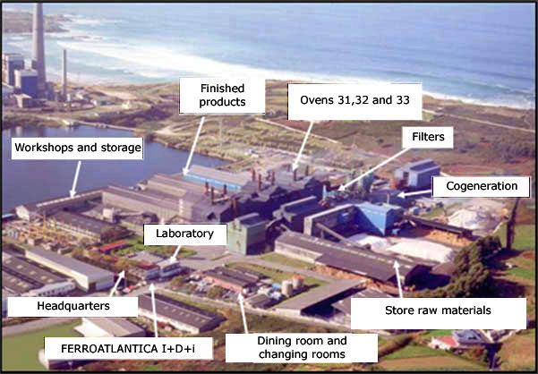

* A 39 MVA furnace for producing SiMe.
* Two 48 MVA furnace for producing SiMe.
* The three furnaces with composite electrodes (ELSA).
* Installations for refining SiMe.
* Corrective systems for collecting and filtering the emissions caused by the factory's activities.
* Installations for classifying and packaging SiMe and Silica Fume® in accordance with the requirements of each client.
* Cogeneration Plant with a power of 6 MW, which transfers the hot gases so that they can be used in a wood dryer.

**Auxiliary installations**

* Mechanical and electrical workshops.
* Laboratory (two in the plant's basement and one general laboratory), fitted with the latest technologies and resources for controlling the characteristics and qualities of the raw materials, intermediate products and final products.
* Replacement parts and supplies warehouse.
* Warehouses and covered silos for raw materials and finished products.
* Administrative offices.

The pilot plant corresponding to the project for producing **Solar-grade Silicon**, using metallurgical silicon, which **FerroAtlántica, S.A.** is implementing through **FerroAtlántica I+D**, has been built in the centre of the site.

2. Hidro Nitro Española, S.A., 组建于940年11月2号，主要发电和制造化学品。

In 1960, it was managed by Carburos Metálicos. In 1968, Mr Juan-Miguel Villar Mir took over as Chairman and oversaw the recovery of Hidro Nitro and its significant industrial expansion.

In 1969 Pechiney Ugine Kuhlmann purchased 40% of the equity.

Subsequently, the Ferromanganese and Silicomanganese furnaces and the Plants of Arias 1 and Arias 2 were commissioned and the company started producing powdered products. In 1991, the active safety system was implemented and the company received the AENOR Quality Certificate, in accordance with the ISO 9001 Standard, in 1992.

In 1996, Hidro Nitro was acquired by Grupo FerroAtlántica, which was part of Grupo Villar Mir, beginning a new plan for the expansion and modernisation of its operations with the commissioning of a cogeneration system, a new Silicomanganese furnace and a new Ferromanganese furnace.

The hydroelectric plants were entered in the Special Regime Register, in accordance with Royal Decree 2818/98.

2007 was the year in which the greatest amount of ferroalloys was produced (99,623 t).

Hidro Nitro has its own railway terminal.

HNE Environmental Controls

Discharge of waste water

The water collected in the plant is used to cool the furnaces and for other sanitation purposes.

Analytical controls have been performed on the corresponding discharges and the corresponding certificates were issued by a Participating Company and the results were reported to the Hydrographical Confederation of the River Ebro.

Discharge of industrial materials

The water collected is used to cool the furnaces and is returned to the river in the same conditions as when collected.

The Integrated Environmental Permit establishes a maximum limit by which the temperature can increase of 3 degrees between the area where the discharge is released and the area upstream. Applus, as a Participating Company, takes measurements every month and in all cases this limit is respected.

The pH levels and the volume of flow are checked daily and they fulfil the limits established in the IEP.

IBMWP INDEX

Every year, during the summer, a Participating Company carries out a Study on the Ecological Condition of the River Cinca, in the areas around HNE, which consists of taking samples from the river's water and analysing them. The report concludes that the ecological status of the River Cinca is GOOD both upstream and downstream from the plant's discharge point, according to the results obtained from the IBMWP (Biological Monitoring Working Party Index) benthonic invertebrates biological indicator. The physiochemical parameters that are studied do not show any alterations in respect of the established quality limits.

Rain discharges

The rainwater is collected in two tanks, to eliminate any solids before it is discharged. Removing the mud was not necessary, due to the low rainfall levels.

Sanitation water discharge

The sanitation water is routed to the municipal sewage system on the industrial estate from where it is pumped out to the Waste Water Treatment Plant of Monzón. Applus performs annual analysis of this waste to ensure that the pH limits and levels of suspended Solids, BD05 (5-day Biochemical Demand) and COD (Chemical Oxygen Demand) do not exceed the amounts stated in the IEP.

Atmospheric Emissions

Emissions controls

Official controls are performed every two years on A-type focal points and every 5 years on C-type focal points.

In-house controls are performed on A-type focal points every fortnight and SO2 and NOx parameter controls are performed on C-type focal points every year.

The plant has established an officially endorsed control system which constantly takes constant readings and records them to ensure that the emissions of particles and CO in the furnace filters (focal points 2, 3, 11 and 19) are within the limits. There are 7 continuous particle measurers and 4 CO2 measurers.

The results obtained fulfil the limits established in the IEP in all cases and are registered and kept in the records corresponding to each focal point.

Air quality control around the factory (immissions)

In 2011, a new piece of equipment that takes samples and measures PM 10 particles in the atmosphere (immission measures), has been installed in the centre of Monzón. The equipment was recently authorised and installed and it works properly. The results are recorded daily and the values obtained fulfil the limits established in Royal Decree 102/2011, of 28 January, on the improvement of air quality.

Production of waste

HNE produces different types of waste:

Hazardous waste: contaminated containers, used oil, toner, contaminated rags and filters, laboratory reagents, etc.

Electric and electronic waste: fluorescent tubes.

Non-hazardous waste: scrap, wood, plastic, rubber belts, etc.

All types of waste are duly stored and labelled and managed with authorised waste disposal companies.

All documents pertaining to the acceptance, control and monitoring of all waste are duly recorded and filed. The declarations on hazardous and non-hazardous waste are issued each year.

Noise

Each year, HNE measures the noise levels in various areas around the perimeter of the plant, through a Participating Company. The levels are measured during the day and at night and in all cases, the levels fulfil the limits established in the Municipal Regulations.

Soil

The following contaminated soil studies have been performed:

Preliminary report on condition of contaminated soil.

Proposed plan for characterisation of soil.

Inspection of subterranean waters and soils

Risk evaluation of contaminated soil.

All studies conclude that the risk associated to the presence of pollution in the different scenarios is acceptable.

Greenhouse Gases

The Regional Government of Aragón has issued the corresponding greenhouse gas emissions permit and the plant has applied for the free allowance of GHG emission rights, with the corresponding methodological report and calculations verified by AENOR.

A．**Monzón factory**

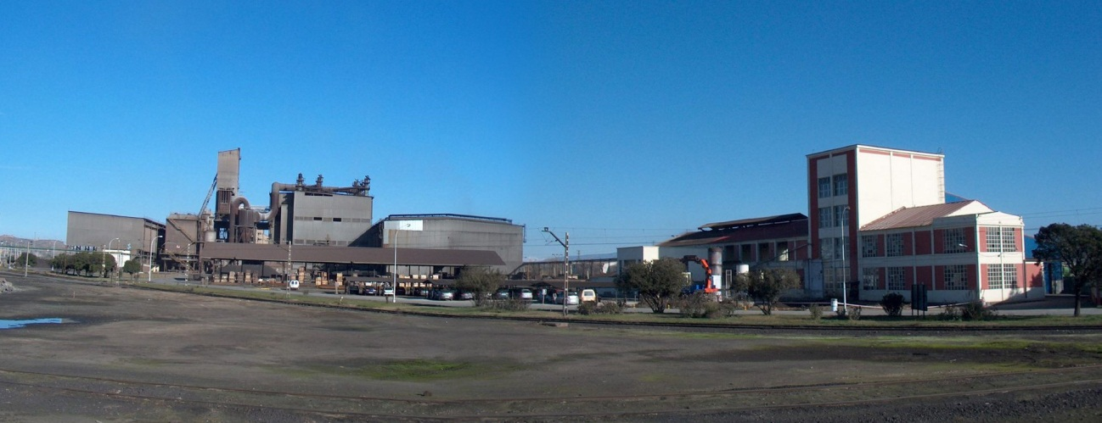

The **Monzón factory** operated by Hidro Nitro is situated on the left bank of the River Cinca, near Monzón, in the Province of Huesca, covering an area of 36 Ha within the Paulés Industrial Estate.

It is at a distance of 140 km from Zaragoza, 144 km from Tarragona, 215 km from Barcelona and 530 Km from Santander.

It is connected to these cities by National Road 240 (Tarragona-San Sebastían) and the Renfe Madrid-Zaragoza–Lérida-Barcelona Railway Line. In addition, the factory has its own railway siding, with a length of 4 km, which includes 6 branches that provide direct access to the factory's different storage warehouses.

The factory's production capacity is 88,000 tonnes a year for Silicomanganese, 46,000 tonnes a year for Ferromanganese and 10,000 tonnes a year for powdered.

**Installations**

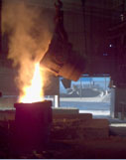

* Two Silicomanganese furnaces with a power of 25 MW each, with three electrodes, with a diameter of 1,800 mm, which handle a current of 115,000 amps each. The furnaces have a rotating drum, with a diameter of 10.5 m and a height of 6 m.

Two Ferromanganese furnaces with a power of 10 MV each; the diameter of the three electrodes is 450 mm and each has the capacity for 31,000 amps; the drum has a diameter of 4.40 m and a height of 2 m. The Ferromanganese furnaces are swivel-mounted and can be rotated; in addition, they can be moved from the loading area to the casting area.

3.

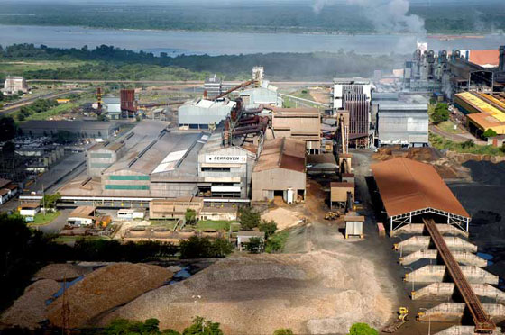

**FerroVen** holds a world-leading position in the ferroalloys industry and the factory which is located in Puerto Ordaz is the only production centre that Grupo FerroAtlántica operates in the American continent and the most important producer of Ferrosilicon ferroalloys.

Ferroalloys are iron master alloys that contain one or more non-ferrous metals as alloying elements for the production of special types of steel, to improve the traction, strength and resistance to wear and corrosion, among other properties.

The factory's annual production capacity is 96,000 tonnes of Ferrosilicon, 22,000 tonnes of Silicomanganese, 38,000 of Ferromanganese, 14,000 of Electrode Paste and 22,000 of Microsilica.

**Installations**

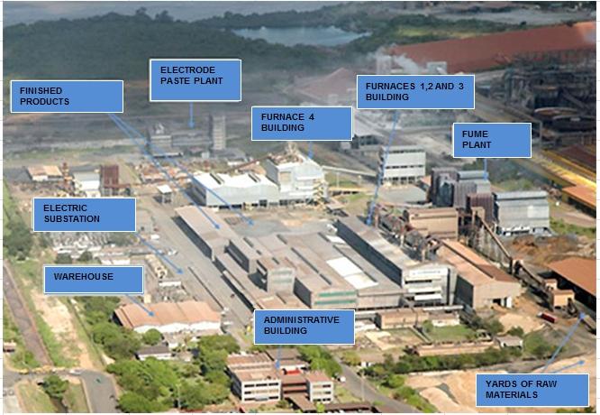

* 4 furnaces for producing ferroalloys.
* Furnace No 4 for producing Manganese alloys. (Ferromanganese and Silicomanganese). The elements are produced by means of a process that reduces the oxides in the manganese mineral, using coal, in electric arc resistance furnaces and at high temperatures produced by using electricity.
* Two  single-phase furnaces for producing electrode paste and calcined anthracite.
* Three furnaces for producing Ferrosilicons with different degrees of purity, through processes that reduce the mineral oxides in quartz, steel, wood, coal, etc, in the electric arc resistance furnaces, based on carbothermal processes.

Fume treatment filters for each furnace.

4.

**Mangshi Sinice Silicon Industry Company Limited** is a Silicon Metal factory located at 12 kilometers at the South of Mangshi City, Dehong Prefecture, Yunnan Province, China.

The plant was built between 2005 and 2008 and started operating in July 2008, and its total production capacity is of 50 000 mt/year of Silicon Metal and 12 000 mt/year of Microsilica.

**Installations**

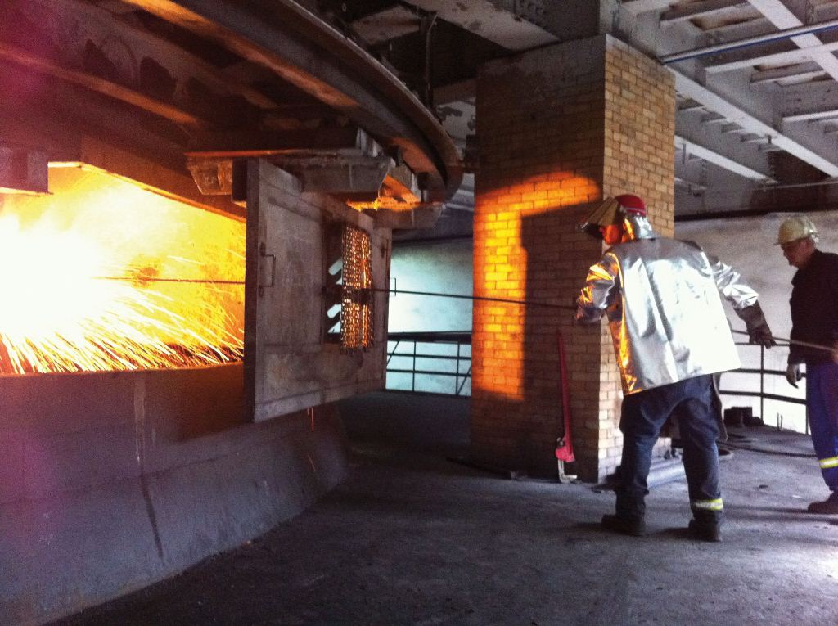

Three furnaces of 27,000 KVA each. During its initial operating time, only two furnaces were put in operation.

5.

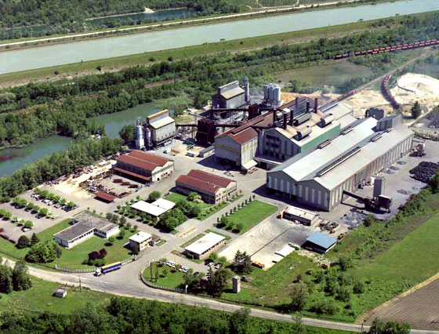

The **Anglefort factory** was built in 1964 by the Nobel Bozel company.

It initially produced Ferrosilicon; as of 1977, it began to produce Silicon Metal through carbothermal reduction.

Its annual production capacity is 35,000 tonnes of Silicon, 13,000 tonnes of Microsilica and 15,000 tonnes of Slurry.

**Installations**

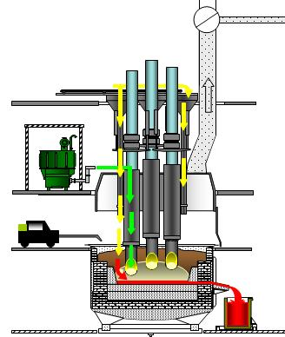

• Two 33 MW furnaces, equipped with compound electrodes for the Silicon and independent treatment filters.

• One crushing-screening line for metallurgical and chemical Silicon.

• One crushing-sifting installation for Silicon dust.

• Four installations for densifying the Microsilica.

6.

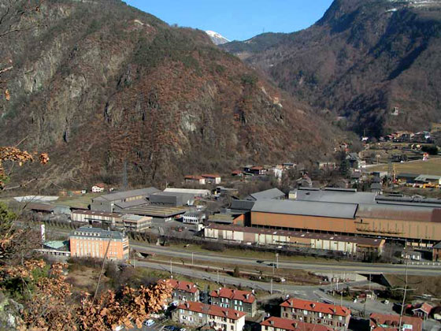

**Chateau Feuillet factory** was launched in 1928 for manufacturing Silico-Calcium and Ferrosilicon under the name of Bozel Society.

After complete their activity with the production of Silicon (carbothermic reduction of quartz).

Its annual production capacity is 23000 tonnes of Silicon, 20000 tonnes of Ferrosilicon, 15000 tonnes of Silico-Calcium and 10000 tonnes of Microsilica.

**Installations**

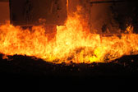

* Two Silicon furnaces (20MW), one Ferrosilicon furnace (18MW), one Silico-Calcium furnace (22MW).
* Each oven has its own treatment plant fumes.
* Each product family has their line of crushing / screening / specific packaging.

Three plants Microsilica densification.

7.

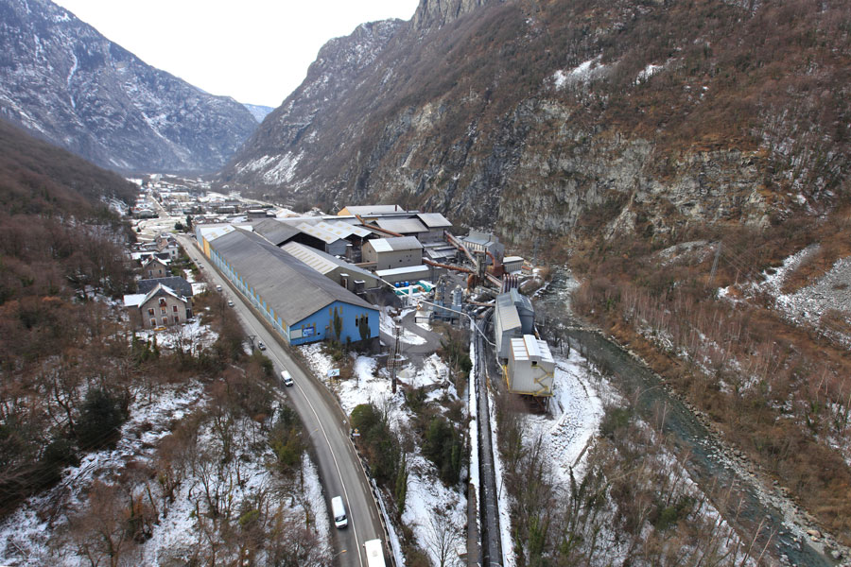

The **Les Clavaux factory** was built in 1898 by Compagnie Universelle d'Acétylène (CUA).

It has produced different types of ferroalloys and silicon alloys and it has been specialising in the production of Silicon Metal based on the carbothermal reduction of quartz since 1980. Its annual production capacity is 35,000 tonnes of Silicon and 12,000 tonnes of Microsilica.

**Installations**

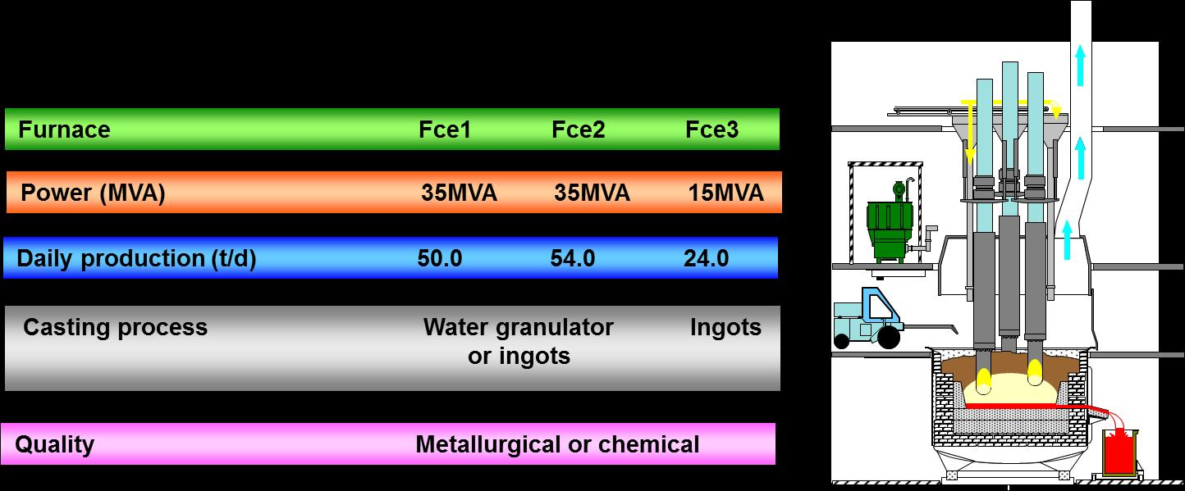

|  |  |
| --- | --- |
|  | * 3 furnaces of 12, 26 and 28 MW, equipped with compound electrodes for the Silicon and independent treatment filters. * 1 granulation workshop for chemical Silicon. * 1 crushing-screening line for metallurgical Silicon. * 2 installations for densifying Microsilica. |

8.

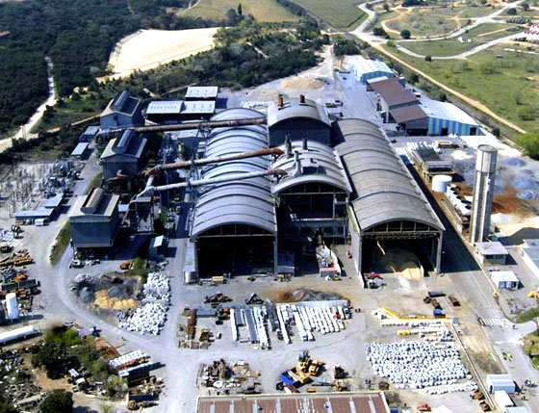

The **Laudun factory** was built in 1958 by the Keller y Leleux Company.

It has manufactured different types of ferroalloys and silicon alloys and currently specialises in the production of high purity Ferrosilicon and Silicon Metal, through carbothermal reduction of quartz.

Its annual production capacity is 14,000 tonnes of Silicon, 20,000 tonnes of Ferrosilicon, 10,000 tonnes de Microsilica and 5,000 tonnes of Inoculants/Nodularisers.

**Installations**

* Three 16, 25 and 35 MW furnaces equipped with Söderberg electrodes for the Ferrosilicon and compounds for the Silicon, and independent treatment filters.
* One crushing-screening line for Ferrosilicon.
* One crushing-screening line for metallurgical Silicon.
* One crushing-screening-powdering-sifting line for chemical Silicon.

Two installations for densifying Microsilica.

9.

The **Montricher factory** was built in 1914 by Société Electrométallurgique de Montricher.

It has produced different types of ferroalloys and has been specialising in the production of Silicon Metal through carbothermal reduction of quartz since 1984.

Its annual production capacity is 33,000 tonnes of Silicate and 12,000 tonnes of Microsilica.

**Installations**

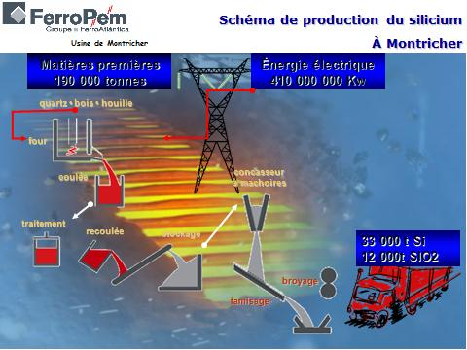

|  |  |
| --- | --- |
|  | * Two 17MW furnaces and 1 25MW furnace, equipped with compound electrodes for the Silicon, and independent treatment filters. * One crushing-screening line for the Silicon for the chemicals market. * One crushing-screening line for the Silicon for the metallurgical market. * Two installations for densifying Microsilica. |

10

The **Pierrefitte factory** was built in 1912 by Société Pyrénéenne du Silico Manganèse.

It has produced various types of ferroalloys and silicon alloys and has been specialising in the production of inoculants through carbothermal reduction of quartz since 1981.

Since 2011, it has also been specialising in the remelting and treatment of Ferrosilicon and Silicon.

Its annual production capacity of Steel and Silicon alloys is 14,000 tonnes and 4,000 tonnes of Microsilica.

**Installations**

|  |  |
| --- | --- |
|  | * One 16 MW furnace equipped with Söderberg electrodes for the production of Steel alloys, with a treatment filter. * One casting line. * Two induction furnaces with a unitary power of 3 MW for the production of Steel and Silicon alloys. * One crushing-powdering-sifting line for transforming inoculants into grain and dust. * One mixer for producing special inoculants. * One installation of Microsilica densification. |

11.

The **Polokwane plant** is situated in the South African province of Limpopo, 8 km south of Polokwane and 360 km north of Johannesburg. The first mining operations began in the 1950s at Witkop ("white hill") and consisted of clearing, extracting and crushing quartz.

The Silicon plant as it now stands was commissioned in the same area in 1974, since when it has been producing high purity metallurgical and chemical Silicon. Most of the products are transported by road to Durban and Richards Bay for subsequent export, whilst a very small percentage is sold locally.

The annual production capacity is 55,000 tonnes per year of Silicon Metal and 25,000 tonnes per year of Microsilica.

**Installations**

* Three 48 MVA furnaces used for high purity metallurgical and chemical Silicate.
* Three filtering chambers to collect the Microsilica.
* Two Microsilica densifying and packing plants.

One Silicon crushing, powdering and packing plant.

12

**Rand Carbide** is situated in the province of Mpumalanga, South Africa, in the city of Emalahleni (formerly "Witbank"), 150 km east from Johannesburg.

The first operations in the plant took place in 1926, when it began producing Calcium Carbide; after a few years, various Ferrosilicon furnaces were commissioned.

In 2008, Silicon Smelters purchased the assets of Rand Carbide and in 2009, the Microsilica plant.

The annual production capacity is 12000 tonnes per year of Silicon Metal 40000 tonnes per year of  FeSi, 15000 tonnes of Microsilica, 10000 tonnes of Inoculants and 22000 tonnes of Electrode Paste.

**Installations**

|  |  |
| --- | --- |
|  | * Two furnaces for production of Ferrosilicon. * One furnace for production of Silicon Metal. * Two filter chambers for collecting Microsilica. * One plant for densifying Microsilica. * One Soderberg electrode paste plant. |

近期，2012.7.21西班牙大西洋铁合金集团宣布将在下半年减产2万吨金属硅，该集团现有金属硅产能25.6万吨。据了解，该集团法国工厂下半年将减产1.2万吨金属硅，法国及南非工厂各减产4000吨金属硅。

#### 生产经营情况

1. 生产情况

Electrometallurgy Division

Grupo FerroAtlántica produced one million tons of ferroalloys in 2011, which is quite close to the record amount produced in 2008, and 19% higher than production in 2010, with activity maintained at all the plants and in all the countries where we are present.

Production was distributed by products in 2011 as follows:

• 313 thousand tons of manganese alloys

• 241 thousand tons of silicon metal

• 222 thousand tons of ferrosilicon, with various degrees of quality.

• 149 thousand tons of microsilicon

• 82 thousand tons of other products, including inoculants and nodulizers

This is the first year that the Mangshi plant in China is in operation. In March, it was started up after the first furnace was repaired, according to the scheduled timeline, and in September the second one entered into operation.

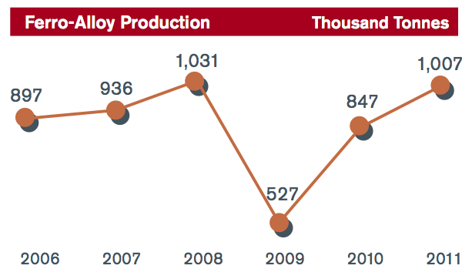

图 3. 大西洋集团近年生产产量

金属硅

Silicon metal

Silicon metal had an excellent first half in 2011, with prices reaching 2,600 Eur/t, only to drop in the second half to levels around 2,200 Eur/t. Overall, the year produced the highest annual price in history, some 2,500 Eur/t, enabling our subsidiary FerroPem to achieve record profits in 2011.

Demand was stronger on the North American market than in Europe, giving rise to a price differential that on many occasions came to more than 200 Eur/t.

In late 2011 and early 2012, circumstances have occurred to weaken demand, especially on the European market. On the one hand, the announcement by a certain European manufacturer in the silicon sector of stoppage periods in addition to those taking place in winter. Secondly, the significant instability in the photovoltaic industry around the world, which has created difficulties for some polysilicon manufacturers. Finally, the lack of strength in the European automobile industry, which is critical to aluminium production.

The Chinese market evolved in a completely different manner than the European and North American markets, as it recorded its greatest increases in sale prices in the final months of 2011 due to the increase in demand from the secondary smelting aluminium industry. Even so, Chinese market prices are still a good deal lower than prices in Europe, with differentials of more than 500 Eur/t, due to the excess installed capacity of the silicon industry.

1. 销售、财务情况

销售

按产品类别分，其近年销售情况如下表、图，所示。

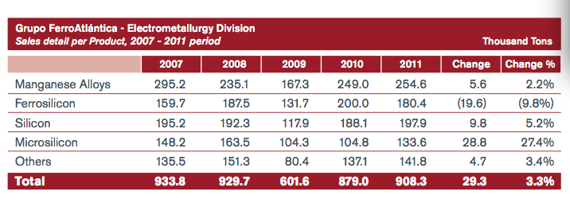

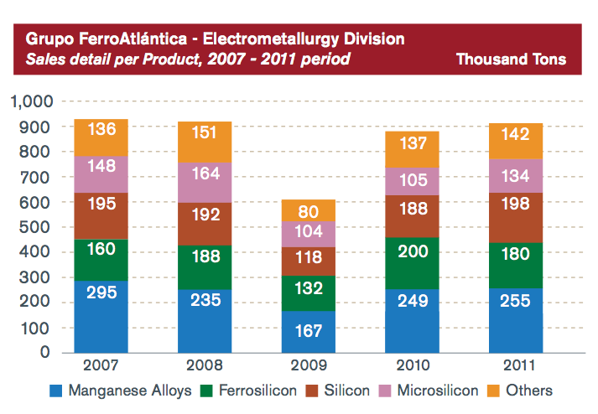

2011年大西洋集团按季度的销售、Ebitada和税后利润演化如下图：

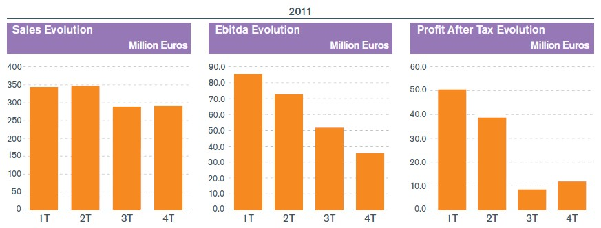

历年财务情况：

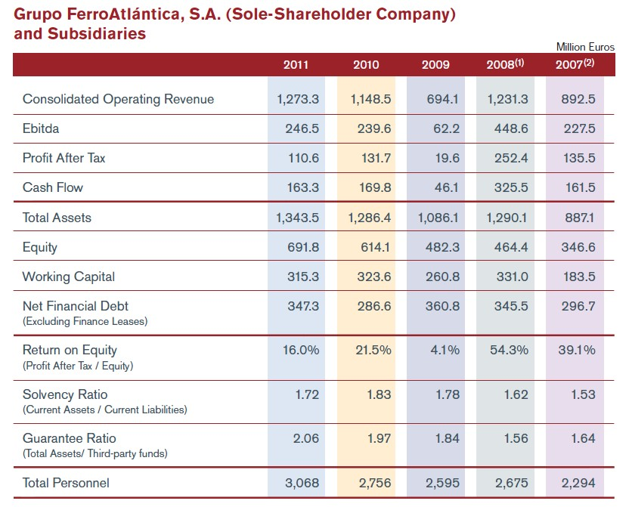

历年各个业务投资情况：

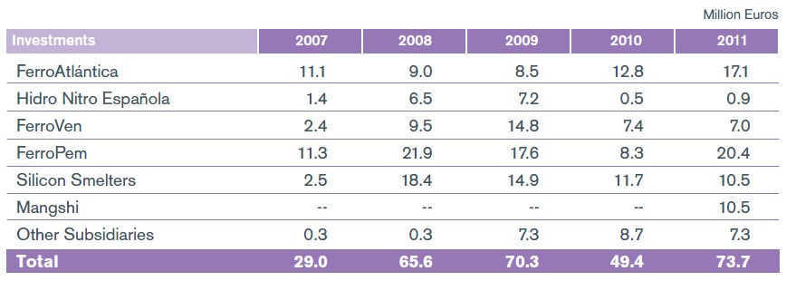

1. 2012年业务预测

根据全球经济发展情况，大西洋集团的业务战略会有所调整，会受欧盟经济的发展特别是西班牙的影响。

力争实现销售额13.166亿欧元。其中7090万为能源方面，12.457亿为冶金业务方面。

实现Ebitda 1.924亿，其中3220万为能源业务贡献，1.602亿为冶金业务贡献。

税后利润8230万欧元，能源和冶金分别为1870万和6360万欧元。

## 挪威埃肯C:\Users\Administrator\AppData\Roaming\Tencent\Users\32329357\QQ\WinTemp\RichOle\N[27A{F$HPY7V[4]56%2]EB.jpg

埃肯在全球硅材料、铸造品、碳素、太阳能级多晶硅等行业处于全球领先地位，具有极高的知名度，拥有多项世界领先的技术，如高温冶炼炉开发和设计、高温冶炼工艺技术、精炼技术、高温炉自动控制技术、湿法冶金技术、冶金法太阳能级多晶硅生产成套技术、自焙电极和复合电极技术、微硅粉收集和增值利用技术、高温炉尾气能量回收技术等。

#### 埃肯业务情况

1)．埃肯硅材料业务

埃肯金属硅业务板块拥有5个核心工厂, 雇员831名，冶炼炉总容量218MW，金属硅产能总计14.8万吨/年，主要产品是金属硅和微硅粉。金属硅主要用户是化学工业、电子工业、光伏太阳能和炼铝，在欧洲市场达64%；，微硅粉主要下游用户是建筑混凝土、耐火材料行业和聚合物材料等，约占全球70%的市场份额，埃肯公司是世界微硅粉市场最主要的供应商。

2)．埃肯铸造业务

埃肯铸造品业务拥有5个核心工厂，雇员547名，冶炼炉总容量232MW，铸造合金总产能26万吨/年。主要产品是特种硅基合金，主要用户是钢铁和铸造，终端用户包括汽车、造船、航空、机械制造、高压输变电和风力发电等。其中，埃肯镁硅铁合金占欧洲市场份额第一，孕育剂占欧洲、美国和印度市场份额第一，硅基特种合金位居中国市场份额第一。

3)．埃肯碳素业务

埃肯碳素业务拥有5个核心工厂，雇员417名，产品主要是电极糊、自焙电极、复合电极等，总产能43万吨/年。用户包括炼钢、铁合金、炼铝和化工等，主要销售区域在欧洲、南美和亚太地区，其中埃肯电极糊占全球市场60%的份额。

4)．埃肯太阳能级多晶硅业务

埃肯自主研究开发了冶金法太阳能级多晶硅生产技术，拥有完全自主知识产权。埃肯于2009年10月建成投产了世界首套冶金法太阳能级多晶硅大型工业化装置，产能6000吨/年，目前正处于达产阶段。与目前广泛采用的西门子法工艺和个别厂家采用的硅烷流化床工艺相比，该技术投资仅是西门子法的40%, 电耗低，仅为前两者的25%和50%。此外，该工艺流程中，产品可直接与下游硅片加工集成，生产过程安全、环保且可靠性强，具有广阔的应用前景和很强的竞争力。

#### 埃肯工业硅

Elkem Silicon Materials is one of the world's leading suppliers of metallurgical silicon. We deliver special products to customers in the chemicals, electronics and aluminium industries worldwide.

Silicon from Elkem is alloyed with aluminium to produce cast aluminium parts, or can be processed by the chemicals sector to a number of products from sealants, cosmetics and electrical insulation materials to lubricating oils and other synthetics used in car manufacturing.

Elkem Silicon Materials has three production plants in Norway

Elkem Bremanger

Elkem Salten

Elkem Thamshavn

#### 埃肯财务情况

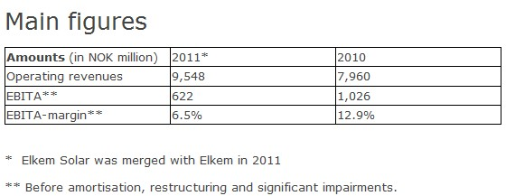

## 全球冶金（Globe Metallurgical）

|  |
| --- |
| Globe Metallurgical Inc. (GMI) is a wholly-owned subsidiary of Globe Specialty Metals Inc. We trace our corporate roots back to 1871 and are today among the world's largest and most efficient producers of metallurgical and chemical-grade silicon metal and silicon-based specialty alloys. We own four manufacturing plants, located in the U.S. States of Ohio, West Virginia, Alabama and New York and market our products to more than 160 customers, predominantly in North America.  Our products are critical inputs in the manufacture of a wide range of industrial and consumer products with growing markets, including silicone compounds, aluminum, photovoltaic solar cells, electronic semiconductors, ductile iron, automotive parts, industrial pipe and steel. Our manufacturing facilities are designed and managed to be highly flexible, enabling us to vary our product mix according to market demand.  We have two wholly-owned subsidiaries, West Virginia Alloys, Inc, which owns and operates our West Virginia plant, and Alabama Sand and Gravel Inc., which operates a quartzite mining operation that supplies us with the majority of our needs for our principal raw material. We also own 50% of Norchem Inc., North America's leading producer of silica fume products, manufactured from byproducts produced by our plants.  （美国）环球特种金属集团公司是全球最大的金属硅和硅系特种合金的生产商，主要生产各种被广泛地应用于需求日益增长的工业领域和日用消费领域的特殊规格硅系合金。公司在伦敦股票交易所上市公司（股票代码：GLBM）。  用户包括有机硅、铝合金和钢铁生产商，以及光伏级和电子级多晶硅制造商。  集团总部位于纽约曼哈顿中心区，在美国俄亥俄州、西弗吉尼亚州、阿拉巴马州、纽约州以及在巴西的帕拉州(Pará)、阿根廷的门多萨省(Mendoza)都建有分厂或子公司，在中国宁夏自治区拥有合资企业。  下属子公司主要有：环球冶金有限公司（美国）、搜秀有限公司（美国）、环球工贸有限公司（巴西）、环球金属有限公司（阿根廷）、宁夏永威炭业有限公司（中国）。 业务部门构成 **1）Globe Specialty Metals, Inc.** - Headquarters, New York, New York  **2）Globe Metallurgical, Inc.** - Main Office, Beverly, Ohio, USA  **Beverly Plant** (Beverly, Ohio)  *5 Furnaces - Silicon Metal, Specialty Alloys, Ferroalloys*  **West Virginia Alloys, Inc.** (Alloy, West Virginia)      Joint Venture Dow Corning  *5 Furnaces - Silicon Metal*  **Selma Plant** (Selma, Alabama)  *2 Furnaces - Silicon Metal*  **Niagara Plant** (Niagara Falls, New York)  *2 Furnaces - Silicon Metal, Ferroalloys*  **Alabama Sand & Gravel Inc.** (Billingsley, Alabama)  *Quartzite Mine*  **3）Core Metals Group** - Main Office, Coraopolis, Pennsylvania, USA  **Bridgeport Plant** (Bridgeport, Alabama)  *1 Furnace – Ferroalloys*  **4）Alden Resources, LLC** - Main Office, Corbin, Kentucky, USA  *Coal Mines*  **5）Solsil, Inc.** - Main Office, Beverly, Ohio, USA  **Beverly Plant** (Beverly, Ohio)  *Solar-Cell Grade Silicon Metal*  **6）Globe Metales S.A.** - Main Office, Buenos Aires, Argentina  **Main Plant** (Mendoza, Argentina)  *2 Furnaces - Calcium Silicon, Magnesium Ferrosilicon*  **Villa Mercedes Plant** (San Luis, Argentina)  *Cored Wire Facility*  **Ultracore Polska** (Police, Poland)  *Cored Wire Facility*  **7）Ningxia Yonvey Coal Industry Co., Ltd.**  **Offices and Plant** - ChongGang, Shizuishan, Ningxia, P.R. China  *Carbon Electrodes*   工业硅 SILICON  We produce high-purity chemical and metallurgical grade silicon metal in our Ohio, West Virginia, Alabama and Niagara Falls, New York US plants. Our Globe Metallurgical subsidiary is the largest producer of silicon metal in North America and as a group we are among the largest producers in the world.  Our Solsil subsidiary manufactures very-high-purity solar-cell-grade silicon and supplies it to top-tier manufacturers of silicon ingots, wafers and photovoltaic ("PV") solar cells. Solsil produces this product using metallurgical production methods. This so-called "upgraded metallurgical-grade silicon" (UMG-Si) is an alternative to solar-cell-grade silicon produced by traditional methods.  Our silicon metal is used by the chemical industry in the production of silicone compounds and by aluminum manufacturers to improve the useful properties of aluminum, as well as in the manufacture of silicon wafers used in photovoltaic solar cells and electronic semiconductors. According to the metals industry research firm, CRU International, our US plants are among the most efficient producers of silicon metal in the world.  Silicone compounds are the main raw material for a large and growing number of industrial and consumer products, including silicone rubber parts, urethane foam, sealants, adhesives, lubricants, food additives, coatings, polishes and cosmetics. Silicones are substitutes in many applications for petroleum-based compounds and the demand for silicones benefits from higher oil prices.  Demand for aluminum has grown steadily in recent years, reflecting increased economic activity in both the developed and developing world, as well as new uses as a lighter, more economical replacement for other materials. Silicon metal consumption by aluminum manufacturers has grown accordingly.  The fastest growing market for silicon metal is for the very-high-purity product from which most photovoltaic ("PV") solar cells are manufactured. The Norwegian Institute of Technology's SINTEF research group projects continued rapid growth in this market, with solar cell usage exceeding current silicon usage for all other applications combined by 2020. |
|  |

#### 财务情况

2012-02-29 17:28:34   来源：富宝资讯

环球特种金属公司公布，由于维护与升级的需要加之当下成交不畅以及价格低廉，其第二季度的盈利水平将呈下降走势。

Bridgeport Fire在第一季度的出货量由54285吨下降5.5%至51306吨，比去年同期的54285吨下降了13.3%。

全球对此公司的需求量在5000吨左右，较低的出货量使得六个炉子不得不停产检修升级。

首席执行官杰夫·布拉德利表示，Bridgeport已恢复全面运作，所有的检修工作也已完成。

全球公布了其第二季度净利润为1340万美元，较其第一季度的2070万美元下降了35%，但与去年同期的1170万美元相比，增长了14.8%。总销售额为1.655亿美元，比第一季度的1.749亿美元下降了5.3%，但与去年同期1.558亿美元相比，增加了6.3%。

截止2011年年底，6个月的净利润同比增长了16.1%至3.404亿美元。

May 7, 2012

**Globe Specialty Metals Reports Third Quarter and Nine Months Fiscal 2012 Results**

* Net income attributable to GSM for the nine months of $45.8 million, up $8.5 million from the prior year
* Diluted earnings per share for the nine months of $0.60, up from $0.49 per share in the prior year
* EBITDA on a comparable basis for the nine months of $108.5 million, up from $84.3 million in the prior year

NEW YORK, May 7, 2012 (GLOBE NEWSWIRE) -- Globe Specialty Metals, Inc. (Nasdaq:GSM) (the "Company") today announces results for the third quarter and nine months of fiscal 2012 ended March 31, 2012.

Net sales for the quarter of $173.4 million were up 5% from the second quarter of fiscal 2012 and flat with the prior year. Shipments of 60,828 MT were up 19% from the second quarter and up 3% from the prior year. Net income attributable to GSM for the third quarter was $11.6 million, compared to $13.4 million in second quarter and $23.4 million in the prior year. Diluted earnings per share for the quarter were $0.15 per share, compared to $0.18 per share in the second quarter and $0.30 per share in the prior year.

EBITDA for the quarter was $28.4 million, compared to $30.8 million in the second quarter and $43.3 million in the prior year. EBITDA on a comparable basis was $29.4 million, compared to $36.6 million in the second quarter and $44.7 million in the prior year.

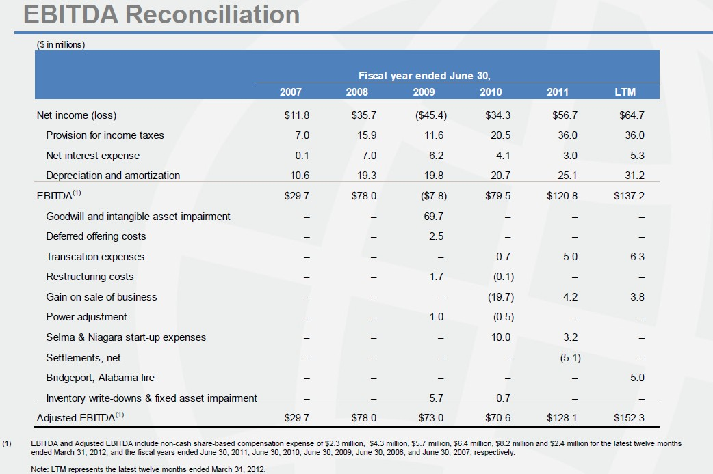

Sales in the quarter increased 5% from the second quarter, on an increase in volume of 19%. The increase in shipments is largely due to the completion of our planned maintenance and upgrades on six of our furnaces at the end of calendar 2011 and the re-start of our Bridgeport, Alabama plant following the fire in November 2011.

Cash and cash equivalents totalled $140.7 million at March 31, 2012 and total debt was $103.4 million, including the $50.0 million Alden acquisition financing and $12.0 million of bank financing for the Alloy, West Virginia joint venture.

Cash flow provided by operating activities was $23.0 million in the quarter, compared to $12.3 million in the second quarter and $23.9 million in the prior year. Capital expenditures totalled $11.3 million in the quarter, primarily related to acquiring mining equipment for Alden in order to open new coal mines and refurbish old equipment.

Diluted earnings per share on a comparable basis were as follows:

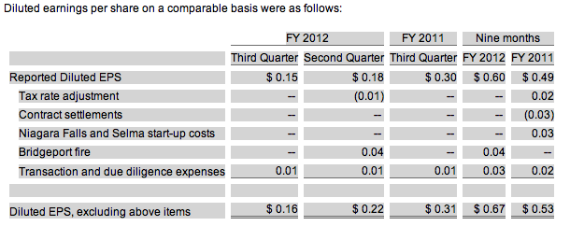

## 巴西瑞玛C:\Users\Administrator\AppData\Roaming\Tencent\Users\32329357\QQ\WinTemp\RichOle\QT5)K)(8%M7]1416C8THG06.jpg

The Rima Group is the largest Silicon Metal producer in Brazil and the fourth in the world. The Silicon Metal produced by Rima is used in the Mettallurgical, Chemical, Electronic and Photovoltaic industries. The material is produced in submerged electric arc furnaces utilizing high quality quartz, charcoal and carbon electrodes. Silicon Metal is an environmentally friend product as it is produced with charcoal coming from Rima’s renewable reforestation.

• Mettallurgical Grade

Having very low levels of impurities, Metallurgical Grade Silicon Metal is used in the production of aluminum alloys, mainly for the automotive industry. The high purity of our product allows for quick solubility and high yield in the alloying process.

• Chemical Grade

Chemical Grade Silicon Metal is the basic raw material in the production of special silicones also called light oils. Light oil products have applications in the areas of medicine, cosmetics, electronics, textile, automotive and construction.

• Micronized Silicon

Utilized in the Semi-conductor Industry, Micronized Silicon is the main raw material in the production of Trichlorosilanes, which are transformed in diodes and processors of high performance (computer microchips).

• Solar Grade Silicon

Solar Grade Silicon Metal is used in the production of Solar Cells, a market segment that is growing exponentially in recent years as an alternative source of electrical energy.

## 湖北三新

湖北三新硅业有限责任公司是一家中外合资的大型硅矿采选加工一体化企业。公司于2009年12月25日成立，注册资本金67000万元。主要产品有：高纯硅石、电子级硅微粉、高纯石英砂、精制低铁石英砂、高纯工业硅、高纯铁合金等。

公司以优质硅石矿资源为基础，以资源节约及综合利用为理念，依靠科技创新，延伸产业链。即从硅石矿开采到系列精细产品开发，对硅资源采用“采选加一体化”发展模式，构建循环经济产业链。

国家已批准公司投资35亿元建设150万吨硅矿开采及加工项目，在产业园内兴建16台33000KVA高纯工业硅电炉。

项目于2010年8月份动工建设，首台高纯工业硅装置已于2011年12月建成投产。

## 芒市卓信

芒市卓信属维拉米尔集团，包括能源/冶金/采掘、以及房地产、化肥、建筑业等下属集团，是西班牙最大的私人企业，创办者维拉米尔先生曾经是西班牙的前副首相，2010年的营业额约80亿欧元，全球雇员人数22000人，属于能源/冶金/采掘业的大西洋铁合金集团，主要生产金属硅及锰合金，在5个国家拥有15间工厂及46座熔炉,2011年在全球的石英矿储备在1亿吨以上，在欧洲拥有14家水电站，木炭的年产能力12万吨以上，自有电极糊产品，以及在欧洲发展上游太阳能产品；在中国投资项目有两个，一个是德宏芒市，2010年12月收购了芒市卓信100%的股份，拥3*27mva熔炉，5万吨/年si 产能，预计工业改造投资计划超过2亿元人民币，若对德宏投资环境有充分信心，将引入世界最顶尖金属硅生产工艺和技术。另一个在四川甘孜康定县，预计2013年投产。

    大西洋铁合金集团是世界第一金属硅生产商，同时也是世界领先的铁合金生产商，公司年度总产量超过一百万吨。我们的产品用于制造钢铁，不锈钢，铝合金，化学部门，硅胶，太阳能发电板等。  
    大西洋铁合金集团西班牙最大的独立水力发电商，总发电量达到190兆瓦。  
    大西洋铁合金集团在2010年度取得了超过 11,50亿欧元的营业额，并在全球范围内聘用超过2700名员工。  
    大西洋铁合金集团：  
-ferroven, 委内瑞拉分公司，在ordaz港拥有一座工厂和石英矿。  
-ferropem, 法国分公司，共拥有六座工厂。  
- silicon smelters, 南非分公司，共拥有两座工厂：处于polokwane的世界最大规模的金属硅厂和处于rand carbide的工厂。   
    大西洋芒市硅业（芒市卓信硅业有限责任公司），处于中国云南。该工厂拥有3座熔炉和3,70万吨的年产量。  
    大西洋甘孜硅业，处于中国四川。该工厂建成后将成为世界最大的金属硅厂，拥有6座熔炉和12万吨的年产量。  
    维拉米尔甘孜能源发展，处于中国四川。计划建造4座水力发电站，总发电量达到400兆瓦

## 云南永昌

云南永昌硅业股份有限公司位于云南省保山市龙陵县，公司由中国企业500强之一云南冶金集团股份有限公司控股，汕头市福瑞投资有限公司、龙陵县国有资产经营有限责任公司参股，注册资本28,571万元，员工1000余人。生产规模为年产金属硅5万吨、硅铁5万吨、微硅粉2万吨。十二五期间，公司建设10万吨/年化学级金属硅节能环保翻番等项目，使生产规模将达到年产金属硅15万吨、硅铁5万吨、微硅粉6万吨。

公司所在地龙陵县交通便利，大（理）瑞（丽）铁路、杭（州）瑞（丽）高速穿境而过，是我国连接南亚东南亚国际大通道的“桥头堡”；境内硅石品质好、储量大，水电资源丰富，电量充盈，电网独立运行。为整合优势资源，本着“装备先进、国内一流、环境友善、科学发展”的原则，公司于2005年以来建成了年产工业硅5万吨、硅铁5万吨、粒度硅粉4000吨生产线各一条，共有25000KVA、12500KVA矮烟罩半封闭旋转式矿热电炉7台，生产线上采用了组合式电极把持器、110KV电压直供电炉、高低压补偿、变频调速、德国西门子PLC自动配料控制、世界先进的收尘和微硅粉加密、粒度硅粉加工等先进技术，先进技术和装备的使用，使电耗等指标达到了行业内先进水平，得到了业内专家和人士的赞誉。2008年，被国家发改委列为第四批铁合金行业准入企业。2010年顺利通过中国有色金属工业协会工业硅分会组织的“25500KVA工业硅大容量电炉技术及产业化”项目科技成果鉴定，被列为目前全国的示范厂；顺利通过全球最大有机硅生产企业美国道康宁有机硅有限公司的产品认证，被该公司列为中国第一家“甲基氯硅烷级金属硅供应商”。