**Tools Used:**

- VS code with C/C++ extensions

- Mingw-w64 for g++ compiler, and debugger

- Microsoft Excel for verification

**\*\*Note:** This application has not been verified it complies with Linux. I have included the Application file in the repository. For further information on the VS Code and MinGW installation, refer to this link under 'Prerequisites': <https://code.visualstudio.com/docs/cpp/config-mingw> .

The .csv output file will be saved in the folder where the application is located. At the moment, the file name is "csv_aligned_output.csv".

**Building:**

1. Follow the steps in the link above to install Visual Studio Code. Once VS Code is installed and open, click on the box icon on the left side of the start window.

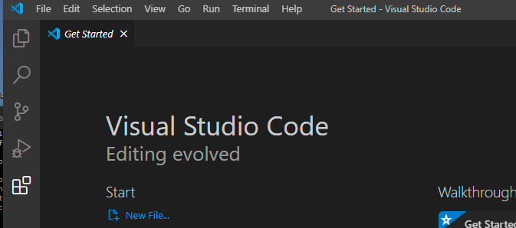

1. Here, search for “C++”, and select “C/C++”. A window should show up on the right side for installation. Click the “Install” button.

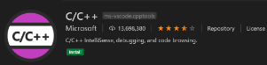

1. To install the g++ compiler, refer back to the link above, and follow steps 3-5 of the 'Prerequisites' section.
2. Next, verify MinGW was properly installed by opening a new command prompt, and typing in: g++ --version.
3. After installing, open up VS Code if it is not still open. Click on ‘File->Open Folder…’, and selecting the folder where ‘csv_aligner.cpp’ is located.
4. From here, build the application by selecting the drop down next to the ‘play’ arrow in the upper right hand corner, and clicking on “Run C/C++ File”.

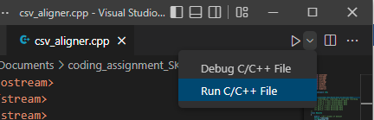

1. A pop up will display different compilers, and build configurations. Select the g++.exe build.

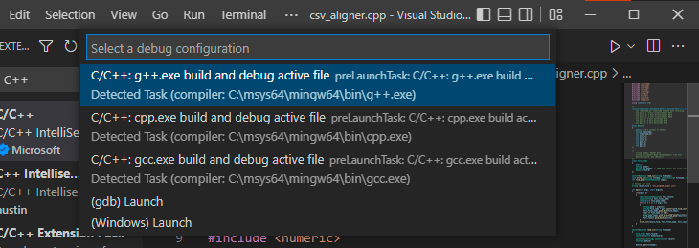

1. A build terminal will display the status of the build. This screen should display once the build is complete.

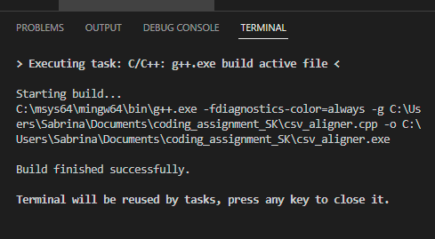

1. Now the application is ready, and is located in the same folder as the ‘csv_aligner.cpp’ file. From any Windows command prompt, change the current directory to that same folder location.
2. In the command prompt, write “csv_aligner”, and then the location with the file names of each of the files you would like to align.

Ex: **csv_aligner C:\User\SK\Doc\walk_data1.csv C:\User\SK\Doc\walk_data2.csv**

1. The .csv file should be in the same folder as the application file.