Robot Dynamite

Game Design Document

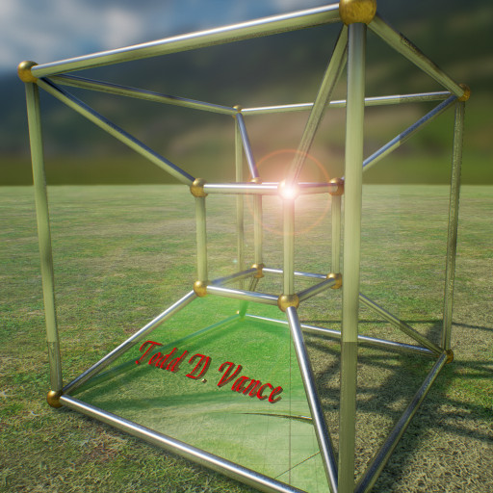

Prepared by:

Todd D. Vance
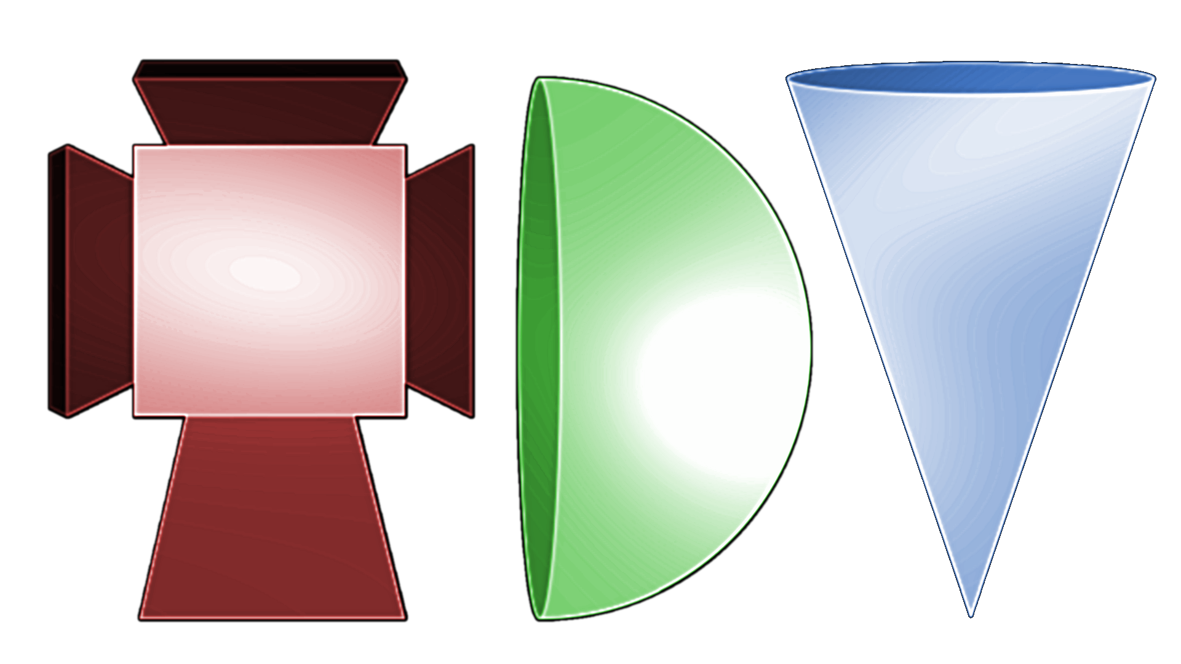

2017

Table of Contents
Revision Notes 2
Introduction 2
Game Analysis 2
Genre 2
Game Elements 3
Game Content 3
Theme 3
Style 3
Game Sequence 3
Players 3
Game Reference 3
Game Technical 3
Game Sales 3
Game Atmosphere 4
Game Play 4
Overall Game States 4
Actions: 5
Options 5
HUD 5
Enemy AI 5
Art 6
Non-pawn actors 6
Inventory 6

Part 1: The Game

Introduction
Alien robots invade the Earth. Earth releases its own robot to fight them.

The purpose of this project is to design and implement a first-person shooter (FPS) game using the Unreal Engine 4 game engine. This project includes at least one complete level of game with documentation. The level will include a representative sample of the things found in FPS games. The game will be single-player and will be focused on action.

Game Analysis

Genre

Action, first person 3D, shooter

Game Elements

Shooting, action, secrets, science-fiction

Game Content

Realism

Theme

One hero against a hoard of attackers

Style

Realism

Game Sequence

simulation

Players

1

Game Reference
Duke Nukem 3D, Quake, Doom, Unreal Tournament

Game Technical
Single player, PC-based, 3D with 2D GUI systems, Unreal Engine 4

Game Sales
Free, MIT License

Game Atmosphere

Insert sketches here.

Game Play
Use mouse/keyboard to explore level, kill (or evade) enemy robots without being killed, and find the level exit to continue to the next level. On the way, pickups for health, armor, weapons, and ammunition, as well as optional secret areas to explore.

The first level is a train station: Robot Dynamite took a train to The Old City where the first wave of killer robots landed.

Player movement abilities include running, lunging, jumping (double-tap for higher jump), crouching.

Player starts with one weapon but can reload or get new weapons from pickups. Weapon switches automatically if pickup is “better” weapon or automatically to best available weapon when current weapon is out of ammo. This feature can be turned off in settings.

Player starts with full health and armor. Hits reduce health, inversely related to the amount of armor, while also reducing armor. Pickups restore health or armor. Super-pickups put health or armor above the normal maximum.

Player can change the difficulty of the next level (or first level if just starting) between easy, normal, hard, impossible. This affects pickups and enemies, as well as the extent that enemies and pickups respawn.

On death, the player restarts the level (future development: save point) with the ammo/health/armor/weapons that were available at the start of that level just played. This is equivalent to save checkpoints being the starts of levels.

New levels are unlocked as prior ones are completed. This persists between game runs

Overall Game States

Splash screen → Main Menu → Quit | Options | New Game | previously unlocked level

new game | previously unlocked level→ choose difficulty → Game

Game → Options | Next Level | Die

Actions:
Look/aim: mouse
Fire: left mouse button
Move forward: right mouse button
strafe: WASD
Jump: spacebar
Crouch: C
Lunge: V

Dodge left or right: Q and E
Options menu: O or ESC
Change weapon: 1-9 or mouse wheel
Select from inventory: [ and ]
Use from inventory: ENTER (ENTER also stops using if continuous, like jetpack)
Use/Push/Do something: F (e.g. open doors)

Optional: Tab: show map

Options

Controls: change controls, mouse sensitivity, invert y axis of mouse
Difficulty: change difficulty of next level loaded (including this level if you die first)
Volume: music and sfx
Resume (game or main menu == title screen)
Return to title screen (if in game)
Exit

HUD
Shows health, armor, current weapon ammo, ammo for each weapon in inventory, current item of inventory

Enemy AI
Patrol between waypoints
Wander randomly
Chase player if detected (sight, hearing, was shot at)
Go to suspected location of player
Flee player if health is low
Attack player if in range

Art
Buildings, walls, floors, ceilings, stairs.
train tracks, bridges, roads, fences
monuments and artifacts
trash cans, trash
posters, etc.

Non-pawn actors
Elevators
Escalators (maybe)
Doors: swing doors, sliding doors (doom style and elevator style), revolving doors
Movement components: spin, fall, incremental transform (e.g. elevator with multiple floors)
Teleporters
Conveyer belt
Secret area
Level exit
Mirror

Inventory
Jetpack
Speed
SCUBA
Night Vision
Flashlight
keycards

Part 2: Technical Details

Inventory System

An Inventory Component can be attached to any pawn actor. This Inventory Component contains an array of Inventory Item objects. Each Inventory Item object contains metadata: the class of the actual item, text to display on pickup, discard, use, and reload, and an image for the item for use in the hud, and an index to show where it goes in the inventory array (which is full of holes—each type of item has its preferred index in a player’s inventory; an array of classes on the pawn class will show which index each Actual Item class gets). In addition is a variable that holds an actual instance of the class, called the Actual Item to distinguish from the Inventory Item wrapper, and it is set to invisible when not being used.

An Actual Item that can be reloaded (a gun, a jetpack with finite fuel, and so on) must implement the Reloadable interface. The item itself maintains things like maximum amount allowed, and reducing the amount as it is used. The amount is a float value (even for bullets) for flexibility.

For convenience, the following conventions are used:

Inventory index 0 is the Melee weapon. This is not reloadable, but is never discarded either—equivalent to infinite ammo.

Indices 1 through 19 are the guns. These are reloadable.

Indices 20 through 29 are vital statistics of the character: health, strength, armor, and so on, that get their own boxes in the HUD separate from the rest of the inventory. These are all reloadable.

Indices 30 through 39 are keys, which are used automatically when at the appropriate lock. These are single use, not reloadable.

Indices 40 on up are all other inventory items that are used by pressing the “Use Inventory” key and scrolled through via the “Select Inventory” keys. They may be reloadable like a jetpack or SCUBA gear, or they might be single use.

Inventory is acquired several ways:

1. default inventory at start of game (a “first gun”, full health and armor, for example).
2. Loading from a saved game
3. Walking over a pickup. The pickups are of two types, actual item, or reload only. An actual item will give you the item and fully load it if reloadable. A reload-only pickup will not work unless you already have the item, in which case it will reload the item. The latter are mostly for ammo packs for guns.

Inventory is lost several ways:

1. player discards something (optional to implement this)
2. a game event takes it away (e.g. player gets captured in a cutscene)
3. A one-use item is used
Note, if reloadable, running out of ammo/amount/whatever generally does not cause loss of the item.

Effects needed
Pickups
Explosions
Mirror/two-way mirror
Smoke
Steam
Spin
Fall
Incremental movement
Switches, including 3-way switch and combo lock and multi-throw switch
Shoot trigger
Pawn trigger
“Use” key trigger (invisible switch)
beam trigger
Under water
In space
Blink/broken light
Pulsing light
Treadmill/conveyor belt
Escalator
Teleporter (one-way and two-way)
Earthquake
Lightning
Thunder
Rain
Curtains that open and close
Adjustable water level
Stream of water (conveyance)
One-way wall
Force field
Destructable wall
CCTV
End level
Spawner actor
Projectile spawner
Placeable mine
Grabber/crane
Level end camera

HUD Specs

Width: 512 pixels
Height: 64 pixels
Text size: 19 pixel points
Small text size: 10 pixel points
Health center position: (54, 43) (0,0 is top left)
Armor center Position: (139, 43)
Ammo center Position: (359, 43)
Inventory center Position: (443, 43)
Inventory icon size: 32x32 (some room for more width)
Weapon stats center-left positions:
X value of 1,2,3: 205
X value of 4,5,6: 238
X value of 7,8,9: 270
Y value of 1,4,7: 32
Y value of 2,5,8: 44
Y value of 3,6,9: 56

The numbers are 10 pixels left of the corresponding values

