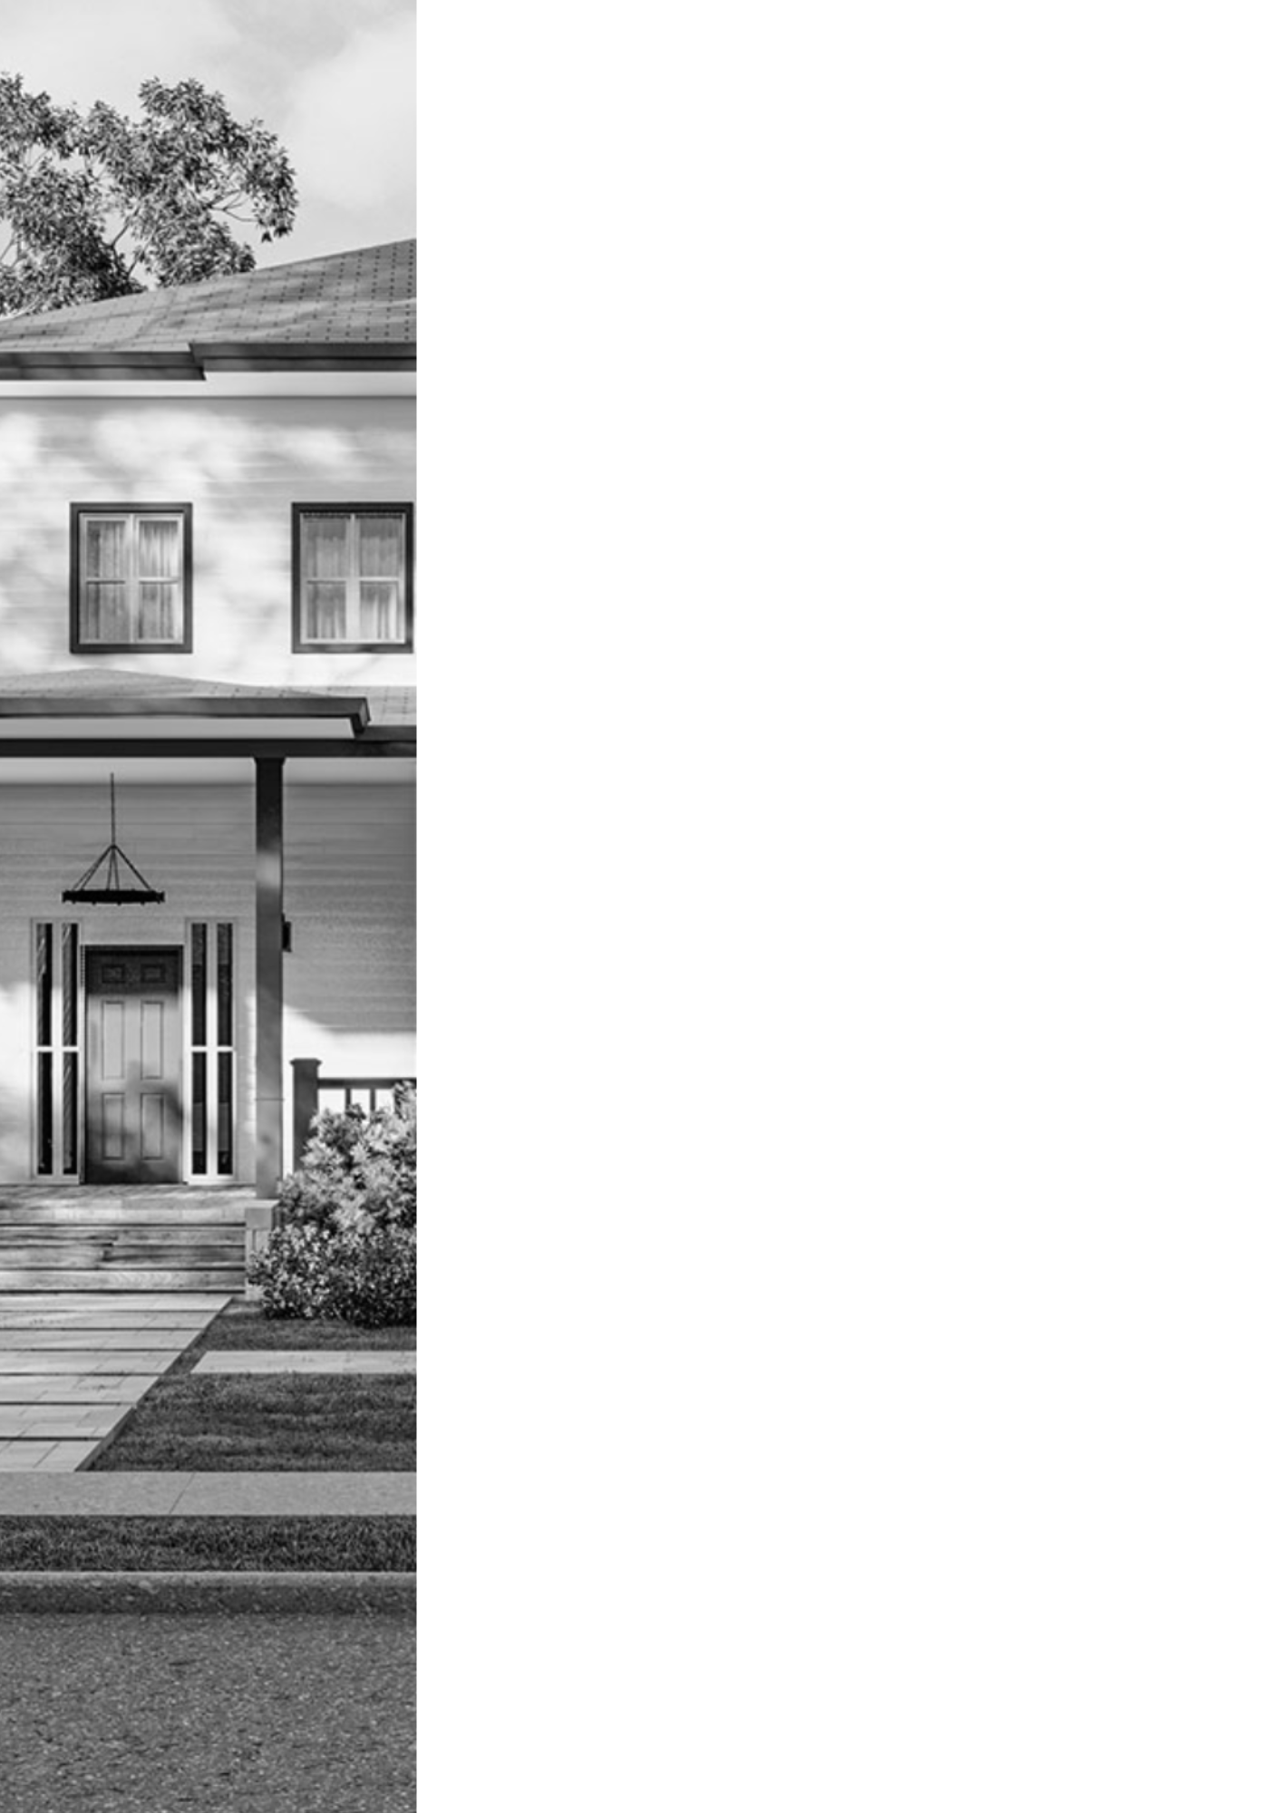

BIMQUOTE  
**PROJECT FEASIBILITY ANALYSIS**

w w w . b i m q u o t e . c o m

[Date]

**Project:**

[Project_Name]

[Project_Address]

 **Lender:**   
 Builders Capital

1019 39th Ave SE, Suite 220

 Puyallup, WA 98374

# Project Summary

|  |  |
| --- | --- |
| **Project Name:** | [Project_Name] |
| **Project Address:** | [Project_Address] |
| **Contractor:** | [Contractor] |
| **Lender:** | [Lender] |
| **Loan Officer:** | [Loan_Officer] |

**Executive Summary**

The project submitted for review is for the ground up construction of [Project_Objective] and the associated sitework in [County], [State]. CFSI has reviewed the budget, plans, and appraisal and completed a Contractor Verification (submitted under separate cover) for this project. Based on the review of these documents CFSI has determined that the project is acceptable as submitted. See below for specific conditions and recommendation, which may reduce the overall project risk.

**Project Details**

The project is the ground up construction of [Project_Objective] and the associated sitework in [County], [State]. The project is ground up construction of [Project_Objective] and the associated sitework for homes located at [Project_Address] in [State]. The building construction consists of wood framed walls, floors and roofs. The foundation systems will be continuous and isolated spread footings. The exterior finishes will be siding.

|  |  |
| --- | --- |
| **Project at a Glance** | |
| Property Type | Residential |
| Area | Suburban |
| Jurisdiction | City of [County] |
| Buildings | [Num_Buildings] |
| Stories | [Num_Stories] |
| Gross Square Footage  Includes garages and porches | [Project_Address]: [Area]sq. ft. |

**Construction Budget**

Budget Review: The overall construction budget submitted for review appears to be sufficient to complete the project as detailed in the construction plans. This budget contains the scopes of work shown on the plans and is adequately detailed to oversee construction and disburse funds on the project.

CFSI is in receipt of the Lender’s Budget in the amount of [Project_Objective_Total] **.**CFSI

recommends that the Lender obtain the Contractor’s budget and confirm this budget reconciles with the Lender’s budget and matches the contract for construction and the submitted budget. This budget was not submitted on an industry standard AIA G702 (Pay Application) and AIA G703, Schedule of Values form. CFSI recommends

that the Lender obtain the Contractor’s AIA G702 (Pay Application) and AIA G703,

Schedule of Values to be used for fund control and inspection purposes.

CFSI completed a detailed budget review to determine if the overall budget is sufficient for the project. Additionally, CFSI completed a line-by-line analysis of the budget. Each individual budget line item is within an acceptable 15% variance to market costs in the area for this type of construction. The overall project cost per square foot is detailed below.

CFSI is not an expert in cost estimating. CFSI’s has utilized industry standard estimating tools and resources. CFSI’s recommendation below represents our professional opinion based on our experience and no other warranty is expressed or implied.

CFSI’s budget review does not include the following items:

* The submitted budget does not appear to include furniture, fixtures or equipment (FF&E) which may be necessary to obtain a certificate of occupancy for the project. CFSI assumed that all FF&E will be provided by the Owner outside of the contract for construction. CFSI recommends the Lender obtain written confirmation from the Owner of how all FF&E will be provided to the project.
* CFSI did not review budget line-item allowances. Budget allowances are typically included for scopes of work which may not have sufficient information to establish a true hard cost or possible project unknown conditions.
* CFSI does not review or confirm any soft cost items which include but are

not limited to permits, plan review fees, utility fees and other project fees. CFSI recommends the Lender obtain confirmation of all soft costs prior to loan closing.

* CFSI did not receive any bids/buyouts from sub-contractors or suppliers for review.
* CFSI recommends a 10% contingency be added to the budget for

any unforeseen occurrences that may arise.

* The submitted budget does not include a separate line item for the Contractor’s Overhead and Profit (O&P) because this project is being completed as Owner/Builder. Industry best practice is to enter into a construction agreement with an arm’s length contractor where O&P is included and broken out in the budget to be disbursed based on the overall project completion percentage. CFSI would like to make the Lender aware that in the event that this Owner/Builder is unable to complete the project, for whatever reason, enlisting a new contractor would likely result in overall cost increases of 4% - 8% of the total budget.

|  |  |  |  |
| --- | --- | --- | --- |
| **[Project_Address]** | | | |
| **Description** | **BQFA Budget** | **% of Total** | **Adequate for Completion** |
| R-100100 - Plans (Soft Cost) | [R-100100_Cost] | [R-100100_Price] | [R-100100_Color] |
| R-100200 - Permits (Soft Costs) | [R-100200_Cost] | [R-100200_Price] | [R-100200_Color] |
| R-100300 - Surveying / Engineering (Soft Cost) | [R-100300_Cost] | [R-100300_Price] | [R-100300_Color] |
| R-100400 - Insurance (Soft Cost) | [R-100400_Cost] | [R-100400_Price] | [R-100400_Color] |
| R-100500 - Perm. Connection Fees Water (Soft Cost) | [R-100500_Cost] | [R-100500_Price] | [R-100500_Color] |
| R-106000 - Perm. Connection Fees Sewer (Soft Cost) | [R-106000_Cost] | [R-106000_Price] | [R-106000_Color] |
| R-107000 - Perm. Connection Fees Electric (Soft Cost) | [R-107000_Cost] | [R-107000_Price] | [R-107000_Color] |
| R-100800 - Perm. Connection Fees Gas (Soft Cost) | [R-100800_Cost] | [R-100800_Price] | [R-100800_Color] |
| R-100900 - Temp. Toilet | [R-100900_Cost] | [R-100900_Price] | [R-100900_Color] |
| R-101000 - Temp. Utilities | [R-101000_Cost] | [R-101000_Price] | [R-101000_Color] |
| R-101100 - Construction Clean Up & Dumpster | [R-101100_Cost] | [R-101100_Price] | [R-101100_Color] |
| R-101200 - Demolition / Clearing | [R-101200_Cost] | [R-101200_Price] | [R-101200_Color] |
| R-101300 - Excavation, Grade, Fill | [R-101300_Cost] | [R-101300_Price] | [R-101300_Color] |
| R-101400 - Foundation Concrete | [R-101400_Cost] | [R-101400_Price] | [R-101400_Color] |
| R-101500 - Foundation Labor | [R-101500_Cost] | [R-101500_Price] | [R-101500_Color] |
| R-101600 - Garage / Basement Concrete | [R-101600_Cost] | [R-101600_Price] | [R-101600_Color] |
| R-101700 - Framing Lumber & Hardware | [R-101700_Cost] | [R-101700_Price] | [R-101700_Color] |
| R-101800 - Framing Labor | [R-101800_Cost] | [R-101800_Price] | [R-101800_Color] |
| R-101900 - Trusses | [R-101900_Cost] | [R-101900_Price] | [R-101900_Color] |
| R-102000 - Rough In Plumbing | [R-102000_Cost] | [R-102000_Price] | [R-102000_Color] |
| R-102100 - Rough In Electrical | [R-102100_Cost] | [R-102100_Price] | [R-102100_Color] |
| R-102200 - Security System | [R-102200_Cost] | [R-102200_Price] | [R-102200_Color] |
| R-102300 - Sewer / Septic | [R-102300_Cost] | [R-102300_Price] | [R-102300_Color] |
| R-102400 - Roofing | [R-102400_Cost] | [R-102400_Price] | [R-102400_Color] |
| R-102500 - Fireplace / Chimney | [R-102500_Cost] | [R-102500_Price] | [R-102500_Color] |
| R-102600 - HVAC | [R-102600_Cost] | [R-102600_Price] | [R-102600_Color] |
| R-102700 - Windows / Sliders | [R-102700_Cost] | [R-102700_Price] | [R-102700_Color] |
| R-102800 - Exterior Doors & Trim | [R-102800_Cost] | [R-102800_Price] | [R-102800_Color] |
| R-102900 - Garage Doors & Openers | [R-102900_Cost] | [R-102900_Price] | [R-102900_Color] |
| R-103000 - Siding | [R-103000_Cost] | [R-103000_Price] | [R-103000_Color] |
| R-103100 - Masonry | [R-103100_Cost] | [R-103100_Price] | [R-103100_Color] |
| R-103200 - Gutters & Downspouts | [R-103200_Cost] | [R-103200_Price] | [R-103200_Color] |
| R-103300 - Exterior Paint | [R-103300_Cost] | [R-103300_Price] | [R-103300_Color] |
| R-103400 - Exterior Concrete (Steps, Walks, Driveway) | [R-103400_Cost] | [R-103400_Price] | [R-103400_Color] |
| R-103500 - Insulation | [R-103500_Cost] | [R-103500_Price] | [R-103500_Color] |
| R-103600 - Drywall | [R-103600_Cost] | [R-103600_Price] | [R-103600_Color] |
| R-103700 - Interior Doors & Trim | [R-103700_Cost] | [R-103700_Price] | [R-103700_Color] |

|  |  |  |  |
| --- | --- | --- | --- |
| **[Project_Address]** | | | |
| **Description** | **BQFA Budget** | **% of Total** | **Adequate for Completion** |
| R-103800 - Interior Paint (Wall, Trim, Door) | [R-103800_Cost] | [R-103800_Price] | [R-103800_Color] |
| R-103900 - Stairs & Railings | [R-103900_Cost] | [R-103900_Price] | [R-103900_Color] |
| R-104000 - Cabinets & Vanities | [R-104000_Cost] | [R-104000_Price] | [R-104000_Color] |
| R-104100 - Countertops & Backsplashes | [R-104100_Cost] | [R-104100_Price] | [R-104100_Color] |
| R-104200 - Finish Plumbing | [R-104200_Cost] | [R-104200_Price] | [R-104200_Color] |
| R-104300 - Finish Electrical & Light Fixtures | [R-104300_Cost] | [R-104300_Price] | [R-104300_Color] |
| R-104400 - Hardwood Flooring | [R-104400_Cost] | [R-104400_Price] | [R-104400_Color] |
| R-104500 - Vinyl / Tile | [R-104500_Cost] | [R-104500_Price] | [R-104500_Color] |
| R-104600 - Carpet | [R-104600_Cost] | [R-104600_Price] | [R-104600_Color] |
| R-104700 - Finish Hardware | [R-104700_Cost] | [R-104700_Price] | [R-104700_Color] |
| R-104800 - Finish Labor | [R-104800_Cost] | [R-104800_Price] | [R-104800_Color] |
| R-104900 - Mirrors & Shower Doors | [R-104900_Cost] | [R-104900_Price] | [R-104900_Color] |
| R-105000 - Appliances | [R-105000_Cost] | [R-105000_Price] | [R-105000_Color] |
| R-105100 - Final Cleaning | [R-105100_Cost] | [R-105100_Price] | [R-105100_Color] |
| R-105200 - Landscaping | [R-105200_Cost] | [R-105200_Price] | [R-105200_Color] |
| R-105300 - Fencing | [R-105300_Cost] | [R-105300_Price] | [R-105300_Color] |
| R-105400 - Decks | [R-105400_Cost] | [R-105400_Price] | [R-105400_Color] |
| R-105500 - Contingency (Soft Cost) | [R-105500_Cost] | [R-105500_Price] | [R-105500_Color] |
| R-105600 - Profit / Overhead (Soft Cost) | [R-105600_Cost] | [R-105600_Price] | [R-105600_Color] |
| R-105700 - Feature - Specify (ie. Solar Panels, Etc.) | [R-105700_Cost] | [R-105700_Price] | [R-105700_Color] |
| **TOTAL** | **[Total_Price]** | **100.00%** |  |

|  |  |  |  |
| --- | --- | --- | --- |
| **Budget Key:** | Acceptable | Not Acceptable | Not Reviewed |

## Cost Per Square Foot:

Contractor’s Cost Per Square Foot: $[CostPerFoot] per square foot

**Budget Review Recommendation:** Acceptable with completed conditions and recommendations

# Construction Contract

CFSI is not in receipt of the construction contract between the Contractor and the Owner. Contractual documents are the primary risk protection for construction projects as they stipulate all agreements, obligations and penalties between the parties. From a lending and legal standpoint, it is imperative to have a clear and concise contract between these parties. Best practice is to have a contract similar to AIA (The American Institute of Architects) A101, Standard Form of Agreement between Owner and Contractor where the basis of payment is a Stipulated Sum or Fixed Price agreement. CFSI recommends that the Lender to obtain a final, fully executed contract for construction prior to loan closing and review this document for any potential lending risk.

CFSI’s is not an expert in contractual documents. CFSI’s recommendation below represents our professional opinion based on our experience and no other warranty is expressed or implied.

**Construction Contract Recommendation**: Acceptable with completed conditions and recommendations

# Plans and Specifications

The submitted plans appear consistent with the overall project information and are sufficiently detailed and adequate for commercial construction project for an asset of this type. Unless otherwise noted, the plans are not stamped and signed by the proper design professional. The plans have not been approved by the jurisdiction.

The project specifications were not received as part of the construction document package.

CFSI is not in receipt of mechanical, electrical or plumbing plans for our review. CFSI has assumed medium grade residential construction and finishes for all elements not shown where possible.

Although the submitted plans have been stamped and signed by the appropriate design professional, they have not been stamped approved by the jurisdiction.

CFSI recommends that the Lender obtain the complete set of jurisdictionally approved plans for their records.

CFSI has reviewed the plans for general conformance to industry standards for a commercial construction project. CFSI has not reviewed these plans for code compliance, errors or omissions. CFSI assumes that the architectural and engineering professionals of records have accurately depicted the project scopes of work and are ultimately responsible for the design and building elements.

**Plans/Specifications Recommendation**: Acceptable with completed conditions and recommendations

# Project Recommendations

* CFSI recommends that the Lender obtain the Contractor’s budget and confirm this budget reconciles with the Lender’s budget and matches the contract for construction and the submitted budget.
* CFSI recommends that the Lender obtain the Contractor’s AIA G702 (Pay Application) and AIA G703, Schedule of Values to be used for fund control and inspection purposes.
* CFSI recommends the Lender obtain written confirmation from the Owner of how all FF&E will be provided to the project.
* CFSI recommends the Lender obtain confirmation of all soft costs prior to loan closing.
* CFSI would like to make the Lender aware that in the event that this Owner/Builder is unable to complete the project, for whatever reason, enlisting a new contractor would likely result in overall cost increases of 4% - 8% of the total budget.
* CFSI recommends that the Lender obtain the complete set of plans.
* CFSI recommends that the Lender obtain the complete set of jurisdictionally approved plans for their records.
* CFSI recommends that the Lender obtain a copy of all permits for permits for their records prior to any post-close disbursements.
* CFSI recommends that the Lender obtain all plan review comments which may include planning, zoning and building systems to determine if there are any critical items which could increase the overall project costs or development risk.
* CFSI recommends that the Lender obtain a copy of the geotechnical report for their records and review the plans and specifications for conformance with the recommendations in this report.
* CFSI recommends that the Lender obtain copies of all environmental reports for their records and review the plans and specifications for conformance with the recommendations in this report.