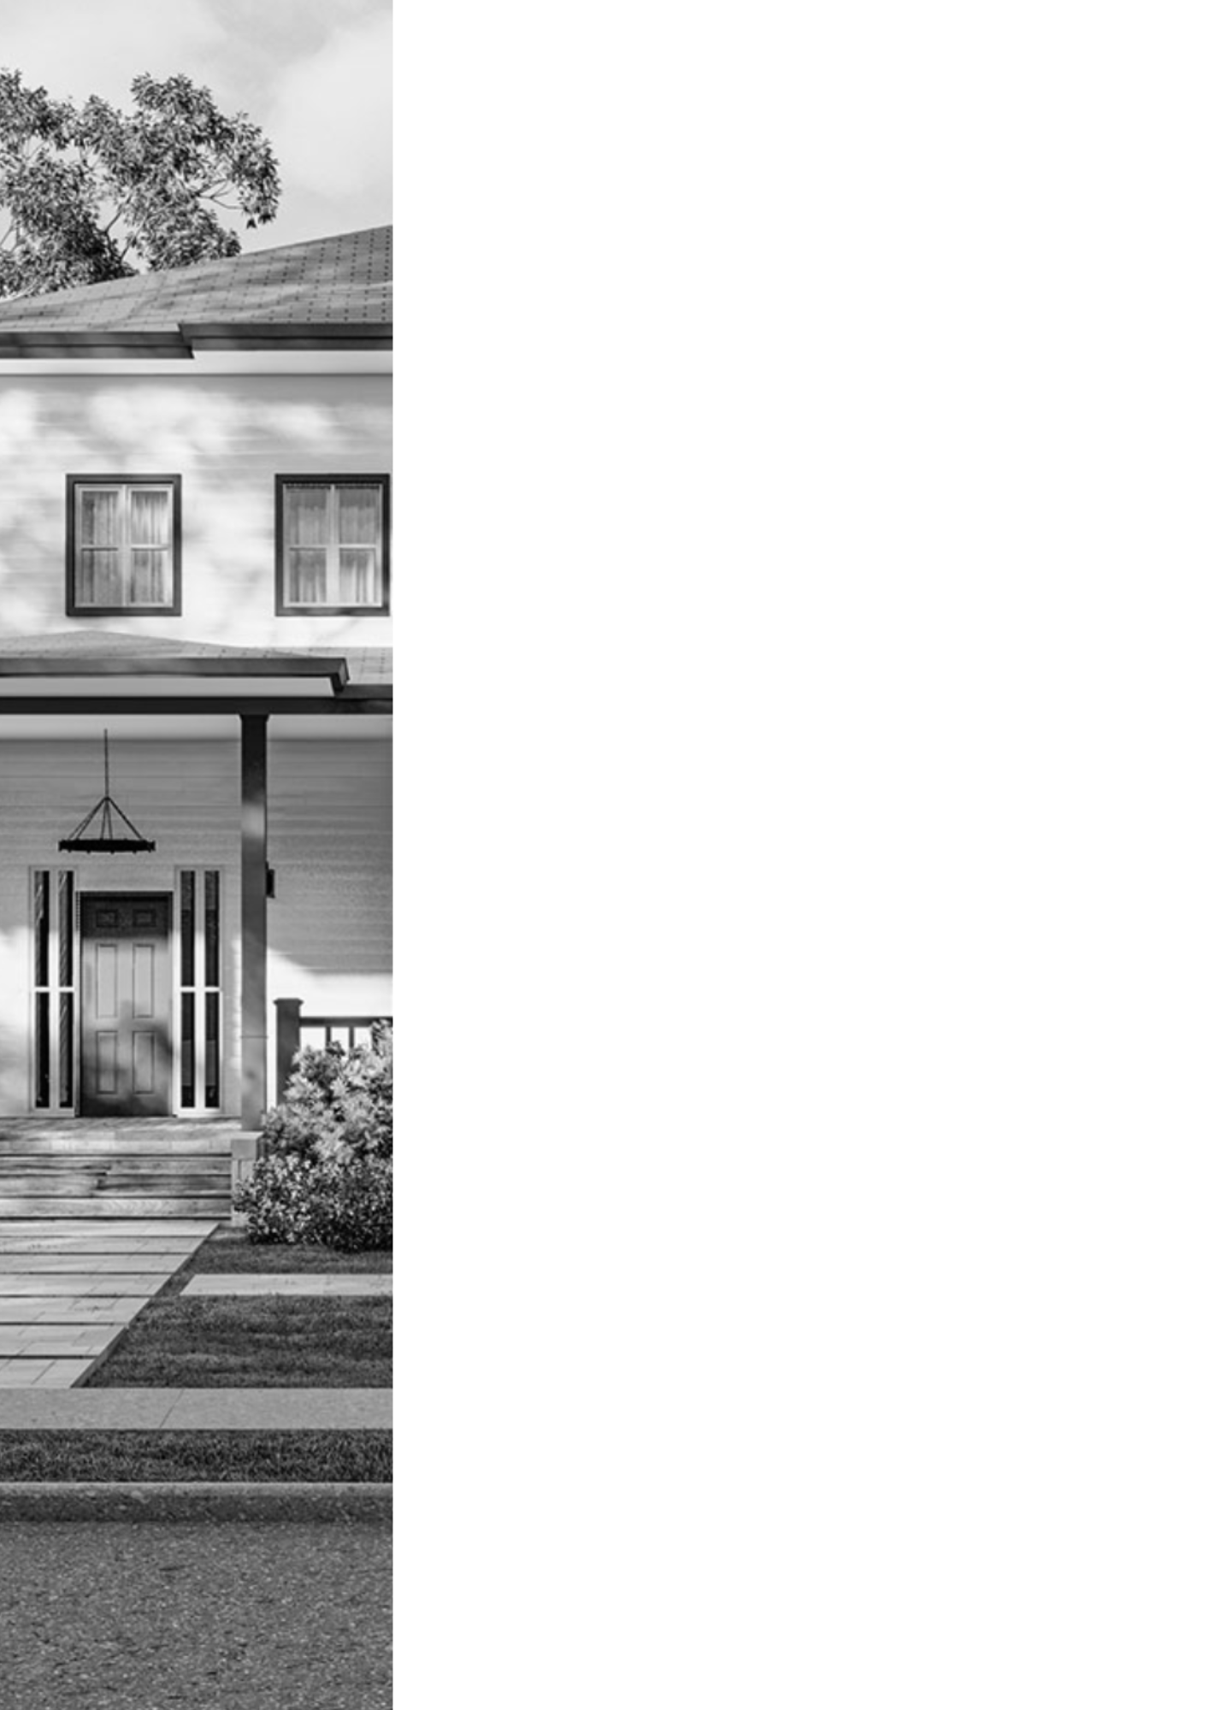

BIMQUOTE  
**PROJECT FEASIBILITY ANALYSIS**

w w w . b i m q u o t e . c o m

[Date]

**Project:**

[Project_Name]

[Project_Address]



**Lender:**   
 Builders Capital

 1019 39th Ave SE, Suite 220

Puyallup, WA 98374

# Project Summary

|  |  |
| --- | --- |
| **Project Name:** | [Project_Name] |
| **Project Address:** | [Project_Address] |
| **Contractor:** | [Contractor] |
| **Lender:** | [Lender] |
| **Loan Officer:** | [Loan_Officer] |

**Executive Summary**

The project submitted for review is for the ground up construction of [Project_Objective] and the associated sitework in [County], [State]. CFSI has reviewed the budget, plans, appraisal and completed a Contractor Verification (submitted under separate cover) for this project. Based on the review of these documents CFSI has determined that the project is acceptable as submitted. See below for specific conditions and recommendation which may reduce the overall project risk.

**Project Details**

The project is the ground up construction of [Project_Objective] and the associated sitework in [County], [State]. The project is ground up construction of [Project_Objective] and the associated sitework for homes located at [Project_Address]in [State]. The building construction consists of wood framed walls, floors and roofs. The foundation systems will be continuous and isolated spread footings. The exterior finishes will be siding.

|  |  |
| --- | --- |
| **Project at a Glance** | |
| Property Type | Residential |
| Area | Suburban |
| Jurisdiction | City of [County] |
| Buildings | [Num_Buildings] |
| Stories | [Num_Stories] |
| Gross Square Footage  Includes garages and porches | [Project_Address]: [Area]sq. ft. |

**Construction Budget**

Budget Review: The overall construction budget submitted for review appears to be sufficient to complete the project as detailed in the construction plans. This budget contains the scopes of work shown on the plans and is adequately detailed to oversee construction and disburse funds on the project.

CFSI is in receipt of the Lender’s Budget in the amount of [Project_Objective_Total] **.**CFSI

recommends that the Lender obtain the Contractor’s budget and confirm this budget reconciles with the Lender’s budget and matches the contract for construction and the submitted budget. This budget was not submitted on an industry standard AIA G702 (Pay Application) and AIA G703, Schedule of Values form. CFSI recommends

that the Lender obtain the Contractor’s AIA G702 (Pay Application) and AIA G703,

Schedule of Values to be used for fund control and inspection purposes.

CFSI completed a detailed budget review to determine if the overall budget is sufficient for the project. Additionally, CFSI completed a line-by-line analysis of the budget. Each individual budget line item is within an acceptable 15% variance to market costs in the area for this type of construction. The overall project cost per square foot is detailed below.

CFSI is not an expert in cost estimating. CFSI’s has utilized industry standard estimating tools and resources. CFSI’s recommendation below represents our professional opinion based on our experience and no other warranty is expressed or implied.

CFSI’s budget review does not include the following items:

* The submitted budget does not appear to include furniture, fixtures or equipment (FF&E) which may be necessary to obtain a certificate of occupancy for the project. CFSI assumed that all FF&E will be provided by the Owner outside of the contract for construction. **CFSI recommends the Lender obtain written confirmation from the Owner of how all FF&E will be provided to the project.**
* CFSI did not review budget line-item allowances. Budget allowances are typically included for scopes of work which may not have sufficient information to establish a true hard cost or possible project unknown conditions.
* CFSI does not review or confirm any soft cost items which include but are not limited to permits, plan review fees, utility fees and other project fees. **CFSI recommends the Lender obtain confirmation of all soft costs prior to loan closing.**
* CFSI did not receive any bids/buyouts from sub-contractors or suppliers for review.
* **CFSI recommends a 10% contingency be added to the budget for any unforeseen occurrences that may arise.**
* The submitted budget does not include a separate line item for the Contractor’s Overhead and Profit (O&P) because this project is being completed as Owner/Builder. Industry best practice is to enter into a construction agreement with an arm’s length contractor where O&P is included and broken out in the budget to be disbursed based on the overall project completion percentage. CFSI would like to make the Lender aware that in the event that this Owner/Builder is unable to complete the project, for whatever reason, enlisting a new contractor would likely result in overall cost increases of 4% - 8% of the total budget.

|  |  |  |  |  |
| --- | --- | --- | --- | --- |
| **Budget Item** | **Variance** | **Submitted** | **BQFA Calculated Budget** | **BQFA % of Total** |
|  |  |  |  |  |

|  |  |  |  |  |
| --- | --- | --- | --- | --- |
| **Budget Item** | **Variance** | **Submitted** | **BQFA Calculated Budget** | **BQFA % of Total** |
|  |  |  |  |  |
|  |  |  |  |  |
| **TOTAL** |  | **[Total_Price_R]** | **[Total_Price]** | **100.00%** |

## Cost Per Square Foot:

Contractor’s Cost Per Square Foot: $[CostPerFoot] per square foot

**Budget Review Recommendation:** Acceptable with completed conditions and recommendation