Assumptions:

Every staff ID is unique to each staff. (Refer to extended section)

Every column should be filled and not have a null value.

In a receipt, the date must be constant.

Each receipt can only be associated with one staff and customer.

If a customer has purchased more than 5 items, a 5 % discount will be discounted in the row total and placed under the discounted row total.

The extended assumption on “Every staff ID is unique to each staff”

In the provided Excel sheet, there were some staff sharing the same name and surname, We have decided to assume that each staff ID shares a single individual and it is very possible for an organisation to have two staff that share the same first name and surname. In the recommendation, we would like to propose a solution to Bits&Bobs to record the staff middle name and the staff email.)

Queries and result that shows different staff id sharing the same name “Paul Guiterrez.”

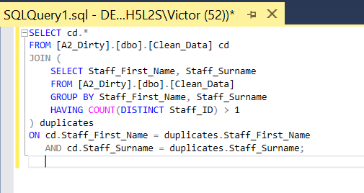



Queries and result shows different staff id sharing the same name “Isabella Rogers.” For staff ID S24 the office location is located at “Wagga Wagga” and for staff ID S157 office location is located at “Dubbo”

