Group Members: Victor Chua Jia Zhi and Sander Fabian

Assumption: Since Leisure Australasia group operates several hotels. We decided that each Hotel should have its own unique primary key with the respective attributes.

Facility: We have assumed that facility is overview of rooms. For example, facilities can be a room but which kind? So, we decided to set the facility as superclass to facility Type where it will be more detailed.

Facility Type: Facility Type, a sub class of Facility would be a specific table that can contain many types of room. For example, couple room, suite, ...etc.

Service Category: We have assumed that service category is a superclass as it can contain many service types. For example, Entertainment which can contain many service Items.

Service Items: Service Items is a subclass service category would be a more specific table that can contain more detailed information about entertainment. For example, under entertainment there can be Music services, Bar drinks, …etc.

Advertised Packages: We have assumed that advertised packages can have many services authorised by an employee as a part of a marketing tactic.

Reservation: We have assumed that reservation can be made online or in-person and what kind of advertised packages they would wish to purchase. A customer can purchase more than 1 advertised packages which will be associated to their customer ID for data integrity purposes.

Bookings: We have assumed that bookings will be made after a reservation is placed that shows the reservation ID, start Date, end Date, quantity, the advertised packages, and customer ID. A customer can have many bookings with different advertised packages as they wish.

Transaction Billing: Since the requirement stated that a guest or customer can purchase things during their stay and will be charged through advertised package prices. We have decided to create a table that allows the user to see the booking and associated advertised packages for billing purposes.

Guest: We have assumed that since customers can have many guests, we will decided to place the customer ID associated with guest to show which guest is under which customer.

Customer: We assumed that customers would be included in this table since it is necessary to store customer data for audit purposes, billing, the guest they have, reservation they have, booking they have.

Head Office: Since only head office can authorise discount over 25 percent. It is necessary to have head office as a table as well.

Employee: Employee was created as well due to the requirement stating that employees are to authorise the advertised packages and is a super class of manager.

Manager: Manager is a sub class of employee and are allowed to give discount less than 25 percent without the consent of the head office.

ERD

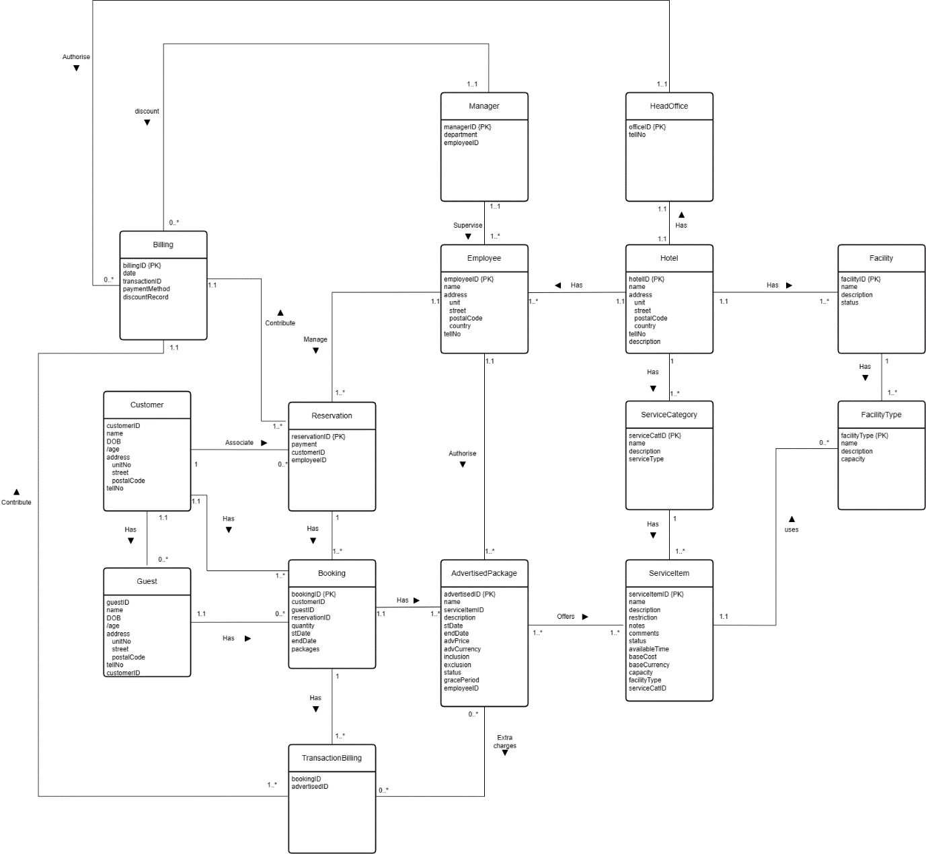

ERD diagram does not contain enhanced features such as generalisation, specialisation, and constraints so we have removed all of them to suit the ERD requirements.

Logical Model

