**Software Requirement Specification**

Report on

**Attendi – College/School Management System**

at

## U. V. Patel College of Engineering



|  |  |
| --- | --- |
| **Internal Guide :** | **Prepared By:** |
| Prof. Sheetal Kumar Dixit |  |
|  | |  |  | | --- | --- | | **Name** | **Enrollnment No** | | Umang Raval | 21012011131 | | Parth Chauhan | 22012012041 | | Yash Prajapati | 21012011125 | | Jainil Nayi | 21012021053 | |
|  | |

**B.Tech Semester V**

**(Computer Engineering)**

###### December 2023

Submitted to,

Department of Computer Engineering / Information Technology

U.V. Patel College of Engineering

Ganpat University, Kherva - 384 012

##### **U.V. PATEL COLLEGE**

##### **OF**

##### **ENGINEERING**



**DD/MM/YY**

### CERTIFICATE

**TO WHOM SO EVER IT MAY CONCERN**

This is to certify that Mr./Ms. **Umang Raval** student of **B.Tech. Semester V (Computer Engineering)** has completed his/her full semester Capstone Project work titled “**Student management application”** satisfactorily in partial fulfillment of the requirement of Bachelor of Technology degree of Computer Engineering of Ganpat University, Kherva, Mehsana in the year 2023-2024

**College Project Guide**

Sign **Dr. Paresh Solanki,**

**Head, Computer Engineering**

Prof. Guide Name

**U.V. PATEL COLLEGE**

##### **OF**

##### **ENGINEERING**



**DD/MM/YY**

### CERTIFICATE

**TO WHOM SO EVER IT MAY CONCERN**

This is to certify that Mr./Ms. **Parth Chauhan** student of **B.Tech. Semester V (Computer Engineering)** has completed his/her full semester Capstone Project work titled “**Student management application”** satisfactorily in partial fulfillment of the requirement of Bachelor of Technology degree of Computer Engineering of Ganpat University, Kherva, Mehsana in the year 2023-2024

**College Project Guide**

Sign **Dr. Paresh Solanki,**

**Head, Computer Engineering**

Prof. Guide Name

##### **U.V. PATEL COLLEGE**

##### **OF**

##### **ENGINEERING**



**DD/MM/YY**

### CERTIFICATE

**TO WHOM SO EVER IT MAY CONCERN**

This is to certify that Mr./Ms. **Yash Prajapati** student of **B.Tech. Semester V (Computer Engineering)** has completed his/her full semester Capstone Project work titled “**Student management application”** satisfactorily in partial fulfillment of the requirement of Bachelor of Technology degree of Computer Engineering of Ganpat University, Kherva, Mehsana in the year 2023-2024

**College Project Guide**

Sign **Dr. Paresh Solanki,**

**Head, Computer Engineering**

Prof. Guide Name

##### **U.V. PATEL COLLEGE**

##### **OF**

##### **ENGINEERING**



**DD/MM/YY**

### CERTIFICATE

**TO WHOM SO EVER IT MAY CONCERN**

This is to certify that Mr./Ms. **Jainil Nayi** student of **B.Tech. Semester V (Computer Engineering)** has completed his/her full semester Capstone Project work titled “**Student management application”** satisfactorily in partial fulfillment of the requirement of Bachelor of Technology degree of Computer Engineering of Ganpat University, Kherva, Mehsana in the year 2023-2024

**College Project Guide**

Sign **Dr. Paresh Solanki,**

**Head, Computer Engineering**

Prof. Guide Name

**Acknowledgment**

I want to express my heartfelt appreciation to Professor Satish Kumar Morya for his invaluable guidance during the development of our Capstone Project, "Tasty Table Recipe Finder." Satish's expertise and unwavering support have been pivotal to the project's success.

Professor Satish Kumar Morya's dedication, expert advice, and encouragement have been instrumental in shaping our project from concept to completion. His mentorship, patience, and constructive feedback helped us navigate challenges and enhance our skills.

We are immensely grateful to Assistant Professor Satish Kumar Morya for his significant contribution to our project's success. We look forward to continuing to learn and grow under his mentorship in our future endeavors.

**Abstract**

Amidst the complexities of modern dietary needs and culinary exploration, traditional recipe finding methods often fall short, leading to frustration and limited options for individuals seeking nutritious and diverse meals. In response, our web application project, "Tasty Table," harnesses the power of React, HTML, CSS, and JavaScript to revolutionize the recipe discovery experience. Inspired by the challenges faced by food enthusiasts and home cooks alike, "Tasty Table" offers a comprehensive solution that seamlessly integrates user-friendly interfaces with advanced search functionalities. Gone are the days of sifting through countless recipe websites or struggling to find recipes tailored to specific dietary preferences or ingredient availability.

With "Tasty Table" users can embark on a culinary journey like never before, exploring a vast database of curated recipes ranging from healthy and wholesome meals to indulgent treats. Leveraging React's component-based architecture, the application provides a seamless browsing experience, allowing users to filter recipes based on dietary restrictions, cooking time, ingredients, and more. Through intuitive design principles and responsive layouts, "Tasty Table" ensures accessibility across devices, empowering users to discover new recipes anytime, anywhere. Whether you're a seasoned chef looking for inspiration or a novice cook seeking guidance, "Tasty Table" is your ultimate companion in the quest for culinary excellence.

**TABLE OF CONTENTS**

1.Introduction

1.1 Project Overview…………………………………………………………………………………

1.2 Background………………………………………………………………………………………

1.3 Purpose

1.3.1 Problem statement………………………………………………………………….….

1.3.2 Project Aim……………………………………………………………………………

1.3.3 Project Objectives……………………………………………………………………..

1.4 Project Scope……………………………………………………………………………………..

1.5 Impact, Significance, and Contributions…………………………………………………………

* 1. Organization of Project Report…………………………………………………………………..

2. Literature review

2.1 Super Cook - Super Cook Website…………………………………

2.2 Recipe Radar - Recipe Radar GitHub Repository…………………...

2.3 Delicieux | Recipe Finder App - Delicieux GitHub Repository……………………

2.4 Yum2Food - Yum2Food GitHub Repository…………………………………..

2.5 Recipe-Finder - Recipe-Finder GitHub Repository ………………………………………

2.6 Recipe Radar - Recipe Radar Website……………………………………………..

2.7 Recipe Finder Cool - Recipe Finder Cool Website………………………………

2.8 British Heart Foundation - Recipe Finder………………………………………………...

2.9 Recipe Finder - Recipe Finder Website………………………………….

2.10Tasty - Tasty Website……………………………………………………….

2.11 Food Network - Food Network Website………………………………………………………...

2.12 Allrecipes - Allrecipes Website………………………………………………………….

2.13 Epicurious - Epicurious Website……………………………………………………………...

2.14 MyRecipes - MyRecipes Website…………………………………………………………..

2.15 Martha Stewart - Martha Stewart Website…………………………………………………….

2.16 Simply Recipes - Simply Recipes Website………………………………….………..

3. Software requirement specifications (SRS)

3.1 Functional requirements………………………………………………………………………….

3.1.1 Functional requirements of module Admin……………………………………………

3.1.1.1 SignUp for Admin……………………………………………………………

3.1.1.2 SignIn for Admin…………………………………………………………….

3.1.1.2 Manage Students……………………………………………………………..

3.1.2 Functional requirements of module Student…………………………………………...

3.1.2.1 SignUp for Customer……………………………………………………...

3.1.2.2 SignIn for Customer………………………………………………………

3.1.2.2 Profile Update………………………………………………………………..

3.2 Non-functional requirements……………………………………………………………………..

3.2.1 Reliability………………………………………………………………………………

3.2.2 Security…………………………………………………………………………………

3.2.3 Efficiency………………………………………………………………………………

3.2.4 Usability………………………………………………………………………………..

3.2.5 Economic……………………………………………………………………………….

4.Diagrams

4.1 Use case diagram…………………………………………………………………………………

4.2 Sequence Diagram……………………………………………………………………………….

4.3 Activity diagram …………………………………………………………………………………

4.4 State diagram……………………………………………………………………………………..

4.5 DFD diagram……………………………………………………………………………………..

4.5.1 DFD level 0…………………………………………………………………………….

4.5.2 DFD level 1…………………………………………………………………………….

4.5.3 DFD level 2…………………………………………………………………………….

4.6 State diagram……………………………………………………………………………………..

5.Prototypes

* 1. Prototypes for module Admin……………………………………………………………………

5.2 Prototypes for module Students………………………………………………………………….

6. Implementation progress

6.1 Milestones Achieved …………………………………………………………………………….

6.1.1 Database Design and Setup…………………………………………………………….

6.1.2 User Authentication…………………………………………………………………….

6.1.3 Student Module………………………………………………………………………...

6.1.4 Faculty Module………………………………………………………………………...

6.1.5 Administrator Module………………………………………………………………….

6.2 Current Status…………………………………………………………………………………….

6.3 Upcoming Tasks………………………………………………………………………………….

7. Conclusion and Future work

7.1 References………………………………………………………………………………………..

**1. Introduction**

**1.1 Project Overview**

"Tasty Table Recipe Finder" is an innovative solution aimed at revolutionizing the way people discover and explore healthy recipes. This web application, built using modern web technologies, offers a comprehensive platform catering to individuals seeking nutritious meal options. It simplifies the process of finding and accessing a wide variety of healthy recipes, thereby promoting a healthier lifestyle.

With user-friendly features and an intuitive interface, the website ensures a seamless browsing experience for users. They can easily search for recipes based on dietary preferences, ingredients, and nutritional requirements. Whether users are looking for gluten-free, vegetarian, low-carb, or keto-friendly recipes, Tasty Table Recipe Finder provides an extensive database of options to suit their needs. By facilitating easy access to nutritious meal ideas, the website aims to encourage healthier eating habits and promote overall well-being.

**1.2 Background**

Traditional approaches to meal planning and recipe discovery often lack emphasis on health and nutrition. Many individuals struggle to find nutritious meal options amidst the abundance of unhealthy choices available. However, with the increasing awareness of the importance of diet in maintaining health, there is a growing demand for platforms that prioritize healthy eating.

Tasty Table Recipe Finder is conceived as a response to this need for a convenient and accessible solution for discovering healthy recipes. By harnessing the power of technology and the internet, the website aims to provide users with a centralized platform for exploring a diverse range of nutritious meal ideas. It acknowledges the importance of promoting healthy eating habits and seeks to empower individuals to make informed dietary choices. With its focus on health and wellness, Tasty Table Recipe Finder aims to inspire users to adopt healthier lifestyles and improve their overall health and well-being.

**1.3 Purpose**

**1.3.1 Problem Statement**

In today's fast-paced world, many people struggle to maintain a balanced and nutritious diet due to the lack of convenient options for finding healthy recipes. Traditional recipe sources often prioritize taste and convenience over nutritional value, making it challenging for individuals to make healthy choices. As a result, many people resort to unhealthy eating habits, leading to various health issues such as obesity, heart disease, and diabetes. There is a pressing need for a comprehensive solution that simplifies the process of finding and accessing healthy recipes, thereby promoting healthier eating habits and improving overall health outcomes. Tasty Table Recipe Finder aims to address this issue by providing a user-friendly platform for discovering nutritious meal options tailored to individual dietary preferences and nutritional needs.

**1.3.2 Project Aim**

The primary aim of Tasty Table Recipe Finder is to promote healthy eating habits and improve overall well-being by providing users with easy access to a diverse range of nutritious recipes. The website seeks to empower individuals to make informed dietary choices by offering a curated selection of healthy recipes that cater to various dietary preferences and nutritional requirements. By simplifying the process of finding and accessing healthy meal ideas, Tasty Table Recipe Finder aims to inspire users to adopt healthier lifestyles and achieve their health and wellness goals.

**1.3.3 Project Objectives**

**1. Nutritious Recipe Discovery:**

- Facilitate easy discovery of healthy recipes based on dietary preferences, ingredients, and nutritional requirements.

- Provide a diverse range of recipe options, including gluten-free, vegetarian, low-carb, and keto-friendly choices.

**2. User-Friendly Interface:**

- Design an intuitive and user-friendly interface for seamless browsing and recipe exploration.

- Ensure accessibility and ease of navigation for users of all backgrounds and experience levels.

**3. Promoting Healthy Eating:**

- Promote healthy eating habits and nutritional awareness through curated recipe collections and educational resources.

- Provide nutritional information and dietary tips to help users make informed dietary choices.

**4. Encouraging Wellness:**

- Inspire users to adopt healthier lifestyles and improve their overall health and well-being through nutritious eating habits.

- Offer personalized recommendations and meal planning assistance to support users in achieving their health goals.

**1.4 Project Scope**

The project scope encompasses the development of a web-based platform that facilitates the discovery and exploration of healthy recipes. Users will be able to search for recipes based on various criteria such as dietary preferences, ingredients, and nutritional content. The website will offer a curated selection of recipes tailored to individual dietary needs, including options for gluten-free, vegetarian, low-carb, and keto-friendly diets. Additionally, the website will provide nutritional information for each recipe, along with educational resources and dietary tips to promote healthy eating habits. The scope of the project also includes designing a user-friendly interface that ensures accessibility and ease of navigation for users.

**1.5 Impact, Significance, and Contributions**

**Impact:**

Tasty Table Recipe Finder is poised to have a significant impact on promoting healthier eating habits and improving overall well-being. By providing users with easy access to a diverse range of nutritious recipes, the website aims to inspire individuals to make healthier dietary choices and adopt healthier lifestyles. This increased emphasis on nutrition and wellness can lead to various health benefits, including weight management, reduced risk of chronic diseases, and improved overall health outcomes.

**Significance:**

The significance of Tasty Table Recipe Finder lies in its potential to address the growing need for convenient and accessible solutions for finding healthy recipes. In today's fast-paced world, where unhealthy eating habits are prevalent, there is a critical need for platforms that prioritize nutrition and wellness. Tasty Table Recipe Finder fills this gap by offering a curated selection of nutritious recipes that cater to individual dietary preferences and nutritional needs. By promoting healthier eating habits and providing users with the tools and resources they need to make informed dietary choices, the website contributes to improving overall health and well-being.

**Contributions:**

Tasty Table Recipe Finder makes several noteworthy contributions to promoting health and wellness. Firstly, it provides users with easy access to a diverse range of nutritious recipes, thereby empowering them to make healthier dietary choices. Secondly, the website promotes nutritional awareness and education by offering valuable information and resources on healthy eating habits. Additionally, Tasty Table Recipe Finder contributes to raising awareness about the importance of nutrition and wellness in improving overall health outcomes. By fostering a community of health-conscious individuals and providing them with the support they need to achieve their health goals, the website plays a vital role in promoting healthier lifestyles and improving overall well-being.

**1.6 Organization of Project Report**

**Literature Survey:**

The literature survey explores existing platforms and resources for finding healthy recipes and identifies gaps and opportunities for improvement.

**Functional and Non-functional Requirements:**

This section outlines the functional and non-functional requirements of Tasty Table Recipe Finder, including features, usability, performance, and security considerations.

**Diagrams:**

Diagrams illustrate the working flows, user interactions, and system architecture of Tasty Table Recipe Finder.

**Prototype:**

The prototype chapter showcases the visual design and user interface of the website, including wireframes and mockups.

**Conclusion and Future Works:**

The conclusion summarizes the key findings and contributions of the project, while future works discuss potential enhancements and developments for Tasty Table Recipe Finder.

**References:**

This section provides references to relevant studies

**2. Literature Survey**

**2.1 Super Cook - Your Ultimate Kitchen Companion**

Super Cook[1] is a revolutionary platform that simplifies meal planning and cooking by utilizing advanced algorithms to suggest recipes based on available ingredients. Whether you're dealing with a limited pantry or looking to use up leftovers, Super Cook[1] offers a seamless experience for discovering new dishes tailored to your preferences. With features like personalized recommendations and dietary filters, Super Cook[1] empowers users to explore a diverse range of recipes while minimizing food waste and maximizing creativity in the kitchen. Additionally, its user-friendly interface makes navigating the platform a breeze, ensuring that even beginner cooks can confidently whip up delicious meals with ease.

**2.2 Recipe Radar - Community-Driven Recipe Discovery**

Recipe Radar[2] is a collaborative project hosted on GitHub, dedicated to creating a centralized hub for discovering and sharing recipes. Developed by a community of passionate food enthusiasts and developers, Recipe Radar[2] offers a transparent and inclusive platform for contributing and exploring a vast array of culinary creations. From traditional favorites to innovative creations, Recipe Radar[2] celebrates the diversity of global cuisine while fostering collaboration and knowledge-sharing within the culinary community. Moreover, its open-source nature encourages experimentation and customization, allowing users to tailor recipes to their own tastes and dietary needs.

**2.3 Delicieux | Recipe Finder App - Your Personalized Culinary Assistant**

Delicieux[3] is more than just a recipe finder app; it's a comprehensive culinary companion designed to streamline meal planning and preparation. With its intuitive interface and sophisticated recommendation engine, Delicieux[3] curates personalized recipe suggestions based on user preferences and dietary restrictions. Whether you're a novice cook or a seasoned chef, Delicieux[3] offers a wealth of inspiration and resources to elevate your culinary skills and expand your repertoire. Additionally, Delicieux[3] integrates seamlessly with meal planning tools and grocery lists, making it a one-stop-shop for all your culinary needs.

**2.4 Yum2Food - Open-Source Culinary Exploration**

Yum2Food[4] is an open-source project hosted on GitHub, aimed at fostering collaboration and innovation in the culinary world. With its transparent development process and active community engagement, Yum2Food[4] invites contributors from around the globe to share their favorite recipes and culinary expertise. From traditional family recipes to cutting-edge culinary creations, Yum2Food[4] serves as a dynamic platform for discovering, sharing, and celebrating the rich tapestry of global cuisine. Furthermore, its commitment to accessibility ensures that users of all backgrounds and skill levels can participate and benefit from the collective knowledge of the community.

**2.5 Recipe-Finder - A Community-Powered Recipe Repository**

Recipe-Finder[5] is a community-powered repository of recipes hosted on GitHub, dedicated to curating and sharing culinary inspiration from around the world. With its collaborative development model and inclusive ethos, Recipe-Finder[5] welcomes contributions from developers and food enthusiasts alike, ensuring a diverse and comprehensive collection of recipes for users to explore and enjoy. Whether you're searching for a quick weeknight dinner or planning a special occasion meal, Recipe-Finder[5] offers a wealth of culinary inspiration at your fingertips. Additionally, its user-friendly interface makes it easy to navigate and contribute to the platform, fostering a sense of community and camaraderie among users.

**2.6 Recipe Radar - Your Gateway to Global Cuisine**

Recipe Radar[6] is a user-friendly platform that simplifies the process of discovering and saving recipes from across the web. With its intuitive interface and powerful search functionality, Recipe Radar[6] makes it easy to find inspiration for your next culinary adventure. Whether you're looking for a specific dish or exploring new cuisines, Recipe Radar[6] offers a curated selection of recipes to suit every taste and occasion. Moreover, its bookmarking feature allows users to save their favorite recipes for future reference, creating a personalized culinary library that grows with each cooking endeavor.

**2.7 British Heart Foundation - Promoting Heart-Healthy Eating**

The British Heart Foundation's Recipe Finder[7] is a valuable resource for individuals looking to adopt a heart-healthy diet. With its extensive collection of nutritious recipes, curated by experts in cardiovascular health, Recipe Finder[7] offers practical solutions for incorporating healthy eating habits into daily life. From wholesome breakfast options to satisfying main dishes and delectable desserts, Recipe Finder[7] provides inspiration for every meal occasion, helping individuals prioritize heart health without sacrificing flavor or variety. Additionally, its educational resources and meal planning tips empower users to make informed choices about their diet and lifestyle, promoting long-term heart health and well-being.

**2.8 Recipe Finder Cool - Explore Culinary Creativity**

Recipe Finder Cool[8] is a user-friendly platform that empowers users to explore culinary creativity and expand their recipe repertoire. With its intuitive interface and comprehensive recipe database, Recipe Finder Cool[8] makes it easy to find delicious recipes for any occasion. Whether you're a novice cook or a seasoned chef, Recipe Finder Cool[8] offers a diverse selection of recipes from around the world to inspire and delight your taste buds. Furthermore, its curated collections and themed recipe lists provide endless inspiration for culinary adventures, making it the perfect tool for discovering new flavors and techniques.

**2.9 Recipe Finder - Your Ultimate Culinary Companion**

Recipe Finder[9] is a comprehensive platform for culinary exploration, featuring a vast collection of recipes spanning various cuisines and dietary preferences. With its user-friendly interface and powerful search functionality, Recipe Finder[9] makes it easy to discover new dishes and plan meals with confidence. Whether you're looking for quick and easy weeknight dinners or gourmet recipes to impress guests, Recipe Finder[9] provides the tools and inspiration you need to unleash your creativity in the kitchen. Additionally, its integrated meal planning and shopping list features streamline the cooking process, saving time and effort for busy home cooks.

**2.10 Tasty - Elevating the Cooking Experience**

Tasty[10] is a premier destination for culinary enthusiasts seeking inspiration and guidance in the kitchen. With its engaging content and innovative approach to recipe creation, Tasty[10] has become a household name synonymous with delicious food and creative cooking techniques. From quick and easy meal ideas to elaborate gourmet dishes, Tasty[10] offers something for every taste and skill level, inspiring millions of home cooks around the world to unleash their culinary creativity. Furthermore, its vibrant community and social media presence encourage users to share their cooking experiences and connect with like-minded food lovers, fostering a sense of camaraderie and shared passion for good food.

**2.11 Allrecipes - Where the World Cooks Together**

Allrecipes[11] is a leading online community for home cooks, offering a vast collection of user-generated recipes, cooking tips, and culinary inspiration. With its dynamic platform and active community engagement, Allrecipes[11] fosters a collaborative environment where cooks of all skill levels can share their passion for food and discover new recipes to try. Whether you're looking for a family-friendly dinner idea or a crowd-pleasing dessert recipe, Allrecipes[11] has you covered with a diverse selection of recipes from around the globe. Additionally, its ratings and reviews system provides valuable feedback from fellow cooks, helping users choose the perfect recipe for any occasion with confidence.

**2.12 Food Network - Your Source for Culinary Inspiration**

Food Network[12] is a premier destination for culinary enthusiasts, offering a wealth of recipes, cooking tutorials, and culinary inspiration from top chefs and experts in the industry. With its dynamic platform and engaging content, Food Network[12] empowers home cooks to expand their culinary repertoire and master new techniques in the kitchen. Whether you're a novice cook or a seasoned chef, Food Network[12] provides the tools and inspiration you need to elevate your cooking game and impress friends and family with delicious homemade meals. Additionally, its cooking competitions and celebrity chef profiles offer behind-the-scenes glimpses into the world of professional cooking, inspiring users to take their culinary skills to the next level.

**2.13 Epicurious - Where Foodies Unite**

Epicurious[13] is a beloved destination for food lovers, offering a curated selection of recipes, cooking tips, and culinary inspiration from top chefs and food experts. With its user-friendly interface and comprehensive recipe database, Epicurious[13] makes it easy to discover new dishes and plan meals with confidence. Whether you're looking for quick and easy weeknight dinners or gourmet recipes to impress guests, Epicurious[13] has you covered with a diverse array of culinary delights to explore and enjoy. Moreover, its seasonal collections and themed recipe lists provide inspiration for every occasion, from holiday feasts to casual gatherings with friends.

2.14 MyRecipes - Your Trusted Source for Delicious Recipes

MyRecipes[14] is a trusted source for delicious recipes, cooking tips, and culinary inspiration, curated by a team of food experts and tested by home cooks like you. With its intuitive interface and comprehensive recipe database, MyRecipes[14] makes it easy to find the perfect recipe for any occasion. Whether you're planning a family dinner, hosting a party, or simply looking for a new culinary adventure, MyRecipes[14] has you covered with a diverse selection of recipes to suit every taste and dietary preference. Additionally, its cooking tutorials and how-to videos provide step-by-step guidance for mastering essential cooking techniques, empowering users to become more confident and proficient in the kitchen.

**2.15 Martha Stewart - Elevating Everyday Cooking**

Martha Stewart[15] is a renowned authority on all things culinary, offering a wealth of recipes, cooking tips, and entertaining ideas to inspire and delight home cooks around the world. With her signature style and attention to detail, Martha Stewart[15] empowers cooks of all skill levels to create delicious meals and memorable dining experiences at home. Whether you're planning a holiday feast, hosting a dinner party, or simply cooking for your family, Martha Stewart[15] provides the guidance and inspiration you need to elevate your everyday cooking to new heights. Additionally, her emphasis on seasonal ingredients and elegant presentation ensures that every meal is a feast for the senses, with flavors and textures that delight both palate and palate.

**2.16 Simply Recipes - Making Home Cooking Simple and Delicious**

Simply Recipes[16] is a go-to destination for home cooks seeking simple and delicious recipes for everyday meals and special occasions. With its extensive collection of tried-and-true recipes, cooking tips, and meal planning ideas, Simply Recipes[16] makes it easy to create flavorful dishes that will impress family and friends. Whether you're a novice cook or a seasoned pro, Simply Recipes[16] offers practical guidance and inspiration to help you master the art of home cooking and create memorable meals with ease. Moreover, its emphasis on accessible ingredients and straightforward techniques ensures that even busy home cooks can enjoy delicious homemade meals without the hassle or stress of complicated recipes.

| **Sr No.** | **Analyzed Project** | **Advantages** | **Disadvantages** |
| --- | --- | --- | --- |
| 1. | Super Cook | - Simplifies meal planning and cooking - Utilizes advanced algorithms for recipe suggestions - Personalized recommendations and dietary filters - User-friendly interface | - Dependency on algorithm accuracy - Limited customization options |
| 2. | Recipe Radar | - Centralized hub for discovering and sharing recipes - Community-driven project fostering collaboration - Transparent and inclusive platform | - Reliance on community contributions for content quality - Lack of centralized curation may lead to inconsistency in recipe quality |
| 3. | Delicieux | - Streamlines meal planning and preparation - Curates personalized recipe suggestions - Integrates with meal planning tools and grocery lists - User-friendly interface | - Dependency on recommendation engine accuracy - Limited database of recipes |
| 4. | Yum2Food | - Fosters collaboration and innovation in the culinary world - Open-source project encouraging contribution from global community - Diverse collection of recipes | - Quality control may vary depending on contributors - Lack of centralized curation may lead to inconsistency in recipe quality |
| 5. | Recipe-Finder | - Community-powered repository of recipes - Inclusive platform for contributors from diverse backgrounds - Curated collection of culinary inspiration | - Reliance on community contributions for content quality - Lack of centralized curation may lead to inconsistency in recipe quality |
| 6. | Recipe Radar | - Simplifies the process of discovering and saving recipes from across the web - Intuitive interface and powerful search functionality - Bookmarking feature for saving favorite recipes | - Reliance on web scraping for content aggregation - Quality of saved recipes may vary depending on the source website |
| 7. | British Heart Foundation - Recipe Finder | - Valuable resource for heart-healthy diet planning - Extensive collection of nutritious recipes curated by cardiovascular health experts - Educational resources and meal planning tips for long-term heart health | - Dependency on the accuracy of nutritional information provided with recipes - Limited to heart-healthy recipes |
| 8. | Recipe Finder Cool | - Empowers users to explore culinary creativity - Comprehensive recipe database with diverse selection - Curated collections and themed recipe lists for inspiration | - Dependency on user-generated content for recipe quality - Lack of professional curation may lead to inconsistency in recipe quality |
| 9. | Recipe Finder | - Comprehensive platform for culinary exploration - Powerful search functionality for discovering new dishes - Integrated meal planning and shopping list features | - Reliance on database accuracy and relevance of search results - Limited to available recipes within the platform |
| 10. | Tasty | - Premier destination for culinary inspiration and guidance - Engaging content and innovative recipe creation - Offers a diverse range of recipes for various tastes and skill levels | - Reliance on branded content may limit recipe diversity - Lack of customization options for personalized recommendations |
| 11. | Allrecipes | - Leading online community for home cooks - Vast collection of user-generated recipes and cooking tips - Dynamic platform for collaborative sharing and discovery | - Quality control may vary depending on user-contributed recipes - Reliance on user ratings and reviews for recipe evaluation |
| 12. | Food Network | - Premier destination for culinary enthusiasts - Offers recipes, cooking tutorials, and culinary inspiration from top chefs - Empowers home cooks to expand their culinary repertoire and master new techniques | - Dependency on professional chefs may limit accessibility for novice cooks - Focus on celebrity personalities may overshadow user-contributed content |
| 13. | Epicurious | - Beloved destination for food lovers - Curated selection of recipes, cooking tips, and culinary inspiration from top chefs and experts - Seasonal collections and themed recipe lists for every occasion | - Dependency on professional chefs for content curation - Reliance on advertisement revenue may impact user experience |
| 14. | MyRecipes | - Trusted source for delicious recipes and culinary inspiration - Curated by food experts and tested by home cooks - Offers a diverse selection of recipes for various tastes and dietary preferences | - Reliance on brand reputation may limit exploration of user-contributed content - Lack of interactive features for user engagement and collaboration |
| 15. | Martha Stewart | - Renowned authority on culinary arts - Offers recipes, cooking tips, and entertaining ideas for home cooks - Emphasis on seasonal ingredients and elegant presentation | - Focus on upscale culinary experiences may alienate novice cooks - Limited diversity in recipe selection may not cater to all dietary preferences and tastes |
| 16. | Simply Recipes | - Go-to destination for simple and delicious home-cooked meals - Extensive collection of tried-and-true recipes and cooking tips - Emphasis on accessible ingredients and straightforward techniques | - Lack of professional curation may result in inconsistency in recipe quality - Limited customization options for personalized recommendations |

1. **Software requirement specifications (SRS)**

**3.1 Functional Requirements**

**3.1.1 Functional Requirements of Admin Module**

**3.1.1.1 SignUp for Admin**

• Input: Admin provides their full name, email address, contact information, and creates a password.

• Process: Validate the provided information, ensuring that the email address is unique, and store it for admin registration.

• Output: Notify the admin that their registration is successful, and they can now sign in to the food recipe finder website.

**3.1.1.2 SignIn for Admin**

• Input: Admin enters their unique admin ID and password.

• Process: Validate the entered admin ID and password against the stored information in the database.

• Output: If validation is successful, redirect the admin to the admin dashboard, granting access to admin-specific functionalities for managing the food recipe finder platform.

**3.1.1.3 Manage Recipes**

• Input: Admin navigates to the "Manage Recipes" section in the admin dashboard.

• Process: Retrieve and display a list of all recipes available on the platform. Admin can add new recipes, edit existing ones, or delete recipes as needed.

• Output: Show the updated list of recipes, reflecting any changes made by the admin.

3.1.2 Functional Requirements of Customer Module

**3.1.2.1 SignUp for Customer**

• Input: Customer provides personal information, including name, email address, contact information, and creates a unique password.

• Process: Validate the provided information, ensure the uniqueness of the email address, and store it for customer registration.

• Output: Notify the customer that their registration is successful, and they can proceed to sign in to the food recipe finder website.

**3.1.2.2 SignIn for Customer**

• Input: Customer enters their unique email address and password.

• Process: Validate the entered email address and password against the stored information in the database.

• Output: Upon successful validation, redirect the customer to the customer module, granting access to customer-specific features for searching and saving recipes.

**3.1.2.3 Save Favorite Recipes**

• Input: Customer finds a recipe they like and clicks on the "Save" button.

• Process: Allow the customer to save the recipe to their list of favorites for easy access later.

• Output: Confirm to the customer that the recipe has been successfully saved to their favorites list.

**3.2 Non-Functional Requirements**

**3.2.1 Reliability**

* The system should have a high level of reliability, with minimal downtime or system failures. It should be available to users 24/7, with scheduled maintenance communicated in advance.
* Data integrity and consistency should be maintained at all times, ensuring that all user and academic records are accurate and reliable.

**3.2.2 Security**

* The app must employ strong security measures to protect sensitive user data, such as personal information and academic records. This includes encryption of data in transit and at rest.
* User authentication and authorization should be robust to prevent unauthorized access to confidential information.
* Regular security audits and updates should be conducted to identify and address potential vulnerabilities.

**3.2.3 Efficiency**

* The system should be highly efficient, with quick response times for user actions and data retrieval.
* It should be capable of handling a large number of concurrent users, especially during peak academic seasons, without significant performance degradation.
* Efficient data storage and retrieval mechanisms should be in place to ensure quick access to student and academic data.

**3.2.4 Usability**

* The user interface should be intuitive and user-friendly, catering to users of varying technical backgrounds.
* The app should provide clear instructions and guidance for users on how to perform tasks such as signing up, signing in, and updating profiles.
* Accessibility features should be integrated to ensure that the app is usable by individuals with disabilities.

**3.2.5 Economic**

* The development and maintenance of the app should be cost-effective, ensuring that the project stays within budget constraints.
* Consideration should be given to minimizing hardware and software requirements to reduce operational costs.
* The app should have a scalable architecture to accommodate future growth without incurring significant economic burdens.

**4. Diagrams**

**4.1 Use case diagram**

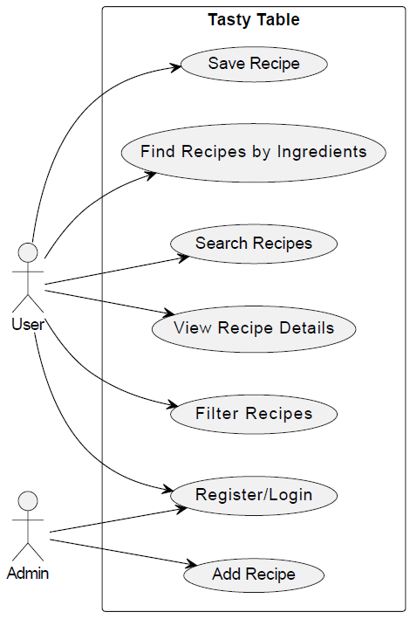

**4.2 Sequence diagram**

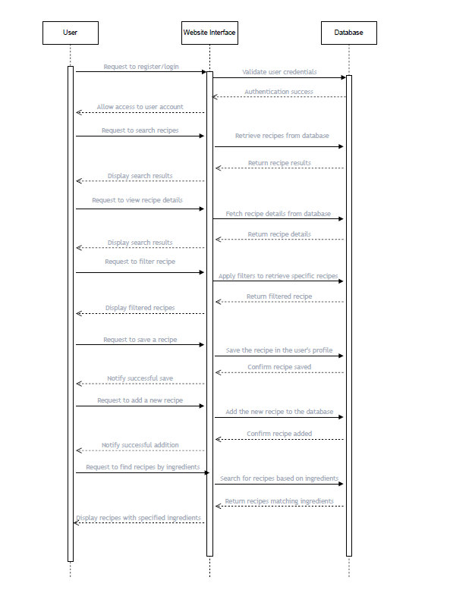

**4.3 Activity diagram**

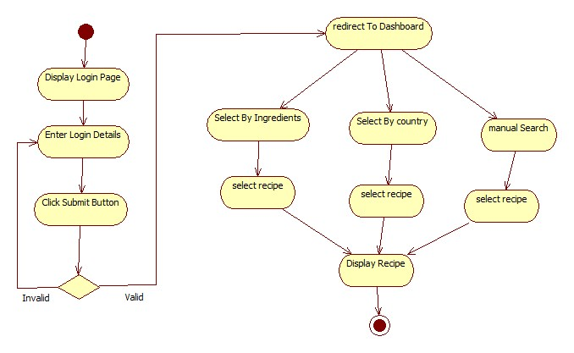

**4.4 State Diagram**

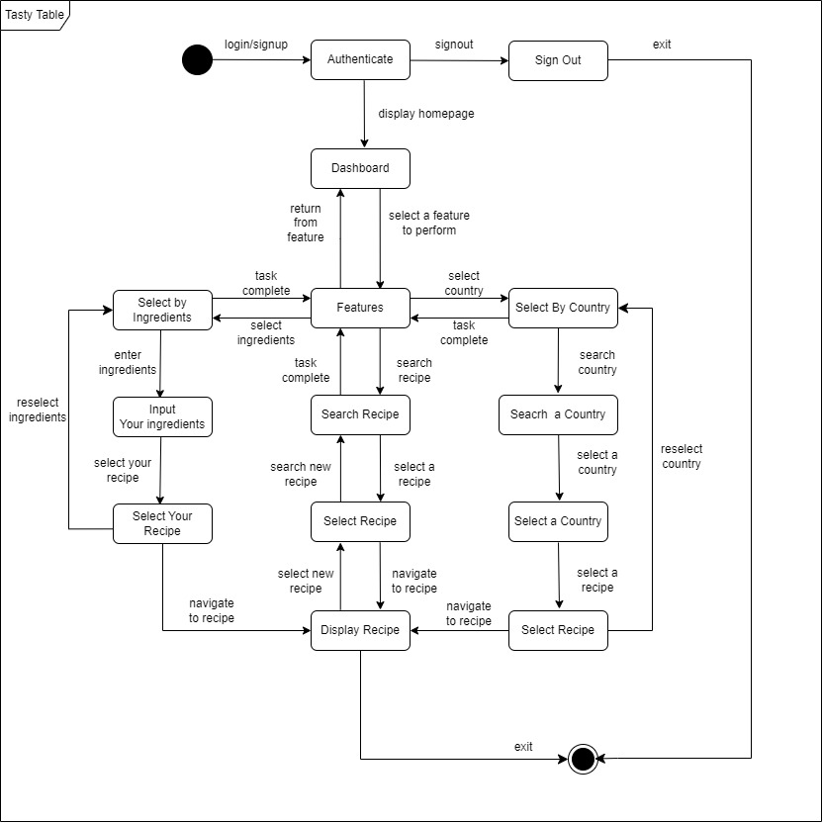

**4.5 DFD diagram**

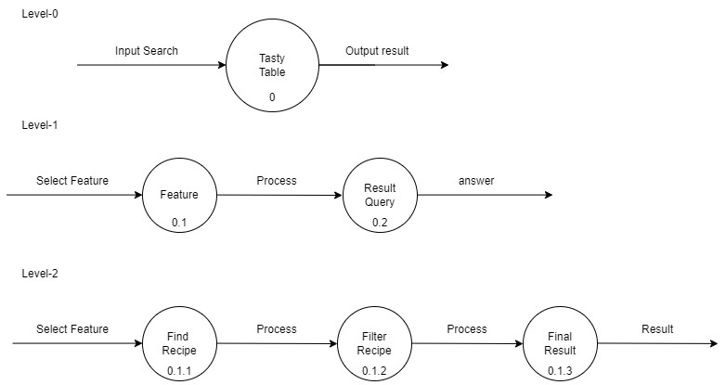

**5. Prototypes**

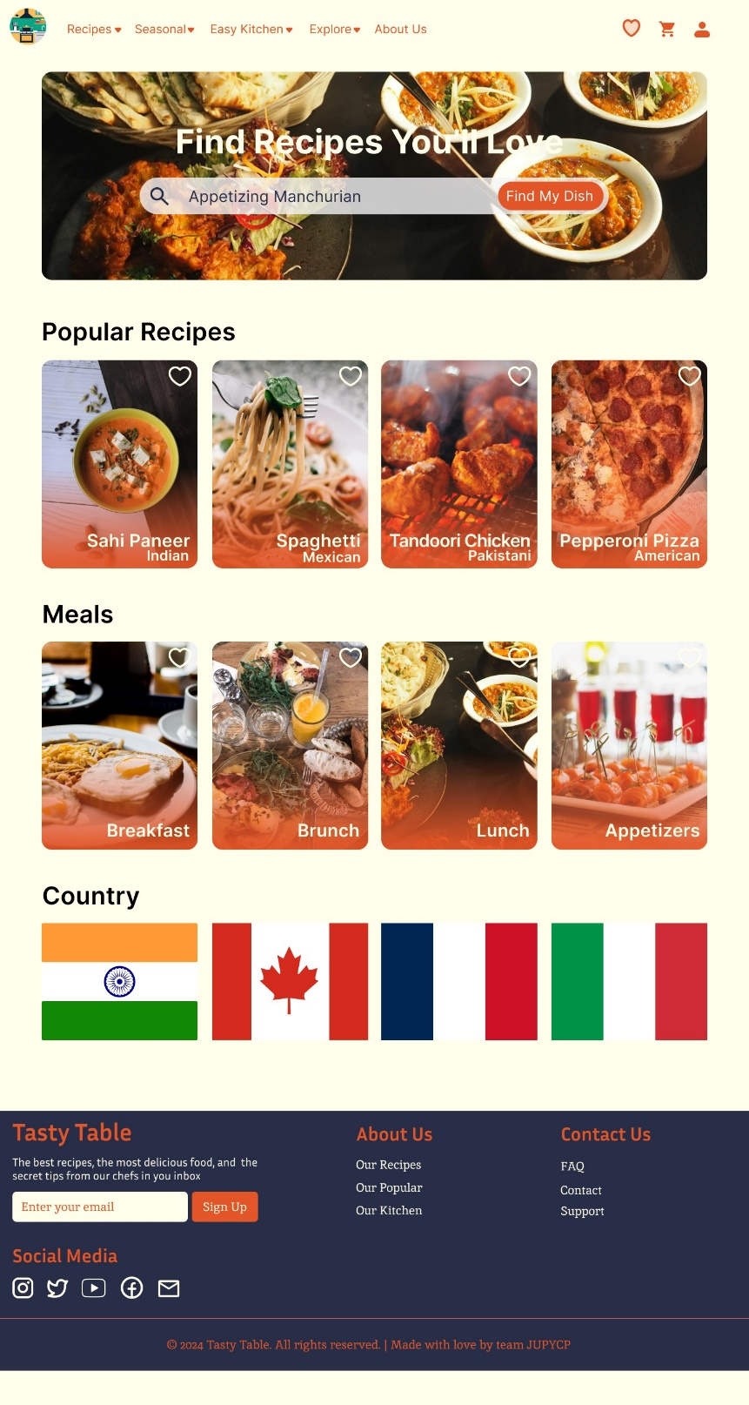

* 1. **Modules Overview:**

**1. User Authentication and Account Management:**

* Handle user registration, login, and account management functionalities.
* Allow users to register, login, and manage their accounts.
* Provide features for updating profile information, changing passwords, and managing preferences.

**2. Recipe Database Management:**

* Design the database schema to store recipe information.
* Implement CRUD operations for managing recipes.
* Categorize recipes and allow users to tag recipes for better organization and searchability.

**3. Search and Filter Functionality:**

* Develop advanced search functionality for recipes.
* Provide filtering options to refine search results based on various criteria.

**4. Recipe Display and Interaction:**

* Design individual recipe detail pages with comprehensive information.
* Implement a rating and review system for user feedback.
* Allow users to save favorite recipes and create personalized collections.

**5. User Interaction and Community Features:**

* Enable social sharing of recipes on various platforms.
* Allow users to submit their own recipes and engage in discussions.
* Implement moderation tools for reviewing and approving user-generated content.

**6. Admin Panel:**

* Develop an admin dashboard for managing users, recipes, and comments.
* Provide user management features and role-based access control.
* Implement content moderation tools for ensuring quality and compliance.

**Technology Stack:**

* **Frontend:**
  + HTML, CSS, JavaScript (or frameworks like React, Vue.js)
  + Bootstrap or Materialize CSS for responsive design
  + AJAX for asynchronous requests
* **Backend:**
  + Node.js with Express.js framework
  + Database: PostgreSQL or MySQL for recipe storage
  + ORM (Object-Relational Mapping) for database interaction
* **Authentication and Authorization:**
  + JWT (JSON Web Tokens) for authentication
  + OAuth for social media login integration
* **Search and Filtering:**
  + Elasticsearch or Apache Solr for advanced search functionality
* **Deployment and Infrastructure:**
  + Web Server: Nginx or Apache
  + Deployment: Docker containers for easy deployment and scalability
  + Cloud Hosting: AWS, Google Cloud Platform, or Microsoft Azure

**6. Implementation Progress**

**6.1 Milestones Achieved**

**6.1.1 Database Design and Setup**

The initial phase of implementation focused on designing and setting up the application's database. This involved defining the database schema, creating tables for recipes, user accounts, ingredients, and other essential data structures. The database has been successfully implemented and tested for data integrity.

**6.1.2 User Authentication**

The user authentication system has been implemented, allowing users to create accounts, log in securely, and manage their profiles. Robust password encryption and validation mechanisms have been integrated to ensure data security.

**6.1.3 Recipe Management Module**

The recipe management module, which includes features for creating, editing, and deleting recipes, has been implemented and is currently in the testing phase. Users can interact with their recipe collections and add new recipes with ease.

**6.1.4 Search and Filter Functionality**

The search and filter functionality, enabling users to search for recipes based on keywords, dietary preferences, and ingredients, has been implemented and is undergoing refinement. Users can easily find recipes that match their preferences and dietary restrictions.

**6.1.5 User Feedback and Ratings**

The user feedback and ratings system, allowing users to rate and review recipes, is under active development. This feature will provide valuable insights for users and enhance the overall user experience.

**6.2 Current Status**

The current status of the implementation phase can be summarized as follows:

• Approximately 50% of the planned features have been implemented.

• The project is progressing according to the initial development timeline.

• Testing and debugging processes are ongoing to ensure software reliability and performance.

• User interface enhancements are being made to improve usability and aesthetics.

**6.3 Upcoming Tasks**

In the next phase of implementation, the development team will focus on the following tasks:

• Completing the user feedback and ratings system to enable users to provide feedback on recipes.

• Enhancing search and filter functionality to improve the accuracy and relevance of recipe search results.

• Integrating social sharing features to allow users to share their favorite recipes with friends and family.

• Implementing advanced user preferences to personalize recipe recommendations and suggestions.

**7. Conclusion and Future Enhancements**

Tasty Table - Recipe Finder is poised to revolutionize the way users discover, create, and share recipes. By providing a comprehensive platform for recipe management and discovery, it aims to simplify the cooking experience and inspire culinary creativity. With robust search and filter functionality, users can easily find recipes that match their dietary preferences, ingredient availability, and cooking preferences. The platform's user-friendly interface and intuitive design make it easy for users to browse, save, and organize their favorite recipes.

Tasty Table holds immense significance in the culinary world. It represents a shift towards a more accessible and inclusive approach to cooking, empowering users of all skill levels to explore new flavors and cuisines. Furthermore, it fosters community engagement and collaboration, allowing users to share their culinary creations and inspire others. Additionally, Tasty Table contributes to the broader conversation on healthy eating and sustainable cooking practices, promoting awareness of food sourcing, nutrition, and environmental impact.

Tasty Table makes several noteworthy contributions to the culinary landscape. Firstly, it democratizes access to culinary knowledge and inspiration, making it easy for users to discover new recipes and cooking techniques. Secondly, it promotes healthy eating habits and balanced nutrition by providing a diverse range of recipes catering to different dietary preferences and nutritional needs. Lastly, Tasty Table fosters a sense of community and connection among users, creating a platform for sharing culinary experiences, tips, and tricks.

In the future, Tasty Table plans to expand its feature set to include meal planning, grocery list generation, and personalized recipe recommendations. Additionally, partnerships with food bloggers, chefs, and nutritionists will enhance the platform's content offerings and provide users with expert insights and guidance. Overall, Tasty Table is committed to empowering users to lead healthier, more fulfilling lives through the joy of cooking and sharing delicious meals.

**7.1 References**

1. Super Cook - Super Cook Website

[https://www.supercook.com/#/desktop](https://www.supercook.com/#/desktop)

2. Recipe Radar - Recipe Radar GitHub Repository

[https://github.com/bryandevelops/RecipeRadar](https://github.com/bryandevelops/RecipeRadar)

3. Delicieux | Recipe Finder App - Delicieux GitHub Repository

[https://github.com/mwasikz/delicieux-recipe-finder](https://github.com/mwasikz/delicieux-recipe-finder)

4. Yum2Food - Yum2Food GitHub Repository

[https://github.com/sur16-cse/yum2food](https://github.com/sur16-cse/yum2food)

5. Recipe-Finder - Recipe-Finder GitHub Repository

[https://github.com/Treasure-Mayowa/Recipe-Finder?tab=readme-ov-file](https://github.com/Treasure-Mayowa/Recipe-Finder?tab=readme-ov-file)

6. Recipe Radar - Recipe Radar Website

[https://www.reciperadar.com/](https://www.reciperadar.com/)

7. British Heart Foundation - Recipe Finder

[https://www.bhf.org.uk/informationsupport/support/healthy-living/healthy-eating/recipe-finder](https://www.bhf.org.uk/informationsupport/support/healthy-living/healthy-eating/recipe-finder)

8. Recipe Finder Cool - Recipe Finder Cool Website

[https://aloorecipes.com/recipe-finder/](https://aloorecipes.com/recipe-finder/)

9. Recipe Finder - Recipe Finder Website

[https://www.recipefinder.com/](https://www.recipefinder.com/)

10. Tasty - Tasty Website

[https://tasty.co/](https://tasty.co/)

11. Allrecipes - Allrecipes Website

[https://www.allrecipes.com/](https://www.allrecipes.com/)

12. Food Network - Food Network Website

[https://www.foodnetwork.com/](https://www.foodnetwork.com/)

13. Epicurious - Epicurious Website

[https://www.epicurious.com/](https://www.epicurious.com/)

14. MyRecipes - MyRecipes Website

[https://www.myrecipes.com/](https://www.myrecipes.com/)

15. Martha Stewart - Martha Stewart Website

[https://www.marthastewart.com/](https://www.marthastewart.com/)

16. Simply Recipes - Simply Recipes Website

[https://www.simplyrecipes.com/](https://www.simplyrecipes.com/)