IA04: Architecture Decision Record and Failure Walkthrough
Identity: jpkanquandah, team Intellectuals, LiftPro Crane Services Website. Personal repository: https://github.com/Dept-of-Comp-Sci-University-of-Ghana/DE-IND-jpkanquandah. Team repository: https://github.com/Dept-of-Comp-Sci-University-of-Ghana/dcit208-client-project-2026-team-engineering-repository-intellectuals. Related team issue: (link in the Sakai portfolio). Date: 23 October 2026.

ADR title and status
ADR: Build the website as a static site that opens WhatsApp, with no back end and no database. Status: Accepted.

Context and assumptions
Client problem: Bernard Nyantakyi gets the same questions about services and prices in his DMs and has no single place that shows his services. Feature: Enquire button that opens WhatsApp with a prepared message. Requirement: a button that sends visitors to his WhatsApp line (D2) and NFR-24 (no customer data stored by the site). Why the decision matters: it decides the cost, security, maintenance and how fast we can deliver.
Assumptions and constraints:
- Users: customers on phones, with limited data. Client: not technical, one person.
- Data: services text, images and one WhatsApp number; no customer data.
- Deployment and cost: free or very cheap hosting (the free Vercel plan is limited to non-commercial use, ADR-003).
- Team: 7 students with web skills but a short deadline (a few weeks, four sprints).
- Privacy: avoid collecting personal data. Scale: small, mostly local enquiries.

Alternatives and decision matrix
- Option A (chosen): static front end plus a wa.me link.
- Option B (rejected): web app with a back end and database that stores enquiries and bookings.
- Option C (rejected for now): WhatsApp chatbot and automated replies.
Weights: 5 is very important, 1 is not important. Scores: 1 is poor and 5 is excellent. Weighted score is weight times score.
Criterion | Weight | A: static + WhatsApp | B: back end + database | Evidence and reasoning
Fit with client need | 5 | 5 (25) | 3 (15) | Client asked only for services plus a WhatsApp button; bookings were not requested
Security and privacy | 5 | 5 (25) | 2 (10) | A stores no customer data; B must protect a database and personal data
Maintainability | 4 | 4 (16) | 2 (8) | Fewer parts to break or update for a non-technical client
Team skill and deadline | 4 | 5 (20) | 3 (12) | Static pages are quick to finish in four sprints
Deployment and cost | 3 | 4 (12) | 2 (6) | Free static hosting versus paying for server and database
Performance and scale | 3 | 5 (15) | 3 (9) | Static files are fast and cheap to serve
Total |  | 113 | 60 | Option C was not scored because it was out of scope (D2)
Decision and balance: Option A. We chose simplicity, privacy and speed over features.
- Benefits: very low risk, low cost, no customer data to protect, fast pages.
- Disadvantages and limits: no booking, no availability, no prices, and the owner cannot see whether a message was read. Content changes need a maintainer.
- New work: a content file kept in source, tests for the link builder, someone trained to update content.
- Revisit if: the client wants bookings, prices that change often, or an admin page.

Personal architecture sketch
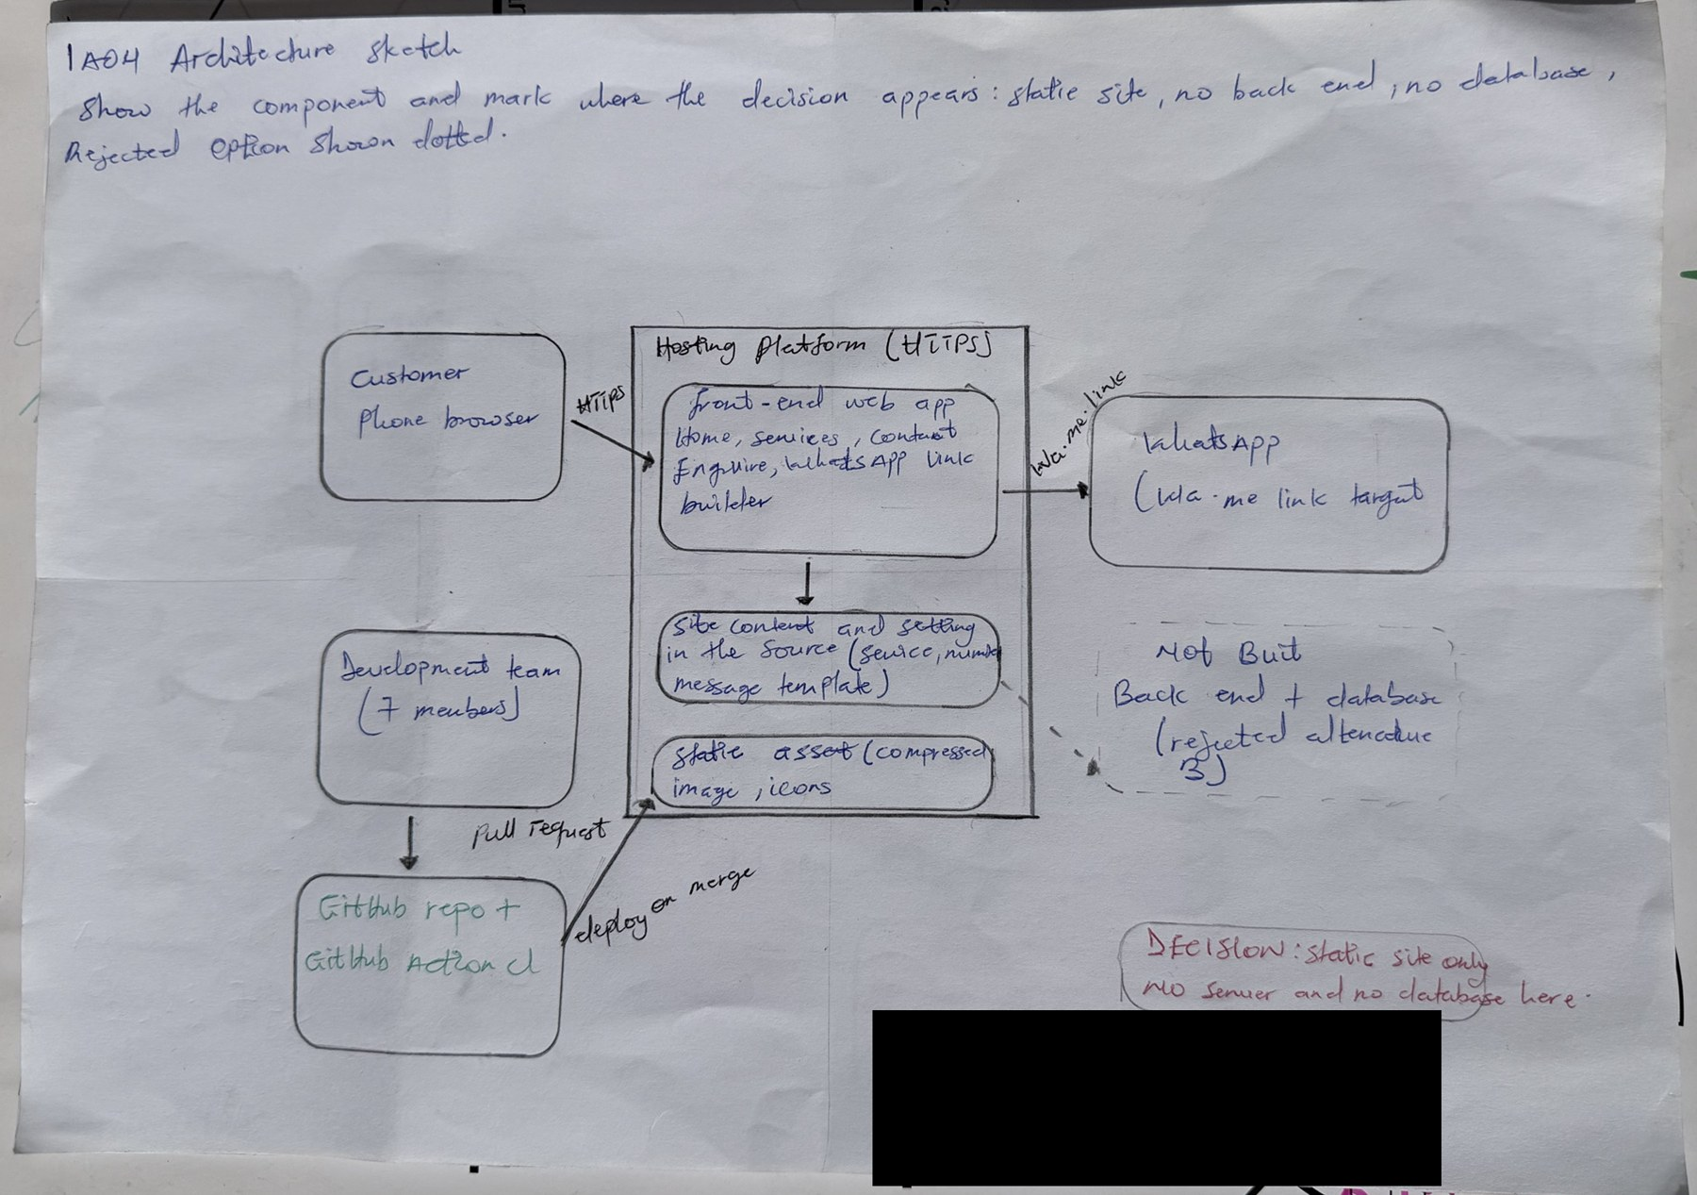
IA04 handwritten architecture sketch
IA04 handwritten architecture sketch
AI note on this drawing: I drew this by hand myself. The layout was based on a reference sketch that Claude suggested, and I can explain every box and arrow in my own words.

Failure walkthrough
Step | Answer
User action and normal path | Customer taps Enquire; browser follows the link; WhatsApp opens with the message
Failing component | The WhatsApp number in the configuration is wrong after a bad merge
Detection | Tests TC-06 and TC-19 fail in CI; if it slips through, the owner notices enquiries missing or a customer reports it
What the user sees | A chat with the wrong person, or no chat
Data at risk | No stored data; the risk is lost customers and a customer’s message going to a stranger
Logs | CI run logs, the pull request history, the host’s deployment log
Immediate mitigation and recovery | Revert the pull request or redeploy the previous version on the host; confirm by clicking every Enquire link
Test of the failure handling | A unit test checks every generated link starts with the approved number

Verification plan
- Run the unit tests for the link builder (make test).
- Check CI passes on the pull request.
- Open the deployed site on a phone and click each Enquire button.
- Ask the client to confirm the number shown and the service names.

Video, commits and declaration
- Video (unlisted, 3 to 4 minutes): https://youtu.be/bMEDxWQgDD4.
- Three meaningful commits made by me as I finished each part: IA4: add jpkanquandah context and alternatives ((link in the Sakai portfolio)); IA4: add jpkanquandah decision and consequences ((link in the Sakai portfolio)); IA4: add jpkanquandah final evidence ((link in the Sakai portfolio)).
- Files: IA04/evidence/architecture-sketch.pdf and IA04/submission/EVIDENCE.md.
- AI used: Yes. Claude (Anthropic), 23 October 2026: drafted the decision matrix and wording from our team documents. I checked the scores against our own reasoning, kept the weights, and verified the decision against the client’s request in D0 and the hosting choice in our ADR.
- Declaration: “I confirm that this submission is based on my team’s actual client project. I have identified all AI assistance used. I can explain the decision, alternatives, trade-offs, failure scenario and evidence in my own words.”

