IA05: API Contract and Failure-Response Walkthrough
Identity: jpkanquandah, team Intellectuals. Repositories: https://github.com/Dept-of-Comp-Sci-University-of-Ghana/DE-IND-jpkanquandah and https://github.com/Dept-of-Comp-Sci-University-of-Ghana/dcit208-client-project-2026-team-engineering-repository-intellectuals. Story: customer enquires about a service. Issue: (link in the Sakai portfolio). Date: 23 October 2026.
Honest note: the website has no HTTP API. The “caller and provider agreement” for this feature is the WhatsApp link builder, a function inside the site that the Enquire button calls. The task allows a non-HTTP equivalent, so I define that contract. I use the descriptive name buildWhatsAppLink for it; the site code may name or inline this logic differently, which does not change the contract.

Purpose and contract
Item | Definition
Role, goal, value | As a customer, I want Enquire to open WhatsApp with the right number and a message about my service, so I do not type it all
Caller | The Enquire button on the Services section (and the “Not sure?” button)
Provider | The link builder function in the front-end code
NFR or constraint | Always use the approved number (NFR-12); store nothing (NFR-24)
Operation | buildWhatsAppLink(serviceId) returns a link string (non-HTTP equivalent of GET /enquiry-link)
Final link form | https://wa.me/<approved number, digits only>?text=<URL-encoded message> (example: https://wa.me/233XXXXXXXXX?text=Hello%2C%20I%20would%20like%20to%20ask%20about%20Mobile%20Crane%20Hire.)
Path or query parameters | serviceId (text, required for a service enquiry; omitted for the general message)
Headers and authentication | None. The function runs in the visitor’s browser.
Authorization | None for visitors. Changing the number or service list is controlled by GitHub review and CODEOWNERS.
Request fields:
Field | Type | Required | Meaning
serviceId | text | Optional | Id of a service in the site content, for example “mobile-crane-hire” (synthetic example)
Message template (config) | text | Required | The fixed sentence with a place for the service name
Number (config) | text of digits | Required | Approved WhatsApp number, international format, no plus or spaces

Validation rules (5)
# | Rule | Kind | Checked by
1 | serviceId must be text | Type | link builder
2 | serviceId must match a service in the content list | Business | link builder
3 | The number must be digits only, 10 to 15 digits | Format | config check or test
4 | The message must be URL-encoded so spaces and symbols do not break the link | Format | link builder, tests TC-08
5 | The number used must be the approved number | Business | tests TC-06 and TC-19

Success response
Outcome: a link is returned and the browser opens WhatsApp. Synthetic example response:
{
"ok": true,
"link": "https://wa.me/233000000000?text=Hello%2C%20I%20would%20like%20to%20ask%20about%20Mobile%20Crane%20Hire.",
"service": "Mobile Crane Hire"
}
Fields: ok says it worked; link is what the button opens; service is the name used in the message. Next display: WhatsApp opens with the message ready to edit. (The real function may return only the link string. The JSON is how I describe the contract.)

Error cases (5)
Case | Outcome | Error code | User-facing message | Logging
Invalid input: serviceId is not text | No link; fall back to the general message | ERR_INVALID_SERVICE_ID | “Please ask the owner about this service.” | Console warning in development
Authorization: someone tries to change the number without review | Change is blocked by branch protection | ERR_REVIEW_REQUIRED | Not visible to visitors; shown on the pull request | GitHub audit trail
Conflict: serviceId matches two services (duplicate id) | Build or test fails | ERR_DUPLICATE_SERVICE | Not shown to visitors; the change cannot be merged | CI log
External service failure: WhatsApp cannot open | Phone shows the WhatsApp page or an error | ERR_WHATSAPP_UNAVAILABLE | Contact section still shows the number | None on the site (nothing is collected)
Missing configuration: number is empty | Build or test fails | ERR_NUMBER_MISSING | Not shown to visitors | CI log
Status of each error case: ERR_REVIEW_REQUIRED is enforced today by GitHub branch protection and CODEOWNERS. The other codes (ERR_INVALID_SERVICE_ID, ERR_DUPLICATE_SERVICE, ERR_NUMBER_MISSING) are the names I give to checks that are planned in the link builder and CI tests, not confirmed in the code. ERR_WHATSAPP_UNAVAILABLE is a behaviour of the phone and WhatsApp, not of our code.

Duplicates and retries
If a customer taps Enquire twice, two chats may open, but nothing is stored, so there is no duplicate record. The function is idempotent (the same input always gives the same link). A retry is safe because it only builds a link. There is no unique constraint or request id because there is no data. The one unsafe retry is the customer sending the same WhatsApp message several times, which is outside our system.

Hand-drawn sequence diagram
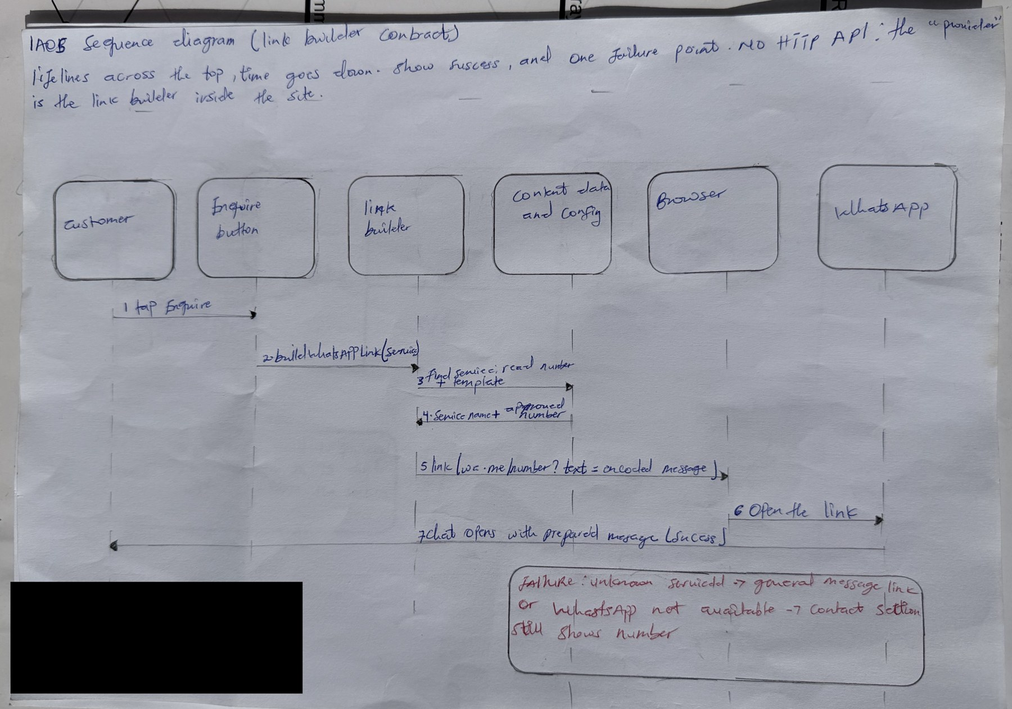
IA05 handwritten sequence diagram
IA05 handwritten sequence diagram
AI note on this drawing: I drew this by hand myself. The layout was based on a reference sketch that Claude suggested, and I can explain every box and arrow in my own words.

Contract tests (6)
# | Test | Input | Expected outcome and response
1 | Valid request | serviceId = existing service | ok true; link starts with wa.me and the approved number; message contains the service name
2 | Missing or invalid field | serviceId = number 123 | ERR_INVALID_SERVICE_ID; general message link
3 | Unauthorized change | Pull request that edits the number without a reviewer | Merge blocked (process test: branch protection and CODEOWNERS)
4 | Conflict or duplicate | Two services with the same id | CI fails with ERR_DUPLICATE_SERVICE
5 | Dependency failure | Open the link on a phone without WhatsApp | Phone shows the WhatsApp page; Contact section still shows the number
6 | Response shape | Valid request | Result contains ok, link and service with the right types

Trade-off, video and files
- Trade-off and open question: a function contract is simple but it cannot protect us if someone edits the number in the source, so we rely on review. Open question: should the number be stored only in one configuration file with its own automated check, or is review enough for a small project?
- Video (3 to 4 minutes): https://youtu.be/bMEDxWQgDD4.
- Files: IA05/API_CONTRACT.md, ERROR_MODEL.md, TEST_PLAN.md, examples/request.json, examples/success-response.json, examples/error-response.json, evidence/sequence-diagram.pdf, AI_DISCLOSURE.md.
- AI used: Yes. Claude (Anthropic), 23 October 2026: drafted the contract tables from my team’s documents. I changed names and examples to use synthetic values only, and marked planned checks as planned. I have not verified the function against the source code, which is why the contract is described as a design.

