IA06: Data Model, Query and State Walkthrough
Identity: jpkanquandah, team Intellectuals. Feature: Enquire about a service. Story: customer enquires about a service. Issue: (link in the Sakai portfolio). Repositories: https://github.com/Dept-of-Comp-Sci-University-of-Ghana/DE-IND-jpkanquandah and https://github.com/Dept-of-Comp-Sci-University-of-Ghana/dcit208-client-project-2026-team-engineering-repository-intellectuals. Date: 23 October 2026.
Honest note: the site has no database. Its “data” is a content file in the source (services, business details and the message template). I model that, and I list a possible Enquiry record as planned for a later version only.

Entities, attributes and relationships
Entity | Attributes (type) | Key
BusinessSettings | businessName (text), location (text), whatsappNumber (digits text), enquiryTemplate (text), generalMessage (text) | one record, key: businessName
Service | id (text), name (text), description (text), imageFile (text), displayOrder (number) | id (unique)
Enquiry (planned only, not built) | enquiryId, serviceId, createdAt | enquiryId
Relationship: one BusinessSettings offers many Services (one-to-many). Each Service appears once in the list. The planned Enquiry would link many-to-one to a Service.
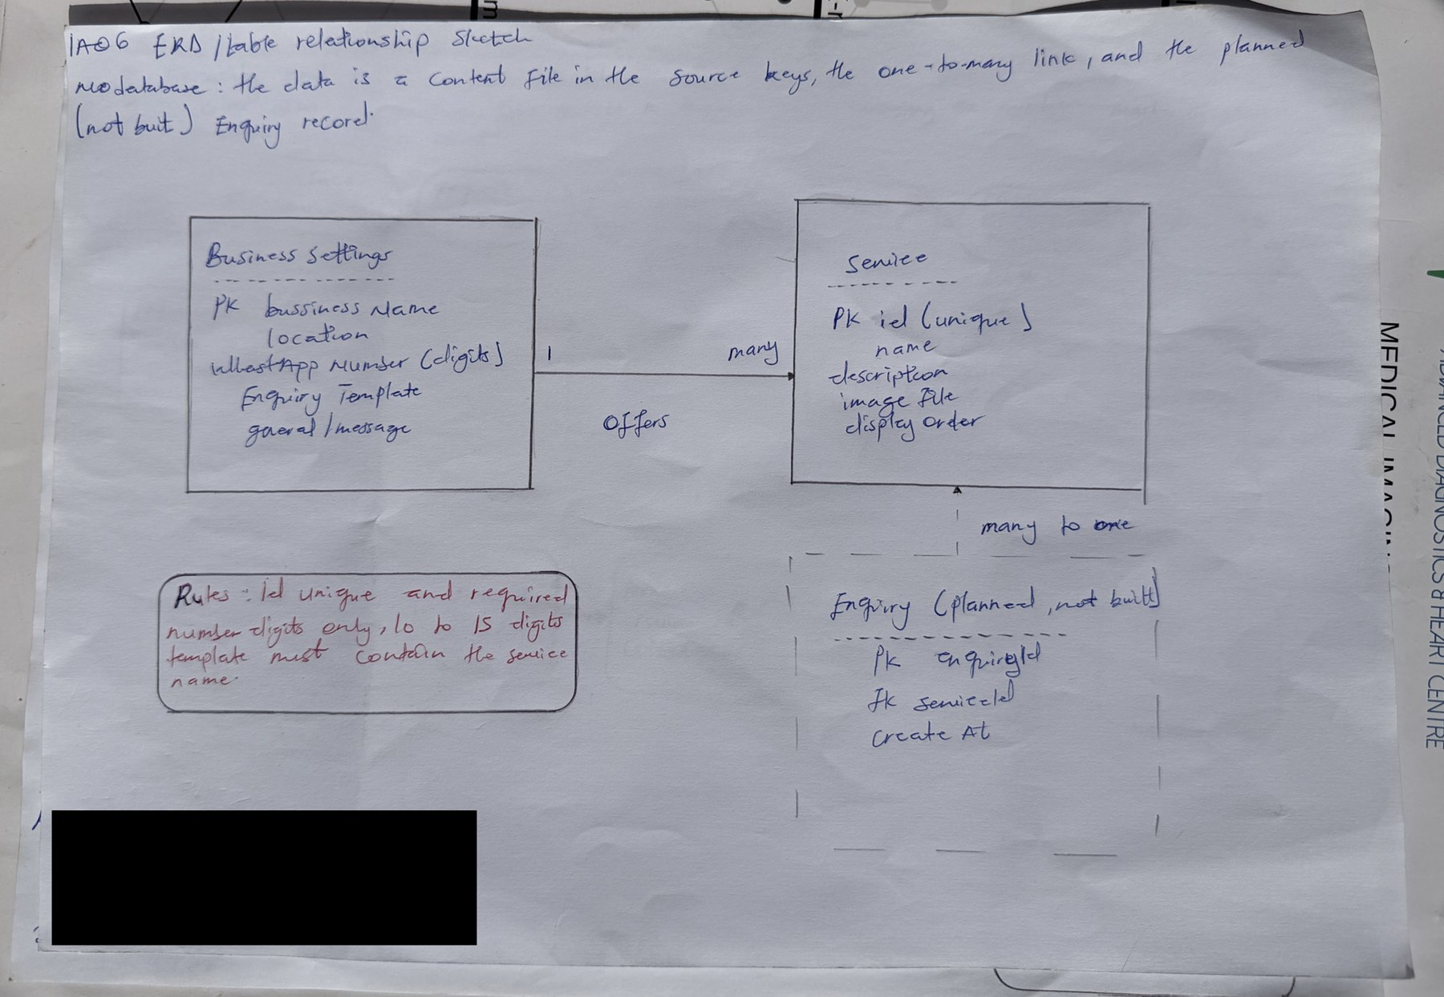
IA06 handwritten ERD sketch
IA06 handwritten ERD sketch
AI note on this drawing: I drew this by hand myself. The layout was based on a reference sketch that Claude suggested, and I can explain every box and arrow in my own words.

Constraints and synthetic sample data
Rule | Where enforced
id is required and unique | content check and unit test (build)
name is required and not empty | content check and tests
whatsappNumber is digits only, 10 to 15 digits | config check, tests TC-06 and TC-19
enquiryTemplate must contain a place for the service name | tests TC-08
imageFile must exist | build step
Only the approved number may be used | tests and code review
All records below are synthetic (made up for this report).
id | name | description | displayOrder
sample-crane-hire | Mobile Crane Hire (sample) | Crane and operator for lifting jobs | 1
sample-heavy-lift | Heavy Equipment Lifting (sample) | Lifting and placing heavy equipment | 2

businessName | location | whatsappNumber
LiftPro Crane Services | Madina, Ghana | 233000000000 (synthetic)
Lifecycle: records are created by editing the content file in a pull request, change when the client approves new text, and are removed by deleting them in a pull request. Every change is reviewed and kept in Git history.

Query and state walkthrough
Action: the customer taps Enquire on a service.
- Input: the service id from the button.
- Data touched: the Service list and BusinessSettings.
- Rule applied: the id must exist; the template is filled with the service name; the whole message is URL-encoded.
- Retrieval: the code finds the service by id and reads the number and template from settings.
- Response: a WhatsApp link, opened by the browser.
No state is stored; the page shows the same thing every time.

Privacy, failures and tests
Sensitive data: the WhatsApp number (public once the client approves, NFR-11) and the client’s private evidence (call notes, screenshots). Who may view or edit: anyone can view the public data; only team members through reviewed pull requests can edit. Must not go into AI tools: the client’s real private phone details, passwords or tokens, and customer chats.
Two realistic failures:
- Duplicate service id: the wrong service name could appear in a message. The build or test should fail so it is not merged.
- Missing or badly formatted number (for example starting with 0 or a plus sign): the link would not open the right chat. The config test fails and the change is blocked.
Six test ideas:
- Every service has a unique id (constraint).
- Every service has a non-empty name (validation).
- The number is digits only and the right length (validation).
- A service name with spaces, an ampersand and an accent is encoded correctly (query).
- No customer data appears in the repository or the page (privacy).
- If the service id is unknown, the general message is used (failure handling).

Video, evidence and AI disclosure
- Video (3 to 4 minutes): https://youtu.be/bMEDxWQgDD4. Sketch: inserted above. Editable work: IA06/.
- AI used: Yes. Claude (Anthropic), 23 October 2026: drafted the entities and sample data. I replaced real values with synthetic ones and checked the entities against our D0 charter and the services the client described. I did not inspect the real content file.

