1. Tell what machine you ran this on

I ran the code on Flip1.

1. What do you think the actual volume is?

The actual volume approximately equals to 25.3125

1. Show the performances you achieved in tables and graphs as a function of NUMNODES and NUMT?

In the table, the first row shows the NUMNODES, the first column shows the NUMT and other cells show the speed using the specified NUMNODES and NUMT. The speed is recorded in the units of ‘Mega Height Computed Per Second’.

|  |  |  |  |  |  |  |  |  |  |  |  |  |
| --- | --- | --- | --- | --- | --- | --- | --- | --- | --- | --- | --- | --- |
|  | 200 | 400 | 600 | 800 | 1000 | 1200 | 1400 | 1600 | 1800 | 2000 | 3000 | 4000 |
| 1 | 6.76 | 6.76 | 6.75 | 9.01 | 12.19 | 12.88 | 12.95 | 12.93 | 12.87 | 12.87 | 12.81 | 12.87 |
| 2 | 12.94 | 13.28 | 13.36 | 13.51 | 19.07 | 22.62 | 23.3 | 21.81 | 25.05 | 22.28 | 23.19 | 23.35 |
| 4 | 25.53 | 26.65 | 25.57 | 26.74 | 35.83 | 47.75 | 49.04 | 49.13 | 49.14 | 49.06 | 48.98 | 49.12 |
| 8 | 47.07 | 49.88 | 49.38 | 48.77 | 52.6 | 56.89 | 60.58 | 95.74 | 95.74 | 95.48 | 97.49 | 97.61 |

In the graph1, the vertical axis indicates the NUMNODES, the horizontal axis indicates the speed using ‘Mega Heights Computed Per Second’ as a unit and the line indicates the number of threads.

In the graph2, the vertical axis indicates the NUMT, the horizontal axis indicates the speed using ‘Mega Heights Computed Per Second’ as a unit and the line indicates the NUMNODES.

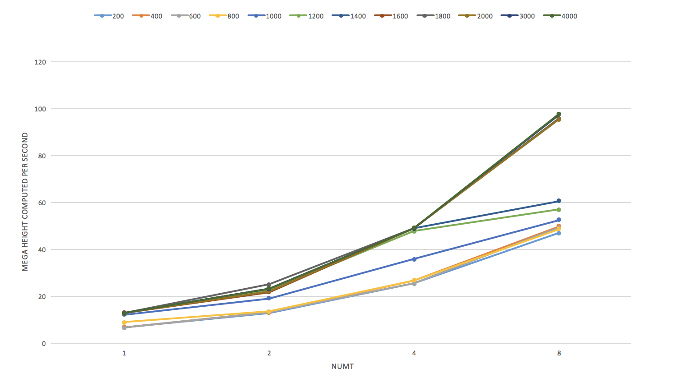

1. What patterns are you seeing in the speeds?
2. As the number of threads increases, the speed will increase. But the speedup of n threads will be less than n.
3. As the number of nodes increases, the speed will increase. But the speed will not increase without limit and will reach the upper bound.
4. Why do you think it is behaving this way?
   1. In the code, the height calculation process of each node has nothing to do with each other, so the speed will increase using parallel programming. But there is some fraction of the total operation that is inherently sequential and can’t be parallelized. So the speedup of n threads will always be less than n.
   2. As the number of nodes increases, the proportion of overhead in parallel programming is getting smaller and the speed will be faster. But there is still an upper bound of the computing capacity of CPU and the speed will not increase without limit.
5. What is the Parallel Fraction for this application, using the Inverse Amdahl equation?

The Parallel Fraction can be calculated by the following equation.

$$F= \frac{n}{n-1}\left(1-\frac{1}{Speedup}\right)=\frac{n}{n-1}\left(1-\frac{{MegaHeight}_{1}}{{MegaHeight}_{n}}\right)$$

|  |  |  |  |  |  |  |
| --- | --- | --- | --- | --- | --- | --- |
|  | 200 | 400 | 600 | 800 | 1000 | 1200 |
| NUMT=2 | 0.955177743 | 0.981927711 | 0.989520958 | 0.666173205 | 0.721552176 | 0.861184792 |
| NUMT=4 | 0.980284632 | 0.995121951 | 0.981358363 | 0.884068811 | 0.87970974 | 0.973682373 |
| NUMT=8 | 0.978724696 | 0.987971131 | 0.986634265 | 0.93172032 | 0.878001086 | 0.884112196 |
|  | 1400 | 1600 | 1800 | 2000 | 3000 | 4000 |
| NUMT=2 | 0.888412017 | 0.814305365 | 0.97245509 | 0.84470377 | 0.895213454 | 0.89764454 |
| NUMT=4 | 0.981239804 | 0.982427573 | 0.984126984 | 0.983557549 | 0.984619573 | 0.983984799 |
| NUMT=8 | 0.898552092 | 0.988510549 | 0.989226775 | 0.988808427 | 0.992687895 | 0.992170006 |

The average of Parallel Fraction is 0.9327.

1. Given that Parallel Fraction, what is the maximum speed-up you could ever get?

The maximum speed-up can be calculated by the following equation.

$$\max{Speedup}= \frac{1}{1-F_{parallel}}$$

The maximum speed-up for the application is 14.86