1. What your own-choice quantity was and how it fit into the simulation.

Two agents are added into the simulation.

The first agent is wolves. Wolves will eat deer each month and will die if there is not enough deer. The number of wolves will increase if the Deer Factor is more than 0.5 and the number of deer is more than 30. Deer Factor can be computed like this:

$$DF=1- e^{-{(\frac{NowNumDeer-30}{10})}^{2}}$$

If the number of deer is not enough to be eaten for half a year, half of the wolves will starve to death.

The second agent is pests. Pests will eat grain each month. The number of pests will increase to top in summer and decrease to bottom in winter. Normal Distribution is applied to simulate the number of pests in each year.

The number of pests can be calculated like this:

$$NowNumPests=2×e^{-\frac{{(NowMonth\%6-6)}^{2}}{4}}+rand$$

1. Create a table with your results

|  |  |  |  |  |  |  |
| --- | --- | --- | --- | --- | --- | --- |
| Month | NowTemp | NowPrecip | NowHeight | NowNumDeer | NowNumWolves | NowNumPest |
| 1 | 21.95 | 7.83 | 0.79 | 37 | 3 | 0 |
| 2 | 30.72 | 10.21 | 3.8 | 27 | 3 | 0 |
| 3 | 53.71 | 10.04 | 4.75 | 21 | 3 | 0.07 |
| 4 | 59.36 | 13.11 | 4.57 | 18 | 2 | 0.44 |
| 5 | 70.2 | 9.7 | 3.51 | 15 | 3 | 0.55 |
| 6 | 64.72 | 6.68 | 2.27 | 12 | 2 | 2.31 |
| 7 | 63.18 | 3.48 | 0 | 9 | 1 | 7.05 |
| 8 | 57.75 | 3.75 | 0 | 8 | 1 | 6.09 |
| 9 | 57.64 | 1.71 | 0 | 7 | 1 | 0.99 |
| 10 | 42.89 | 0 | 0.66 | 6 | 1 | 0.39 |
| 11 | 38.19 | 2.12 | 3.99 | 4 | 1 | 0.14 |
| 12 | 28.97 | 6.24 | 5.73 | 4 | 1 | 0.02 |
| 13 | 39.49 | 8.94 | 13.55 | 6 | 1 | 0 |
| 14 | 28.94 | 10.97 | 15.82 | 16 | 1 | 0.01 |
| 15 | 51.29 | 13.32 | 17.64 | 25 | 2 | 0.12 |
| 16 | 60.6 | 9.89 | 17.26 | 33 | 2 | 0.75 |
| 17 | 67.28 | 10.73 | 15.43 | 38 | 2 | 1.12 |
| 18 | 67.21 | 7.99 | 12.81 | 42 | 2 | 2.03 |
| 19 | 62.94 | 5.15 | 8.37 | 43 | 3 | 6 |
| 20 | 72.73 | 0.85 | 0 | 39 | 4 | 5 |
| 21 | 46.24 | 0 | 0 | 35 | 5 | 2.28 |
| 22 | 37.77 | 1.43 | 0 | 30 | 5 | 0.71 |
| 23 | 39.47 | 0.1 | 1.27 | 25 | 5 | 0.11 |
| 24 | 37.08 | 5.3 | 6.68 | 18 | 2 | 0.01 |
| 25 | 29.67 | 7.88 | 9.11 | 18 | 3 | 0 |
| 26 | 40.54 | 10.71 | 16.87 | 21 | 2 | 0.01 |
| 27 | 45.87 | 9.91 | 22.31 | 29 | 3 | 0.05 |
| 28 | 53.23 | 12.71 | 23.22 | 36 | 3 | 0.74 |
| 29 | 66.33 | 10.79 | 21.39 | 41 | 3 | 0.99 |
| 30 | 72.07 | 7.96 | 19 | 45 | 4 | 6.18 |
| 31 | 72.67 | 4.87 | 6.19 | 48 | 5 | 4.87 |
| 32 | 73.5 | 2.44 | 0 | 40 | 6 | 1.57 |
| 33 | 56.08 | 0 | 0 | 34 | 3 | 1.45 |
| 34 | 53.02 | 0.37 | 0 | 31 | 3 | 0.2 |
| 35 | 43.35 | 2.58 | 3.41 | 28 | 3 | 0.04 |
| 36 | 22.46 | 5.42 | 3.36 | 22 | 3 | 0 |
| 37 | 39.09 | 8.33 | 10.84 | 18 | 3 | 0 |
| 38 | 39.52 | 11.92 | 18.36 | 23 | 2 | 0.01 |
| 39 | 54.36 | 11.03 | 19.11 | 31 | 2 | 0.14 |
| 40 | 57.33 | 10.37 | 18.91 | 37 | 2 | 0.47 |
| 41 | 66.12 | 10.51 | 17.61 | 42 | 2 | 1.25 |
| 42 | 60.59 | 7.82 | 14.8 | 45 | 3 | 4.51 |
| 43 | 78.41 | 3.85 | 5.33 | 46 | 4 | 6.9 |
| 44 | 71.02 | 0.62 | 0 | 37 | 5 | 2.07 |
| 45 | 57.8 | 0 | 0 | 32 | 5 | 1.69 |
| 46 | 44.28 | 1.9 | 0 | 27 | 5 | 0.15 |
| 47 | 37.8 | 0 | 2.23 | 22 | 2 | 0.14 |
| 48 | 21.29 | 3.57 | 1.9 | 16 | 2 | 0.01 |
| 49 | 25.66 | 6.28 | 2.6 | 12 | 1 | 0 |
| 50 | 40.61 | 9.98 | 10.45 | 9 | 2 | 0.01 |
| 51 | 36.01 | 11.26 | 17.06 | 16 | 1 | 0.07 |
| 52 | 64.92 | 12.73 | 16.78 | 25 | 2 | 0.57 |
| 53 | 56.23 | 8.9 | 15.95 | 32 | 2 | 2.2 |
| 54 | 62 | 6.48 | 11.29 | 37 | 2 | 1.26 |
| 55 | 77.73 | 4.62 | 8.41 | 38 | 2 | 2.81 |
| 56 | 66.14 | 1.74 | 2.41 | 36 | 2 | 6.06 |
| 57 | 46.54 | 0 | 0 | 27 | 2 | 1.16 |
| 58 | 54.27 | 0.49 | 0 | 25 | 2 | 0.74 |
| 59 | 38.54 | 2.91 | 3.02 | 23 | 2 | 0.09 |
| 60 | 26.23 | 6.07 | 3.65 | 18 | 2 | 0.01 |
| 61 | 24.94 | 6.7 | 4.18 | 15 | 3 | 0 |
| 62 | 33.49 | 9.85 | 9.27 | 13 | 2 | 0.01 |
| 63 | 38.32 | 13.45 | 16.02 | 18 | 1 | 0.13 |
| 64 | 63.01 | 9.85 | 15.61 | 27 | 2 | 0.31 |
| 65 | 55.38 | 11.48 | 15.45 | 33 | 2 | 2.56 |
| 66 | 73.51 | 6.5 | 10.01 | 38 | 2 | 6.1 |
| 67 | 70.24 | 3.36 | 0 | 37 | 2 | 7.3 |
| 68 | 67.46 | 1.22 | 0 | 35 | 2 | 2.68 |
| 69 | 50.99 | 0.76 | 0 | 33 | 2 | 2.2 |
| 70 | 51.05 | 0 | 0 | 31 | 2 | 0.43 |
| 71 | 40.8 | 2.96 | 3.67 | 29 | 2 | 0.12 |
| 72 | 30.27 | 3.39 | 5.15 | 23 | 2 | 0.01 |

1. Draw a graph

The X axis shows the number of month in the six years and the Y axis shows the quantity of each item. As the legend shows, the blue curve indicates the temperature; the yellow curve shows the number of deer; the gray curve shows the height of the grain; the orange curve indicates the precipitation; the dark blue curve shows the number of wolves; the green curve shows the number of pests.

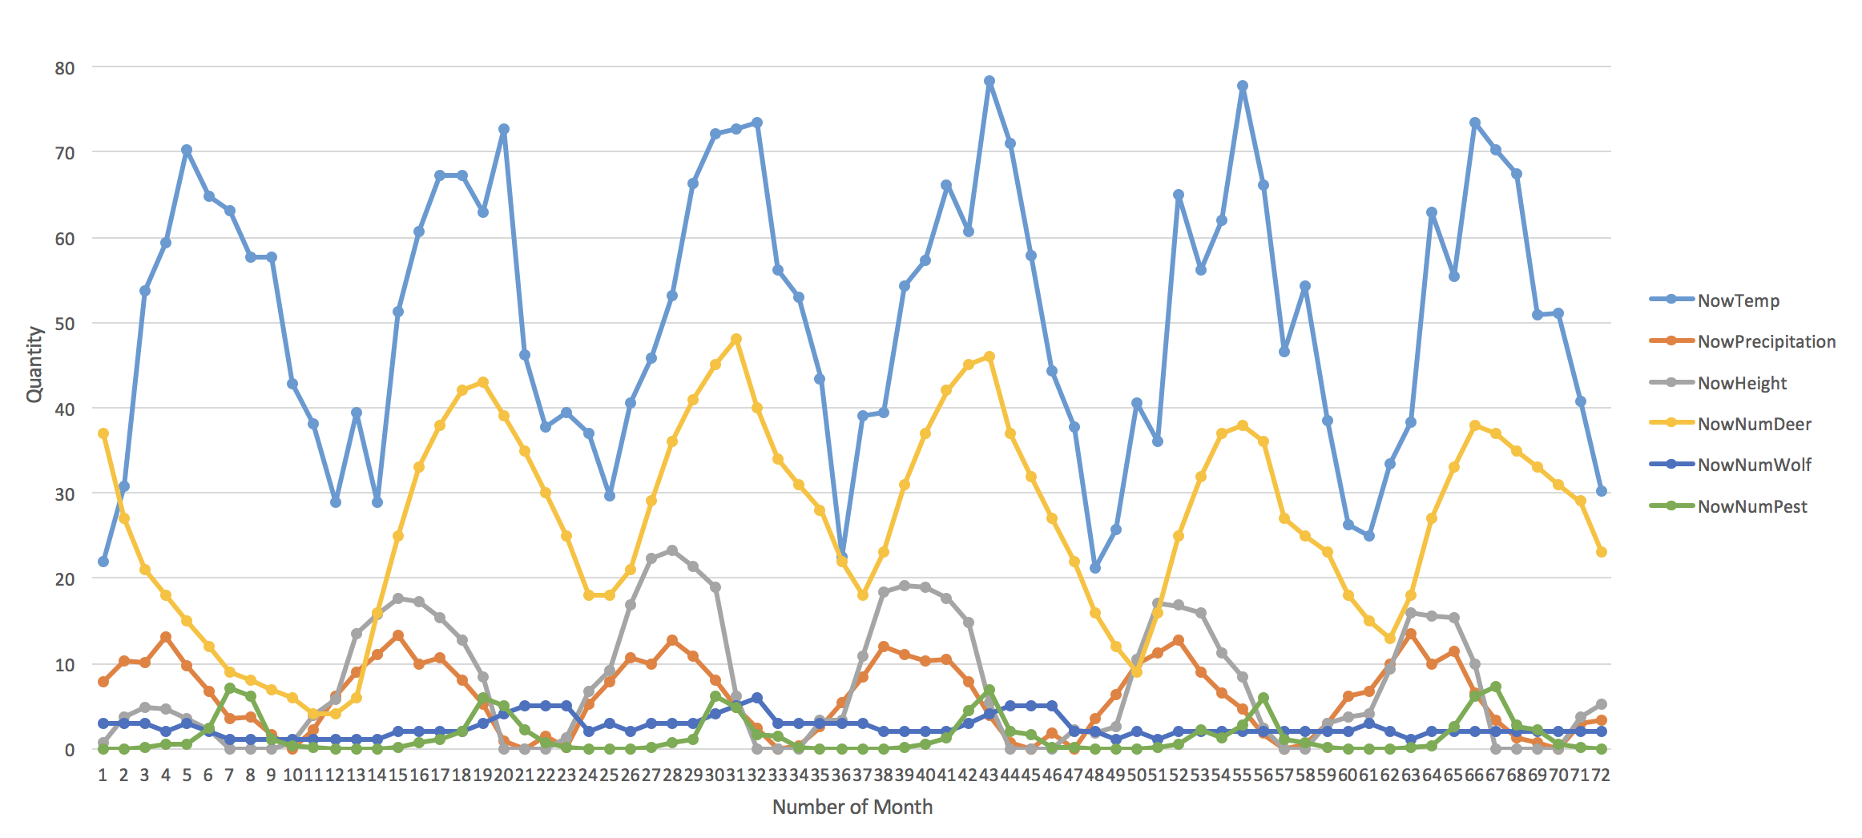

1. Commentary
   1. The temperature (blue curve) and the precipitation (orange curve) follow cosine and sine wave patterns with some randomness added.
   2. The number of pests (green curve) follows normal distribution with some randomness added. It will reach the top in July or August and reach the bottom in winter.
   3. The number of wolves (dark blue curve) is related to the number of deer. When there are many deer, the number of wolf will increase and when there are not enough deer for wolves to eat, the number of wolf drops.
   4. The number of deer (yellow curve) is influenced by the height of grain and the number of wolves. As the height of grain increases, more deer can be feed by the amount of grain. When the height of grain decreases, some deer die and the number of deer drops. The wolves eat deer each month and die when there is not enough deer. The changing pattern of the number of wolves and deer is similar to the that of deer and grains.
   5. The height of grain (gray curve) is influenced by the temperature, the precipitation, the number of deer and the number of pests. If there are no other factors except for temperature and precipitation, the height of grain will keep increasing with some waves. As the agent ‘deer’ is added to the simulation, the height of grain will drop if there are too many deer. If there is not enough grain for deer, some deer will die and the number of deer will drop. The height of grain will start to increase again when the number of deer is small. As the agent ‘pests’ is added to the simulation, the height of grain will drop a lot in each summer. Eventually, the height of grain will fluctuate from 0 to 25 inches.