1. Tell what machine you ran this on

I ran the code on rabbit.

1. Create a table with your results

|  |  |  |  |  |  |  |  |
| --- | --- | --- | --- | --- | --- | --- | --- |
| NUMT | 1K | 10K | 100K | 16M | 32M | 48M | 64M |
| 1(NON-VEC) | 116.19 | 133.74 | 140.51 | 159.28 | 215.84 | 227.14 | 250.8 |
| 2(NON-VEC) | 191.16 | 252.93 | 269.82 | 313.88 | 317.88 | 348.96 | 324.85 |
| 4(NON-VEC) | 169.75 | 440.6 | 518.13 | 618.56 | 626.81 | 631.88 | 634.36 |
| 1 | 442.12 | 528.62 | 596.49 | 544.84 | 628.49 | 696.9 | 704.72 |
| 2 | 565.16 | 1023.75 | 1181.69 | 983.61 | 1078.86 | 1025.53 | 1105.4 |
| 4 | 252.49 | 1382.07 | 1489.31 | 1548.02 | 1625.46 | 2210.8 | 2499.51 |

1. Draw graphs

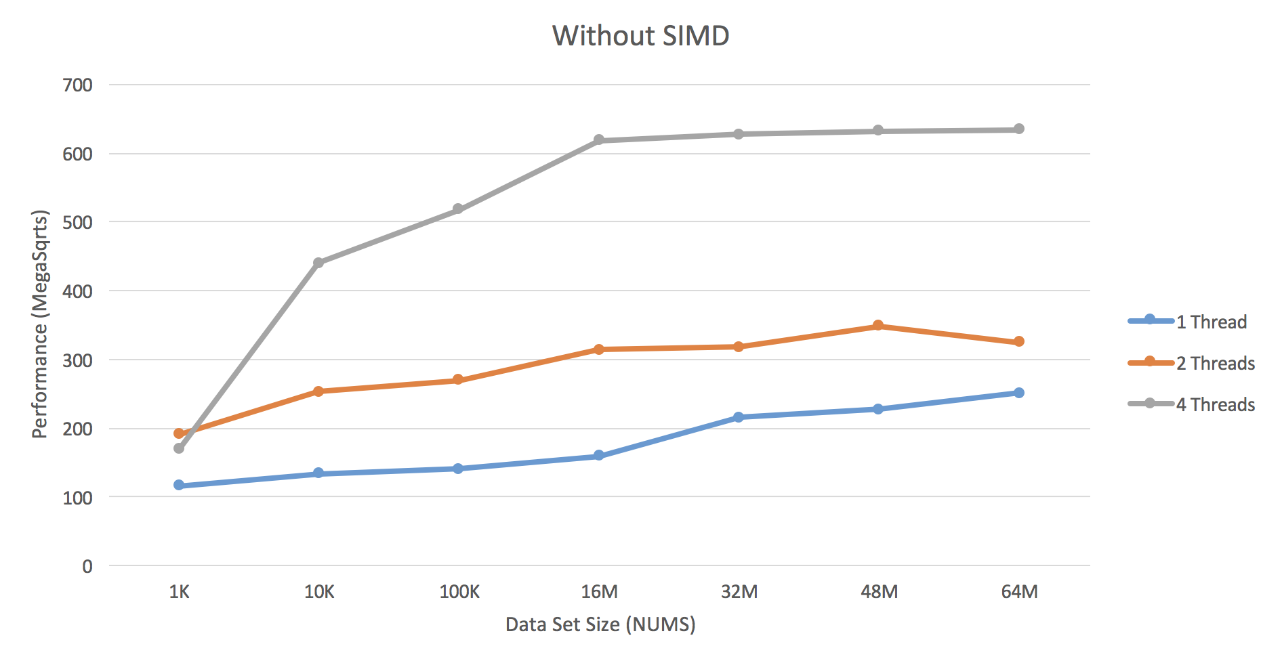

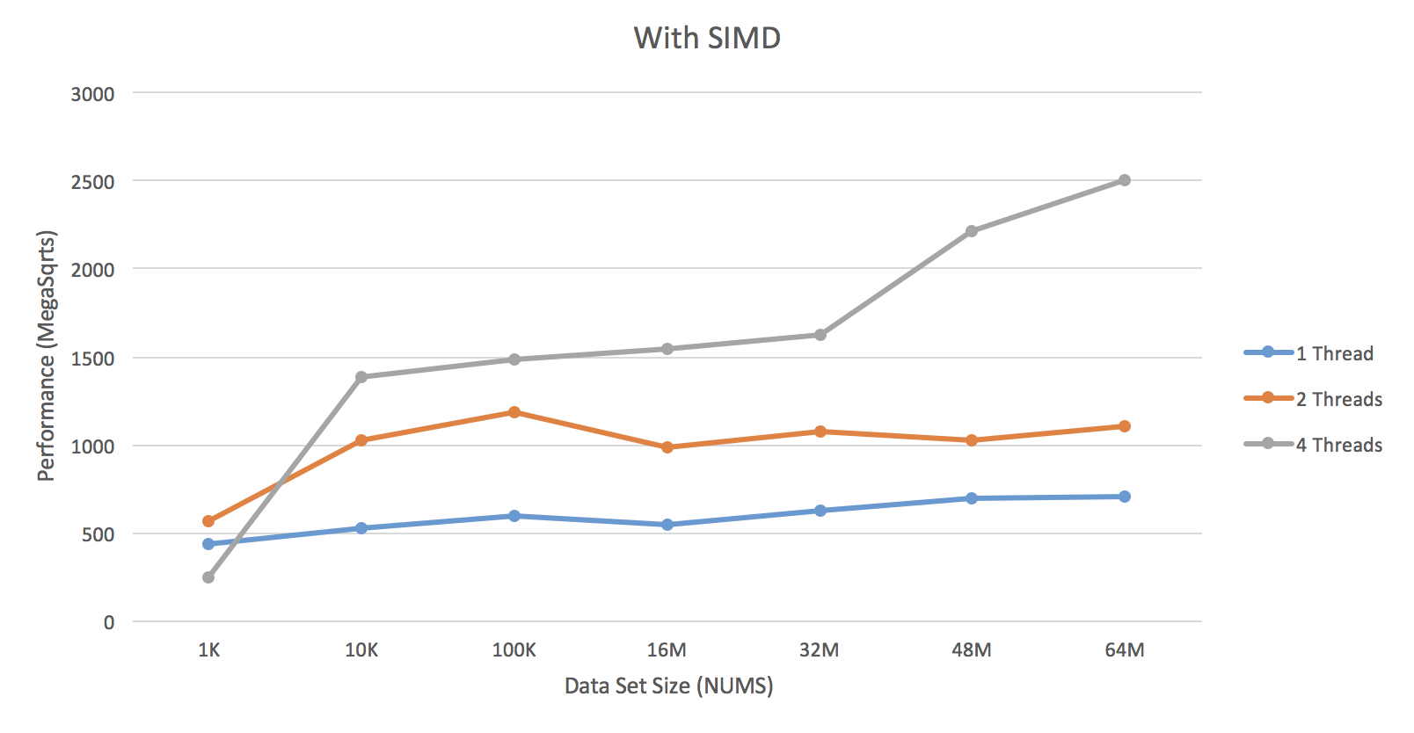

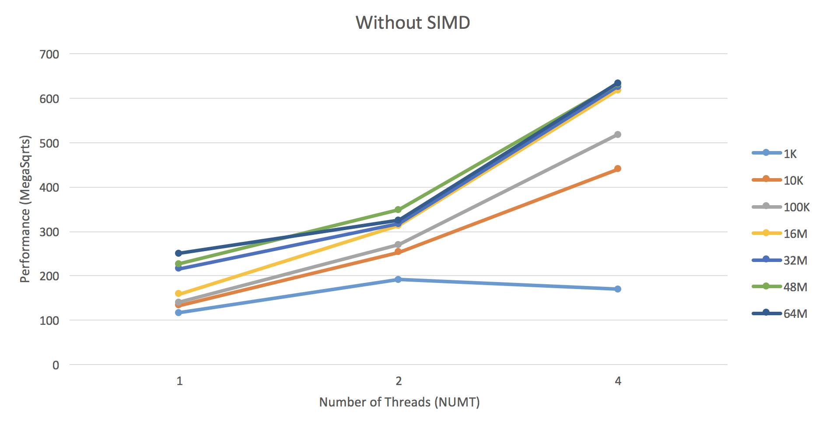

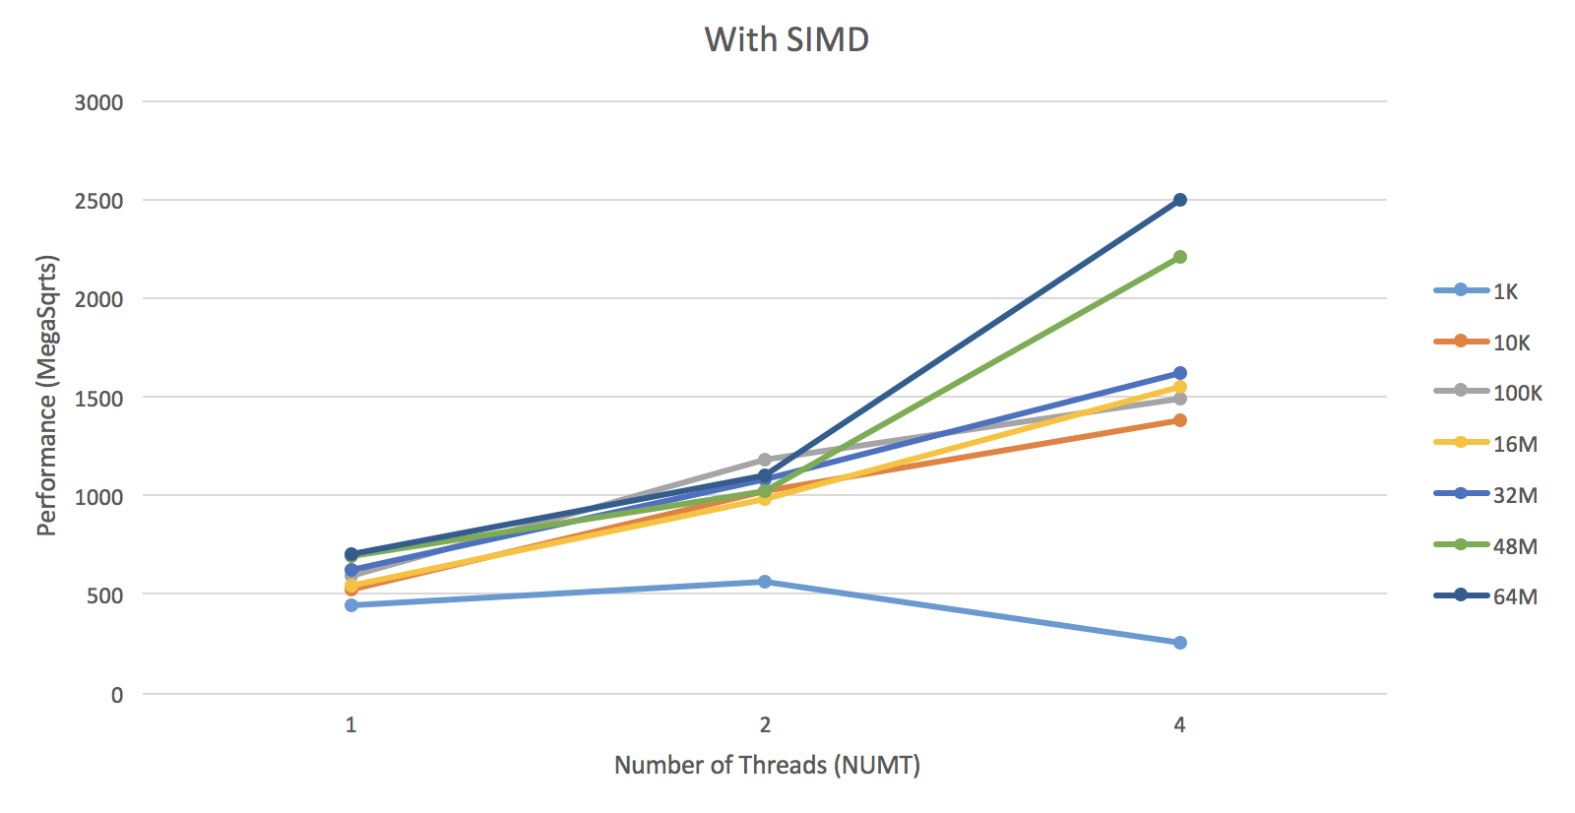

1. What patterns are you seeing in the performance curves?
2. Why do you think the patterns look this way?
3. What does that mean for the proper use of vectorized parallel programming?
   1. The data set size is essential for performance. If the data size is too small, the benefit of SIMD will be shaded by the additional work for SIMD.