Part 1. Multiply and Multiply-Add

1. What machine you ran this on

Rabbit

1. Show the tables and graphs

Multiply

|  |  |  |  |  |  |  |
| --- | --- | --- | --- | --- | --- | --- |
| Global Work Size  Local Work Size | 1K | 512K | 1M | 2M | 4M | 8M |
| 1 | 12.634 | 297.75 | 335.415 | 347.764 | 357.583 | 368.02 |
| 4 | 12.157 | 730.267 | 1028.4 | 1199.128 | 1304.054 | 1405.909 |
| 16 | 9.381 | 1044.486 | 1924.526 | 2953.169 | 3558.433 | 4658.192 |
| 32 | 17.012 | 1382.496 | 2127.235 | 3769.023 | 5131.112 | 6913.257 |
| 128 | 12.836 | 1492.512 | 2248.31 | 4528.479 | 6110.645 | 8814.017 |
| 512 | 15.245 | 1423.752 | 2774.568 | 4477.334 | 6356.547 | 9918.18 |
| 1024 | 16.843 | 1183.366 | 2697.739 | 4477.87 | 6149.519 | 9732.953 |

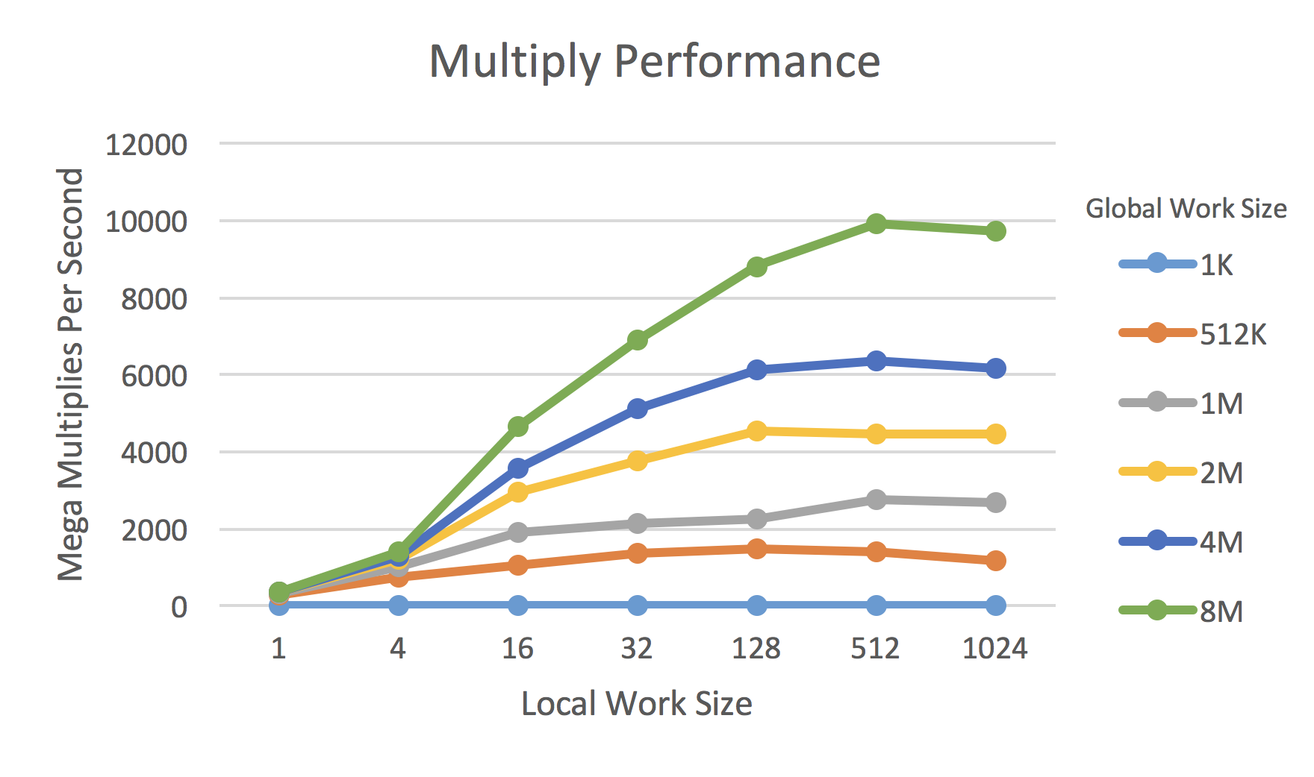

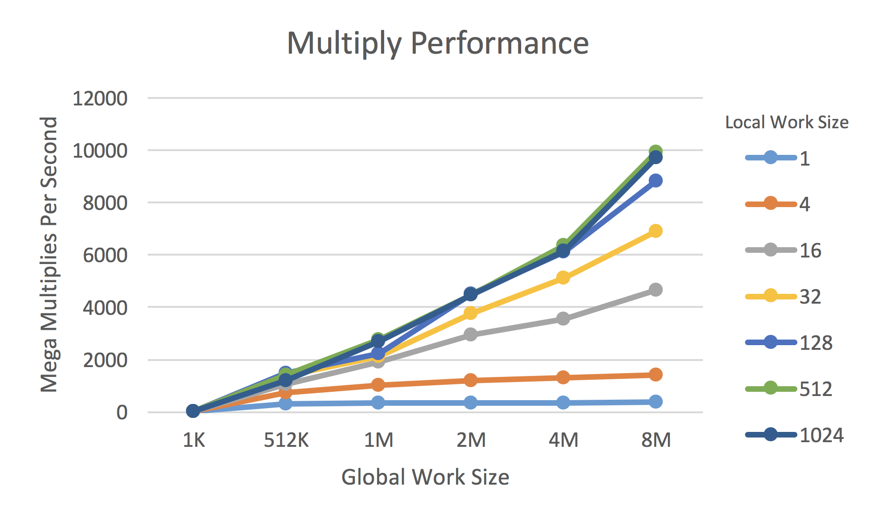

Multiply-Add

|  |  |  |  |  |  |  |
| --- | --- | --- | --- | --- | --- | --- |
| Global Work Size  Local Work Size | 1K | 512K | 1M | 2M | 4M | 8M |
| 1 | 12.196 | 293.998 | 314.318 | 338.996 | 350.037 | 356.878 |
| 4 | 12.775 | 749.675 | 840.435 | 1145.398 | 1280.855 | 1358.077 |
| 16 | 12.507 | 1121.229 | 1637.602 | 2630.931 | 3629.013 | 4446.899 |
| 32 | 12.503 | 1006.628 | 1820.887 | 3461.241 | 4598.781 | 6537.135 |
| 128 | 17.969 | 1349.102 | 2526.458 | 3716.582 | 5983.486 | 8567.375 |
| 512 | 12.858 | 1015.784 | 2587.173 | 3607.215 | 6065.366 | 7923.491 |
| 1024 | 16.946 | 1334.807 | 2472.643 | 3828.932 | 5989.895 | 8338.278 |

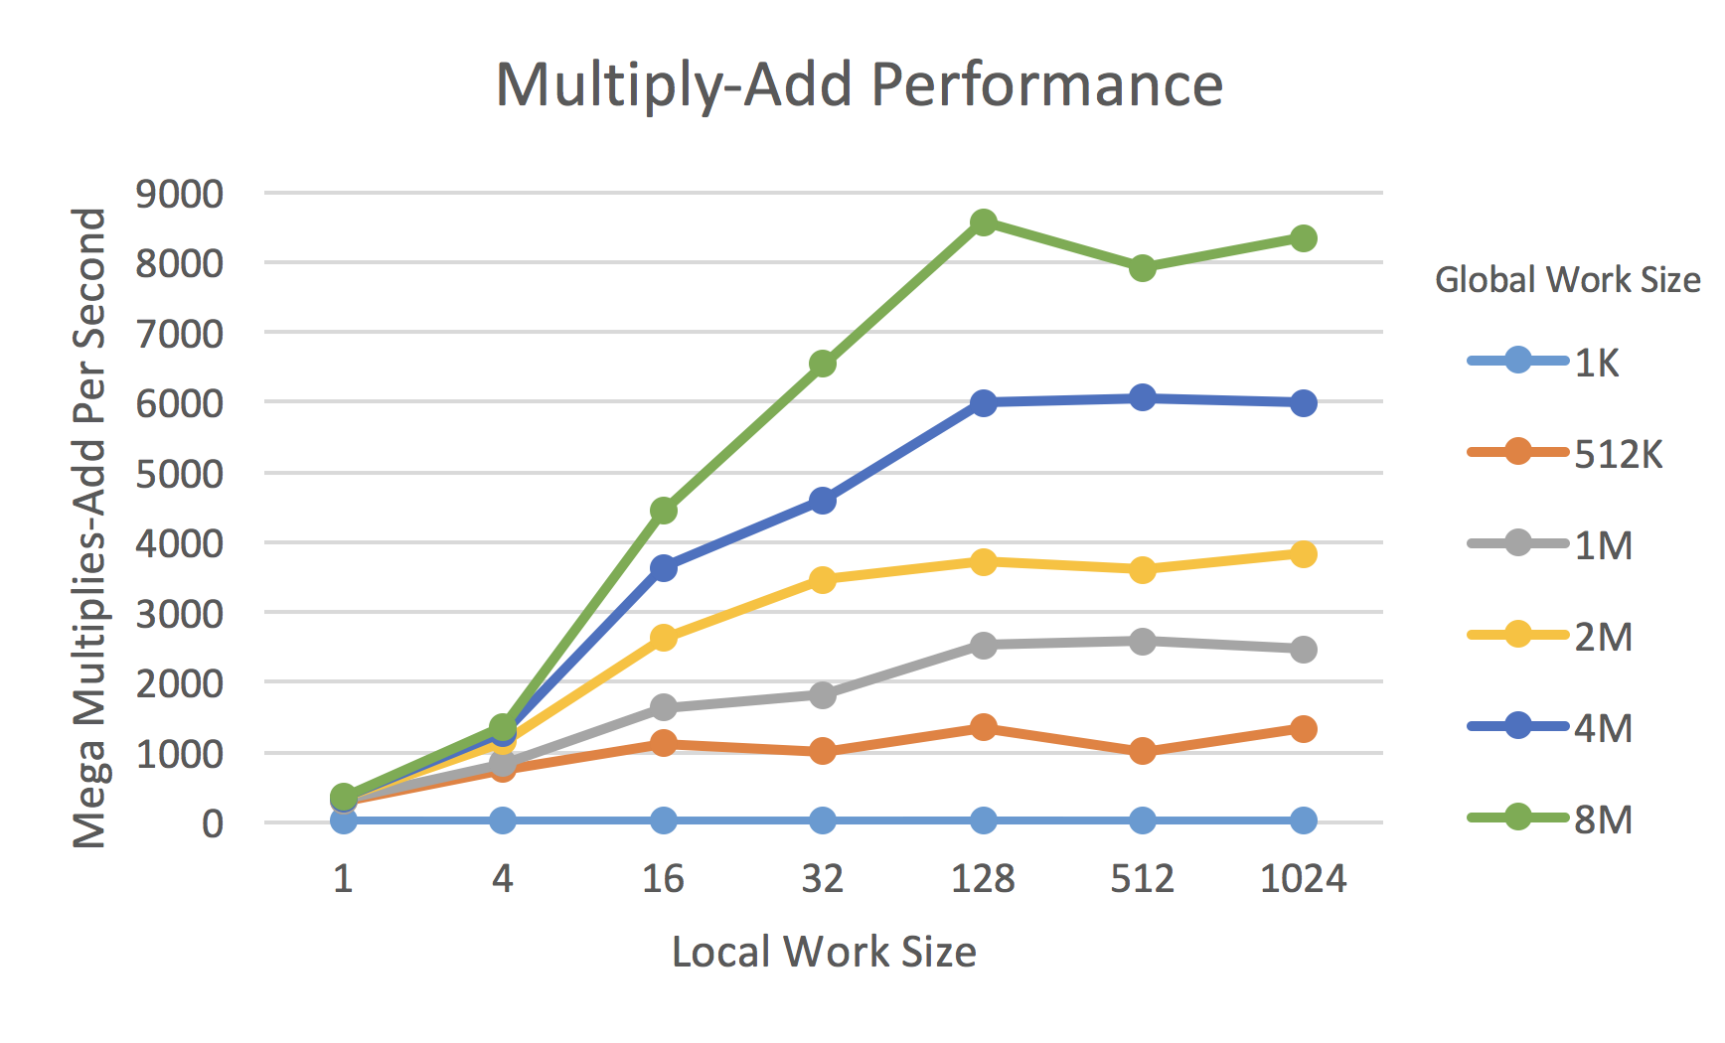

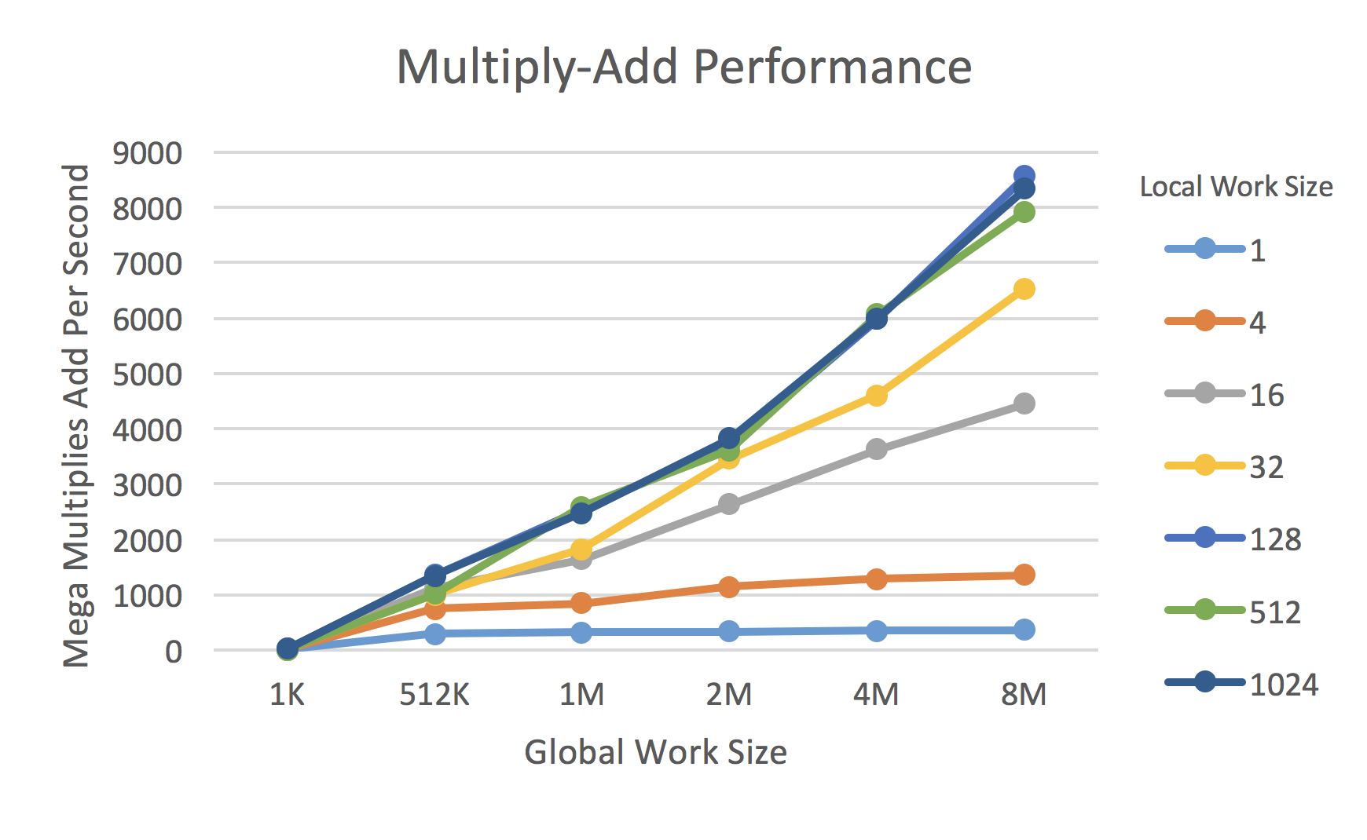

1. What patterns are you seeing in the performance curves?

For a given global work size, the performance increases when the local work size increases and the performance reaches top when local work size equals to 128.

For a given local work size, the performance increases when the global work size increases.

1. Why do you think the patterns look this way?

When the local work size is too small (like 1 or 4), there are more processing elements in the compute units are idle and a lot of compute time are wasted.

When the global work size is too small, the GPU is not so busy and not enough work done on GPU can’t overcome the overhead of setting all up.

1. What is the performance difference between doing a Multiply and doing a Multiply-Add?

For a given global work size and a given local work size, the performance of doing a Multiply is better than doing a Multiply-Add. This makes sense. The kernel of Multiply-Add is more complicated than Multiply, so the processing time of doing Multiply-Add on GPU is longer.

1. What does that mean for the proper use of GPU parallel computing?

There is a sweet pot for the local work size and 128 is a good choice, according to the experiments.

If the data size is too small, it is not worth to do it on GPU. Only when the data size is big enough, the GPU parallel computing can overcome the overhead of setting up.

Part 2. Multiply-Reduction.

1. show the table and graph

|  |  |  |  |  |  |  |  |  |
| --- | --- | --- | --- | --- | --- | --- | --- | --- |
| Array Size (Mega Numbers) | 1 | 2 | 4 | 6 | 8 | 16 | 32 | 64 |
| Performance (Mega Multi and Reduction Per Second) | 1570.919 | 2231.946 | 2741.834 | 3045.247 | 3200.265 | 4010.672 | 4435.883 | 4960.188 |

1. What pattern are you seeing in this performance curve?

The performance increases as the array size increase and the top performance is close to 5000 Mega Multiplied and Reduced Per Second.

1. Why do you think the pattern looks this way?

When the array size is less than 60 Mega Numbers, the GPU is not so busy and the overhead may cost too much time.

1. What does that mean for the proper use of GPU parallel computing?

If the data size is too small, it is not worth to do it on GPU. Only when the data size is big enough, the GPU parallel computing can overcome the overhead of setting up.