1. What machine you ran this on

A computer in the CGEL.

1. What dynamic thing did you do with the particle colors?

The initial particle colors are randomly generated. Then the green channel will increase dramatically and the red and blue channel will increase slightly, so the particle colors look like a combination of light cyan and light yellow. At last, the particles will be nearly white.

1. Screenshots

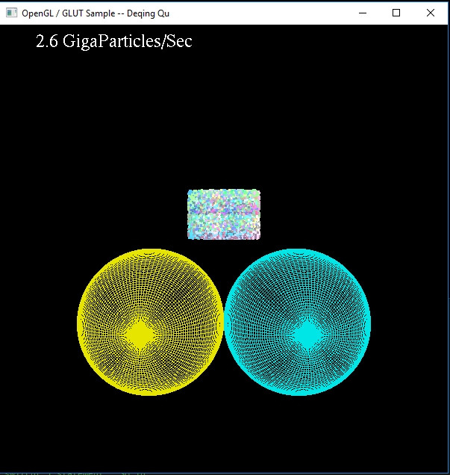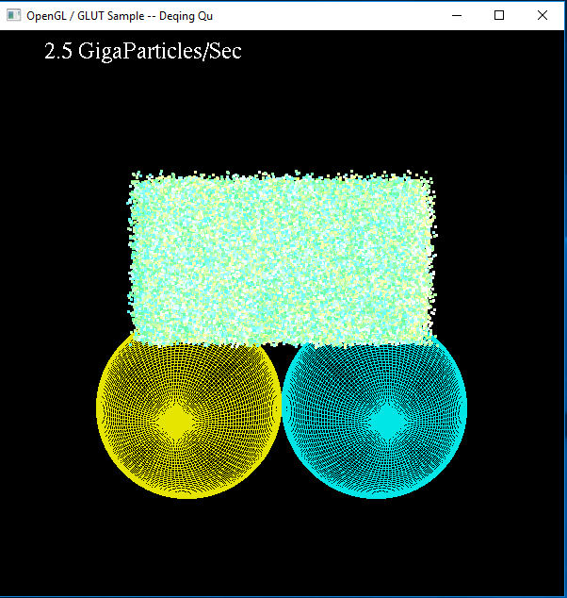

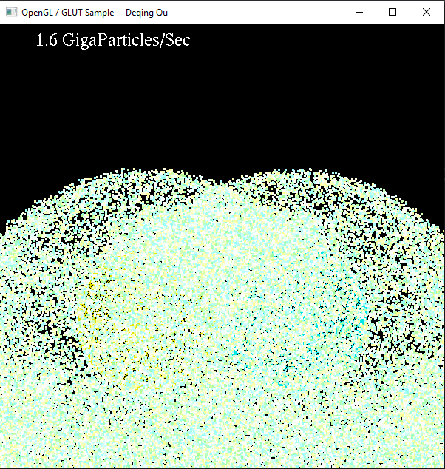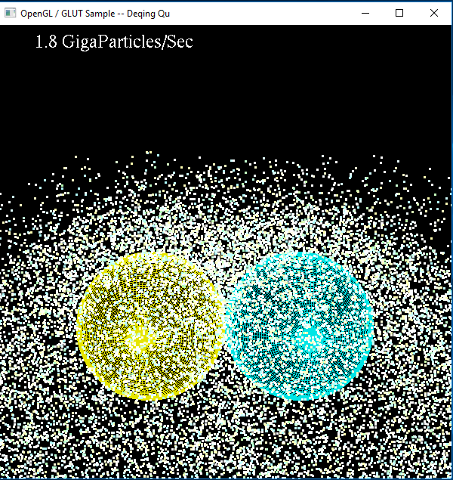

1. Show the tables and graphs

|  |  |  |  |  |  |  |  |  |
| --- | --- | --- | --- | --- | --- | --- | --- | --- |
| Number of Particles (X1024) | 128 | 256 | 512 | 1024 | 2048 | 4096 | 8192 | 12288 |
| Giga Particles Per Second | 0.4279 | 0.7706 | 1.2589 | 1.9458 | 2.4466 | 3.0228 | 3.3799 | 3.4552 |

1. What patterns are you seeing in the performance curves?

For a given local work-group size, the performance increases when the number of particles increases and the performance reaches top when the number of particles is close to 8192 * 1024.

1. Why do you think the patterns look this way?

When the number of particles is small, the GPU is not so busy and not enough work done on GPU can’t overcome the overhead of setting all up.

1. What does that mean for the proper use of GPU parallel computing?

If the data size is too small, it is not worth to do it on GPU. Only when the data size is big enough, the GPU parallel computing can overcome the overhead of setting up.