*Project*

AAS-Webclient

**MOD01: Nameplate-Generator**

TINF22F, Software Engineering I Praxisproject 2023/24

*Customer*

Markus Rentschler, Ivan Bogicevic

Lerchenstraße 1, 70178 Stuttgart

*Supplier*

Armin Taktar (Project Leader)

Lara Lorke (System Architect)

David Bauer (Product Manager)

Ümmühan Ay (Documentation)

Rafael Sancho Pernas (Developer)

Kyle Zieher (Test Manager)

Rotebühlplatz 41, 70178 Stuttgart

*Author*

David Bauer 06.05.2024

**CONTENTS**

[1 Scope](../../../../../../../sanchora/Downloads/TINF21C_MOD01_Team_1_1v0.docx" \l "_Toc134696481) 3

[2 Glossary](../../../../../../../sanchora/Downloads/TINF21C_MOD01_Team_1_1v0.docx" \l "_Toc134696482) 3

[3 Module Requirements](../../../../../../../sanchora/Downloads/TINF21C_MOD01_Team_1_1v0.docx" \l "_Toc134696483) 3

[3.1 User View](../../../../../../../sanchora/Downloads/TINF21C_MOD01_Team_1_1v0.docx" \l "_Toc134696484) 3

[3.2 Requirements](../../../../../../../sanchora/Downloads/TINF21C_MOD01_Team_1_1v0.docx" \l "_Toc134696485) 3

[4 Analysis](../../../../../../../sanchora/Downloads/TINF21C_MOD01_Team_1_1v0.docx" \l "_Toc134696491) 3

[5 Design](../../../../../../../sanchora/Downloads/TINF21C_MOD01_Team_1_1v0.docx" \l "_Toc134696492) 4

[6 Implementation](../../../../../../../sanchora/Downloads/TINF21C_MOD01_Team_1_1v0.docx" \l "_Toc134696493) 4

[7 Module Tests](../../../../../../../sanchora/Downloads/TINF21C_MOD01_Team_1_1v0.docx" \l "_Toc134696494) 5

# 1 Scope

The AAS web client is a display interface for presenting the data taken from an AASX server. Therefore, correct generation and display of Nameplates are important.

# 2 Glossary

* AAS: Asset Administration Shell
* AASX: file format to store an asset
* NPG: Nameplate Generator

# 3 Module Requirements

## 3.1 User View

The user can view the Nameplate for the specific Asset at will, they are able to generate and download the Nameplate in the form of a SVG-File. This is triggered by a button, that is present in every Asset.

## 3.2 Requirements

REQ/ NPG-API (The API of the NPG must be available)

# 4 Analysis

A API request must be made to the NPG, a valid response must be received. The data from the response must be displayed correctly and a download feature must be present.

# 5 Design

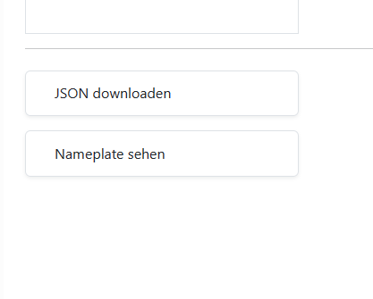

When the User clicks on the <Nameplate sehen>-Button the SVG-File will be shonw fullscreen and can be downloaded from there.

# 6 Implementation

In the file assetBody.js with the function openNameplateGen the API from the Nameplate Generator gets send a request with the Asset ID.

In the previous project, this functionality wasn´t implemented. There was no basis for the function.

The openNameplateGen creates a link that is automaticly pressed to go to the response SVG-File.

{

const data = await fetch("http://localhost:8080/Nameplate/GenerateByReference/"+shellBody.hide.URL)

.then(() => {

const link = document.createElement('a')

link.href = data;

link.download = 'nameplate.svg';

document.body.appendChild(link);

link.click();

document.body.removeChild(link);

}).catch()

};

Sometimes the API returns no response, this is likely due to the Nameplate Generator server being down or unreachable.

# 7 Module Tests

Testing for this module is conducted through usability tests. An Asset is choosen and then the <Nameplate sehen>-Button is pressed. The expected result is a redirect to a new page where the SVG-File that has been returned by the API of the specific Asset is shown. There it can be downloaded.