Spaceship Lights

Description
This simple Arduino project demonstrates how to control multiple LEDs using a single button input. When the button is not pressed, only one green LED lights up. When the button is pressed, the middle red LED lights up and the other red LED flickers between on and off. The project simulates lights one would find in a 90’s sci-fi movie.

Exercise
Create a set of lights representative of a 90’s spaceship: blinking lights, basic colors and a button to make them do something.

Features
- Reads input from a single button connected to pin 2.
- Controls three LEDs connected to pins 3, 4, and 5.
- Demonstrates conditional logic.

Components Used
- 1 × Arduino Uno R3
- 1 × Push button
- 3 × LEDs
- 4 × 10kΩ resistors
- Breadboard and jumper wires

Circuit Overview
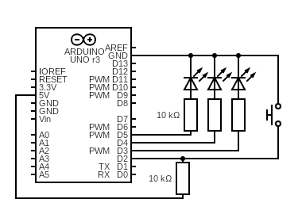
Code
1. int switchState = 0;
2.
3. void setup() {
4. pinMode(2, INPUT);
5. pinMode(3, OUTPUT);
6. pinMode(4, OUTPUT);
7. pinMode(5, OUTPUT);
8. }
9.
10. void loop() {
11. switchState = digitalRead(2);
12. if (switchState == LOW) {
13. digitalWrite(3, HIGH);
14. digitalWrite(4, LOW);
15. digitalWrite(5, LOW);
16. }
17.
18. else {
19. digitalWrite(3, LOW);
20. digitalWrite(5, HIGH);
21.
22. delay(250);
23. digitalWrite(4, HIGH);
24. digitalWrite(5, LOW);
25. delay(250);
26. }
27. }
28.

Video Demo Link
https://youtu.be/h1eXPkIsA9E

Learned Lessons
- Dusted off knowledge about electrical schema’s
- Dusted off knowledge on how to assign variables in Arduino
- Took time to properly set up documentation and what I want in the repo.

