- Go to Try NVIDIA NIM APIs
- Select „Login“
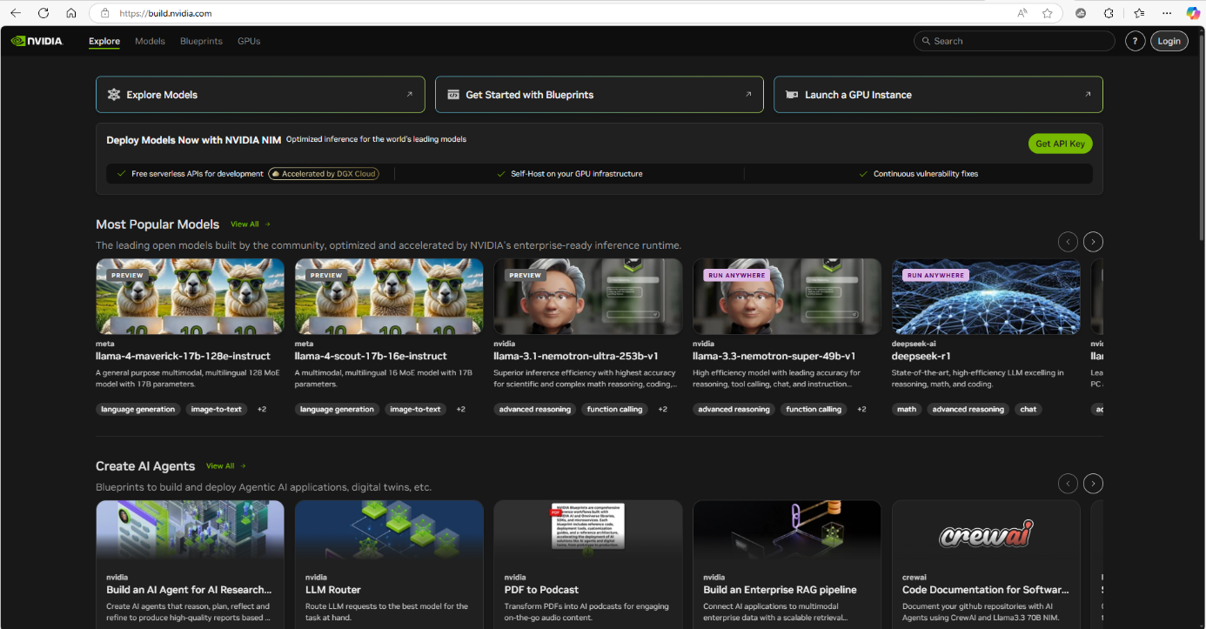
- Enter your desired email for registration and click next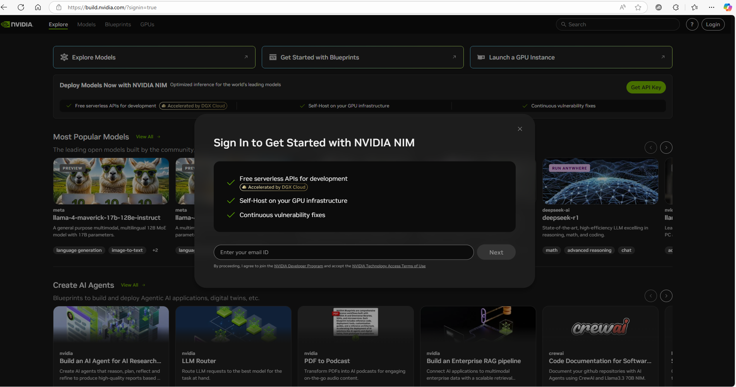
- Enter your desired password and create the account
- Enter the verification code reveived by email

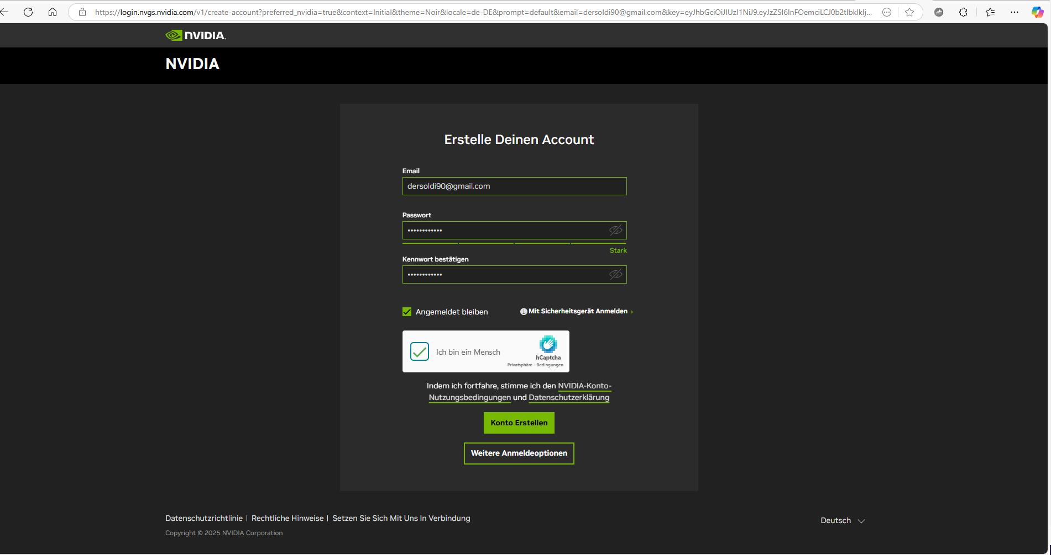

- Enter a desired name for your Cloud Account and create it

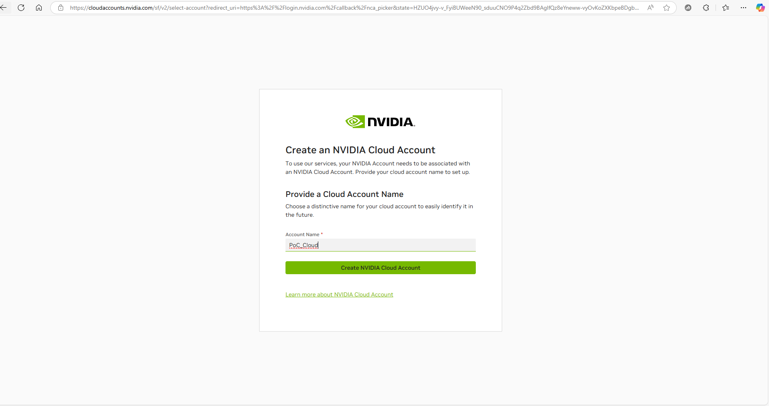

- Your account is set up

