I.

What:

Why: Disconnect between elderly and children on bus? Or on field

Where:

II. Half-vignette

What: Kids standing looking right at you

Why: Impression of Namo & Luus, feeling of the “other”

Where:

What:

Why: Ideas about potential violence with transparency, how have this society dealt with conflict

Where: Night time

What:

Why: Privacy

Where: Corporate life

What:

Why: Potential to biohack?

Where:

**CORPORATE VIGNETTE**

*STEADY HANDHELD/MOBILE Char = main character*

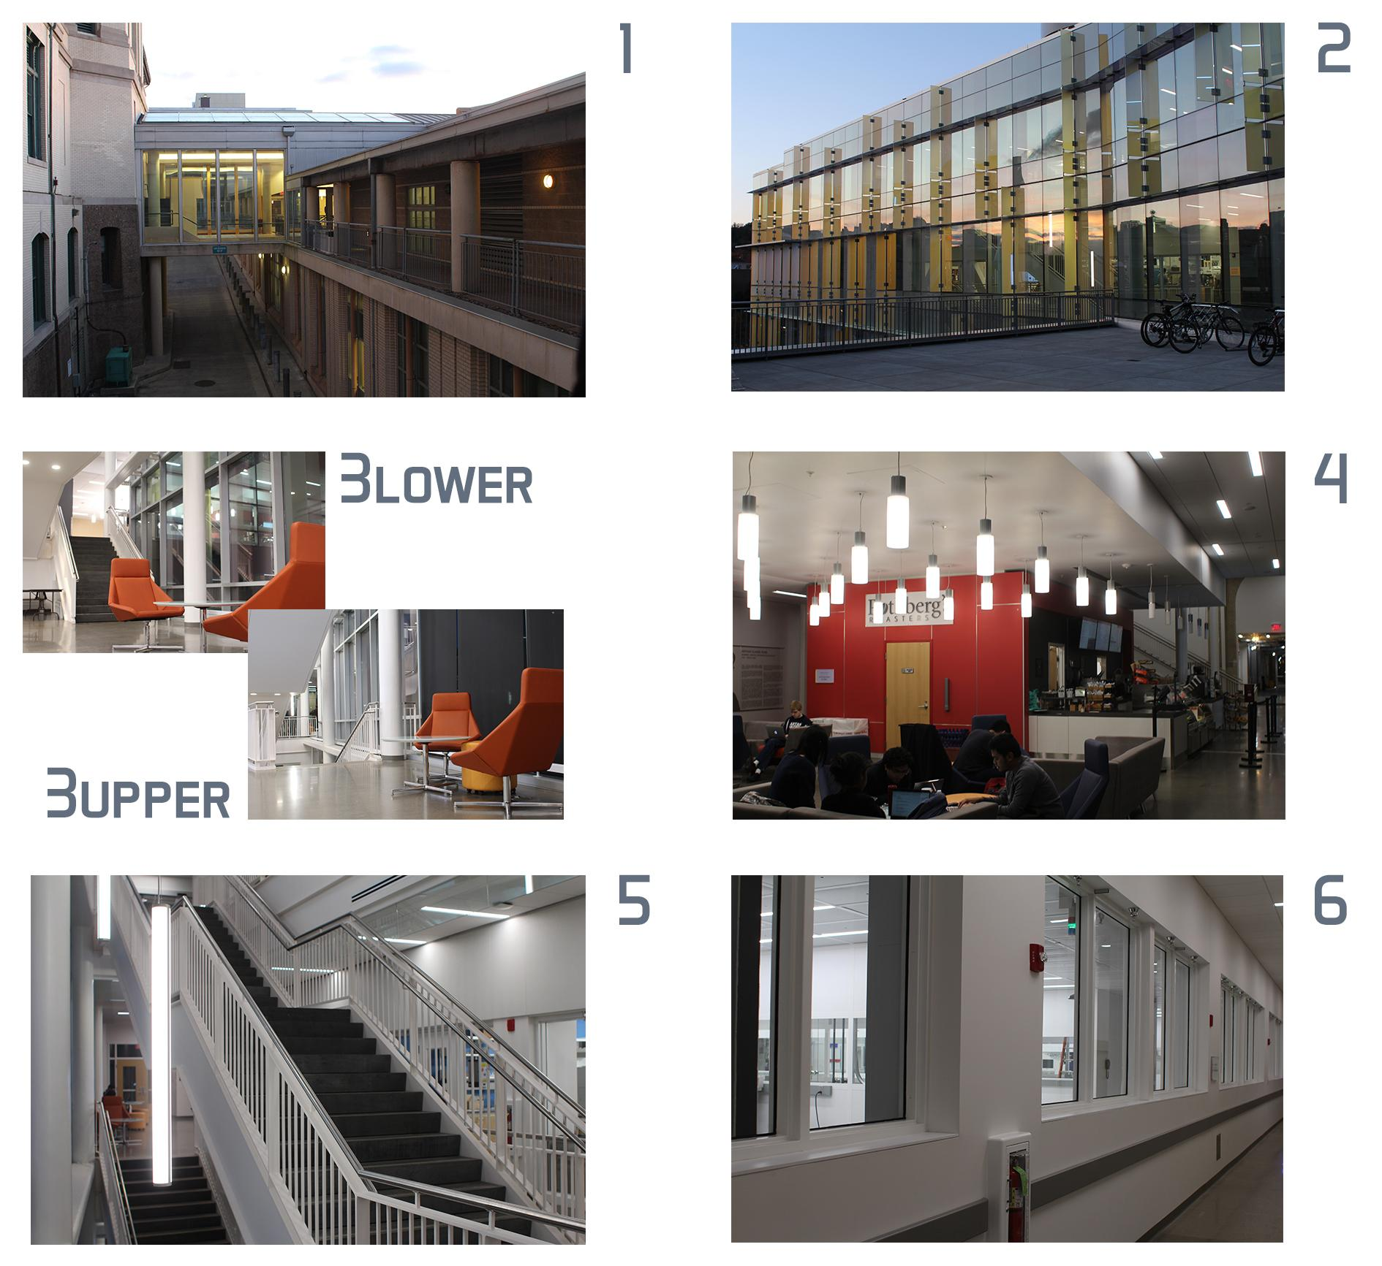

*Few external shots of building to establish setting*

*{1} Top view, car driving up driveway. Cut to street level, car pulls up (revealing it’s driving itself), Exec (sitting in back) exits vehicle, looking up, walks off screen*

*{2} walking towards door (stationary shot)*

*{?? 3L ??} establishing transition shot with medium-distance follow as he walks forward*

*{4} (multiple shots/angles) showing Char walking up to cafe line (only one person in front of him, finishing up). (Continuous shot) it’s Char’s turn, walks up to register person. Both look at each other for a second or two. Worker then goes and prepares coffee (still continuous shot?) and hands over. Char then scans finger/palm/something on something (bio-auth payment?) and walks off*

*{5} (multiple angles, including above, below and behind) Walking up the stairs*

*{3U} (camera stationary but rotating) Walks up stairs, and towards right side of hallway/camera, camera pans as Char walks past, but stops once chair/occupants in shot center. Occupants of chair all look at Char, then back to staring at each other. Keep shot for a few seconds to emphasize staring/silence*

*{glass window wall in background} (tracking shot) walking to right of camera*

*{tech labs in background} (tracking shot) walking to left of camera. Maybe some shots of the rooms themselves (no Char in shot)?*

*? bio-auth door scene*

*{6} (follow from behind? Improv the cam) Char walking down hallway, passes Employee- both turn as they pass each other, stop walking and face each other (camera catches up?). Stare for a awkward length then (shake hands?) turn around to continue on their way*

*{?} Enter office/conference room/somewhere with a monitor and sits down/goes in front of monitor. Monitor displays some auto-ID recognition and logs in. A text-based editing screen appears (minimal) with what looks like a legal doc mostly written (title large enough to be read from a distance?* ***“Privacy and Transparency Agreement v14.32”****). Document looks like it’s typing and erasing / editing by itself. Camera slowly closes in on Char, and we slowly start hearing Char’s thoughts.*

CHAR

Section 7 Clause 3 [header] cloud storage and

**Possible subjects:**

* **They have right to “mute” your device if your thoughts are deemed malicious on a level deemed as terrorist, or mind-control, or mentally damaging, etc**
* **They have right to expand or reduce the physical range of the device through updates (for local-based communication/listening)**
* **Thoughts transferred through nonlocal communication (uploaded to internet, browsing internet, or participating in chats/calls with someone nonlocal) are recorded/saved in cloud storage/databases here?**
* **Not responsible for any personal information that you think of and others may “hear” around you (social security, other ID/numbers/important info)**

*Vignette ends with camera slowly backing away from Char (and to far side of room?)*