**Semester:** I

**Subject Name:** Embedded and Iot Technology

**Name:** Aishwarya Pandurang Jawalekar

**Class:** MSc. Computer Science (Part-1)

**Roll No.:** 18

**Exam Seat No.:** 13228318

Certificate

**This is to certify that**

Mr. /Miss. Aishwarya Pandurang Jawalekar

Roll No. 18 Exam Seat No. 13228318 Satisfactorily completed the Practical in Embedded And Iot Technology As laid down in the regulation of University Of Mumbai for the purpose of MSc (Computer Science) Semester -I (Practical) Examination 2022 -2023 .

*Date:*

*Place:*

*Head*

*Dept. of Computer Science*

*Signature of Examiners*

*Professor In-charge Computer Science*

**1)_______________________**

**2)_______________________**

(DEPARTMENT OF COMPUTER SCIENCE)

|  |  |  |  |  |
| --- | --- | --- | --- | --- |
| Date | Sr. No. | Practical Name | Pg. No. | Remark |
|  | 1 | Design and implement basics embedded circuits  1. Automatic Alarm system- Alarm should get tigger by senor 2. Timer based buzzer 3. Sensor based Counting device |  |  |
|  | 2 | Demonstrate communication between two embedded devices using UART port |  |  |
|  | 3 | Built an IoT system to send ticket before entering the bus. |  |  |
|  | 4 | Demonstrate an IoT based game which can be played between two player who are physically at a considerable distance. |  |  |
|  | 5 | Develop a IoT application which will record the movement and orientation of your phone and give the data back to the PC |  |  |
|  | 6 | Develop an IoT application that will raise an alarm whenever with going to rain outside based on the weather prediction data |  |  |
|  | 7 | Deploy an IoT application which will alert you by beeping or vibrating your phone whenever you get someone call your name. |  |  |
|  | 8 | Develop an IoT application for monitoring water levels in tanks and automatically start the motor to fill the tank if the level goes below the critical level. |  |  |
|  | 9 | Develop an IoT module to which measure the intensity of light and send the same to your PC/ Phone |  |  |
|  | 10 | Develop an IoT application for Motion detection |  |  |

**Practical 1: Design and implement basics embedded circuits**

**1.(a) Automatic Alarm system- Alarm should get tigger by sensor:**

**Steps to Perform:**

**Step 1:** 1) Take Motion Sensor

2) Take Component - MCU Board

3) Take Alarm

**Step 2:** 1) Now we will connect the Motion Sensor to MCU Board with

IoT custom cable connect Motion Sensor (D0) to connect with MCU Board (D0)

2)Then we will connect MCU board to Alarm with IoT custom cable connect MCU

Board (D1) to Alarm (D0)

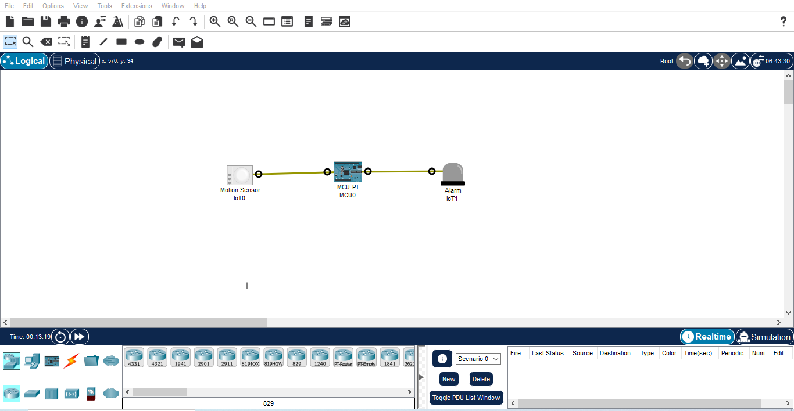

**Step 3 :** 1) Now click on MCU Board go to Programming then Select New, Select Template-

Empty-Python then click on Create

2) Click on main.py file then write code

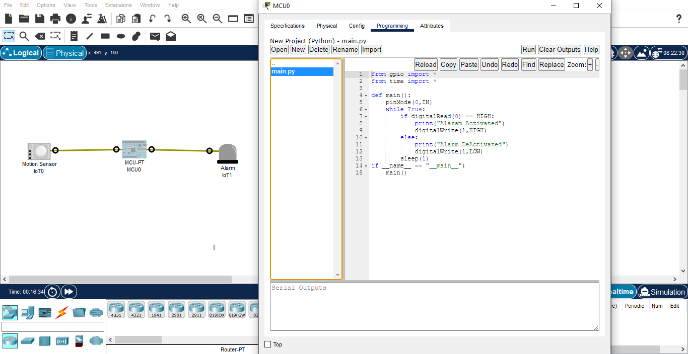

**Code :-**

from gpio import *

from time import *

def main():

pinMode(0,IN)

while True:

if digitalRead(0) == HIGH:

print("Alaram Activated")

digitalWrite(1,HIGH)

else:

print("Alarm DeActivated")

digitalWrite(1,LOW)

sleep(1)

if __name__ == "__main__":

main()

**Step 4 :** 1) Click on Run

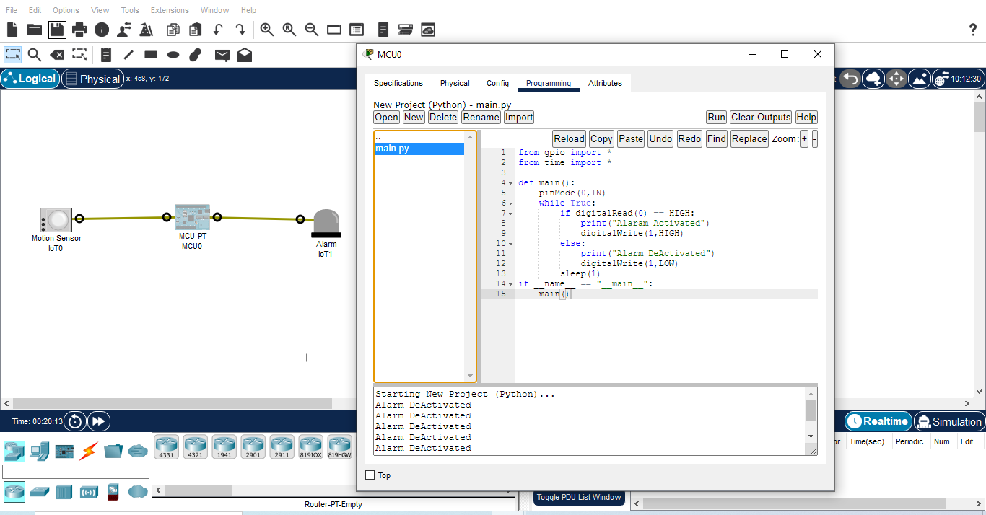

**1.(b) Timer based buzzer:**

**Steps to Perform:**

**Step 1:** 1) Take Component - MCU Board

2) Take Alarm

**Step 2:** 1) Now we will connect MCU board to Alarm with IoT custom cable connect MCU

Board (D0) to Alarm (D0)

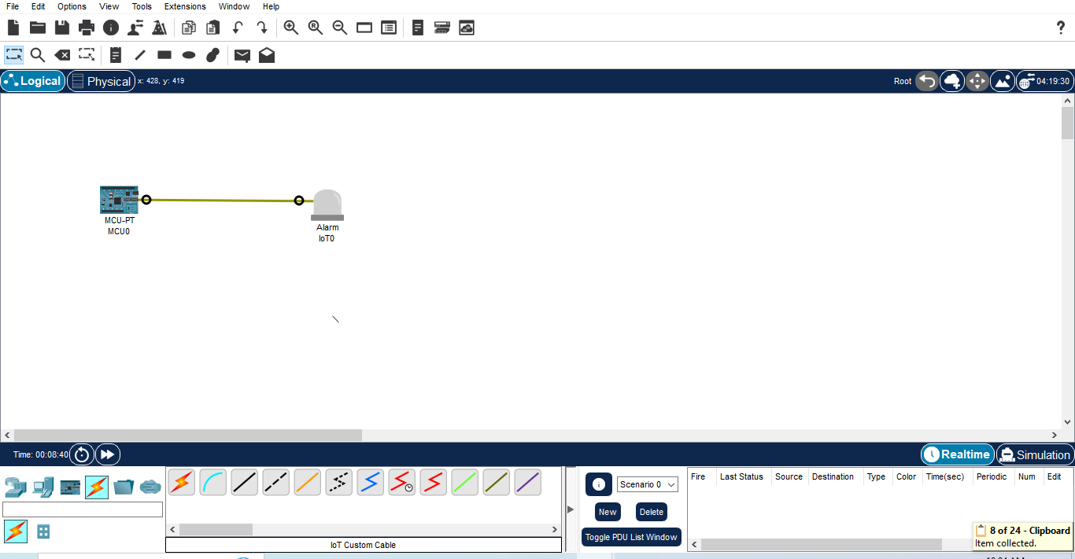

**Step 3:** 1) Now click on MCU Board go to Programming then Select New, Select Template-

Empty-Python then click on Create

2) Click on main.py file then write code

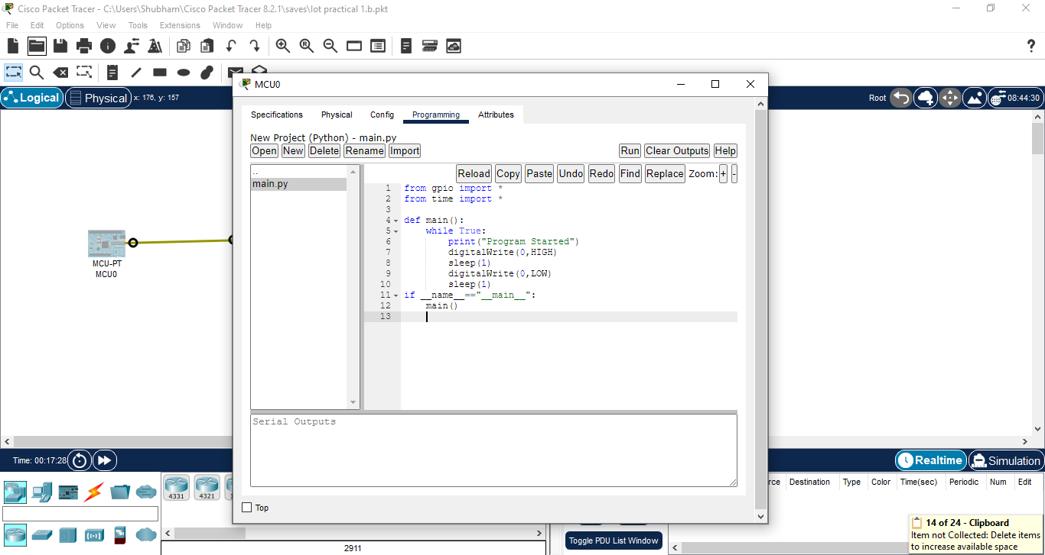

**Code:**

from gpio import *

from time import *

def main():

while True:

print("Program Started")

digitalWrite(0,HIGH)

sleep(1)

digitalWrite(0,LOW)

sleep(1)

if __name__=="__main__":

main()

**Step 4 :** 1) Click on Run

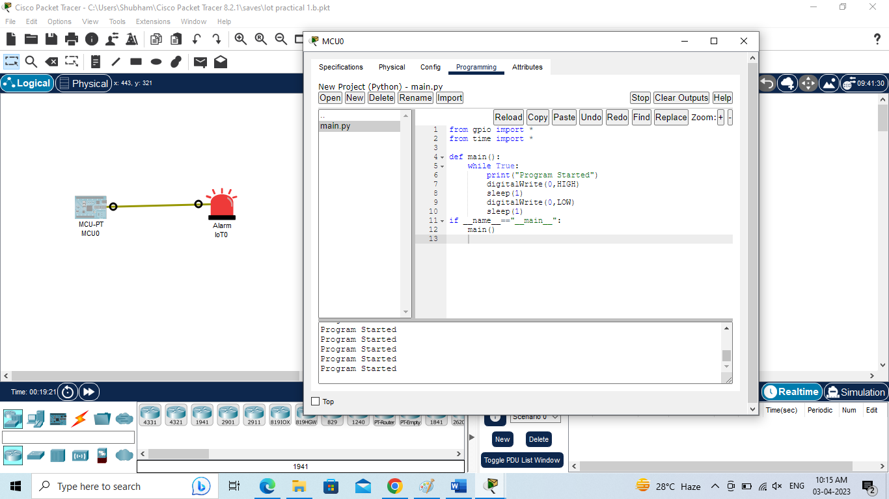

**1.(c) Sensor based Counting device:**

**Steps to Perform:**

**Step 1:** 1) Take Motion Sensor

2) Take Component - MCU Board

**Step 2:** 1) Now we will connect the Motion Sensor to MCU Board with

IoT custom cable connect Motion Sensor (D0) to connect with MCU Board (D0)

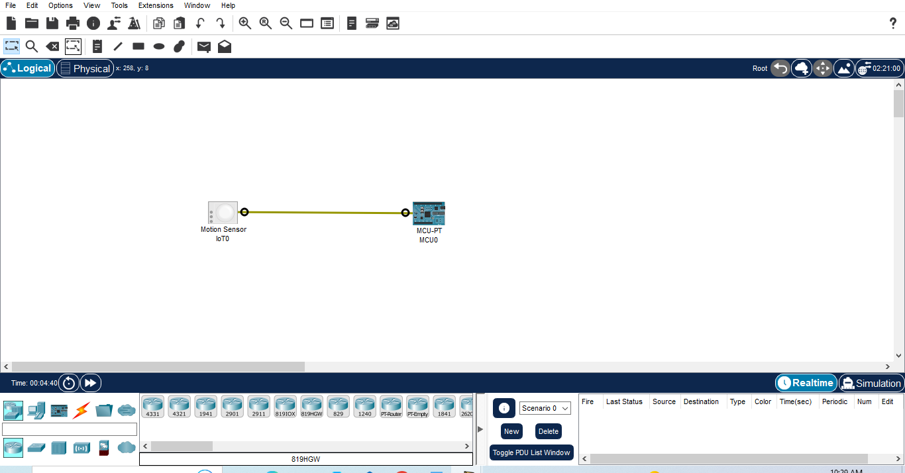

**Step 3 :** 1)Now click on MCU Board go to Programming then Select New , Select Template-

Empty-Python then click on Create

2) Click on main.py file then write code

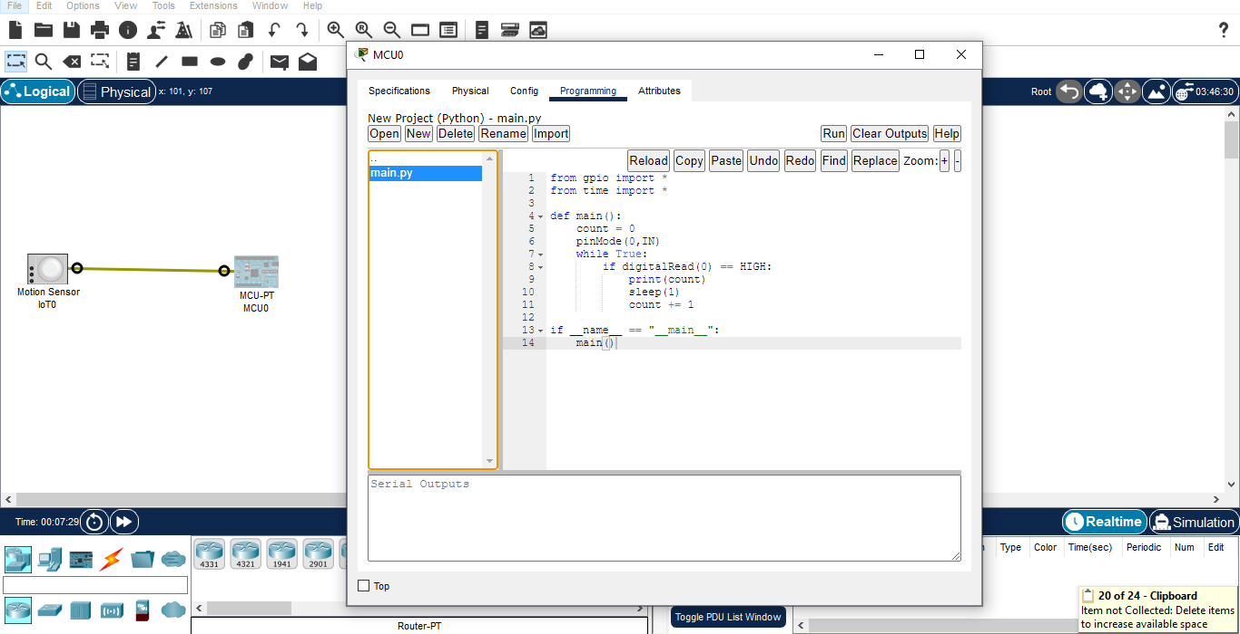**Code:**

from gpio import *

from time import *

def main():

count = 0

pinMode(0,IN)

while True:

if digitalRead(0) == HIGH:

print(count)

sleep(1)

count += 1

if __name__ == "__main__":

main()

**Step 4 :** 1) Click on Run

2) Press Alt button then Start Counting

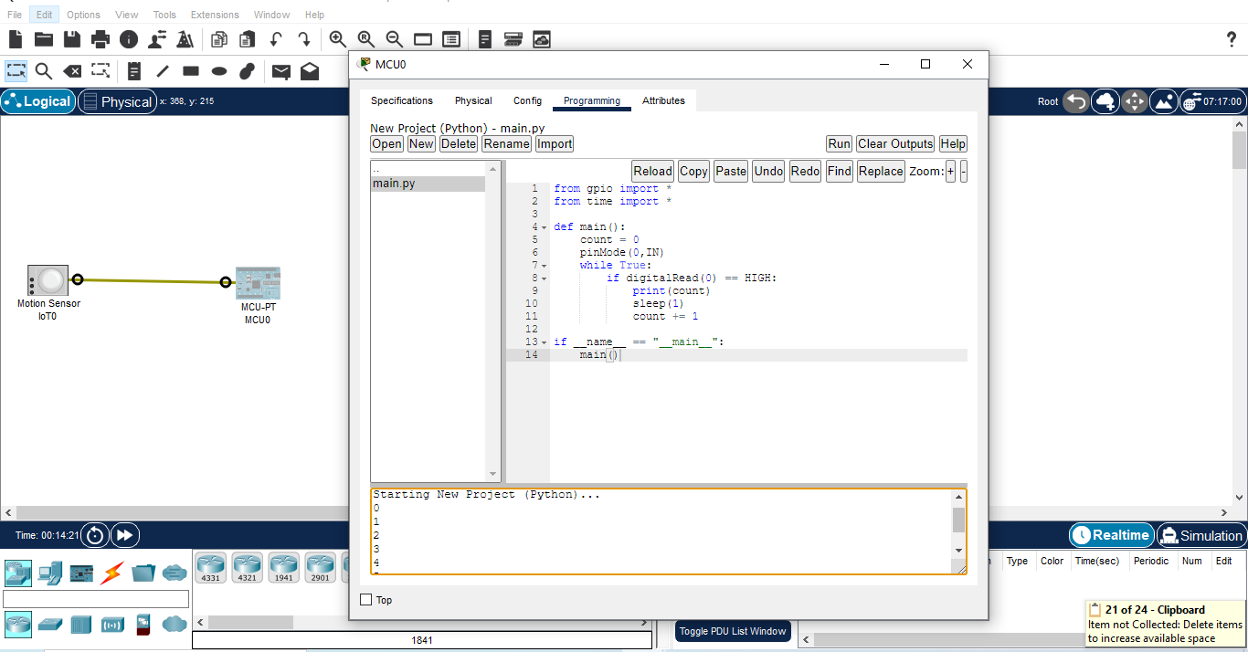

**Practical 2**

**Demonstrate communication between two embedded devices using UART port**

**Steps to Perform:**

**Step 1:** 1) Take Smoke Sensor

2) Take Component - MCU Board

3) Take Alarm

4) Take LCD

**Step 2:** 1) Now we will connect Smoke Sensor to MCU Board with IoT custom cable

connect Smoke Sensor (D0) to MCU Board (D0)

2) Then we will connect MCU Board to Alarm with IoT custom cable connect MCU

Board (D1) to Alarm (D0)

3) Then we will connect MCU Board to LCD with IoT custom cable connect MCU

Board (D2) to LCD (D0)

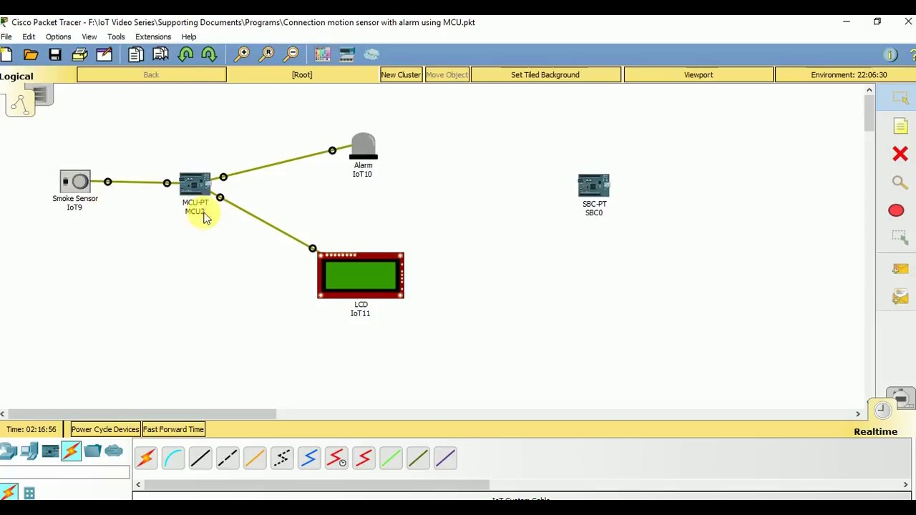

**Step 3:** 1) Now click on MCU Board go to Programming then Select New, Select Template-

Empty-Python then click on Create

2) Click on main.py file then write code

**Practical 3**

**Built an IoT system to send ticket before entering the bus**

**Steps to Perform:**

**Step 1:** 1) Take LCD

2) Take Component - MCU Board

3) Take RFID Reader

4) Take DLC Home Gateway

5) Take PC

6) Take Door

7) Take RFID Card

**Step 2:** 1) Now we will connect LCD to MCU Board with IoT custom cable

connect LED (D0) to MCU Board (D0)

2) Then go to the RFID Reader click on Advanced then click i/o config

then go the Analog slots and collect value 2 then close.

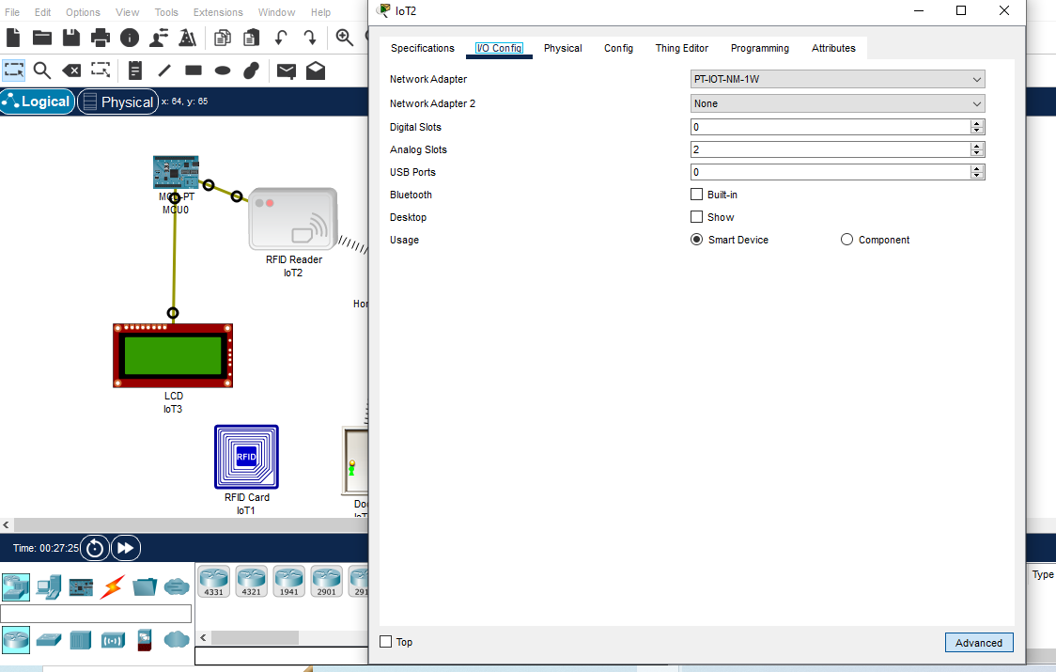

3) Now we will connect RFID Reader to MCU Board with IoT custom cable connect

RFID Reader (A1) to MCU Board (A0)

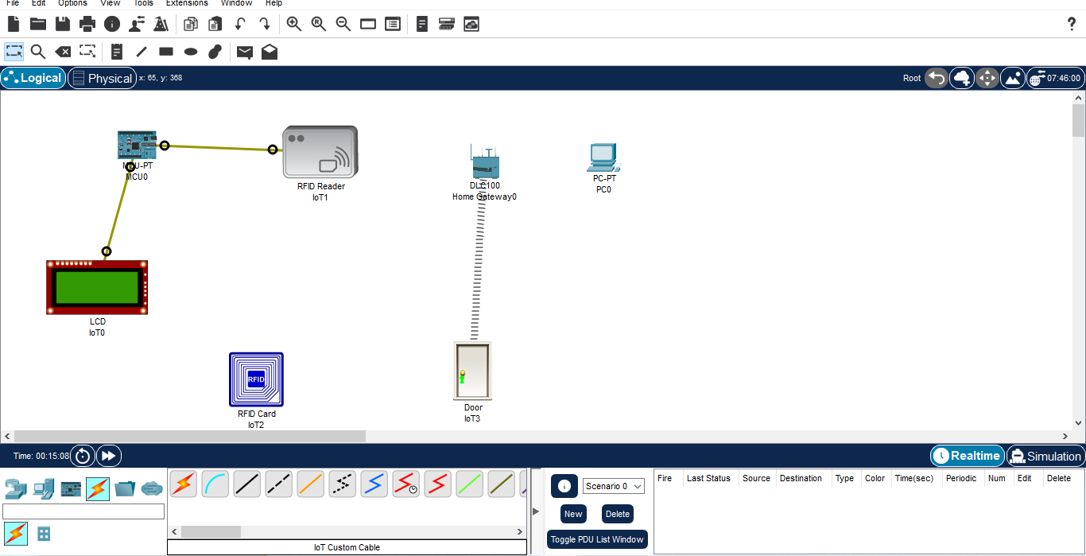

**Step 3:** 1) Click on pc then go to the physical then switch off then select PT-HOST-NM-1W

Then switch on.

2) Then go to the config click on wireless0 then select HomeGateway then close

3) Then go to RFID Reader click on i/0 config then select network Adapter (PT-IOT-NM

1W) then go to config and select Home Gateway

**Step 4:** 1) Now click on MCU Board go to Programming then Select New, Select Template-

Empty-Python then click on Create

2) Click on main.py file then write code

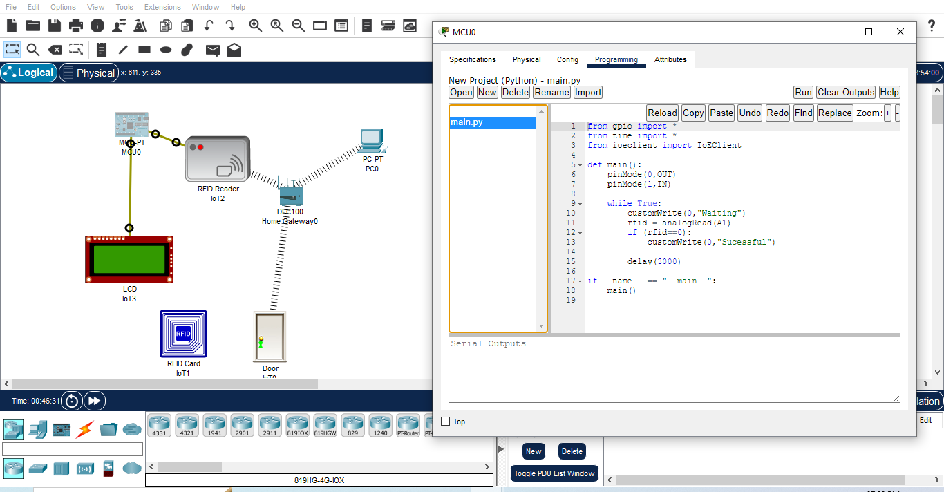

**Code:**

from gpio import *

from time import *

from ioeclient import IoEClient

def main():

pinMode(0,OUT)

pinMode(1,IN)

while True:

customWrite(0,"Waiting")

rfid = analogRead(A1)

if (rfid==0):

customWrite(0,"Sucessful")

delay(3000)

if __name__ == "__main__":

main()

**Step 5:** 1) Click on Run

2) Drag RFID Card and Drop in front of RFID Reader

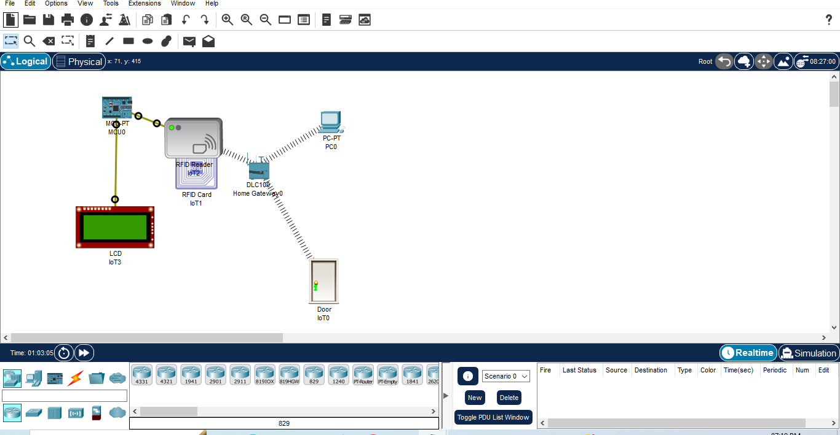

**Practical 4**

**Demonstrate an IoT based game which can be played between two player who are physically at a considerable distance**

**Steps to Perform:**

**Step 1:** 1) Take Fan

2) Take Window

3) Take Smart Phone

4) Take Thermostat

5) Take DLC (Home gateway)

**Step 2:** 1) Now we will connect Thermostat to DLC (Home gateway)

Copper Straight cable connect Thermostat (Fastethernet0) to DLCBoard (Ethernet1)

2) Then go to DLC (Home Gateway) config IP

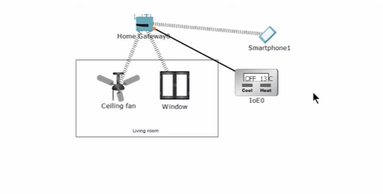

**Step 3:** 1) Now we will click Thermostat then go to config change display name and select Home gateway then click on FastEthernet 0 then select IP configuration DHCP

2) Then go to Smart Phone then click on Desktop then click on conditions and click on add

Name – Turn the celling fan

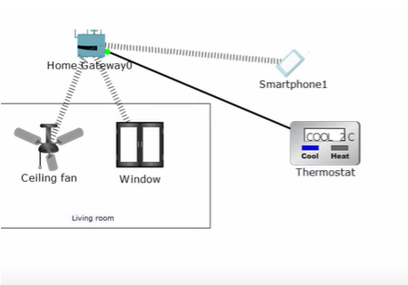

**Practical 5**

**Develop a IoT application which will record the movement and orientation of your phone and give the data back to the PC**

**Steps to Perform:**

**Step 1:** 1) Take Motion Detector

2) Take Webcam

3) Take Switch 2960

4) Take Genetic Server

**Step 2:** 1) Now we will connect Switch to Server with Copper Straight cable

connect Switch(FastEthernet0/1) to Server (FastEthernet0)

2) Then connect Switch to Motion Detector with Copper Straight cable

connect Switch(FastEthernet0/2) to Motion Detector (FastEthernet0)

3) Now we will connect Switch to Webcam with Copper Straight cable connect Switch (FastEthernet0/3) to Webcam (FastEthernet0)

**Step 3:** 1) Click on Server go to Desktop then go IP configuration and set the IP

2) Then go to the Webcam then click on config then set the IPs

3) Then go to Server click on Desktop then go to Web Browser then fill URL then Register Server Login

4) Then go to Webcam click on Config select Remote Server

5) Same goes for Motion Detector

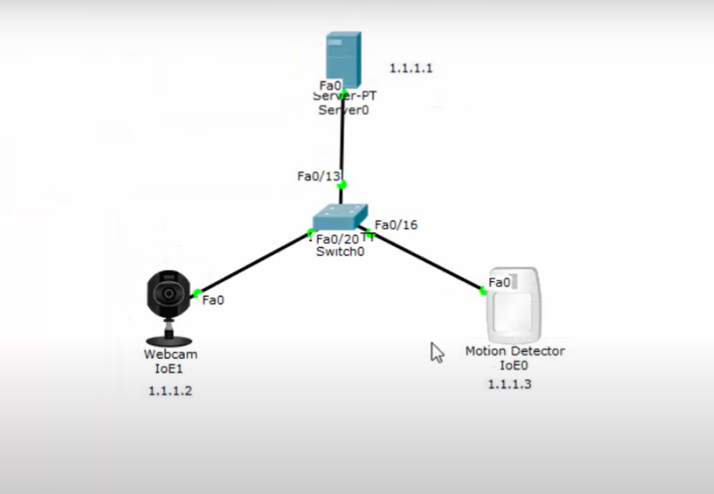

**Practical 6**

**Develop an IoT application that will raise an alarm whenever with going to rain outside based on the weather prediction data.**

**Steps to Perform:**

**Step 1:** 1) Take Alarm

2) Take Component - MCU Board

3) Take Humiture Sensor

4) Take Humiture Monitor

5) Take Humidifier

**Step 2:** 1) Now we will connect the Alarm to MCU Board with

IoT custom cable connect Alarm (D0) to connect with MCU Board (D0)

2) Then we will connect the MCU Board Humiture sensor with

IoT custom cable connect MCU Board (D1) to connect with Humiture sensor (A0)

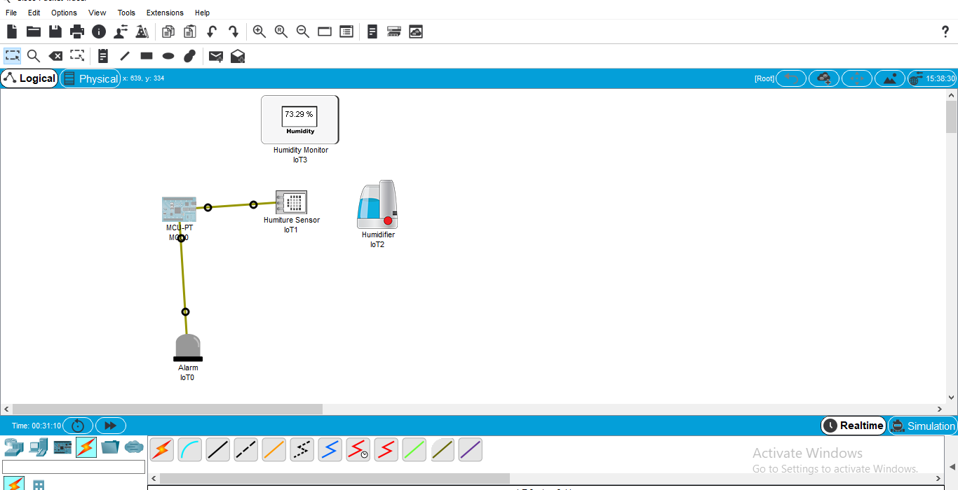

**Step 3 :** 1) Now click on MCU Board go to Programming then Select New, Select Template-

Empty-Python then click on Create

2) Click on main.py file then write code

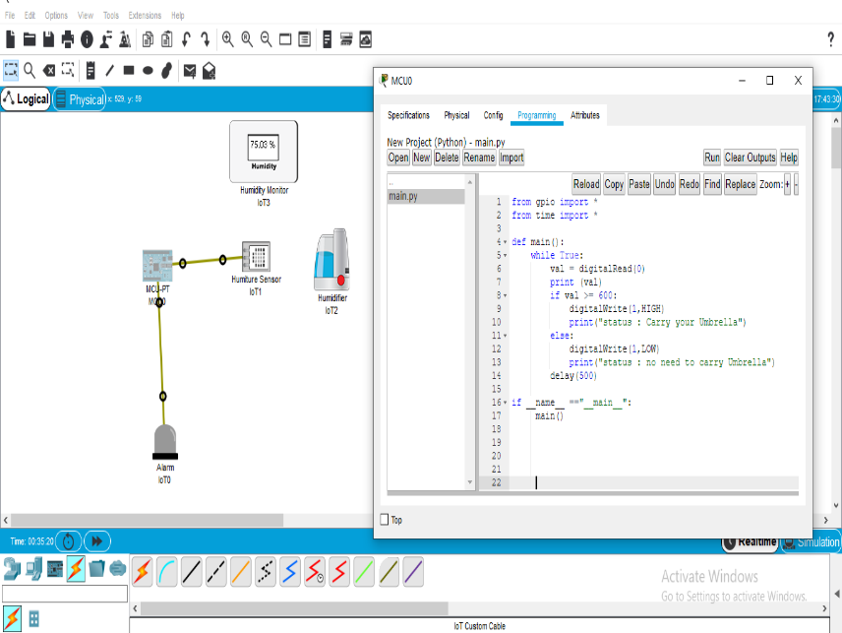

**Code:**

from gpio import *

from time import *

def main():

while True:

val = digitalRead(0)

print (val)

if val >= 600:

digitalWrite(1,HIGH)

print("status : Carry your Umbrella")

else:

digitalWrite(1,LOW)

print("status : no need to carry Umbrella")

delay(500)

if __name__ =="__main__":

main()

**Step 4 :** 1) Click on Run

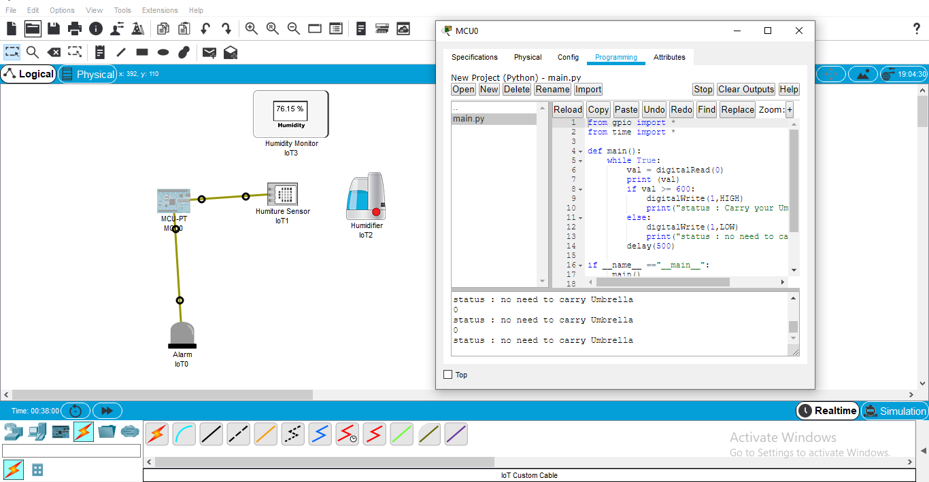

**Practical 7**

**Deploy an IoT application which will alert you by beeping or vibrating your phone whenever you get someone call your name.**

**Steps to Perform:**

**Step 1:** 1) Take LCD

2) Take Component - MCU Board

3) Take Temperature Sensor

4) Take Laptop

5) Take DCL(HomeGateway)

6) Take Thermostat

**Step 2:** 1) Now we will connect the LCD to MCU Board with

IoT custom cable connect LCD (D0) to connect with MCU Board (D0)

2) Then we will connect MCU board to Temperature Sensor with IoT custom cable

connect MCU Board (A0) to Temperature Sensor (A0)

3) Now we will connect Thermostat to DLC (Home gateway)

Copper Straight cable connect Thermostat (Fastethernet0) to DLCBoard (Ethernet1)

4) Then we will connect Laptop to DLC (Home gateway)

Copper Straight cable connect Laptop (Fastethernet0) to DLCBoard (Ethernet2)

**Step 3:** 1) Now click on MCU Board go to Programming then Select New, Select Template-

Empty-Python then click on Create

2) Click on main.py file then write code

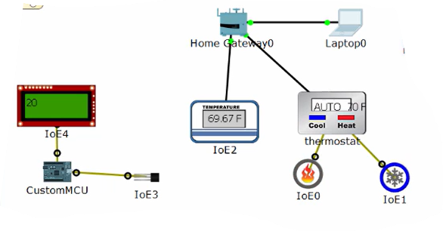

**Practical 8**

**Develop an IoT application for monitoring water levels in tanks and automatically start the motor to fill the tank if the level goes below the critical level**

**Steps to Perform:**

**Step 1:** 1) Take LED

2) Take Component - MCU Board

3) Take Motor

4) Take Water sensor

5) Take Water Level Monitor

6) Take Lawn Sprinkle

**Step 2:** 1) Now we will connect LED to MCU Board with IoT custom cable

connect LED (D0) to MCU Board (D0)

2) Then we will connect MCU Board to Water Sensor with IoT custom cable connect MCU Board(D1) to water sensor (A0)

3) Now we will connect MCU Board to Motor with IoT custom cable connect MCU Board(D2) to Motor (A0)

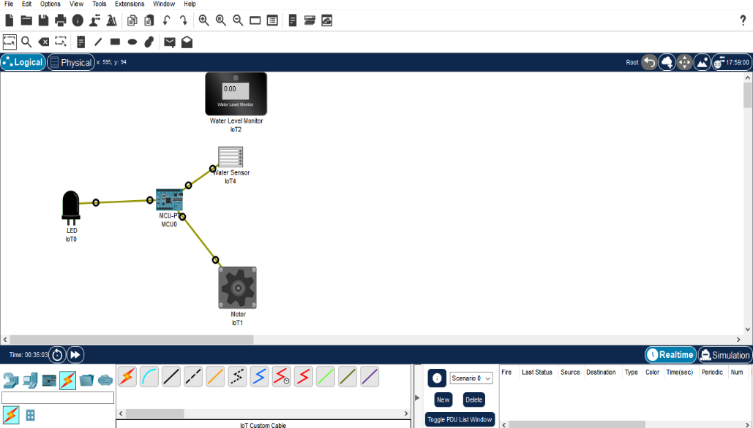

**Step 3:** 1) Now click on MCU Board go to Programming then Select New, Select Template-

Empty-Python then click on Create

2) Click on main.py file then write code

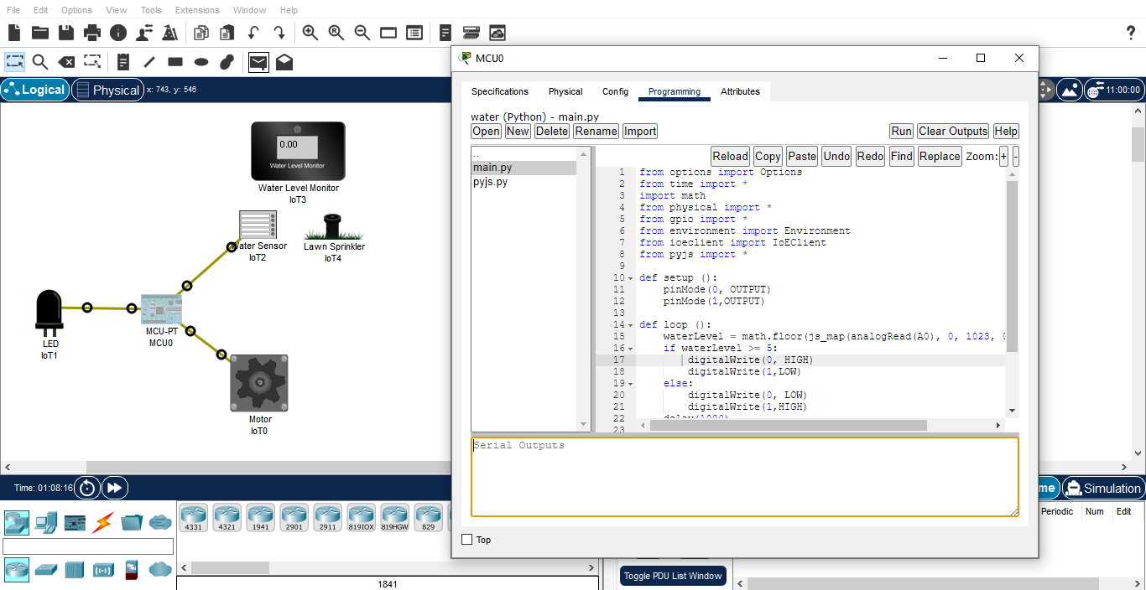

**Code:**

from options import Options

from time import *

import math

from physical import *

from gpio import *

from environment import Environment

from ioeclient import IoEClient

from pyjs import *

def setup ():

pinMode(0, OUTPUT)

pinMode(1,OUTPUT)

def loop ():

waterLevel = math.floor(js_map(analogRead(A0), 0, 1023, 0, 20) + 0.5)

if waterLevel >= 5:

digitalWrite(0, HIGH)

digitalWrite(1,LOW)

else:

digitalWrite(0, LOW)

digitalWrite(1,HIGH)

delay(1000)

if __name__ == "__main__":

setup()

while True:

loop()

idle()

**Step 4:** 1) Now click on MCU Board go to Programming then Select New, Create new python file of name pyjs.py and click on Create

2) Click on pyjs.py file then write code

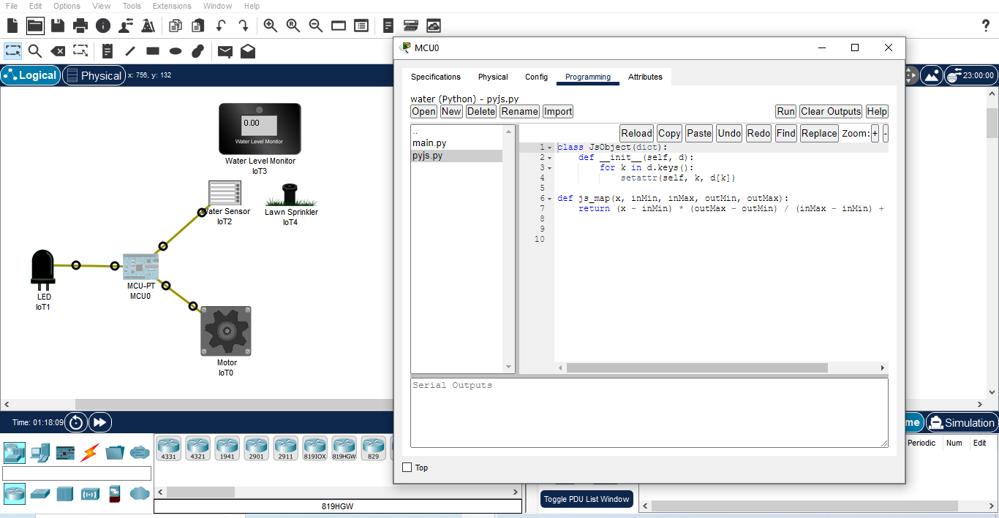

**Code:**

class JsObject(dict):

def __init__(self, d):

for k in d.keys():

setattr(self, k, d[k])

def js_map(x, inMin, inMax, outMin, outMax):

return (x - inMin) * (outMax - outMin) / (inMax - inMin) + outMin

**Step 5:** 1) Click on Run

2) Press Alt button then Start

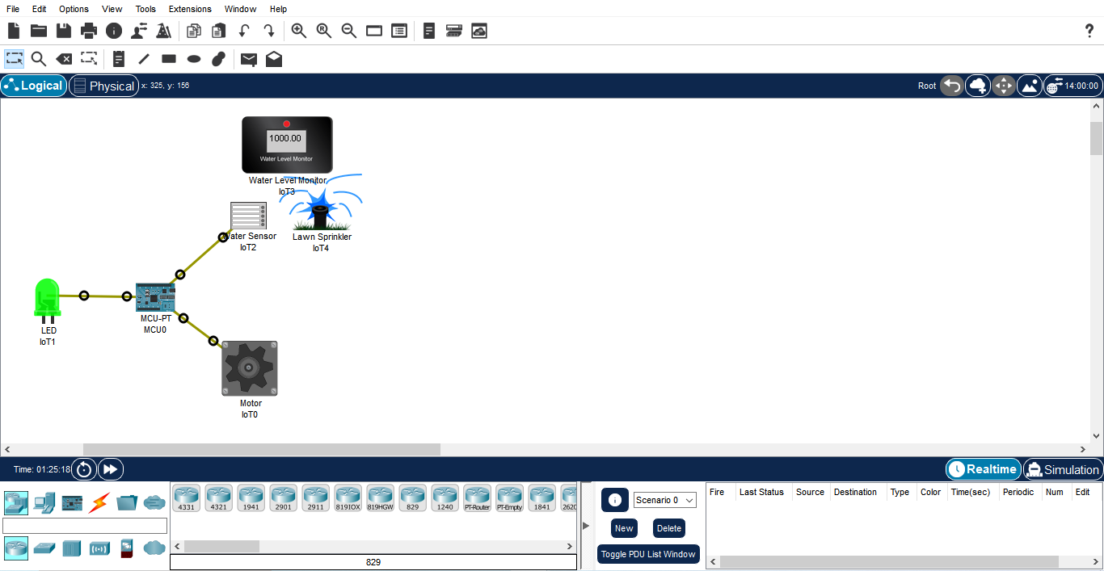

**Step 6:** Wait for some time motor will run automatically.

**Practical 9**

**Develop an IoT module to which measure the intensity of light and send the same to your PC/ Phone**

**Steps to Perform:**

**Step 1:** 1) Take Breadboard

2) Take Resistor

3) Take LDR

4) Take Laptop

5) Take MCU Board

6) Take Jumping Cable

**Step 2:** 1) LDR put on Breadboard

2) Resistor going to connect one end of a resistor and one end of the Breadboard

3) We connect MCU Board to Breadboard Using Jumper wire

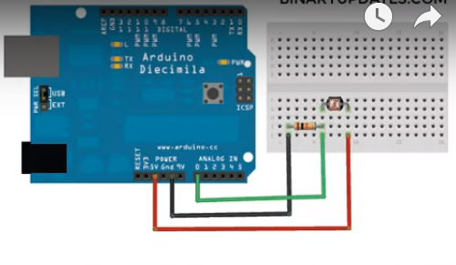

**Step 3:** 1) Now we will connect Breadboard and MCU board Using Red colour jumper wire

2) Then Connect MCU board to using Yellow colour jumper wire

3) Then free end of Resistor to MCU Board using Green Colour jumper wire

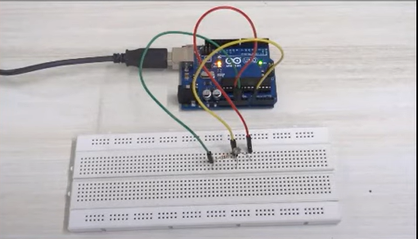

**Practical 10: Develop an IoT application for Motion detection**

**Steps to Perform:**

**Step 1:** 1) Take Fan

2) Take Component - SBC Board

3) Take Motion Sensor

**Step 2:** 1) Now we will connect Fan to SBC Board with

IoT custom cable connect Fan (D0) to connect with SBC Board (D0)

2) Then we will connect SBC board to Motion Sensor with IoT custom cable connect MCU Board (D1) to Motion Sensor (D0)

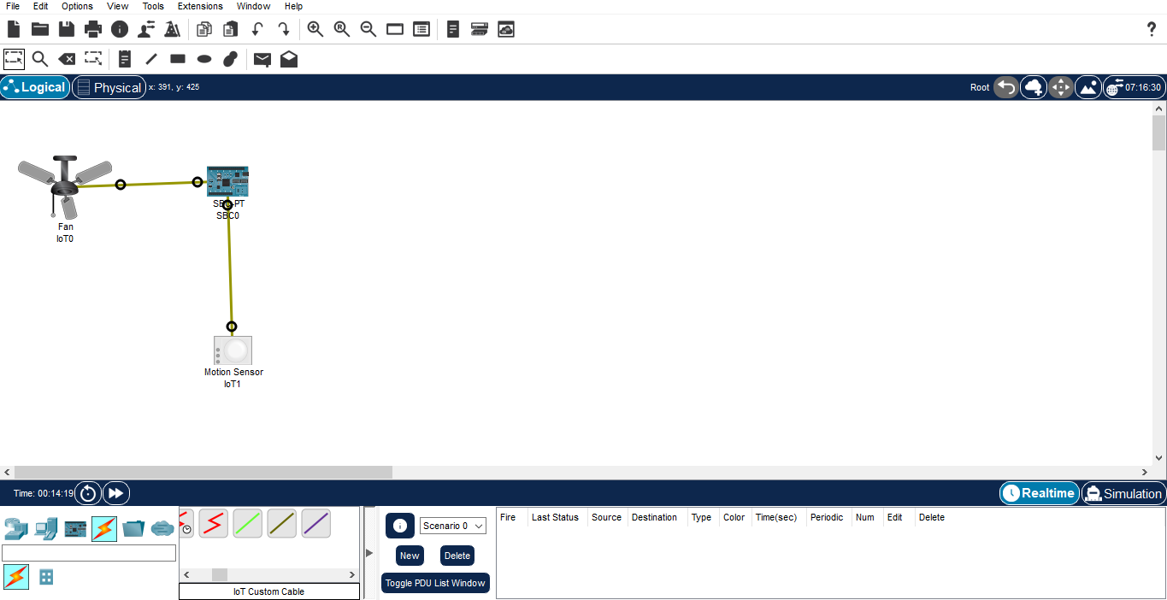

**Step 3:** 1) Now click on SBC Board go to Programming then Select New, select Template

Empty-Python then click on Create

2) Click on main.py file then write code

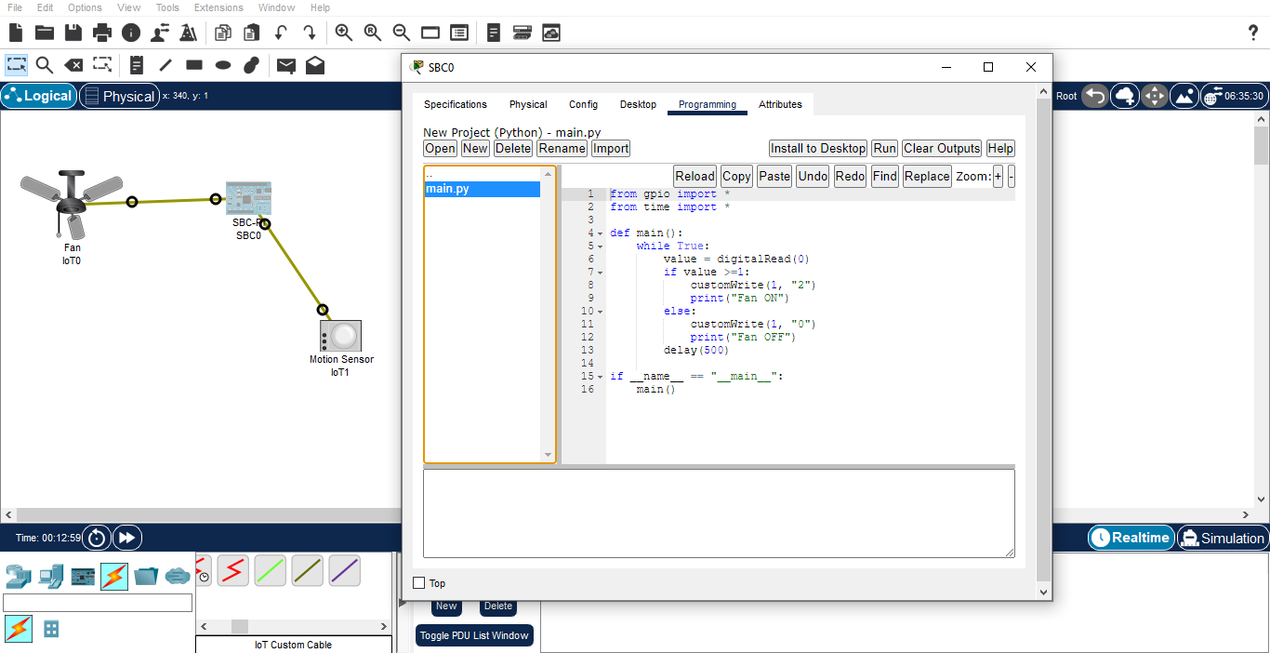

**Code :-**

from gpio import *

from time import *

def main():

while True:

value = digitalRead(0)

if value >=1:

customWrite(1, "2")

print("Fan ON")

else:

customWrite(1, "0")

print("Fan OFF")

delay(500)

if __name__ == "__main__":

main()

**Step 4 :** 1) Click on Run

