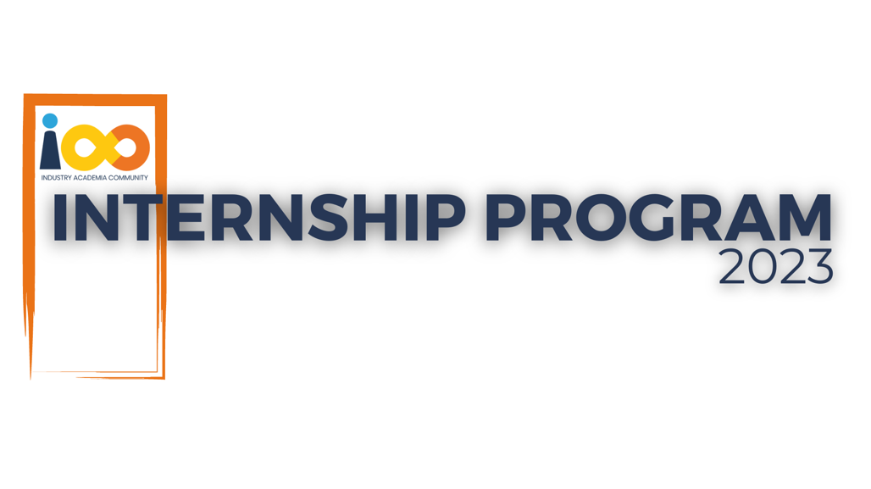

SRS DOCUMENT

PYTHON  
  
Resume insights using Python

|  |  |  |  |
| --- | --- | --- | --- |
| **Created By:** | Aishwarya Pandurang Jawalekar | **Approved By:** | Suraj Mane |
| **Created On:** | 22-SEP-2023 | **Approved On:** | DD-MMM-YYYY |

**SRS DOCUMENT**

**BACKGROUND**

Millions of students apply for internships/jobs every year ,resumes play an important role in playing the first impression .The recruiters spend a max of 2-3 minutes reviewing a resume after landed in their mailbox or job board ,ATS application .Surprising more than 70% of resumes get rejected in the initial screening.

**PROJECT OVERVIEW:**

The aim is to conduct a comprehensive analysis of student interns to gain insights about relationship between their academic performance ,event participation ,career aspiration and factors influencing their success .We have collected a dataset containing various attributes for each student .

**HARDWARE REQUIREMENT:**

minimum hardware requirements--RAM:512 MB or more.Processor:Pentinum-IV onwards . Hard Disk Space: 40 GB or more .

**SOFTWARE REQUIREMENT:**

VS Code, Python, Python Libraries

**CONSTRAINTS:**

Python

**ASSUMPTIONS:**

Assume the data collected is reliable unless proven otherwise

**RISKS:**

Incomplete or inaccurate data from interns records or surveys.

**FUNCTIONAL REQUIREMENTS:**

Create dataframe for the available data and perform operations on that data.

**NON-FUNCTIONAL REQUIREMENTS:**

Scalability ,Data security and privacy

**EXTERNAL INTERFACE REQUIREMENTS:**

Jupyter Notebook is the interface for this project

**TECHNOLOGY USED:**

Python