**WZDx Data Feed Self-Validation Check List**

1. Validated WZDx data feed using JSON schema validator
2. Visually validated that all road events locations are within my jurisdiction using an external mapping tool
3. Reviewed current business rules and check WZDx data feed for adherence
4. Reviewed complex work zones in WZDx feed to validate that your system implements the work zone accurately
5. If using event_type detour have validated that it connects to the appropriate road event(s)
6. Verified that RoadEventFeedInfo contact name and email are the appropriate technical contact for questions involving the WZDx data feed
7. Verified that RoadEventFeedInfo update_frequency is accurate for your system
8. Validated that my geospatial coordinates adhere to the level of accuracy provided by my mapping system

Name ________________________________ Contact Email ___________________________

WZDx version_________

# Steps to take when validating if a new WZDx data feed is compliant

## Validate if the feed follows the required WZDx schema version

* 1. Go to [https://www.jsonschemavalidator.net/](https://gcc01.safelinks.protection.outlook.com/?url=https%3A%2F%2Fwww.jsonschemavalidator.net%2F&data=02%7C01%7CWesley.Alford.CTR%40dot.gov%7Cb9c273c2ba9c46d10f1608d84acdd757%7Cc4cd245b44f04395a1aa3848d258f78b%7C0%7C0%7C637341595227459524&sdata=LdBb1ZUTIl4BfksTdQReT8vTe9MUyTZPiHsJGdfRrs8%3D&reserved=0)
  2. Paste the JSON Schema for the WZDx version you seek to verify on the left-hand box (WZDx schemas can be found here: <https://github.com/usdot-jpo-ode/jpo-wzdx/tree/master/create-feed/schemas>)
  3. Paste the content of the feed on the right-hand box
  4. Validation results will appear below your inputs. Note down any inconsistencies that the feed has with the WZDx JSON Schema. Reach out to help desk or the technical assistance forum if you would like assistance resolving these errors.

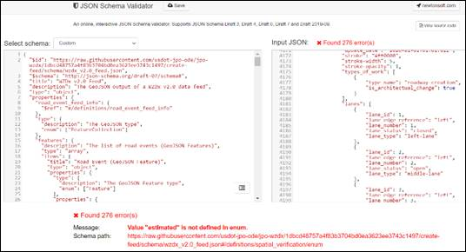

### TxDOT example (retrieved 12/15/20)

[https://www.jsonschemavalidator.net/s/P3hottVt (view here)](https://www.jsonschemavalidator.net/s/P3hottVt)

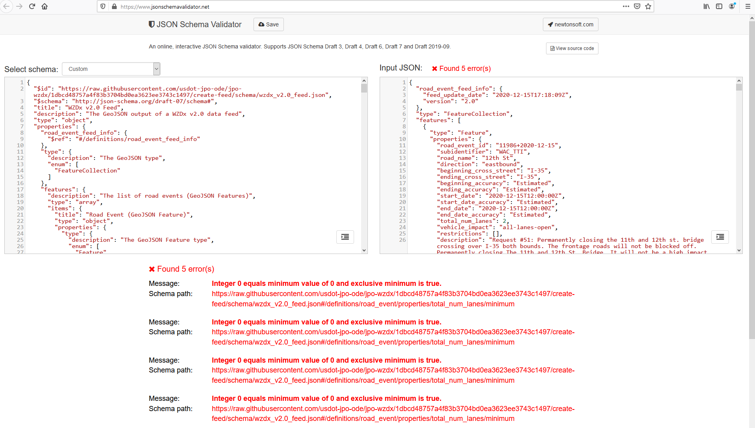

### MassDOT example (retrieved 12/15/20)

[https://www.jsonschemavalidator.net/s/9C3NUxHM (view here)](https://www.jsonschemavalidator.net/s/9C3NUxHM)

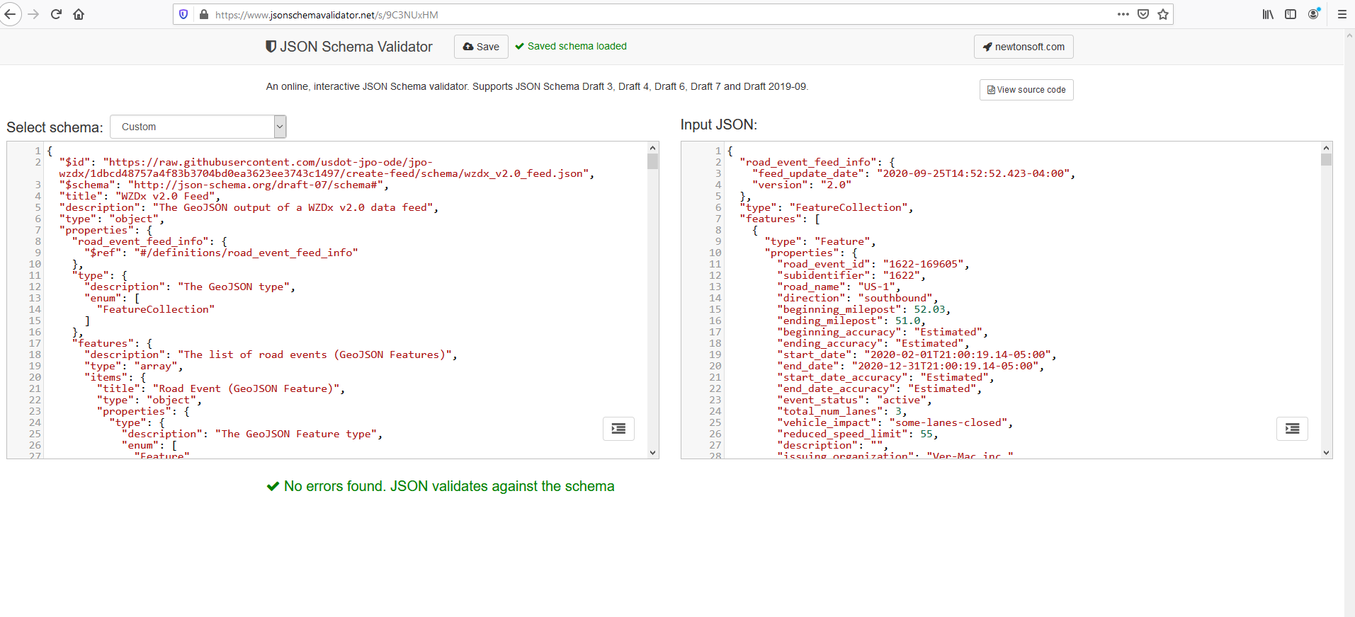

## Validate if the feed contains valid GeoJSON and valid locations

* 1. Go to [https://geojson.io/](https://gcc01.safelinks.protection.outlook.com/?url=https%3A%2F%2Fgeojson.io%2F&data=02%7C01%7CWesley.Alford.CTR%40dot.gov%7Cb9c273c2ba9c46d10f1608d84acdd757%7Cc4cd245b44f04395a1aa3848d258f78b%7C0%7C0%7C637341595227469480&sdata=Rcs%2BOEkFFYDUJc2lMcuG%2BZ60xq1wfiuStIne%2F8vHxU0%3D&reserved=0)
  2. Paste the feed’s current content in the right-hand box. The map should change on the left if the GeoJSON is valid. If it is not valid GeoJSON, the right-hand box will have red margins where the GeoJSON is invalid.
  3. Spot check for the following in the map:
     1. Are the locations marked within the feed boundary indicated by the data provider (by state or other administrative boundaries, depending on how you are aggregating data)
     2. Make sure that the locations marked make sense for work zones (e.g. Are the locations on roadways or in the middle of a lake)
     3. Click on some markers to spot check the feature's properties - does the road_name value match the road that it is on?

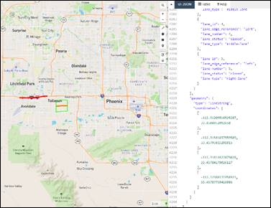

### TxDOT example (retrieved 12/15/20)

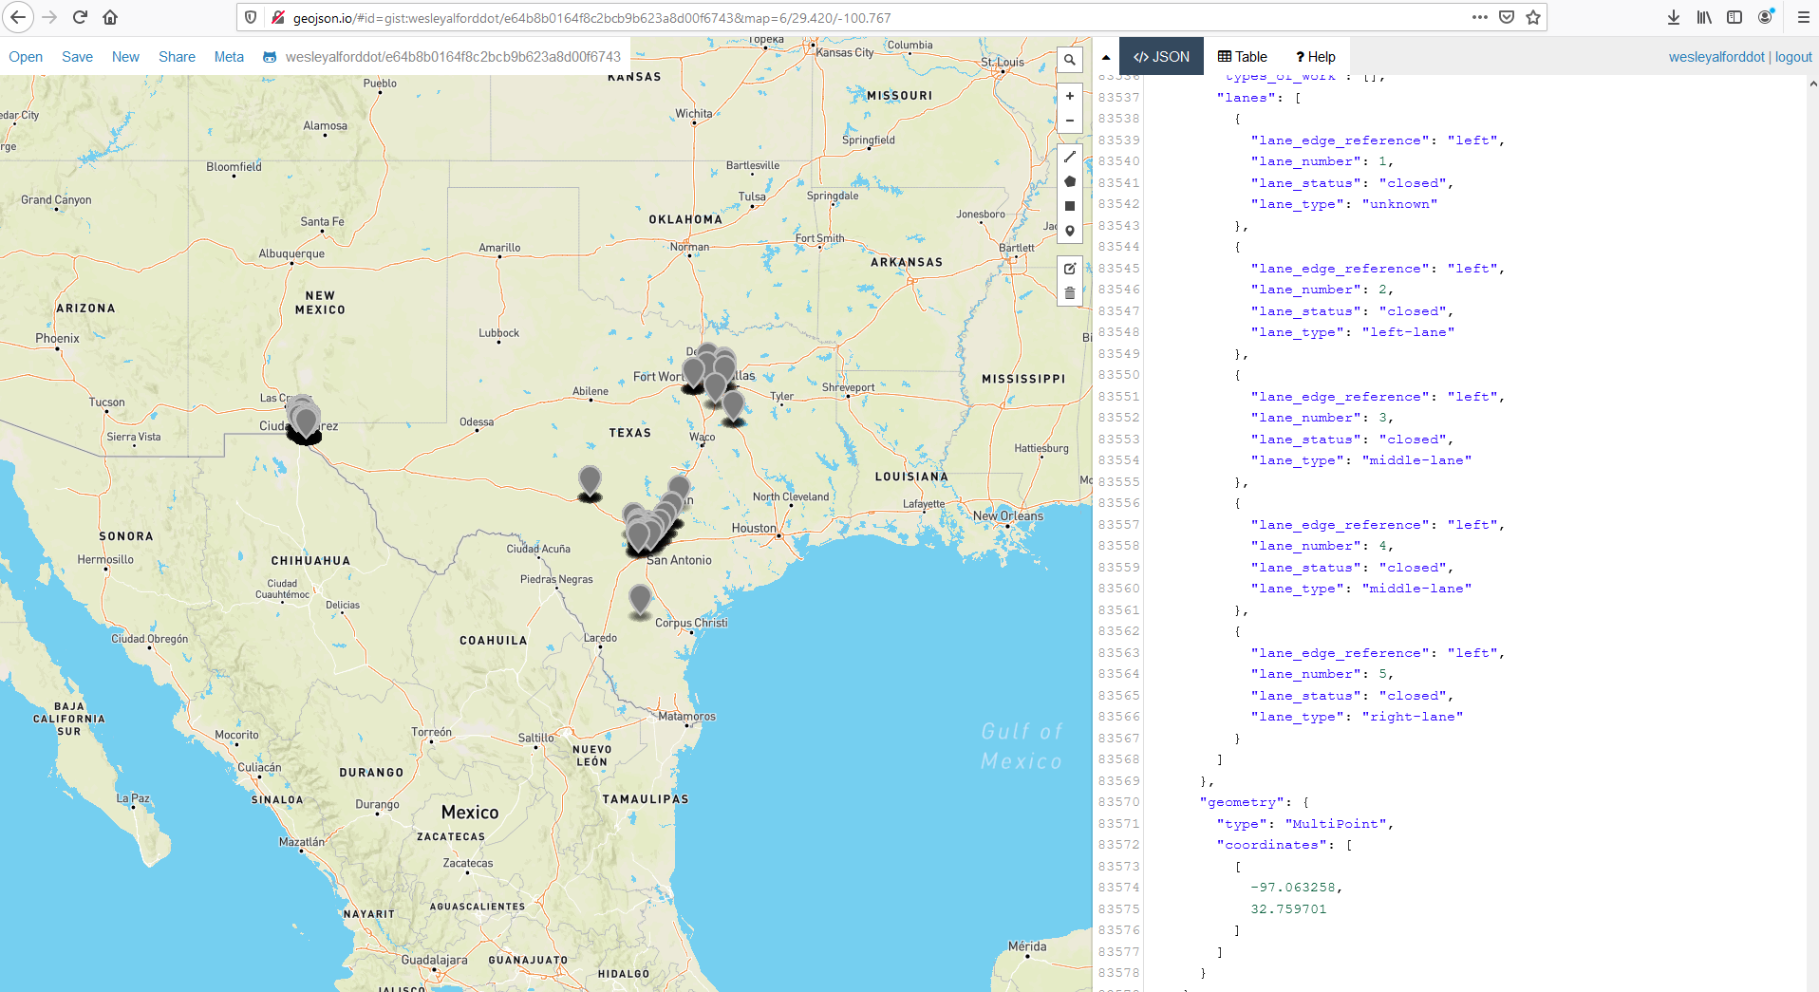

### MassDOT example (retrieved 12/15/20)

[View online example here](http://geojson.io/#id=gist:wesleyalforddot/5118702a7667ee3522418154f72ef39f&map=12/42.4402/-71.0558)

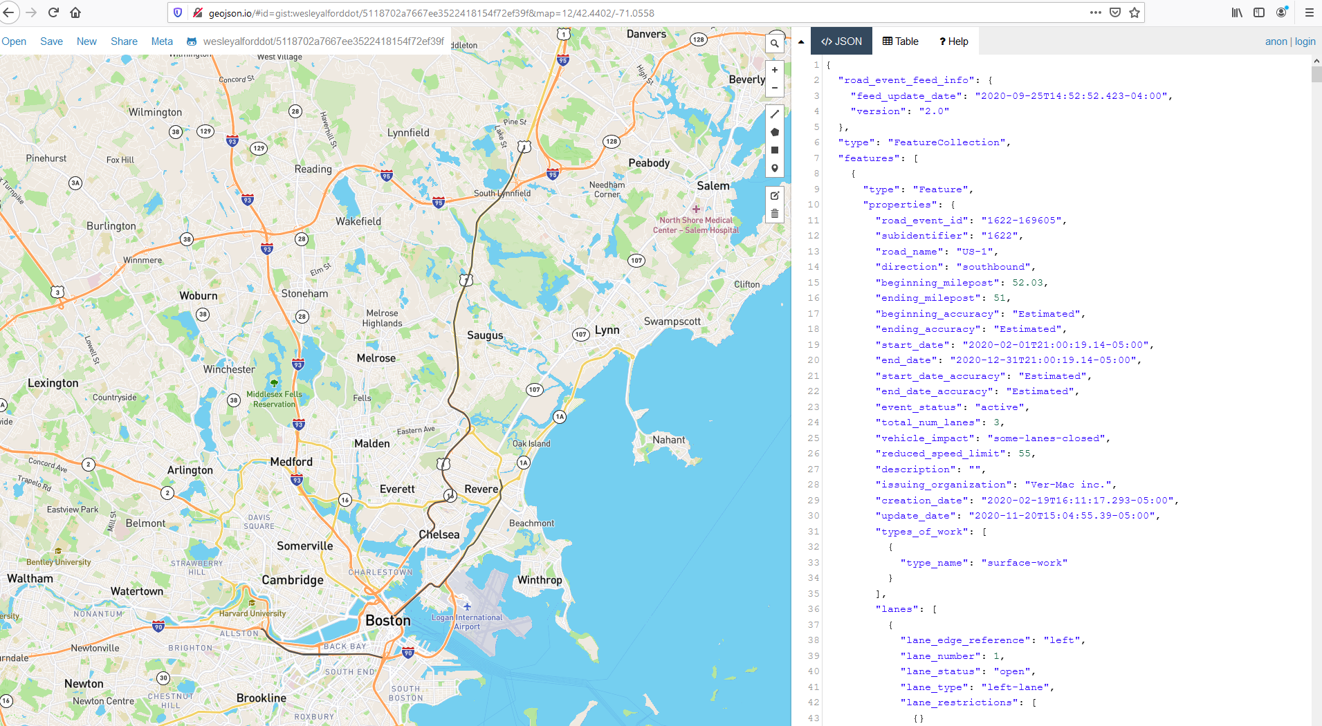

## Validate adherence to business rules

* 1. Current business rules are located here [https://github.com/usdot-jpo-ode/jpo-wzdx/tree/master/create-feed](https://gcc01.safelinks.protection.outlook.com/?url=https%3A%2F%2Fgithub.com%2Fusdot-jpo-ode%2Fjpo-wzdx%2Ftree%2Fmaster%2Fcreate-feed&data=04%7C01%7CWesley.Alford.CTR%40dot.gov%7C4684f9424c20440eff7b08d8872bb203%7Cc4cd245b44f04395a1aa3848d258f78b%7C0%7C0%7C637407969024916220%7CUnknown%7CTWFpbGZsb3d8eyJWIjoiMC4wLjAwMDAiLCJQIjoiV2luMzIiLCJBTiI6Ik1haWwiLCJXVCI6Mn0%3D%7C1000&sdata=w53DMq3Dn%2FoWCnpVD7TE%2BrxI3YbPIomlFvcEzLlpv3g%3D&reserved=0)
  2. As you go through the business rules check that existing road event adhere to the rules, consider documenting examples by using a geoJSON visualizer and the corresponding code snippet(s) from the WZDx data feed
     1. In the event that you do not have a work zone that interacts with a business rule consider creating a simulated work zone to understand how your system implements the work zone

## Reviewed complex work zones in WZDx feed

* 1. Complex work zones often require several linked road events.
  2. A single road event can only describe individual changes to each field, so a work zone that has differing number of lane closures, numerous speed restriction zones, etc. must be described by more than one road event.
  3. For guidance in constructing complex work zones see draft example work zone implementations here: [https://github.com/usdot-jpo-ode/jpo-wzdx/discussions/131](https://github.com/usdot-jpo-ode/jpo-wzdx/discussions/131%20)

## If using event_type detour have validated that it connects to the appropriate road event(s)

* 1. Check that road event Relationship is defined for the detour and the connected road events
     1. road_event_id for the detour is listed in the children array of each road event that detour is routing around
     2. road_event_id for each road event that the detour is routing around is listed in the parents array of the detour

## Validate the feed's metadata

* 1. Validate the road_event_feed_info and road_event_data_sources
     1. The links and contact information are correct and active

## Verify that RoadEventFeedInfo update_frequency is accurate for your system

* 1. How often is your system capable of updating? The following are some useful questions to determine this:
     1. Are there manual validation steps before the data feed is updated?
     2. What is the total time for a change at the work zone to be reflected in the data feed?
     3. If your system automatically polls data to populate the data feed, how often does this automatic polling occur?

## Check geospatial coordinates for precision

* 1. Make sure coordinates don't have excessive decimal places that would infer more accuracy than your mapping system has (usually less than 5 or 6 decimal places)