A DCDSL PROJECT REPORT
ON
Cybersecurity Incident Monitoring and Threat Analytics Dashboard
Submitted By
Adwaiy Gupta 25070126018
Aashi Agrawala 25070126003
Adrika Gupta 25070126016
Aditi Chitnis 25070126012
UNDER THE GUIDANCE OF
[Guide name and designation]
DEPARTMENT OF ARTIFICIAL INTELLIGENCE & MACHINE LEARNING
SYMBIOSIS INSTITUTE OF TECHNOLOGY, PUNE
A.Y. [Academic year]

DEPARTMENT OF ARTIFICIAL INTELLIGENCE & MACHINE LEARNING
CERTIFICATE
This is to certify that the DCDSL Project work entitled “Cybersecurity Incident Monitoring and Threat Analytics Dashboard” is carried out by Adwaiy Gupta (25070126018), Aashi Agrawala (25070126003), Adrika Gupta (25070126016), Aditi Chitnis (25070126012), in Artificial Intelligence & Machine Learning, Symbiosis International (Deemed University), Pune during the academic year [Academic year].
Name and Signature of the Guide Dr. Shilpa Bade-Gite
Head, Department of AI&ML

TABLE OF CONTENTS
1 Introduction 1
2 Problem Statement 2
3 System architecture and modules 2
4 Functional requirements 4
5 Entities, relationships and attributes 5
6 Relational schema 7
7 Implementation 8
8 User Interface 19
9 Conclusion 22
10 References 22

1 Introduction

1.1 Project overview
An office security team needs to turn scattered login records and network-flow logs into cases that someone can investigate. A CSV full of suspicious events is not yet an incident-management system: the team must preserve the evidence, explain why an event was flagged, assign responsibility and record what happened next. We built a small Security Operations Center application to demonstrate that complete workflow.
The application validates uploaded security datasets, stores raw and normalised events in MongoDB, runs Python detection, and creates deduplicated incidents in MySQL. Analysts use a Streamlit dashboard to inspect evidence, assign cases, record response actions and update status. The original version uses explainable rules; the current version retains authentication rules and adds a trained random-forest network classifier.
Headline results. On the same 889-row network test split, the trained classifier raises recall from 14.32% for the rule baseline to 95.18%, with no measured false positives. The saved verification reports record 97 passing unit and UI tests and 2 passing live database integration tests. The analytics layer provides ten saved SQL reports, six MongoDB pipelines and read-only custom query editors.

1.2 Purpose and objectives
The main objective is a working database-driven application that demonstrates relational design and document-oriented storage through one traceable pipeline. Each incident should lead back to its alert and source events, while repeated imports should not create duplicate cases. The interface should make the results understandable without requiring an analyst to inspect every CSV row manually.
Objective | Observable output
Preserve security evidence | Normalised event documents with original fields and dataset labels
Identify activity requiring review | Standardised alerts with rule or model evidence
Manage accountable response | Persistent assignments, status changes and audit entries
Demonstrate database concepts | Joins, grouping, nested queries, stored procedures and MongoDB pipelines
Verify behaviour | Unit, UI and opt-in live database integration tests

1.3 Scope
This is a CSV-driven educational prototype, not a live enterprise SIEM. It does not intercept packets, block addresses or replace an analyst. The supplied authentication and network datasets represent different environments and remain separate throughout processing. Model scores describe the supplied representative data, not a validated deployment on an organisation’s live traffic.

2 Problem Statement

2.1 The office incident
At the start of a shift in an illustrative cyber office, an analyst receives two exports: an authentication log and a network-flow file. One account has repeated login failures. Another account appears from several access origins within a short period. A network export contains unusual flows, but most rows look similar when viewed in a spreadsheet. The exports do not explain which observations deserve a case, who owns that case or whether another analyst already handled it.
Without a shared workflow, the analyst copies records between spreadsheets, searches for evidence again and risks opening the same case twice. A suspicious label in a dataset may be mistaken for an independently detected attack. When a case is eventually resolved, the response can remain in a separate note rather than beside the original evidence. The next shift sees a count of events but cannot reliably reconstruct the investigation.

2.2 Defined problem
Design and implement a Python application that converts separate authentication and network CSV datasets into a provenance-preserving evidence store, detects suspicious activity, generates unique incidents, and provides an auditable response workflow. Use MongoDB for variable event and alert documents and MySQL for structured entities, incident relationships and response records.

2.3 Questions addressed
How can heterogeneous records be validated without inventing missing fields? How can event evidence and relational incident records remain linked without a cross-database foreign key? How can repeated imports be safe? How can analysts distinguish observed labels from generated alerts, and selectively exclude a CSV from analysis without deleting its stored evidence?

2.4 Sustainable development alignment
SDG 9 concerns resilient infrastructure and innovation. This prototype supports that theme through a reproducible monitoring pipeline and traceable investigation of digital infrastructure events. SDG 16 includes effective and accountable institutions; persistent assignments and audit histories support accountability in the office response process [1, 2]. These are qualitative design alignments, not measurements of UN target achievement.
Only SDGs 9 and 16 are selected. The application does not claim to reduce cybercrime rates, establish legal evidence admissibility or quantify institutional impact.

3 System architecture and modules

3.1 End to end architecture
Python coordinates two databases with different responsibilities. MongoDB keeps the evidence and ingestion history; MySQL keeps the operational case records. Streamlit [6] reads both stores and invokes the application services for approved changes. Figure 1 shows the implemented processing order.
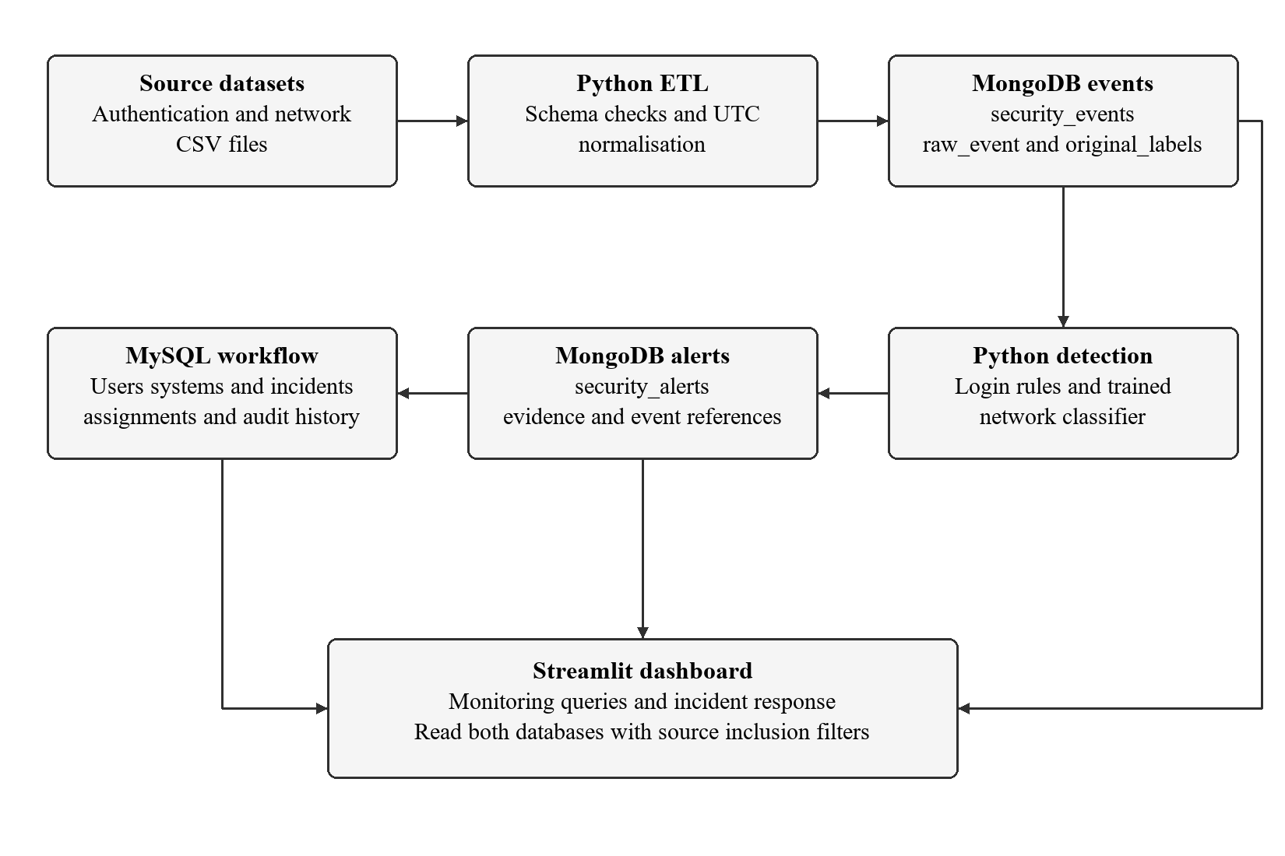

3.2 Cross database linkage
An alert has a stable detection_key, source_dataset and event_references. The corresponding MySQL incident stores the detection key, source dataset and a source event identifier. Incident Response uses those identifiers to retrieve the MongoDB alert and related events. These are application-level references; neither database enforces a foreign key into the other.
A successful MongoDB write followed by a failed MySQL write can leave evidence without its incident. The pipeline records progress and can be retried with idempotent writes. This is retry-based recovery, not an atomic transaction spanning both databases. A transactional outbox and reconciliation worker would strengthen a production version.
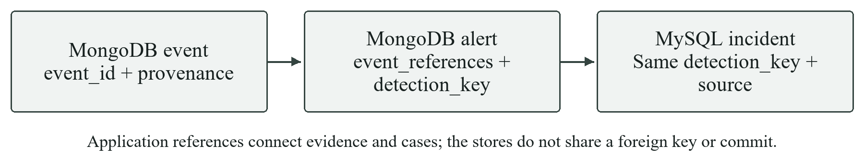
Diagram 1 Evidence references between MongoDB events alerts and MySQL incidents

3.3 Module responsibilities
Package | Responsibility | Main components
config | Environment and source mappings | Settings; dataset_mappings
etl | Validate, normalise and orchestrate imports | Loaders; schema_detection; pipeline; upload_history
database | Connections and persistence | MySQLDatabase; MongoDatabase; SecurityEventRepository
detection and ml | Generate alerts and evaluate network classification | failed_login; suspicious_access; ml_network; network_model
incidents | Create cases and manage analyst response | IncidentService; AssignmentService
analytics | Saved reports and restricted custom queries | sql_queries; mongo_aggregations; custom_queries
ui and pages | Dashboard state and seven user-facing views | Filters; visibility; evidence; query editor
tests and scripts | Repeatable setup, checks and reports | pytest; verify_project; model audit

3.4 Why both MySQL and MongoDB
MySQL is preferred for incidents and assignments because those records have stable attributes, explicit relationships and business rules. Foreign keys prevent orphan assignments; status and severity constraints reject invalid values; a transaction can update an incident and its audit entry together. Joins support analyst workload and response reporting [3].
MongoDB is preferred for source events because authentication and network records contain different fields. A common event envelope supports filters while raw_event and nested alert evidence preserve source-specific detail. Documents and aggregation pipelines provide a convenient match for that access pattern [4].
SQL could also store the logs, including JSON columns. MongoDB is a justified modelling choice rather than a technical necessity or a claim that SQL cannot handle such data. The dual-store design adds operational complexity and requires explicit consistency handling.
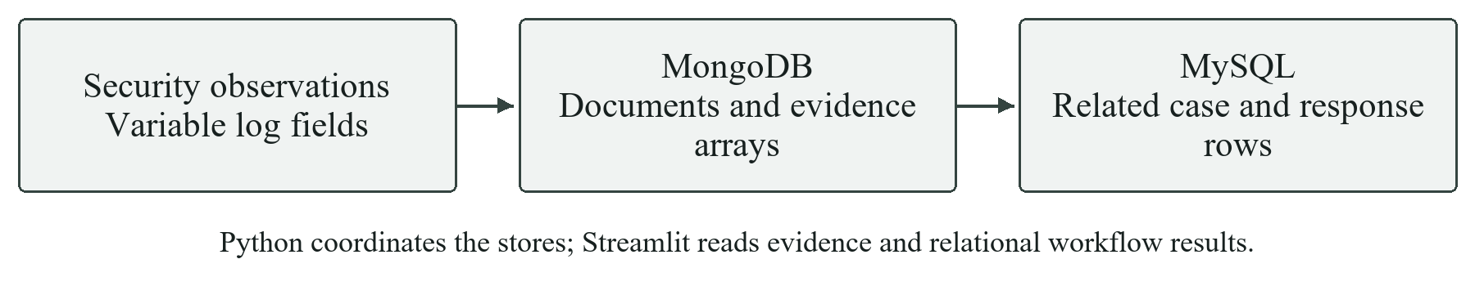
Diagram 2 Why flexible evidence and structured case management use separate stores

3.5 Application and database lifecycle
The lifecycle describes how we plan, design, build, load, test and maintain the application and its databases. It is broader than the runtime CSV-to-incident pipeline in section 3.1. The stages below follow the course lifecycle framework and show how each stage applies to our cybersecurity monitoring project.
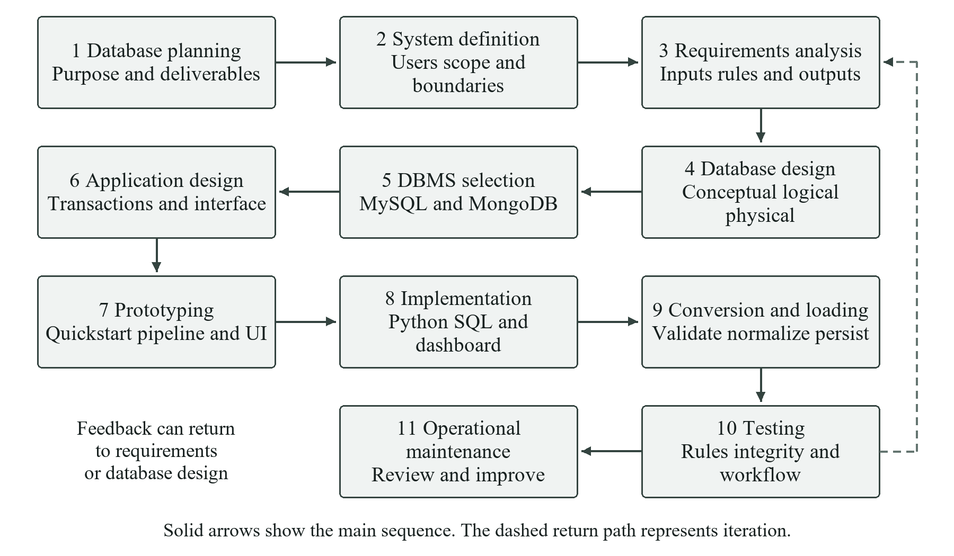
Diagram 32 Application and database lifecycle with feedback between stages
1 Database planning. We defined the objective as converting separate authentication and network CSV records into traceable security incidents. The planned deliverables include both database stores, explainable detection, analyst response, advanced queries and an interactive dashboard. SDGs 9 and 16 provide the project context, while the database workflow remains the core deliverable.
2 System definition. The system boundary is a local educational SOC application. Its users are analysts who import files, inspect evidence and manage cases. Inputs include supported CSVs, detection settings, filters and response notes; outputs include events, alerts, incidents and analytics. Live packet capture, real IP blocking and automatic enforcement are outside this scope.
3 Requirements collection and analysis. We translated the monitoring scenario into the functional requirements in chapter 4. We inspected the supplied CSV columns before mapping them, identified required and optional fields, and separated the authentication and network sources. Requirements also cover duplicate prevention, CSV inclusion controls, persistent case history and meaningful validation errors.
4 Database design. Conceptual design identifies users, systems, categories, incidents, analysts and their relationships. Logical design converts these into normalized MySQL relations and MongoDB event, alert and ingestion documents. Physical design specifies data types, InnoDB tables, primary and foreign keys, uniqueness rules and indexes for frequent time, identity and source filters.
5 DBMS selection. MySQL was selected for structured case relationships, referential integrity, joins and transactional response operations. MongoDB was selected for varied source rows, embedded evidence and event aggregations. This separation is a modelling choice: application references connect the two stores, but do not create a shared database transaction.
6 Application design. Transaction design groups related MySQL case, assignment and audit changes so they commit or roll back together. Interface design organizes monitoring, analytics, identity investigation, incident response, ingestion and database exploration. Python services validate user actions and keep persistence logic separate from Streamlit presentation.
7 Prototyping. The quickstart CSVs provide a smaller starting point for checking import, storage, detection and dashboard interaction before using the development files. Explicitly synthetic examples provide predictable demonstrations. The rule-based network baseline and the later trained classifier extension allow comparison without treating supplied labels as detector output.
8 Implementation. The design is implemented through Python ETL and detection packages, PyMongo repositories, MySQL connection and incident services, SQL schema and procedure scripts, and Streamlit pages. The network extension loads a saved classifier for inference; ordinary uploads do not retrain it. Environment variables keep credentials out of source code.
9 Data conversion and loading. Loaders validate columns, parse timestamps and normalize source rows into event envelopes while retaining raw context and labels. The pipeline persists events in MongoDB, generates and stores alerts, and creates deduplicated MySQL cases. Stable IDs support repeat imports. Source provenance prevents accidental correlation between unrelated environments.
10 Testing. Testing checks rule boundaries, malformed inputs, missing fields, duplicates and the incident-response lifecycle. Unit and UI tests use controlled fixtures, while the separate integration checks exercise both databases. Model evaluation compares held-out predictions with labels. Test findings feed back into requirements, schema mappings, services and interface behaviour rather than ending the design process.
11 Operational maintenance. For the local prototype, maintenance involves checking database connectivity, reviewing failed import runs, investigating alert quality and applying controlled code or schema updates. Future operational practice should include tested backups and restores, access reviews and independent model validation. These are maintenance responsibilities, not a claim that a production maintenance programme has already been deployed.
The lifecycle is iterative rather than strictly sequential. For example, an unavailable user identifier found during loading can require a revised mapping and nullable relationship; a test showing duplicate cases can require a stronger uniqueness rule. After such changes, affected imports, queries and response operations should be tested again. Feedback therefore connects maintenance and testing back to requirements, database design and application design.

4 Functional requirements
ID | Requirement | Implementation and verification
FR1 | Import supported CSV datasets | Schema detection, preview, validation and 25 MB upload limit
FR2 | Preserve source context | UTC timestamps, original_labels, raw_event and source_dataset
FR3 | Store events and alerts | MongoDB upsert batches and unique event/detection indexes
FR4 | Detect authentication threats | Five failures in five minutes; three access origins in ten minutes by default
FR5 | Detect suspicious network flows | Saved trained classifier and configurable probability threshold
FR6 | Create unique incidents | MySQL unique detection_key and transactional creation
FR7 | Manage response | Assign analyst, investigate, record actions, resolve or mark false positive
FR8 | Support monitoring | Overview, trends, source labels, affected identities and systems
FR9 | Track every source file | Persistent file library, import attempts and existing-source discovery
FR10 | Exclude a CSV without deleting it | Persistent inclusion controls applied to dashboard and query scope
FR11 | Demonstrate advanced retrieval | Ten saved SQL analyses, six MongoDB pipelines and procedure interface
FR12 | Support custom exploration | Read-only SQL and MongoDB editors, limits and downloads

4.1 Quality and security requirements
Credentials are loaded from environment variables rather than embedded in source code. SQL values are parameterised, invalid input is reported before import where possible, and database failures produce meaningful UI messages. Query results are bounded; the dashboard must not disclose connection details through raw driver errors.
Repeatability, evidence provenance and clear limitations are part of correctness. A zero inserted count on a repeat import means existing records were retained, not that the pipeline failed. Dataset labels and model-generated predictions must remain visibly distinct.

5 Entities, relationships and attributes

5.1 Relational entity model
A user can own several observed systems and can be associated with several incidents. A system can have several incidents. Each incident belongs to one threat category. Assignments associate an analyst with an incident over time, while audit rows record case actions. Nullable user_id and system_id allow an incident to remain valid when no identity or endpoint is known.
An observed network endpoint is not automatically a confirmed internal asset. The system_type observed_network_endpoint preserves this distinction. Shared addresses across source datasets do not merge systems because source_dataset is part of their external uniqueness rule.
Entity | Key and main attributes | Meaning
users | user_id; username; email; department; role; status; source_dataset; external_user_id; created_at | Observed identity, namespaced by source
systems | system_id; hostname; ip_address; os; system_type; location; owner_id; source_dataset; external_system_id | Observed endpoint; ownership is optional
analysts | analyst_id; name; role; team; active; created_at | Demonstration responders
threat_categories | category_id; category_name; description; default_severity | Shared classification dictionary
incidents | incident_id; user_id; system_id; category_id; incident_time; severity; description; status; detected_by; source_dataset; source_event_id; detection_key; created_at; updated_at; resolved_at | Operational case and its source references
assignments | assignment_id; incident_id; analyst_id; assigned_at; resolved_at; response_action; comments | Assignment and response history
incident_audit_log | audit_id; incident_id; analyst_id; action; old_status; new_status; notes; created_at | Application-recorded case actions
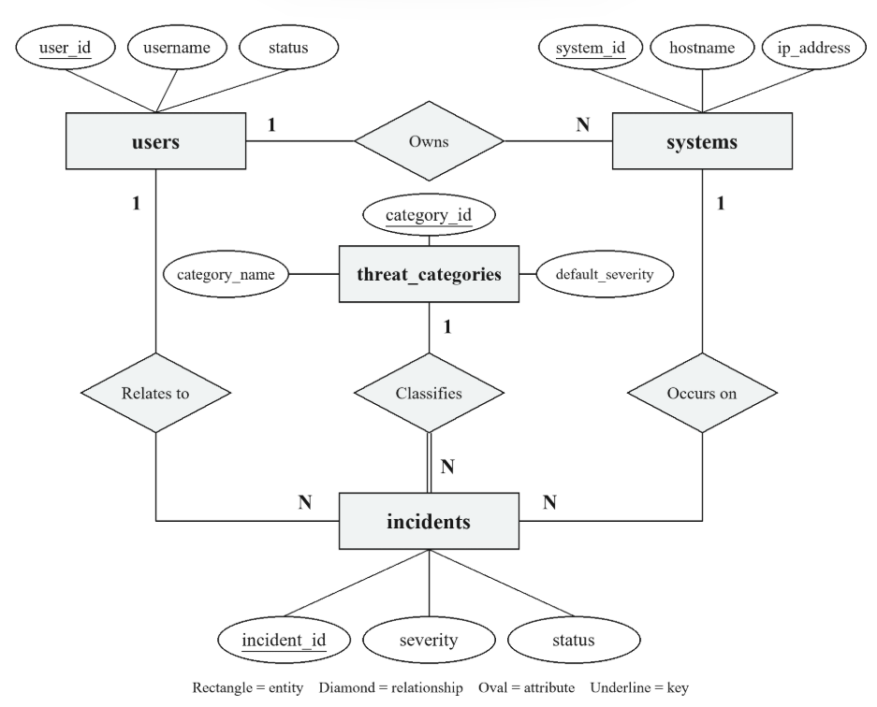

5.2 MongoDB document model
security_events contains the canonical envelope plus optional user, device, IP and flow context. raw_event embeds the cleaned source row. original_labels retains supplied ground truth separately. security_alerts stores alert_id, detection_key, rule_name, timestamp, severity, source_dataset, title, description, event_references and evidence.
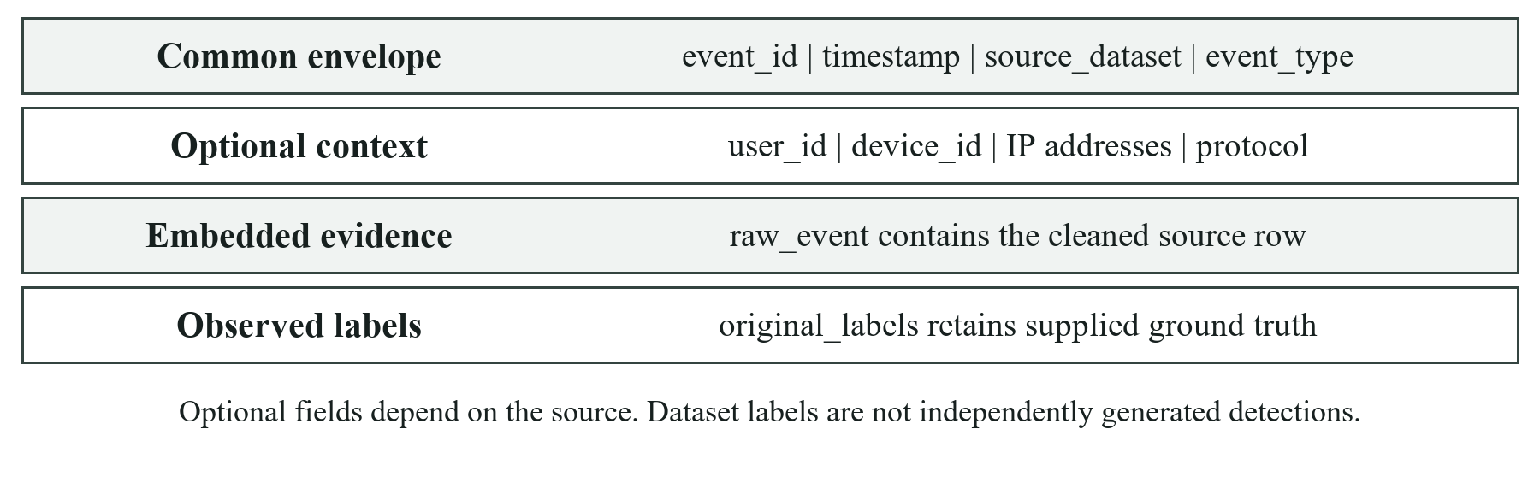
Diagram 3 Layers inside a security_events document
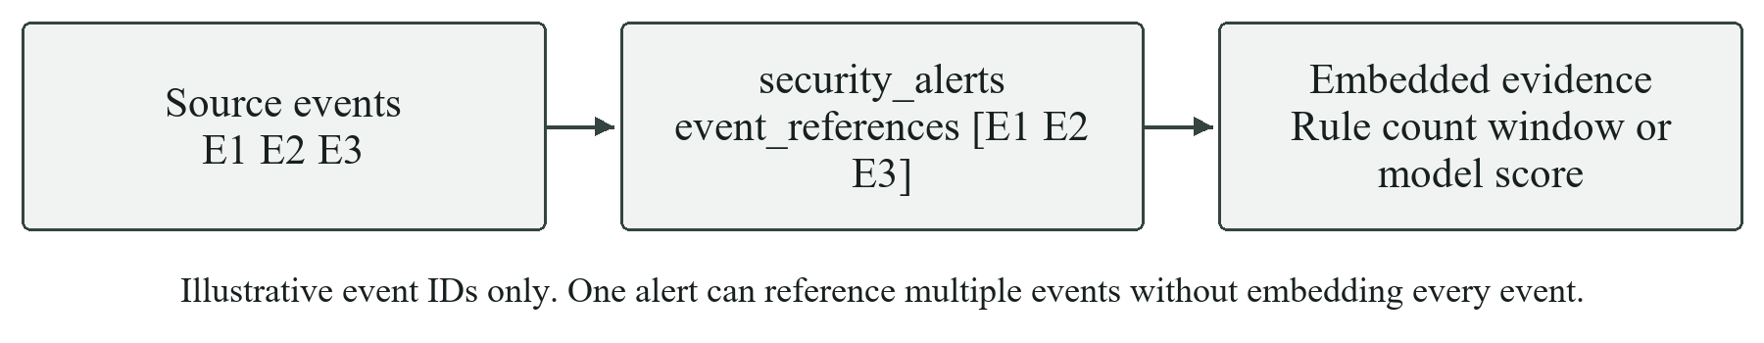
Diagram 4 A security_alerts document references source events and embeds detector evidence
ingestion_uploads stores file identity, original name, content hash, schema, source and inclusion preference. ingestion_runs stores each attempt’s configuration, progress, outcome and error state. Existing sources discovered in the databases have a separate record kind; the application does not invent historical upload times or content hashes for them.
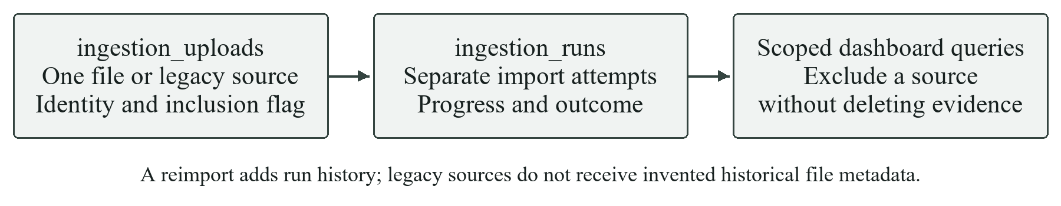
Diagram 5 Upload registry import history and analytical inclusion

6 Relational schema

6.1 Keys and integrity rules
Relation | Primary key | Foreign keys | Additional uniqueness
users | user_id | None | source_dataset and external_user_id
systems | system_id | owner_id to users | source_dataset and external_system_id
analysts | analyst_id | None | None beyond primary key
threat_categories | category_id | None | category_name
incidents | incident_id | user_id; system_id; category_id | detection_key
assignments | assignment_id | incident_id; analyst_id | Assignment history allows several rows
incident_audit_log | audit_id | incident_id; analyst_id | Each action has its own audit_id
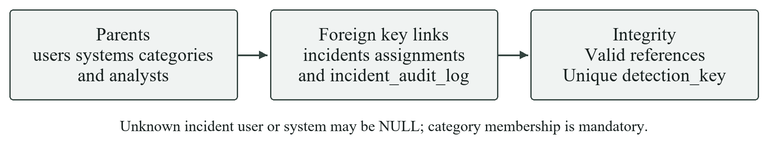
Diagram 6 How primary keys foreign keys and uniqueness protect the relational schema

6.2 Normalisation rationale
The relational design targets third normal form for operational entities. Each row has one primary key and scalar attributes. Category descriptions and analyst details are stored once rather than repeated in every incident. Assignment records resolve the many-to-many history between analysts and incidents, while response history is separated from the current incident state.
External identity values are not globally unique. The composite source and external ID constraint avoids merging unrelated environments. The incident detection key is a separate candidate key for duplicate prevention. Nullable foreign keys express missing knowledge rather than creating invented user or internal-system records.
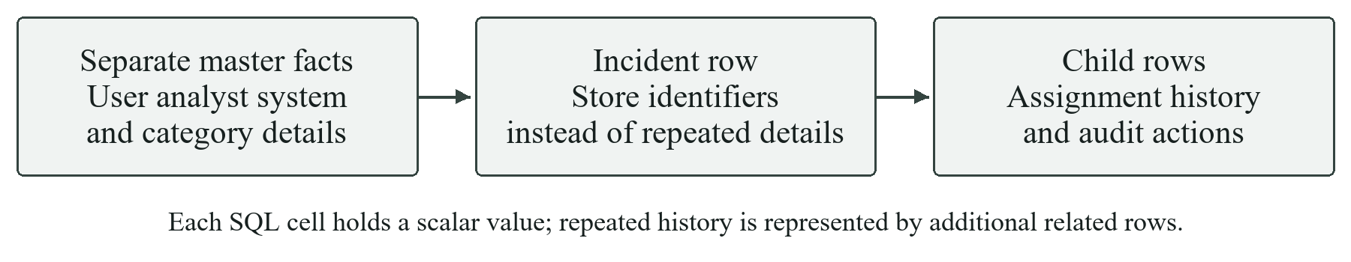
Diagram 7 Normalisation separates master data cases and repeating history

6.3 Deletion and temporal semantics
Deleting a referenced user or system sets the corresponding incident link to NULL; categories referenced by incidents cannot be removed. Assignment and audit children cascade when an incident is deleted at database level. The user-facing CSV exclusion control performs none of these deletions: it only changes analytical visibility.
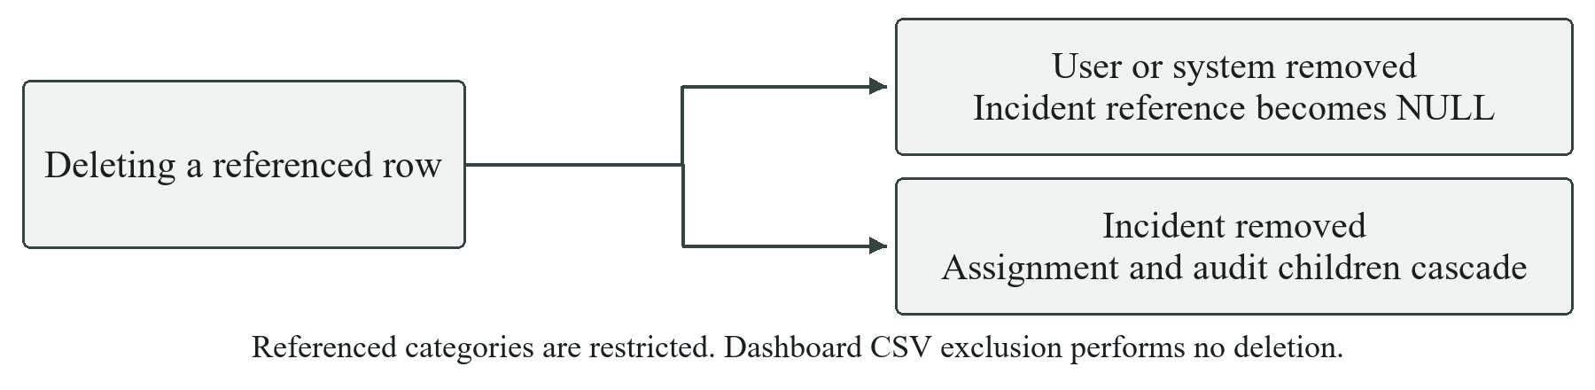
Diagram 8 Deletion behaviour preserves optional links and removes dependent case history
incident_time is the security event time. created_at is the database case-creation time. Response duration is measured from created_at to resolved_at, so an imported historical event does not produce a misleading months-long operational response time. Audit entries are appended by application operations, but are not a tamper-proof ledger against a privileged database administrator.
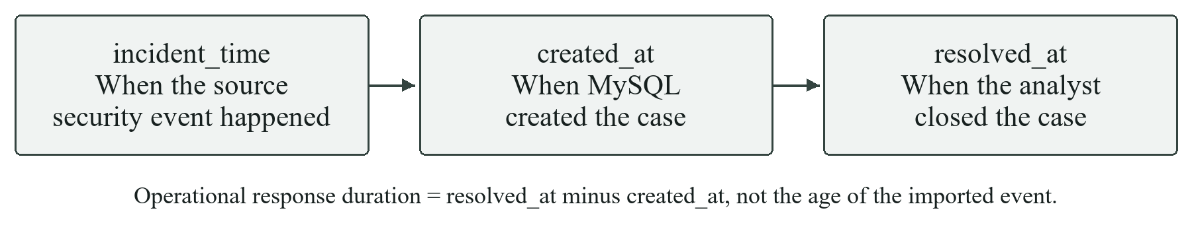
Diagram 9 Event time case creation and resolution time have different meanings

7 Implementation

7.1 Native local installation
The demonstrated Windows setup runs without Docker Desktop. It requires Python 3.11 or later, MySQL Server 8 or later, and MongoDB Community Server. MySQL Workbench, MongoDB Compass and mongosh are useful inspection tools, not substitutes for the database servers. Start the MySQL and MongoDB services before running the application. The complete source is in the project repository [9].
cd ml_version
python -m venv .venv
.\.venv\Scripts\Activate.ps1
python -m pip install -r requirements.txt
Copy-Item .env.example .env
python -m streamlit run app.py
When using the existing root virtual environment, activate that environment instead of creating another. Configuration is read from ml_version/.env when present, otherwise from the parent project .env. Replace placeholders locally; never include actual passwords or connection secrets in a submitted report or a Git commit.
Variable | Purpose
MYSQL_HOST and MYSQL_PORT | Local MySQL endpoint, normally localhost and 3306
MYSQL_DATABASE and MYSQL_USER | Application schema and database account
MYSQL_PASSWORD | Locally configured application account password
MONGODB_URI and MONGODB_DATABASE | MongoDB connection and database name
LOG_LEVEL | Application logging level
Initialise MySQL by running database/schema.sql, database/seed.sql and database/procedures.sql in order in Workbench using an appropriately authorised account. MongoDB collections and indexes are prepared by the application. Put the supplied CSVs in data/raw. The original rule-only application and ml_version remain separate folders.
The saved model can be used as supplied. To reproduce training, run python scripts/train_network_model.py. Launch Streamlit from ml_version so relative data and report paths resolve correctly. The local dashboard is normally available at http://localhost:8501.

7.2 Table creation scripts
CREATE DATABASE IF NOT EXISTS cyber_soc
CHARACTER SET utf8mb4 COLLATE utf8mb4_0900_ai_ci;
USE cyber_soc;

CREATE TABLE IF NOT EXISTS users (
user_id BIGINT UNSIGNED AUTO_INCREMENT PRIMARY KEY,
username VARCHAR(150) NOT NULL,
email VARCHAR(255) NULL,
department VARCHAR(150) NULL,
role VARCHAR(100) NULL,
status VARCHAR(30) NOT NULL DEFAULT 'active',
source_dataset VARCHAR(100) NOT NULL,
external_user_id VARCHAR(150) NOT NULL,
created_at TIMESTAMP NOT NULL DEFAULT CURRENT_TIMESTAMP,
CONSTRAINT ck_users_status CHECK (status IN ('active', 'inactive', 'locked')),
CONSTRAINT uq_users_source_external UNIQUE (source_dataset, external_user_id),
INDEX ix_users_username (username),
INDEX ix_users_status (status)
) ENGINE=InnoDB;
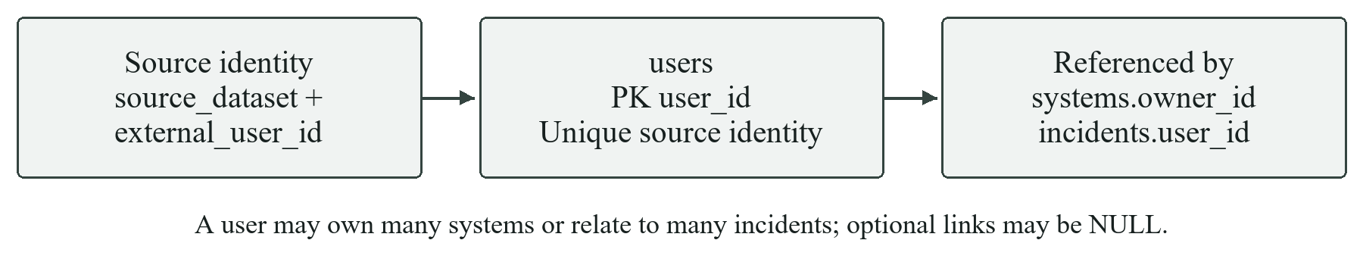
Diagram 10 Relational structure and links of the users table

CREATE TABLE IF NOT EXISTS systems (
system_id BIGINT UNSIGNED AUTO_INCREMENT PRIMARY KEY,
hostname VARCHAR(255) NULL,
ip_address VARCHAR(45) NULL,
os VARCHAR(150) NULL,
system_type VARCHAR(100) NULL,
location VARCHAR(255) NULL,
owner_id BIGINT UNSIGNED NULL,
source_dataset VARCHAR(100) NOT NULL,
external_system_id VARCHAR(255) NOT NULL,
created_at TIMESTAMP NOT NULL DEFAULT CURRENT_TIMESTAMP,
CONSTRAINT fk_systems_owner FOREIGN KEY (owner_id) REFERENCES users(user_id)
ON UPDATE RESTRICT ON DELETE SET NULL,
CONSTRAINT uq_systems_source_external UNIQUE (source_dataset, external_system_id),
INDEX ix_systems_ip_address (ip_address),
INDEX ix_systems_owner (owner_id)
) ENGINE=InnoDB;
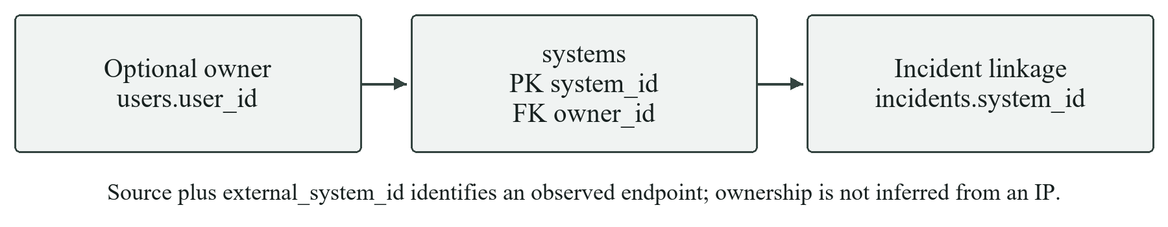
Diagram 11 Relational structure and links of the systems table

CREATE TABLE IF NOT EXISTS analysts (
analyst_id BIGINT UNSIGNED AUTO_INCREMENT PRIMARY KEY,
name VARCHAR(150) NOT NULL,
role VARCHAR(100) NOT NULL,
team VARCHAR(100) NOT NULL,
active BOOLEAN NOT NULL DEFAULT TRUE,
created_at TIMESTAMP NOT NULL DEFAULT CURRENT_TIMESTAMP,
INDEX ix_analysts_team_active (team, active)
) ENGINE=InnoDB;
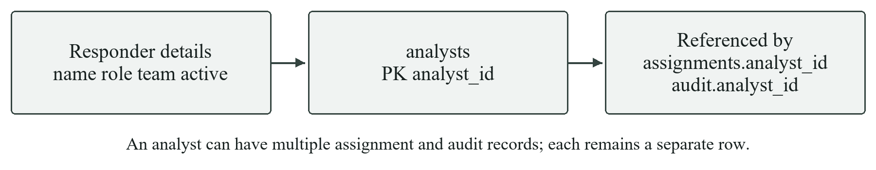
Diagram 12 Relational structure and links of the analysts table

CREATE TABLE IF NOT EXISTS threat_categories (
category_id BIGINT UNSIGNED AUTO_INCREMENT PRIMARY KEY,
category_name VARCHAR(100) NOT NULL UNIQUE,
description VARCHAR(500) NOT NULL,
default_severity VARCHAR(20) NOT NULL,
CONSTRAINT ck_categories_severity CHECK (
default_severity IN ('low', 'medium', 'high', 'critical')
)
) ENGINE=InnoDB;
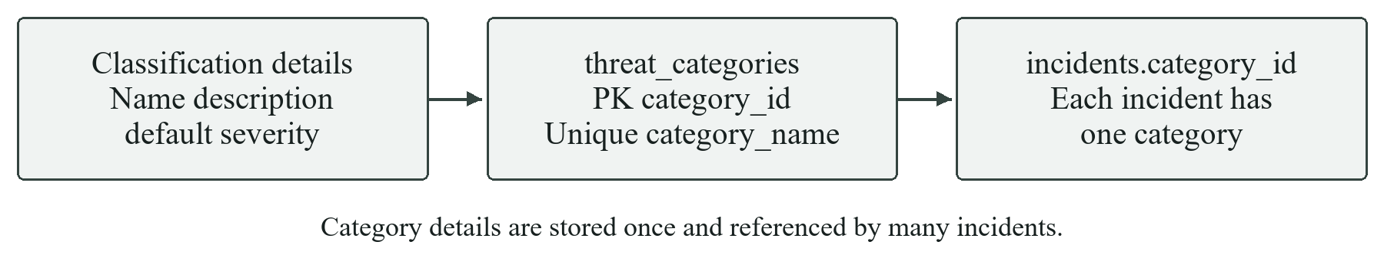
Diagram 13 Relational structure and links of the threat_categories table

CREATE TABLE IF NOT EXISTS incidents (
incident_id BIGINT UNSIGNED AUTO_INCREMENT PRIMARY KEY,
user_id BIGINT UNSIGNED NULL,
system_id BIGINT UNSIGNED NULL,
category_id BIGINT UNSIGNED NOT NULL,
incident_time DATETIME(6) NOT NULL,
severity VARCHAR(20) NOT NULL,
description TEXT NOT NULL,
status VARCHAR(30) NOT NULL DEFAULT 'open',
detected_by VARCHAR(150) NOT NULL,
source_dataset VARCHAR(100) NOT NULL,
source_event_id VARCHAR(255) NULL,
detection_key CHAR(64) NOT NULL,
created_at TIMESTAMP NOT NULL DEFAULT CURRENT_TIMESTAMP,
updated_at TIMESTAMP NOT NULL DEFAULT CURRENT_TIMESTAMP ON UPDATE CURRENT_TIMESTAMP,
resolved_at DATETIME(6) NULL,
CONSTRAINT fk_incidents_user FOREIGN KEY (user_id) REFERENCES users(user_id)
ON UPDATE RESTRICT ON DELETE SET NULL,
CONSTRAINT fk_incidents_system FOREIGN KEY (system_id) REFERENCES systems(system_id)
ON UPDATE RESTRICT ON DELETE SET NULL,
CONSTRAINT fk_incidents_category FOREIGN KEY (category_id)
REFERENCES threat_categories(category_id) ON UPDATE RESTRICT ON DELETE RESTRICT,
CONSTRAINT ck_incidents_severity CHECK (severity IN ('low', 'medium', 'high', 'critical')),
CONSTRAINT ck_incidents_status CHECK (
status IN ('open', 'assigned', 'investigating', 'resolved', 'false_positive')
),
CONSTRAINT uq_incidents_detection_key UNIQUE (detection_key),
INDEX ix_incidents_time (incident_time),
INDEX ix_incidents_status_severity (status, severity),
INDEX ix_incidents_user (user_id),
INDEX ix_incidents_system (system_id),
INDEX ix_incidents_category (category_id),
INDEX ix_incidents_source (source_dataset, source_event_id)
) ENGINE=InnoDB;
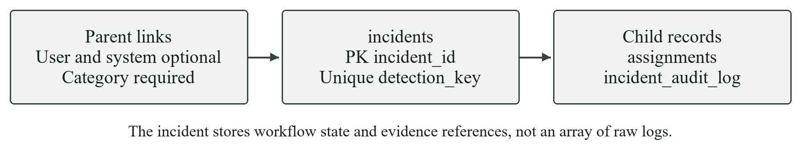
Diagram 14 Relational structure and links of the incidents table

CREATE TABLE IF NOT EXISTS assignments (
assignment_id BIGINT UNSIGNED AUTO_INCREMENT PRIMARY KEY,
incident_id BIGINT UNSIGNED NOT NULL,
analyst_id BIGINT UNSIGNED NOT NULL,
assigned_at DATETIME(6) NOT NULL DEFAULT CURRENT_TIMESTAMP(6),
resolved_at DATETIME(6) NULL,
response_action TEXT NULL,
comments TEXT NULL,
CONSTRAINT fk_assignments_incident FOREIGN KEY (incident_id)
REFERENCES incidents(incident_id) ON UPDATE RESTRICT ON DELETE CASCADE,
CONSTRAINT fk_assignments_analyst FOREIGN KEY (analyst_id)
REFERENCES analysts(analyst_id) ON UPDATE RESTRICT ON DELETE RESTRICT,
INDEX ix_assignments_incident (incident_id, assigned_at),
INDEX ix_assignments_analyst_open (analyst_id, resolved_at)
) ENGINE=InnoDB;
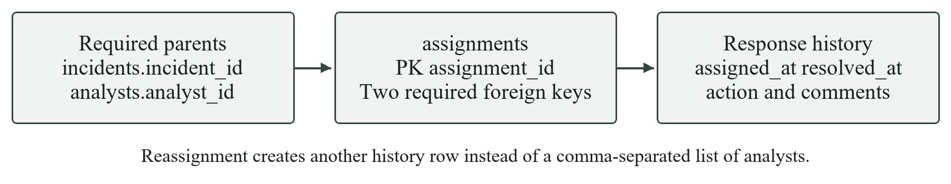
Diagram 15 Relational structure and links of the assignments table

CREATE TABLE IF NOT EXISTS incident_audit_log (
audit_id BIGINT UNSIGNED AUTO_INCREMENT PRIMARY KEY,
incident_id BIGINT UNSIGNED NOT NULL,
analyst_id BIGINT UNSIGNED NULL,
action VARCHAR(100) NOT NULL,
old_status VARCHAR(30) NULL,
new_status VARCHAR(30) NULL,
notes TEXT NULL,
created_at DATETIME(6) NOT NULL DEFAULT CURRENT_TIMESTAMP(6),
CONSTRAINT fk_audit_incident FOREIGN KEY (incident_id)
REFERENCES incidents(incident_id) ON UPDATE RESTRICT ON DELETE CASCADE,
CONSTRAINT fk_audit_analyst FOREIGN KEY (analyst_id)
REFERENCES analysts(analyst_id) ON UPDATE RESTRICT ON DELETE SET NULL,
INDEX ix_audit_incident_time (incident_id, created_at)
) ENGINE=InnoDB;
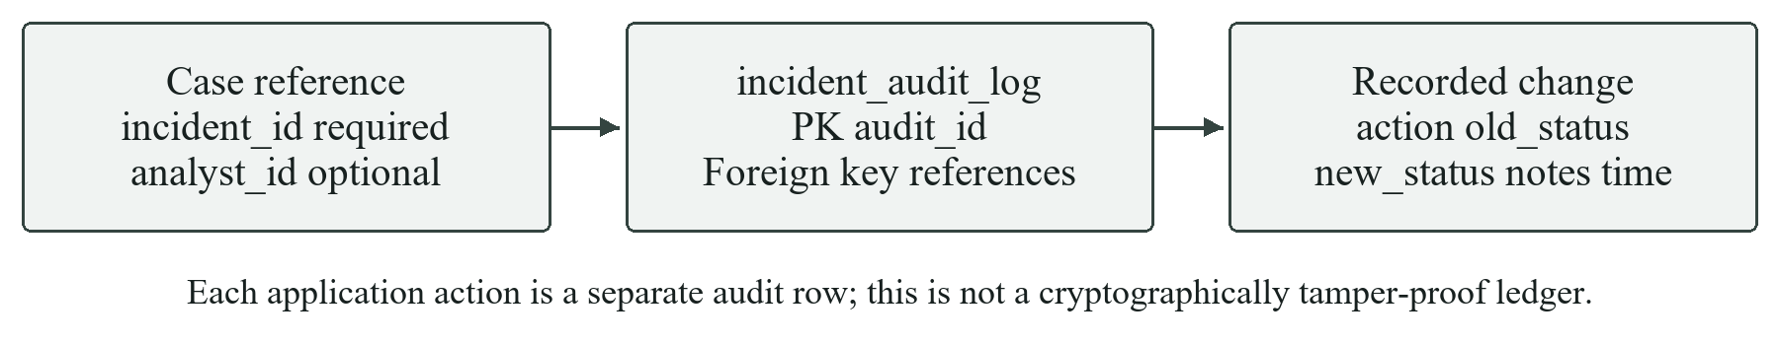
Diagram 16 Relational structure and links of the incident_audit_log table
Source: ml_version/database/schema.sql. The script uses InnoDB, matching key types, explicit relationships and indexes. Database initialisation is separate from normal dashboard use.

7.3 Event storage and indexes
The normalised envelope gives different event types a common query surface while preserving the full source row. This example is explicitly synthetic and illustrates document shape; it is not a record claimed to have been observed in a real office.
{
"event_id": "SYN-DEMO-BRUTE-1",
"timestamp": {"$date": "2026-10-24T09:00:00Z"},
"source_dataset": "synthetic_demonstration",
"event_type": "authentication",
"user_id": "SYN-DEMO-BRUTE",
"source_ip": "192.0.2.10",
"device_id": "SYN-DEVICE-1",
"authentication_result": "failure",
"original_labels": {"is_attack_ip": false, "is_account_takeover": false},
"raw_event": {"data_origin": "SYNTHETIC DEMONSTRATION ONLY"}
}
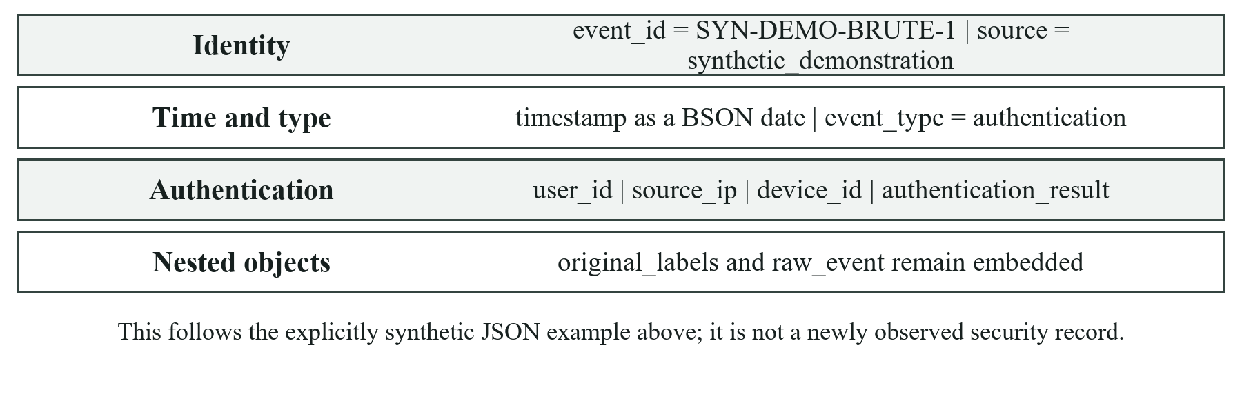
Diagram 17 Reading the synthetic MongoDB event example by document layer
Collection | Index or access pattern
security_events | Unique event_id; timestamp; user_id plus timestamp; event_type plus timestamp; source_ip plus timestamp; source_dataset plus event_id
security_alerts | Unique alert_id and detection_key; timestamp; severity plus timestamp
ingestion_uploads | hidden plus uploaded_at
ingestion_runs | upload_id plus started_at
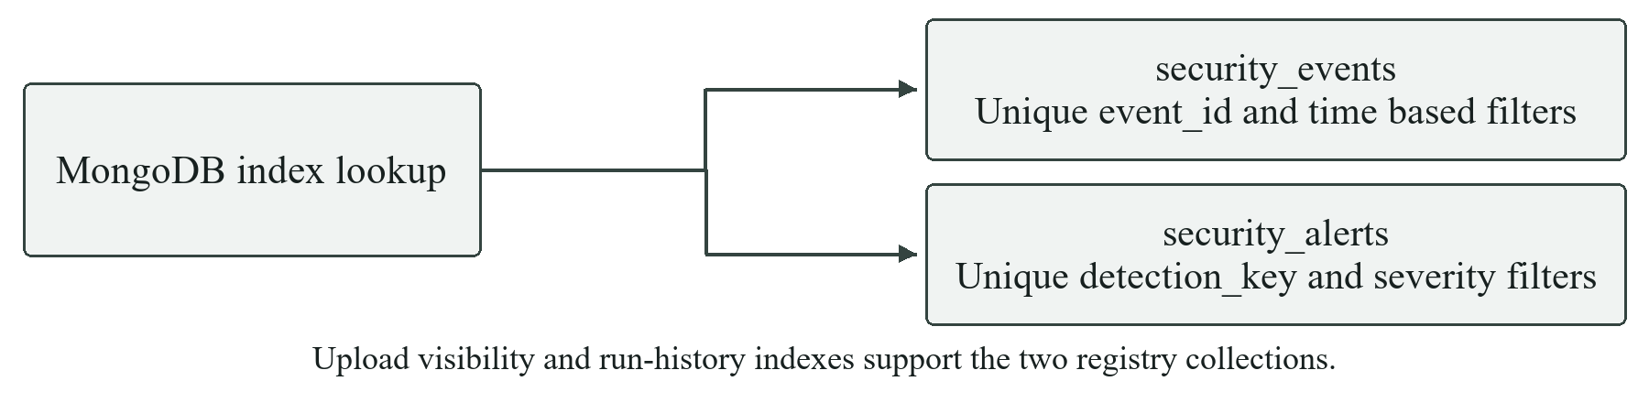
Diagram 18 Indexes support identity checks and frequent evidence retrieval paths
SecurityEventRepository creates unordered batches of UpdateOne operations using $setOnInsert and upsert=True. Existing event IDs or detection keys retain their stored documents; the summary separately reports inserted and duplicate counts. Event retrieval supports page and page_size validation and excludes raw_event from the default list view.
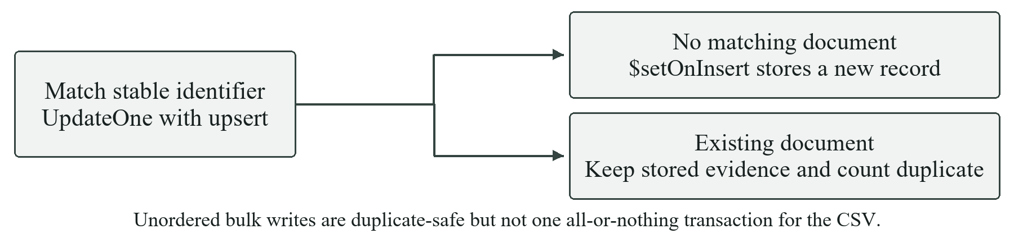
Diagram 19 How event and alert upserts distinguish new records from duplicates
MongoDB document validation in this project is implemented at the Python ingestion boundary; the source does not install a server-side JSON Schema validator. Malformed direct writes made outside the application would therefore need separate database controls.
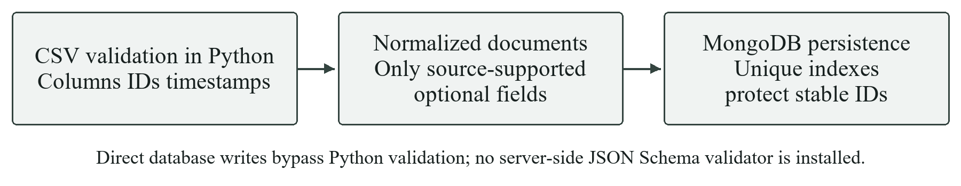
Diagram 20 Validation responsibilities at the Python ingestion boundary

7.4 Dataset provenance and mappings
Supplied file | Inspected quickstart shape | Mapping highlights
rba_authentication_events_quickstart.csv | 5,000 rows and 14 columns | login_timestamp to UTC timestamp; ip_address to source_ip; login_successful to success or failure
unsw_nb15_network_events_quickstart.csv | 4,444 rows and 40 columns | id to source event ID; event_timestamp to UTC; proto to protocol; flow features retained
The supplied archive contains representative development datasets using RBA and UNSW-NB15 field concepts. These are not presented as verbatim official benchmark records. Development files are used after the quickstart pipeline works. No Kaggle account or external download is required for the supplied workflow.
Authentication columns also include country, city, device_id, device_type, os, browser, failure_reason, is_attack_ip and is_account_takeover. failure_reason is optional and has 4,503 missing values in the inspected quickstart file. The two supplied attack indicators are preserved as labels, not used to generate alerts.
The network file contains duration, packets, bytes, rates, TTL, load, loss, timing, jitter and connection-count features, with proto, service and state as categorical fields. attack_cat and label are retained for category analysis and evaluation. Model inputs exclude both labels, row ID, timestamp and endpoint addresses.

7.5 Import validation and file identity
Validation checks required columns, empty datasets, timestamps, missing identifiers and duplicate identifiers. Upload schema detection chooses an appropriate loader, and unsupported or ambiguous inputs produce an error. Model feature preparation also checks required feature columns. The 25 MB application limit bounds in-memory parsing; it is not a general-purpose large-log ingestion service.
New uploads are identified by original filename plus SHA-256 content hash. Reimporting the same file creates another run under the same library record; changing its content creates a separate entry. File-scoped event IDs and provenance prevent otherwise overlapping IDs in different uploaded files from mixing evidence.
Existing sources are discovered from stored MySQL and MongoDB records and made selectable without reimporting them. Inclusion switches filter queries before aggregation, so excluded records do not contribute to totals. Existing sources without a known original file remain source entries rather than fabricated CSV exports.
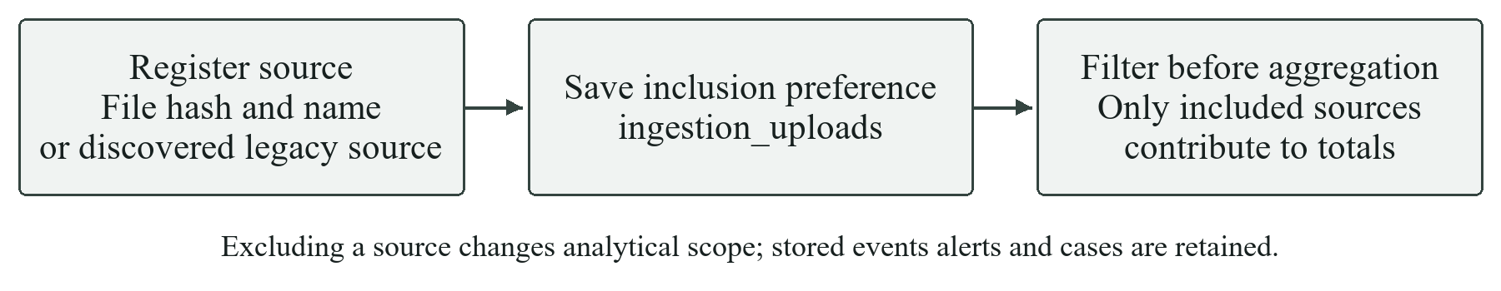
Diagram 21 How file identity and persistent visibility scope dashboard results

7.6 Authentication rules
Repeated failed-login detection sorts authentication failures by UTC time and maintains a deque for each source_dataset and user_id. Events older than the configured five-minute duration leave the deque. At least five failures, including the boundary at exactly five minutes, produce a high-severity alert. A four-failure sequence is a negative control. A suppression interval avoids repeated alerts for the same burst.
Suspicious access examines successful authentication events. By default, three distinct IP and device combinations for the same source-local user within ten minutes generate a medium-severity alert. The implementation counts combinations, not three IPs independently of devices. Missing users are skipped; shared IPs and legitimate device changes can cause false positives. The rule reports suspicion rather than confirmed compromise.
The current rules process the events provided to one pipeline call. They do not maintain a durable cross-upload rolling window. The multi-origin rule emits at most one alert per source and user in a batch. These limits matter when splitting one logical log stream across several files.

7.7 Standard alert and deduplication
Every detector returns a DetectionAlert containing rule_name, timestamp, source_dataset, severity, title, description, event_references and evidence. Stable hashes provide alert IDs and detection keys. MongoDB has a unique detection-key index, and MySQL has a separate unique detection_key constraint. The model version and probability are stored as evidence for model-generated alerts.
IncidentService checks the detection key, obtains the threat category, creates source-local users or observed endpoints when justified, and inserts the incident and creation audit entry in one MySQL transaction. A uniqueness conflict is handled by retrieving the existing case. User and system links remain nullable.
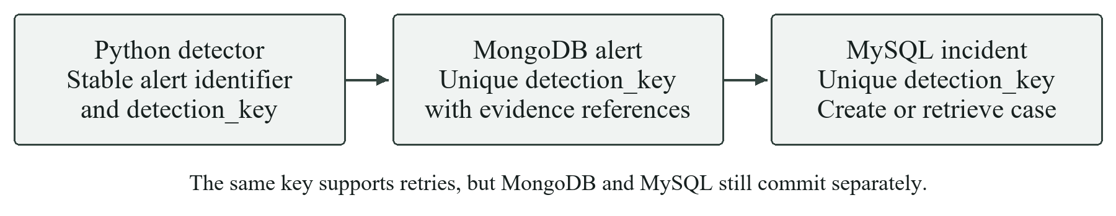
Diagram 22 Deduplicated alerts and incidents share an application detection key

7.8 Response workflow
The analyst can assign a case, move it into investigation, record actions and notes, resolve it, or mark it false positive. Services validate incident and active analyst IDs and preserve audit information. Reassignment closes the previous active assignment; reopening retains the case history. Resolution-time reporting uses case creation rather than the imported event date.

7.9 Model design and measured comparison
The current version uses a scikit-learn RandomForestClassifier with 400 trees, maximum depth 18, minimum leaf size 2, balanced_subsample class weights and random seed 42. A ColumnTransformer imputes numeric features with medians and categorical features with their most frequent value, then one-hot encodes proto, service and state with unknown-category handling. There are 31 numeric and 3 categorical source features.
Training uses 2,666 rows, validation 889 and test 889 from the 4,444-row network quickstart file. A validation search selects a decision threshold of 0.88 while targeting at least 0.95 recall. This is threshold selection, not a separate probability-calibration model. Test labels are used for scoring after training; they are not input features [5].
Same 889 row test split | Rule baseline | Random forest
True positives | 113 | 751
False negatives | 676 | 38
False positives | 16 | 0
True negatives | 84 | 100
Accuracy | 22.16% | 95.73%
Precision | 87.60% | 100.00%
Recall | 14.32% | 95.18%
F1 score | 24.62% | 97.53%
Source: models/network_classifier_metrics.json, training timestamp 10 October 2026. The baseline is evaluated on the same test rows using its batch-derived statistical thresholds. The model substantially reduces false negatives on that supplied split, but 38 labelled attacks are still missed. Zero measured false positives in 100 normal test rows is not evidence that false positives are impossible.
Precision measures the fraction of alerts that correspond to labelled attacks; recall measures the fraction of labelled attacks detected. A binary network prediction does not independently identify a specific attack family. Observed attack_cat distributions remain dataset-label analysis, not model family predictions.

7.10 Overfitting audit
Check | Saved audit result | Interpretation
Training and test F1 | 98.63% versus 97.53% | Gap of approximately 1.10 percentage points
Exact feature duplicates | 0 within quickstart; 0 train to test overlap | No exact duplicate leakage found by this check
Nested five fold recall | Mean 95.87%; range 94.04% to 96.83% | Moderate variation across same-source folds
Chronological holdout recall | 94.42% on 889 rows | Later events remain imperfectly detected
Development-only evaluation | 10,556 rows after removing 4,444 overlaps | Recall 94.89%; 296 false negatives; 0 false positives
Source: models/overfitting_audit.json. The development-only rows are distinct from quickstart after overlap removal, but come from the same prototype generator. These checks do not show a large train-test gap or exact duplicate leakage. They cannot rule out generator-specific patterns, unmeasured leakage or failure on real traffic.
The two largest saved feature importances are spkts and sbytes, together accounting for about 77% of impurity-based importance. This concentration deserves scrutiny: a classifier can exploit generated packet and byte patterns without learning behaviour that transfers to another environment. Feature importance is not causal evidence.

7.11 Advanced SQL analyses
Incidents With Context
SELECT i.incident_id, i.incident_time, i.severity, i.status,
tc.category_name, u.username, s.hostname,
a.name AS assigned_analyst
FROM incidents i
JOIN threat_categories tc ON tc.category_id = i.category_id
LEFT JOIN users u ON u.user_id = i.user_id
LEFT JOIN systems s ON s.system_id = i.system_id
LEFT JOIN assignments assn
ON assn.assignment_id = (
SELECT MAX(a2.assignment_id) FROM assignments a2
WHERE a2.incident_id = i.incident_id
)
LEFT JOIN analysts a ON a.analyst_id = assn.analyst_id
ORDER BY i.incident_time DESC
Incident Counts By Category Severity
SELECT tc.category_name, i.severity, COUNT(*) AS incident_count
FROM incidents i
JOIN threat_categories tc ON tc.category_id = i.category_id
GROUP BY tc.category_name, i.severity
HAVING COUNT(*) >= %s
ORDER BY incident_count DESC
Average Response Time
SELECT tc.category_name,
AVG(TIMESTAMPDIFF(SECOND, i.created_at, i.resolved_at)) AS avg_seconds,
COUNT(*) AS resolved_count
FROM incidents i
JOIN threat_categories tc ON tc.category_id = i.category_id
WHERE i.status = 'resolved' AND i.resolved_at >= i.created_at
GROUP BY tc.category_name
ORDER BY avg_seconds DESC
Incidents Per User
SELECT u.user_id, u.username, COUNT(i.incident_id) AS incident_count
FROM users u
LEFT JOIN incidents i ON i.user_id = u.user_id
GROUP BY u.user_id, u.username
ORDER BY incident_count DESC, u.username
Incidents Per System
SELECT s.system_id, s.hostname, s.ip_address, COUNT(i.incident_id) AS incident_count
FROM systems s
LEFT JOIN incidents i ON i.system_id = s.system_id
GROUP BY s.system_id, s.hostname, s.ip_address
ORDER BY incident_count DESC, s.hostname
Analyst Workload
SELECT a.analyst_id, a.name,
COUNT(assn.assignment_id) AS total_assignments,
SUM(assn.assignment_id IS NOT NULL AND assn.resolved_at IS NULL
AND i.status IN ('assigned','investigating')) AS active_assignments
FROM analysts a
LEFT JOIN assignments assn ON assn.analyst_id = a.analyst_id
LEFT JOIN incidents i ON i.incident_id = assn.incident_id
GROUP BY a.analyst_id, a.name
ORDER BY active_assignments DESC, total_assignments DESC
Unresolved Critical Incidents
SELECT i.incident_id, i.incident_time, tc.category_name, i.description
FROM incidents i
JOIN threat_categories tc ON tc.category_id = i.category_id
WHERE i.severity = 'critical'
AND i.status IN ('open', 'assigned', 'investigating')
ORDER BY i.incident_time ASC
Users Above Average Incident Count
SELECT u.user_id, u.username, COUNT(i.incident_id) AS incident_count
FROM users u
JOIN incidents i ON i.user_id = u.user_id
GROUP BY u.user_id, u.username
HAVING COUNT(i.incident_id) > (
SELECT AVG(user_incident_count)
FROM (
SELECT COUNT(*) AS user_incident_count
FROM incidents
WHERE user_id IS NOT NULL
GROUP BY user_id
) counts_per_user
)
ORDER BY incident_count DESC
Daily Incident Trend
SELECT DATE(incident_time) AS incident_date,
COUNT(*) AS daily_count,
SUM(COUNT(*)) OVER (ORDER BY DATE(incident_time)) AS cumulative_count
FROM incidents
GROUP BY DATE(incident_time)
ORDER BY incident_date
Source Dataset Summary
SELECT source_dataset,
COUNT(*) AS incident_count,
SUM(status IN ('open', 'assigned', 'investigating')) AS unresolved_count,
SUM(severity IN ('high', 'critical')) AS serious_count
FROM incidents
GROUP BY source_dataset
ORDER BY incident_count DESC
Source: analytics/sql_queries.py. %s denotes a bound parameter, not string interpolation. The dashboard adds source-inclusion scope and a row limit. These reports demonstrate joins, grouping, HAVING, nested queries and a window function.

7.12 Aggregation examples
The saved catalogue contains six pipelines [7]. The following examples are valid pipeline arrays for security_events. The dashboard prepends an inclusion filter before grouping so excluded CSVs cannot contribute to aggregate counts.
Observed category distribution
[
{"$match":{"attack_category":{"$nin":[null, ""]}}},
{"$group":{"_id":"$attack_category", "event_count":{"$sum":1}}},
{"$sort":{"event_count":-1, "_id":1}}
]
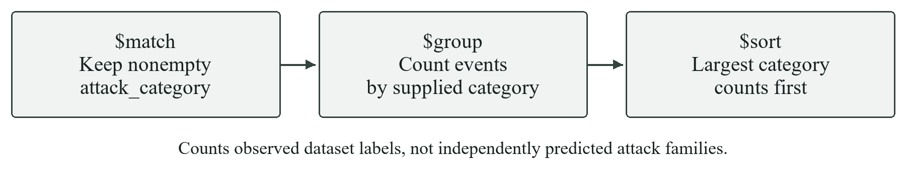
Diagram 23 Observed category distribution aggregation stages
Hourly volume
[
{"$group":{"_id":{"$dateTrunc":{"date":"$timestamp",
"unit":"hour", "timezone":"UTC"}}, "event_count":{"$sum":1}}},
{"$sort":{"_id":1}}
]
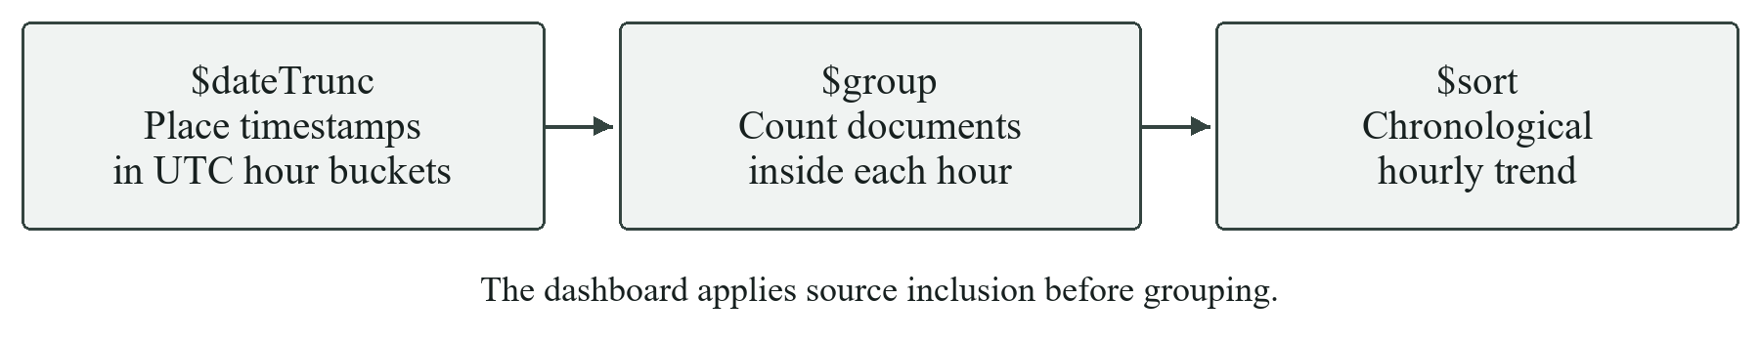
Diagram 24 Hourly volume aggregation stages
Top source IPs
[
{"$match":{"source_ip":{"$nin":[null, ""]}}},
{"$group":{"_id":"$source_ip", "event_count":{"$sum":1}}},
{"$sort":{"event_count":-1, "_id":1}}, {"$limit":10}
]
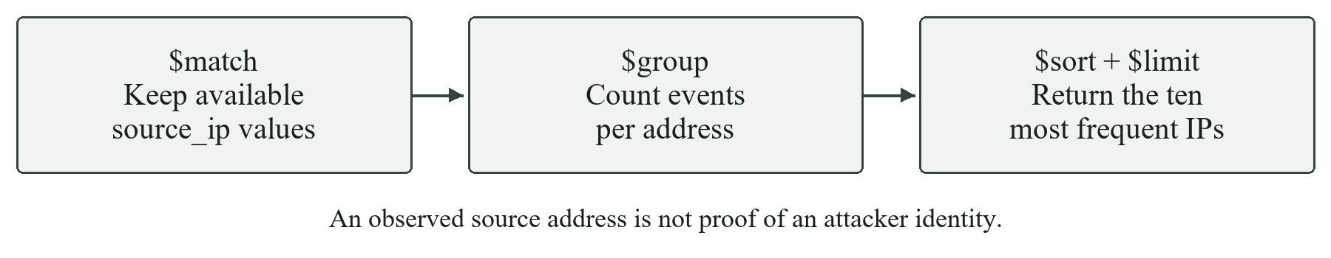
Diagram 25 Top source IPs aggregation stages
Failed logins by user
[
{"$match":{"event_type":"authentication", "authentication_result":"failure",
"user_id":{"$nin":[null, ""]}}},
{"$group":{"_id":"$user_id", "failed_logins":{"$sum":1}}},
{"$sort":{"failed_logins":-1, "_id":1}}, {"$limit":20}
]
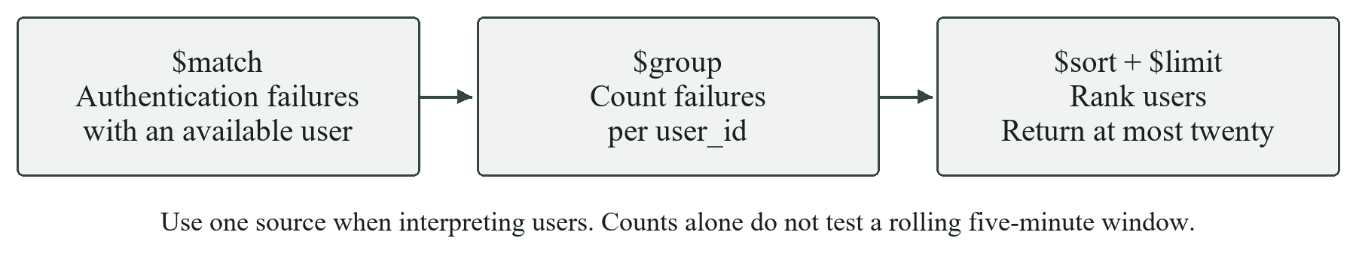
Diagram 26 Failed logins by user aggregation stages
High-severity alerts by rule (uses security_alerts)
[
{"$match":{"severity":{"$in":["high", "critical"]}}},
{"$group":{"_id":"$rule_name", "alert_count":{"$sum":1},
"latest_alert":{"$max":"$timestamp"}}},
{"$sort":{"alert_count":-1, "_id":1}}
]
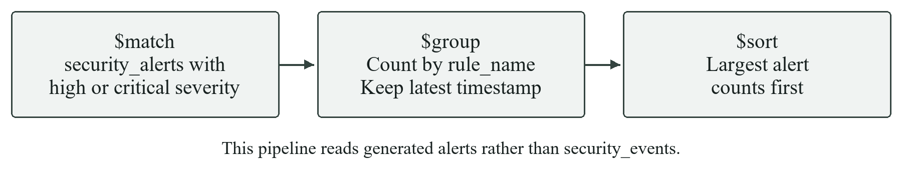
Diagram 27 High-severity alerts by rule aggregation stages
The sixth saved pipeline is a daily event trend, using the hourly pattern with unit set to day. Source: analytics/mongo_aggregations.py. $dateTrunc requires a supported MongoDB server version.
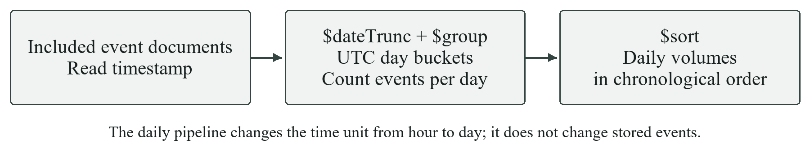
Diagram 28 Daily event trend uses the same grouping concept with day buckets

7.13 Stored procedures and indexes
USE cyber_soc;

DROP PROCEDURE IF EXISTS sp_user_security_summary;
DELIMITER //
CREATE PROCEDURE sp_user_security_summary(IN p_user_id BIGINT UNSIGNED)
BEGIN
SELECT
u.user_id,
u.username,
u.status AS user_status,
COUNT(i.incident_id) AS total_incidents,
SUM(i.status IN ('open', 'assigned', 'investigating')) AS unresolved_incidents,
SUM(i.severity IN ('high', 'critical')) AS high_or_critical_incidents,
MAX(i.incident_time) AS latest_incident_time,
AVG(
CASE WHEN i.status='resolved' AND i.resolved_at >= i.created_at
THEN TIMESTAMPDIFF(SECOND, i.created_at, i.resolved_at)
END
) AS average_resolution_seconds
FROM users u
LEFT JOIN incidents i ON i.user_id = u.user_id
WHERE u.user_id = p_user_id
GROUP BY u.user_id, u.username, u.status;
END//
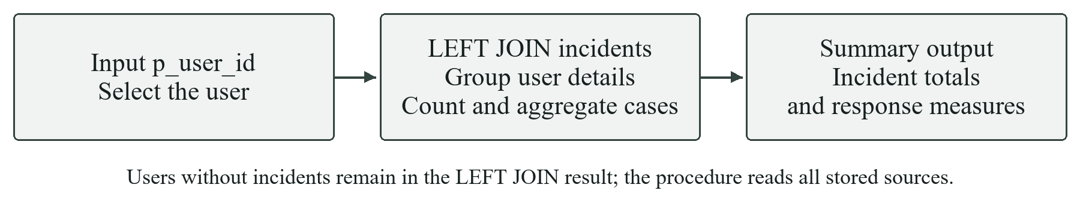
Diagram 29 Execution path of the user security summary stored procedure
The second supplied procedure, sp_resolve_incident, validates the incident and active analyst, locks the incident row, updates resolution fields and assignments, inserts an audit entry and commits. It has an exception handler that rolls back and re-signals SQL failures. The complete definition is in database/procedures.sql.
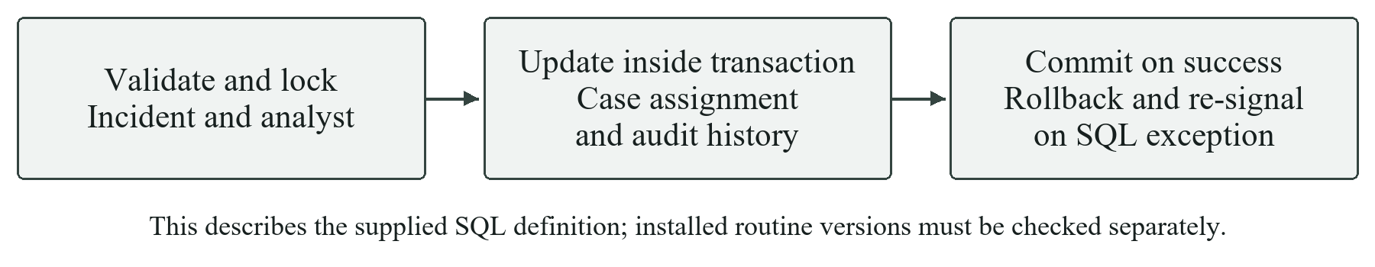
Diagram 30 Transactional execution path of the incident resolution procedure
The Python AssignmentService powers the dashboard workflow. Stored procedure definitions may need administrator routine-management privileges to refresh. The currently installed procedure must be checked against the source version; a successful source edit is not proof of a completed database migration. Its demonstration is disabled while datasets are excluded because the installed procedure reads all stored sources.
MySQL indexes cover incident time, status and severity, identity and system links, category, provenance and active analyst assignments. There are no persistent SQL views installed by schema.sql. Dashboard-specific visible relations are query-time common table expressions rather than stored views.

7.14 Restricted custom query editors
The SQL editor parses one SELECT with SQLGlot [8], checks approved tables and functions, rewrites source-bearing relations structurally, and binds exclusion values. Execution uses a read-only MySQL transaction and a five-second execution limit. MongoDB accepts JSON filters or approved pipeline stages and blocks writes, JavaScript and cross-collection sources. Both editors cap displayed results at 500 rows and check result size against 5 MB.
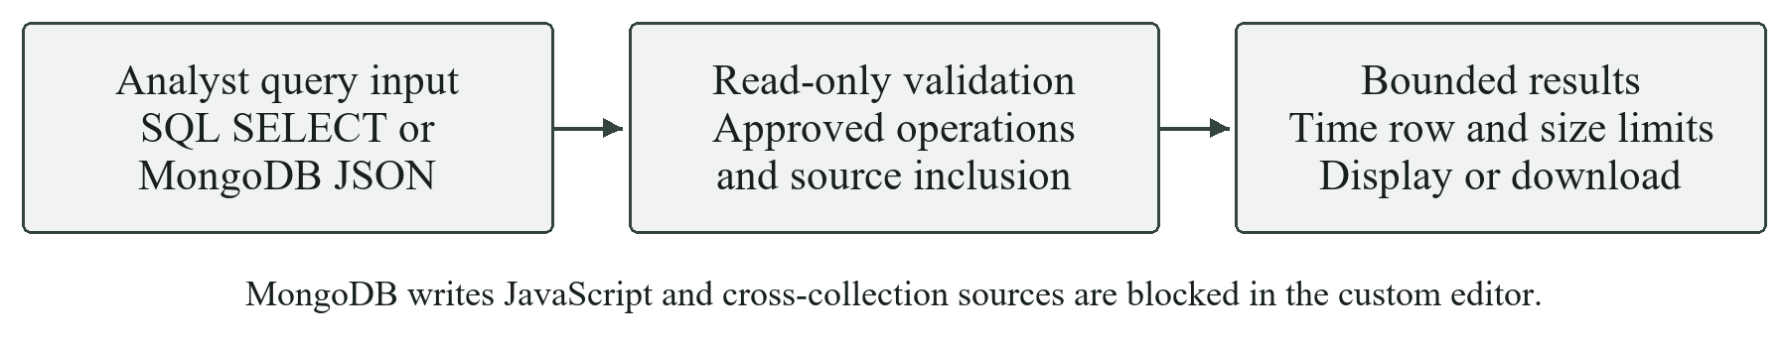
Diagram 31 Read-only query validation and scoped result retrieval

7.15 Verified test results
The saved verification reports dated 24 October 2026 record 97 passing unit and UI tests and 2 passing live database integration tests, with no failures or errors. Unit tests and UI tests use controlled fixtures or database doubles; they are not evidence that a live database connection works. The separate integration checks exercise real MySQL and MongoDB connections.
Test area | Representative checks | Evidence
Authentication rules | Five failures trigger; four do not; time-window boundary; multiple origins | tests/test_detection.py and related detector tests
ETL and validation | Malformed timestamps, missing optional context, empty datasets and supplied labels | tests/test_loaders.py and validation/upload tests
Persistence and response | Duplicate imports/incidents, invalid analyst/status, assignment, resolution and reopening | Repository, service and live workflow tests
Dashboard | Seven views render; filters persist; CSV controls; editor forms and result persistence | tests/test_dashboard.py
Query scope and safety | Writes, unsafe SQL functions, system tables, MongoDB writes and JavaScript rejected | tests/test_custom_queries.py
Live integration | Import to MongoDB; create SQL case; respond; analytics; read-only custom query exclusions | tests/test_response_integration.py
python scripts/verify_project.py
python scripts/verify_project.py --integration
Reports include UTC timestamps, JUnit results and a SHA-256 source fingerprint so the Evidence page can flag changes since verification. The live workflow creates uniquely named synthetic fixtures, rolls back its MySQL rows, and removes only its own MongoDB documents. The custom-query integration check is read-only.

7.16 Failure handling
The application distinguishes validation errors from service failures, closes cursors and connections, rolls back failed SQL transactions and records import failures in run history. Database connection errors do not display credentials. Re-running an interrupted import can reconcile later stages through stable IDs; a dedicated cross-store reconciliation job remains future work.

7.17 Mapping to the supplied evaluation rubric
Evaluation criterion | Marks | Where the project demonstrates it
Application Design and Functionality | 2 | Chapters 3, 4 and 8: modular architecture, ingestion, detection and analyst response
Python Programming Implementation | 2 | Sections 7.4 to 7.10: functions, classes, file handling, validation, exceptions and modular services
Database Integration SQL and NoSQL | 2 | Chapters 5 and 6; sections 7.2 to 7.8: schema, indexes, persistence and evidence linkage
Advanced Querying and Retrieval | 2 | Sections 7.11 to 7.14: ten SQL analyses, six pipelines, stored procedures and custom editors
Code Quality Documentation and UI | 1 | README, mappings, typed modules, shared UI and the seven-view dashboard
Testing Validation Security and Error Handling | 1 | Sections 7.14 to 7.16: parser restrictions, input checks, failure handling and 99 passing checks
The rubric totals 10 marks. This mapping identifies inspectable evidence; the final grade depends on the evaluator’s review and the team’s demonstration. The database application remains the central contribution. The trained classifier is an extension and does not replace database design, advanced queries or response workflow requirements.

7.18 Team organisation
The project spans dataset research and relational design, MongoDB and detection, Python integration and incident services, and interface/testing/documentation. Each group member is expected to explain the integrated workflow end to end. A shared walkthrough connects the original CSV, stored source evidence, generated alert, relational incident and response history.

7.19 Demonstration acceptance path
Start with a fresh synthetic CSV from Data Pipeline. Show validation, stored MongoDB events, generated alerts and MySQL incidents. Open one case, inspect its source evidence, assign an analyst, add a response and resolve it. Return to the analytics views, then exclude and re-include the CSV to demonstrate filtered reporting without deletion. Finish with a joined SQL analysis and a MongoDB aggregation.

8 User Interface

8.1 Command Center and monitoring
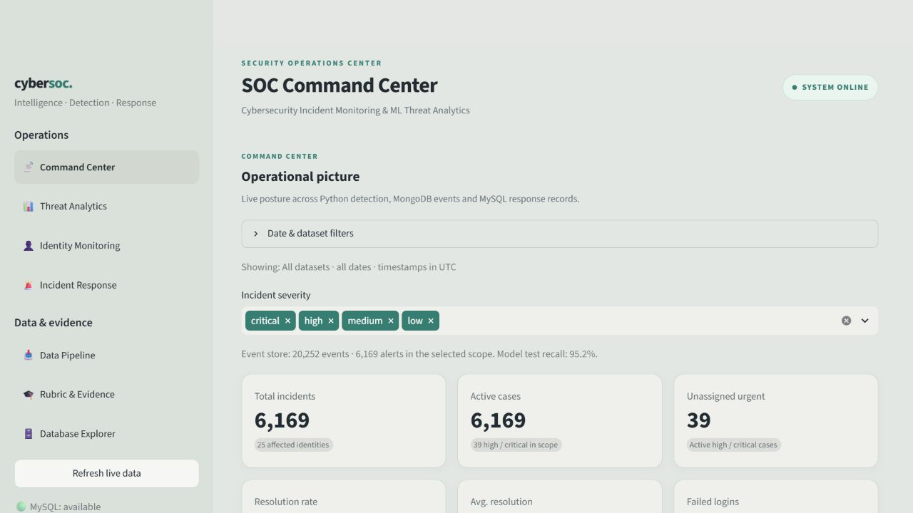
Command Center combines incident KPIs, event-store context and an investigation queue. Date and source filters persist across operational views. Severity and category chart selections can narrow the queue, and high-severity incident IDs are highlighted in red. Sidebar checks report MySQL, MongoDB and model availability rather than merely displaying a decorative online badge.
At capture time, the all-source database snapshot showed 20,252 events, 6,169 alerts and 6,169 incidents, including historical rule-generated and later model-generated cases. All cases were active, with 39 high or critical and 25 affected identities; 545 failed login events were shown. These are stored snapshot counts, not the number of model test rows or a measured deployment detection rate.
View | How an analyst uses it
Threat Analytics | Inspect observed categories separately from generated alerts, time trends and network model evidence
Identity Monitoring | Search source-local users/devices and inspect activity and linked incidents
Rubric and Evidence | Review implementation mapping, connection health and dated verification artefacts

8.2 Data Pipeline and CSV inclusion
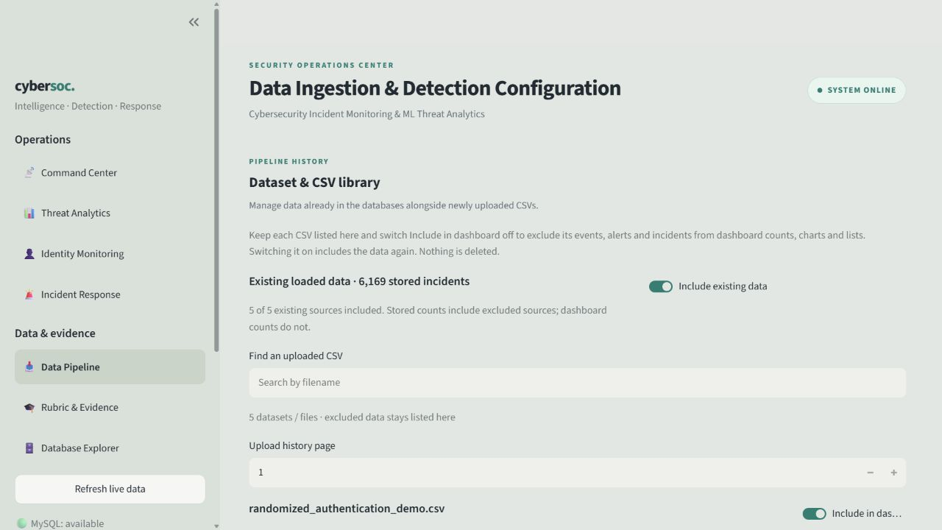
Each CSV remains visible in the library even when its data is excluded. Include in dashboard changes whether the source contributes to incident lists, charts, KPIs and scoped queries; it does not delete stored events or hide the file card. Include existing data controls sources that were loaded before per-upload tracking existed.
For an import, select a supported CSV, inspect the detected schema and preview, choose detection settings and run Validate import and detect. The pipeline summary separates rows processed, newly inserted records and duplicates. Reimporting an unchanged file may report zero new inserts and many duplicates; that is successful duplicate prevention.

8.3 Reproducible synthetic demonstration
The built-in generator creates 12 explicitly synthetic authentication events: five failed logins for one identity, three successful origins for a second identity, and four failures for a negative control. At default thresholds the expected result is two alerts and two incidents. The expected counts are a design target: the observed outcome is whatever the displayed import summary reports, and the two should be compared rather than assumed to match.

8.4 Incident Response
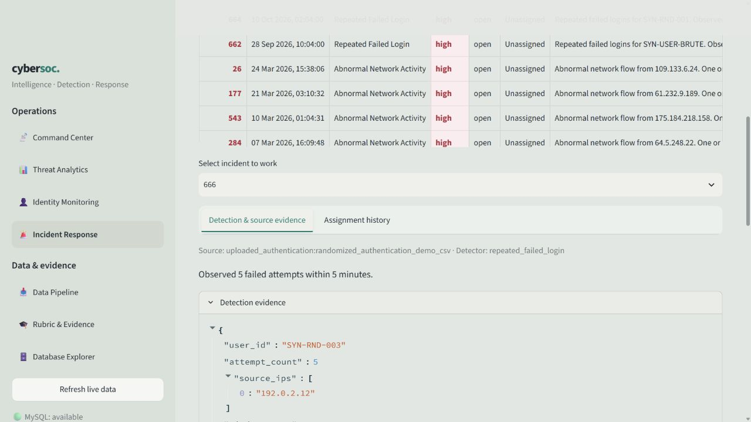
Select an incident, inspect its detection evidence and source events, then assign an active analyst. Change status to investigating, record response actions and notes, and resolve or mark false positive as appropriate. The case’s audit history and assignment history remain available. Response actions record analyst decisions and recommendations; the application does not actually reset passwords or block IPs.

8.5 Database Explorer
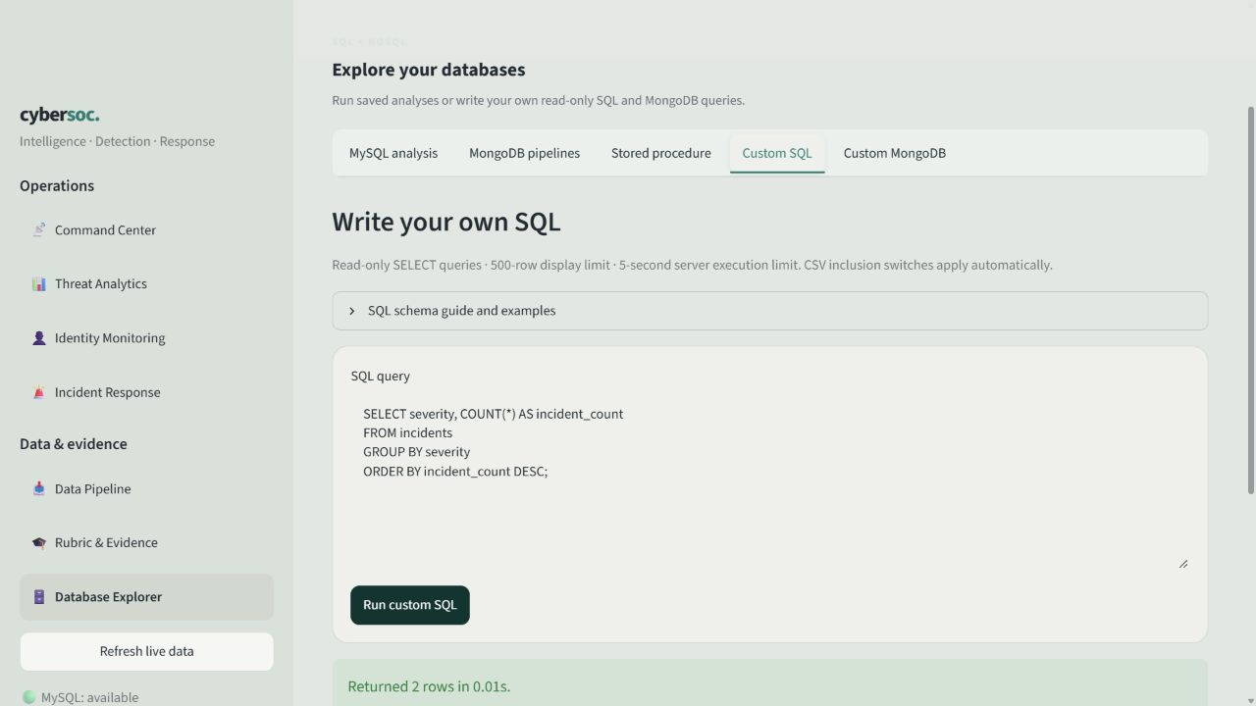
Choose a saved analysis or open Custom SQL / Custom MongoDB. Edit the query, run it and inspect or download the results. The example SQL groups incidents by severity. Unsupported statements are rejected, and source inclusion is applied before aggregation. Stored-procedure behaviour and scope limitations are explained beside its button.

9 Conclusion

9.1 Outcome
The project implements a working path from security CSVs to persistent evidence and accountable incident handling. MongoDB preserves heterogeneous events, generated alerts and import histories. MySQL maintains relational entities, unique incidents, analyst assignments and response audit records. Python services connect these responsibilities, and Streamlit exposes them through monitoring, ingestion, response and database-exploration views.
The trained network extension improves recall from 14.32% for the rule baseline to 95.18% on the same supplied 889-row test split. That result is useful within the prototype but does not eliminate false negatives or establish external generalisation. Authentication alerts remain explainable rules. Observed labels, independent detections and analyst decisions retain different meanings throughout the interface.
The latest stored checks report 97 passing unit/UI tests and 2 passing live database integration tests. The live workflow verifies storage, deduplication, response actions and filtered analytics without retaining its test cases. CSV-level visibility controls make both legacy sources and later uploads independently selectable without destructive deletion.

9.2 Remaining limitations
The current system is intended for a local educational demonstration. It lacks production authentication and role-based permissions, an atomic cross-database commit, durable streaming windows across uploads and independent real-world model validation. Its audit trail records application actions but is not cryptographically tamper-evident. A network address is an observed endpoint, not proof of internal ownership or attacker identity.

9.3 Future work
The next technical priorities are a least-privilege authenticated deployment, a reconciliation/outbox mechanism for partial writes, durable event-window state, and validation on an independently sourced network dataset. Explain plans and representative load tests should guide indexing and pagination changes. Any live response automation would require separate scope, authorisation and safeguards.
The result demonstrates the database concepts required by the course through an integrated security workflow, with technical limitations made explicit rather than hidden behind a polished dashboard.

10 References
[1] United Nations Department of Economic and Social Affairs. Goal 9 Industry innovation and infrastructure.
https://sdgs.un.org/goals/goal9
[2] United Nations Department of Economic and Social Affairs. Goal 16 Peace justice and strong institutions.
https://sdgs.un.org/goals/goal16
[3] Oracle. MySQL 8.0 Reference Manual Foreign key constraints.
https://dev.mysql.com/doc/refman/8.0/en/create-table-foreign-keys.html
[4] MongoDB. Embedded data in your MongoDB schema.
https://www.mongodb.com/docs/manual/data-modeling/embedding/
[5] scikit-learn. RandomForestClassifier API reference.
https://scikit-learn.org/stable/modules/generated/
sklearn.ensemble.RandomForestClassifier.html
[6] Streamlit. Streamlit documentation.
https://docs.streamlit.io/
[7] MongoDB. Aggregation pipelines.
https://www.mongodb.com/docs/manual/core/aggregation-pipeline/
[8] SQLGlot. Parser and expression documentation.
https://sqlglot.com/sqlglot.html
[9] Project source repository. Main implementation at commit 4bee733.
https://github.com/DereFX/cybersecurity-incident-monitoring-dashboard
[10] UNSW Canberra. The UNSW-NB15 Dataset. Official dataset description and source downloads. Accessed 24 October 2026.
https://research.unsw.edu.au/projects/unsw-nb15-dataset
[11] Nour Moustafa and Jill Slay. UNSW-NB15 a comprehensive data set for network intrusion detection systems (UNSW-NB15 network data set). Military Communications and Information Systems Conference (MilCIS), IEEE, 2015.
https://research.unsw.edu.au/projects/unsw-nb15-dataset
[12] Stephan Wiefling, Paul René Jørgensen, Sigurd Thunem and Luigi Lo Iacono. Login Data Set for Risk-Based Authentication. Version 1.0.0. Zenodo, 30 June 2022. Dataset DOI 10.5281/zenodo.6782156.
https://doi.org/10.5281/zenodo.6782156
[13] Stephan Wiefling, Paul René Jørgensen, Sigurd Thunem and Luigi Lo Iacono. Pump Up Password Security! Evaluating and Enhancing Risk-Based Authentication on a Real-World Large-Scale Online Service. ACM Transactions on Privacy and Security, 2022. DOI 10.1145/3546069.
https://doi.org/10.1145/3546069
Dataset provenance. References [10] to [13] acknowledge the original network and authentication research sources. This project processes the representative generated quickstart and development CSVs supplied in cybersecurity_project_datasets.zip, as documented in its README_DATASETS.txt. These files preserve source field concepts but are not verbatim records from the original datasets. The reported classifier scores apply to the supplied project data.

