**Part 1**

# Overview:

This program is used to investigate the pattern of the power meter usage over a few days. It will generate different graphs with a given power meter data. This program will look at the cumulative usage, and plot a graph with the data. This program also produce a non-cumulative graph, to identify the date and time where most power is used. It also generate a graph for each different day allowing you to have an idea of the trends and the usage for each day.

# Guide:

You will need a power meter data file called “formattedMeter.csv” in the same file of the python file. The data file need to follow a “Date,power” format. (Example file is included below, Figure 1) “Date_and_time,Power_meter” is also required for the first line. The Date format is day-month-year (dd-mm-yyyy). While the time format is Hour:Minute:Second (hh:mm:ss). Please not that a space is needed to separate the date and time. A comma is required to separate the time and the power.

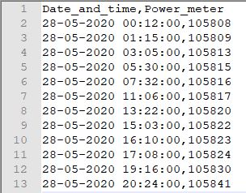

Figure 1 - Power Meter File format

After having the power meter data file, you can proceed to run the program. The program will generate a cumulative and a non-cumulative graph at the current directory of the program. The graph for each day will also be generated, the number of graph generated will depends on the amount of days you have put in the power meter data file.

# Discussion:

By having the power meter data file you will be able to generate the graph that can be used to analyse the power usage. It allows you to identify the highest usage and the lowest usage. You can also look in depth in to each day, and identify the highest usage in that day.

The program read the data file and create a dictionary “Date_and_time” and “Power_meter” with pandas. With this we can generate an cumulative graph by plotting “Date_and_time” versus “Power_meter”. And the program will also create a non cumulative graph with the difference of each values in “Power_meter”. The program will also sort the date and generate a usage graph for each day. This is done through a loop to generate multiple graph.

**Part 2**

# Overview:

This program is used to investigate the power used in each device in an household. It will generate 3 graph, allowing you to see the pattern of the power usage for each device. The graph generated shows the total power used for each device, the amount of hour this devices is used and total power used for each hour. This can be used to see the patter of the power usage in a household each day.

# Guide:

For this program you will need a data file called “myhouse.csv”. The format of the myhouse.csv can be seen below. Please note that the first line of the file must be the residents number with a format (Residents:num) , and the line below should be the device usage data with a format (Device:Power_Rating:Time_used). The Device will be the name of each device , the Power_rating will be the power rating of that device, and the Time_used will be the time that the devices is on. To indicate that the devices is on for 1 hour = 1, half an hour = 0.5, 15 min = 0.25, and off for 1 hour = 0.

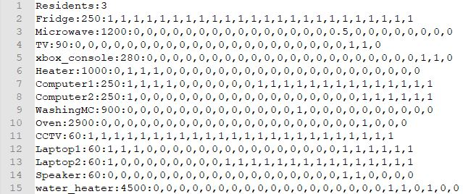

Figure 2 - myhouse.csv file format

After having the data file, you can proceed to run the program. The program will generate the graph of total power used for each device, the amount of hour this devices is used and total power used for each hour.

# Discussion:

By having the formatted data file, this program will generated the following graph, total power used for each device, the amount of hour this devices is used and total power used for each hour. You can then analysis the power that is used for each devices through the graph. You will be able to see the hours that have the most power used and the device that is consuming the most power in that day.

The program reads the file and separate each data, as for hour per device graph, it adds up all the hour of usage in the data file and output a graph. The total power per hour is calculated by summing the (time_used*powerrating). The total power use for each device is done by adding up all the hour used for each device and multiply it with their specific power rating.

**Part 3**

# Overview:

This program is used to investigate the power used in a street/suburb. This program is used to simulate a street/suburb so that we will be able to analysis the power usage in the view of an electricity provider. The graph generated in this program included each different house type and the user can change the house type and the amount of house type using the “streetInfo.csv”. This program also generate graph showing the hour usage of each type of house. And a pie chart of which type of house is using the majority of the power.

# Guide:

For this program you will need a data file called “streetInfo.csv”. The format of this file will be (house type num:file_name:num_of_type). The format can be seen in the picture below.

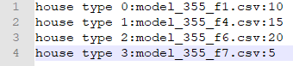

Figure 3 - streetInfo.csv file format

As for the file_name, the file should follow the format in part 2. And it is required to be in the same directory as the program file. This way it allows the user to put any file they want as the house type, and you can add as many house type as possible. The num_of_type is the amount of the house type you want to use for the simulation.

Please not that you will need the Part3Class.py to be in the same directory as Part3.py, in order for the program to run.

With all this data file setup in the exact format, you will be able to run the program. The different graph will be generated as the program execute.

# Discussion:

The program allows the user to put any file they want as the house type, and you can add as many house type as possible in the streetInfo.csv, this is really useful if you are trying to simulate different scenarios and it gives you the flexibility for the simulation.

By having the formatted data file, this program will generated a bar chart with all the types of housing. We will be able to identify and compare the amount of power usage from each type of house. You can also look at the usage per hour graph, allowing the user to compare the usage per hour for each house. At the end there is an graph for total power used as a whole street/suburb. This allows the user to look at the highest and lowest power usage for each hour.