**Topic**:

**What is your project about?**

Although Steven Pinker famously argued that humans are now living in the most peaceful era in the history of our species [1], many contemporaries disagree [2]. One needs only to look at the Syrian Civil War [3], Rohingya genocide in Myanmar [4], or Russian annexation and incursion into the Ukraine [5] to understand why there might be skepticism to the claim. While western democracies may be living in their most enlightened age of humanity, full of modern convenience and materialism, there is absolutely no denying that numerous places teeter on the edge of the other side of the spectrum.

       As such, our project looks to further understand one of these long time conflict zones, Sudan. A country that split into two nations in 2011 [6], has seen numerous and nearly continuous internal conflict since gaining its independence from Egyptian and British claims in 1956. [7] Specifically we aim to identify factors that lead to individuals leaving their homes, who are internally displaced persons, or a refugee to neighboring nations over the course of the most recent conflicts, 2013 through 2015.

**Project Question:**

**What specific question are you seeking to answer with this project?**

How did the intensity of military conflict or war influence the South Sudanese populations to leave their homes to become refugees during the December 2013 through December 2015 time period?

If time permits, additional factors as variation to the treatment variable:

Socio-economic, to include per capita income pre and during, access to work pre and during, access to food and clean water pre and during, access to transportation etc.

Other militarily considerations, to include population distance to military facilities, military range capabilities etc.

Other conflict considerations, distance to conflict, munitions used etc.

**Ideal Experiment:**

**What experiment would you run to answer your question?**

In an ideal experiment, we would examine the percentage of a population leaving their homes, either as IDPs or refugees to another country (response variable). The country examined would then be split in four quadrants by intensity of conflict (in terms of fatalities per 10,000 population). One quadrant would be zero conflict, the next low, then medium and high. This is our treatment variable. Each quadrant would have equal socioeconomic variables (although highly varying within) with access to transportation means, food, water, and other physiological necessities at the onset. We would then compare each quadrant into how many individuals left as the conflict progresses.

**Pick a Study Context:**

**Where can you get the data that (a) measures your outcome variable, and (b) includes variation in treatment variable?**

In order to properly identify our outcome variable as well as variations in treatment, we are going to use multiple data sources.

Our outcome variable is the percentage of population leaving their homes in a specified region. In order to have those numbers we use data from Humanitarian Data Exchange Platform (UN OCHA). This data can be supplemented and corroborated by the Socioeconomic Data and Applications Center (SEDAC).

UN OCHA also has in-depth demographics information that will allow us to determine certain cultural and socio-economic conditions in regions. This data can also be supplemented and corroborated by SEDAC

For determining military capability factors, we will need to understand what type of equipment the Sudanese and South Sudanese Military has, where its located, and what its potential is. While a dataset is not directly built, two CIA factbook documents could be used to construct such data.

Finally, for determining conflict levels and intensity, The Armed Conflict Location and Event Data (ACLED) Project can be used to determine individual battles, their location, as well as the battle damage assessment to the civilian population. This would then be used in conjunction with other datasets to calculate the amount of deaths per capita in a given region.

**Project Design:**

**Given the context you want to study (and the data you can find), what design do you think would be feasible?**

Much of the data is spread across several sources and is often incomplete because there is a lack of infrastructure in these regions or there is conflict. However, there is enough (even if the data is not all consolidated), there is enough to build a picture of South Sudan from 2013-15.

For our control group we would then look at regions within South Sudan which did not experience conflict, or limited intensity conflict, over the same period. From this we could then do a region level analysis of high intensity conflict in South Sudan and compare it to the low intensity conflict region, and do a difference and difference analysis of what percentage of the population is displaced based upon the proximity of conflict.

**Model Results:**

For this experiment we will be using a difference and difference analysis with the treatment variable being conflict.

Results if hypothesis is True:

If the hypothesis is true, we will see a change in the migration trend from the control vs experimental group. Additionally, the trend will continue throughout the course of the conflict.

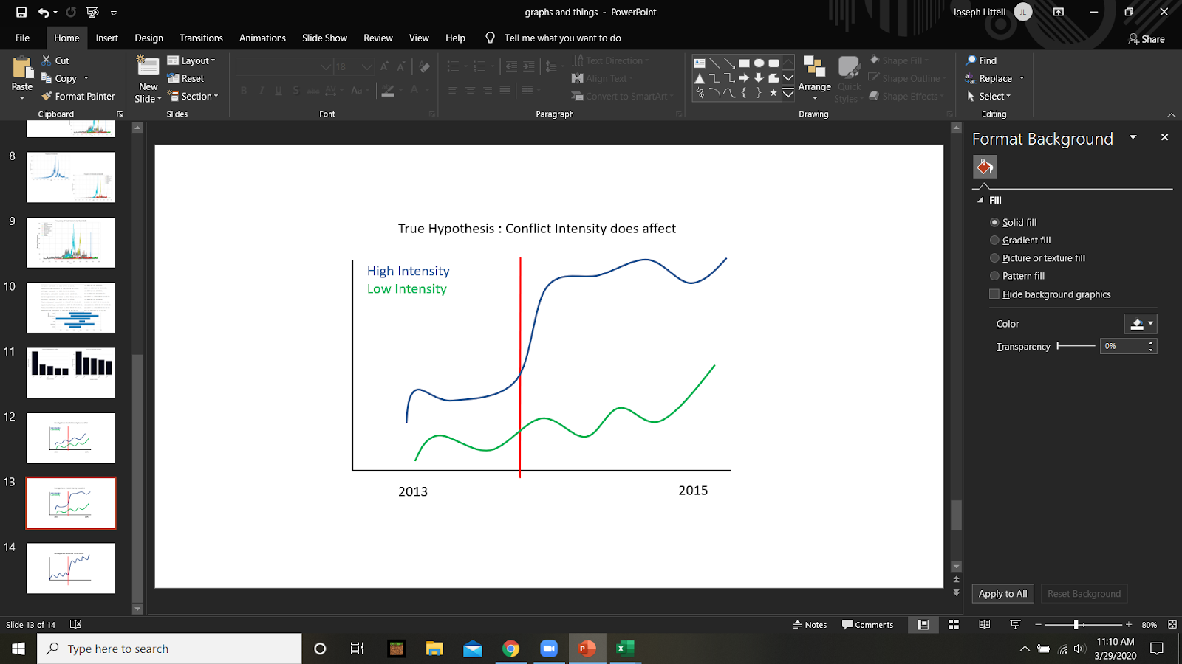

Results if hypothesis is False:

There will be no meaningful change in the control and experimental countries, or conflict could decrease migration.

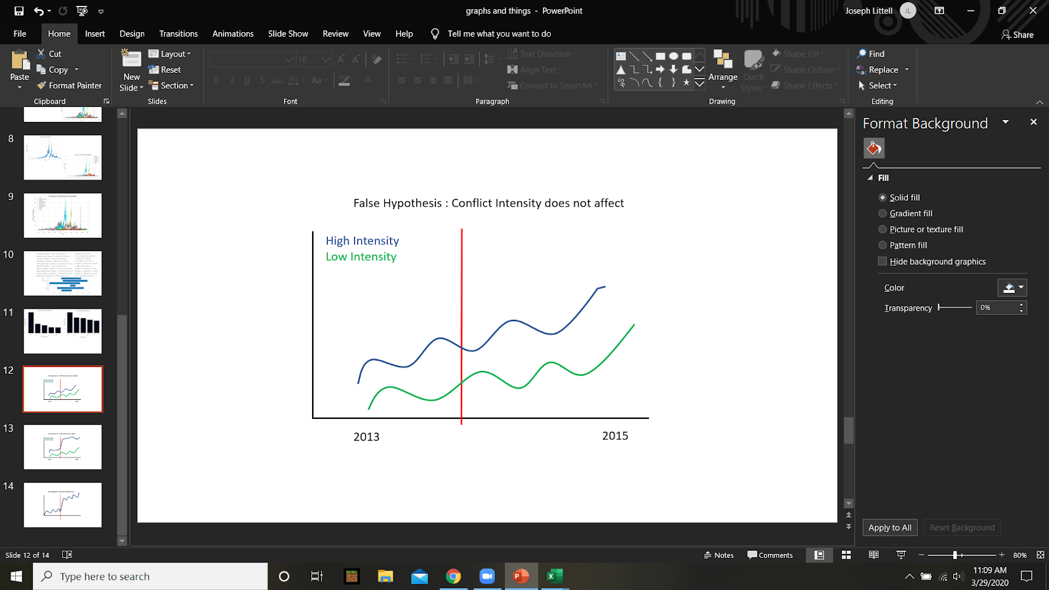

**Final Variables Required:**

Regional demographics and socio-economic factors for each region in both the control. As well as the intensity of the conflict by region (fatalities per 10000 citizens). Our response variable will be all forms of emigration (displacement, seeking asylum, etc) as a percentage of the population.

**Data Sources:**

South Sudan Poverty levels: <https://data.humdata.org/dataset/world-bank-poverty-indicators-for-south-sudan>

South Sudan Settlement data: <https://data.humdata.org/dataset/south-sudan-settlement-data>

South Sudan Conflict: <https://data.humdata.org/dataset/ucdp-data-for-south-sudan>

South Sudan road network: <https://data.humdata.org/dataset/south-sudan-road-network>

South Sudan IDPs: <https://data.humdata.org/dataset/south-sudan-displacement-multi-sectoral-village-assessment-idps-returnees-iom-dtm>

South Sudan rainfall, conflict, and food insecurity: <https://data.humdata.org/dataset/rainfall-conflict-and-food-insecurity-measurement-in-post-succession-sudan-and-south-sudan>

South Sudan IDPs: <https://data.humdata.org/dataset/south-sudan-displacement-multi-sectoral-village-assessment-idps-returnees-iom-dtm>

South Sudan refugees form ss: <https://data.humdata.org/dataset/unhcr-asylum-seekers-originating-ssd>

South Sudan refugees in SS: <https://data.humdata.org/dataset/unhcr-asylum-seekers-residing-ssd>

South Sudan IDPs: <https://data.humdata.org/dataset/idmc-idp-data-for-south-sudan>

Socioeconomic indicators: <https://data.humdata.org/dataset/unesco-dsei-south-sudan>

Population estimates 2008-15: <https://data.humdata.org/dataset/south-sudan-county-population-estimates-2008-2015>

Population estimates 2015-2020

<https://data.humdata.org/dataset/south-sudan-county-population-estimates-2015-2020>

food prices

<https://data.humdata.org/dataset/wfp-food-prices-for-south-sudan>

<https://international.ipums.org/international/index.shtml>

<https://international.ipums.org/international-action/sample_details/country/sd#sd2008a>

<http://popstats.unhcr.org/en/resettlement>

<https://www.cia.gov/library/publications/the-world-factbook/>

**References:**

[1] <https://stevenpinker.com/taxonomy/term/4265>

[2] <https://www.scientificamerican.com/article/steven-pinker-this-is-historys-most-peaceful-time-new-study-not-so-fast/>

[3] <https://www.cfr.org/interactive/global-conflict-tracker/conflict/civil-war-syria>

[4] <https://www.hrw.org/world-report/2019/country-chapters/burma>

[5] <https://www.brookings.edu/blog/order-from-chaos/2019/03/18/five-years-after-crimeas-illegal-annexation-the-issue-is-no-closer-to-resolution/>

[6] <https://www.bbc.com/news/world-africa-14069082>

[7] <http://countrystudies.us/sudan/20.htm>