**Abstract**:

In less than two years after gaining its independence from Sudan, South Sudan was plunged into civil war. After two years of indiscriminate violence, nearly 285 thousand South Sudanese citizens were killed, with another 3.5 million displaced from their homes [1]. As with other contemporary wars in the continent and across the globe, many civilians caught in the crossfire had to make the decision to leave their homes or their family for safety. Although many decided to leave, a large portion stayed behind. This study aims to understand the factors that led some individuals to flee, while others sat through the horrors of civil war. Using data from various sources to include the United Nation’s Office of Humanitarian Assistance (UN OCHA)[2] and High Commissioner for Refugees (UN HCR)[3], the Armed Conflict Location and Event Data Project (ACLED)[4], and the South Sudan National Bureau of Statistics (SSNBS)[5], we determined how various factors pertaining to poverty, access to transportation, potable water and health care, and gender and child populations affect county level displacement and migration levels per capita.

**Introduction:**

Many people in academia and news media argue that human society is living in the most peace time in history. [6] Despite the relative peace, large scale conflict and genocide are happening all across the globe as civil wars rage in Syria [7] and the Ukraine [8], and Rohingyas are slaughtered in northwestern Myanmar. [9] Despite these large-scale conflicts, these regions all still house millions of people, vulnerable to the ill-effects of war. It is with this that simply the level of intensity of a conflict, or how many people die per capita, is not the sole determining factor of population displacement. All to common are news editorials depicting non combatants living in hollowed out abodes in Aleppo, Syria, or gang violence going unabated in the favelas of Sao Paolo, Brazil.

If a certain segment of the population would not leave regardless of the violence around them, we hypothesis that other factors must be at play. In order to understand the why, we attempted to create a dataset factoring in different demographics and variables affecting South Sudan in its civil war lasting from December 2013 through December 2015. In doing so, we collected information from various trusted sources such as UN OCHA, UNHCR, ACLED, and SSNBS. This allowed us to look at access to various goods and services, as well as key demographics within the country when accessing their effects on migration.

Ultimately, understanding why people do not leave these regions can allow for better planning in the onset of these conflicts by organizations like the United Nations HCR and OCHA, US Aid, and various other Non-Governmental Agencies responding to humanitarian crisis around the globe. With strong modeling, IDP and Refugee encampments can be in place faster, with the adequate number of resources required for the predicted population that is inbound.

**Background:**

South Sudan has been in perpetual conflict since Sudan gained independence from England and Egypt in January 1956. [X] Before officially gaining independence, a lack of representation amongst the Muslim dominated newly formed government caused guerilla warfare to break out in the predominately Christian southern region of Sudan. From 1955 to 1972, Sudan’s first civil war ravaged the newly independent country, leaving half a million people dead. [X] A relative peace lasted for nearly 11 years before a second civil war broke loose, leading to a 22-year conflict that ultimately led to the independence of South Sudan. [X]

With South Sudan’s independence in 2011, migration into the region was greatly increased, however it wasn’t without its struggles, natural disasters caused large internal displacement in 2012 (figure 1), however most were able to return home before hostilities arose. South Sudan was also in a number of small conflicts during these two years (as seen in figure2) where border clashes with Sudan were common, as well as fighting off factions of Joseph Kony’s Lord’s Resistance Army.

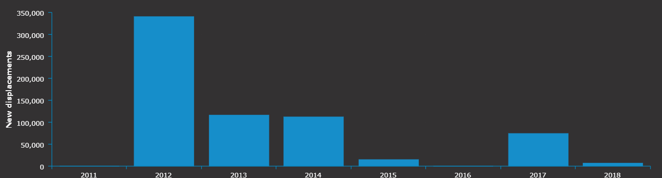

Figure 1: South Sudanese New IDPs from 2011-2018 caused by disaster

This in-migration outpaced these smaller conflicts and was steady until December 2013 when President Salva Kiir Mayardit accused his Vice President Riek Machar and ten other politicians of attempting a coup d’état. For the next two years, South Sudan was once again plunged into war, however this time instead of being a Christian minority fighting against the Muslim Majority to the north, the fight was mainly across ethinic lines, where President Kiir’s Dinka majority attacked Vice President Machar’s Nuer minority. Due to the sectarian violence, numerous attacks were against unarmed civilians as opposed to attacks against military targets that caused collateral damage to the civilian population. Another major issue was do the number of deaths caused outside of war, due to the lack of access to food, clean water, and basic health care.

After the civil wars end in December 2015, most IDPs still remained away from their home, either due to lack of physiological necessities in the area, they had nothing to physically return to, or the underlying ethnic tensions made it dangerous to return. Although major fighting stopped in 2015, an uneasy truce has gone on through 2020.

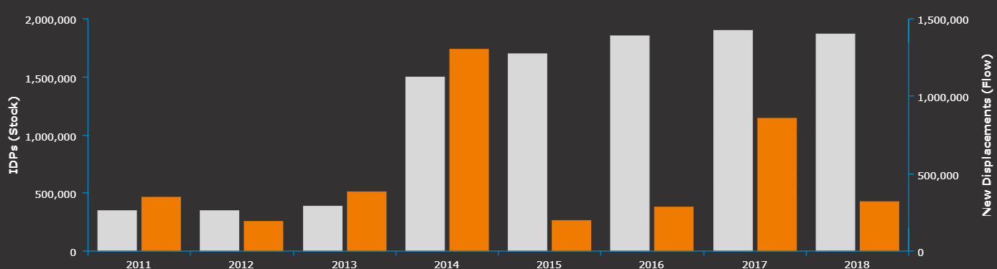

Figure 2: South Sudanese new IDPS (organge) and total (seen in gray) from 2011-2018 caused by conflict

**Data:**

Data was sourced from multiple agencies and non profit groups to include the United Nations HCR and OCHA, Armed Conflict Location and Event (ACLED) Data Project, and South Sudan’s National Bureau of Statistics.

The final data is as follows:

|  |  |  |
| --- | --- | --- |
| Column name | Data Type | Description |
| State | String | Identifier for the State within South Sudan (10 in total) |
| County | String | Identifier for the county within a state within South Sudan (86 in total) |
| Year | Integer | All data was tabulated by yearly aggregates |
| Population | Integer | Estimated data based on census data from UN OCHA |
| Pop_percent_Change | Float | Percentage of the population change from the year prior. |
| Fatalities | Integer | Numeric count of deaths caused by the conflict summed at the county, state, and year aggregate |
| Intensity | Float | Numeric count of fatalities per 10,000 population |
| Hospitals | Integer | Numeric count of operational primary care hospitals within a county |
| ESTIMATED YIELD | Float | Numeric count of fresh water by 1000 gallons in a county |
| Population_Percent_child | Float | Percentage of the population that is under the age of 18 (not inclusive) within a county |
| Population_Percent_Female | Float | Percentage of the population that is female within a county |
| Poverty_rate | Float | Percentage of population that falls under the UN Poverty rate of 2 USD per day. |
| Airport | Categorical | The highest level of airport within a region, where Large is an International Airport, Medium is a recognized regional airport, and small is a county airstrip predominately for private aircraft. |
|  |  |  |

Data on the fatalities within the conflict are aggregated by event through the ACLED. This data was grouped by state county and year, summing all fatalities in a locality for that year, ranging from the county’s independence in 2011 through the final ceasefire in December 2015. This data was then used to group counties by high or low intensity conflict, where the average of the intensity in the conflict, which are the years 2014 and 2015, is over one per ten thousand. This intensity variable by county created our control and treatment groups.

Population, population demographics, water yield, hospitals and airport data were taken from UN OCHA’s Humanitarian Database (HDX) from both UN HCR and UN OCHA sources. Population was taken yearly from 2011 through 2015, as were the children and female demographics. In order to create the Pop_percent_chance variable, we took the population from the year prior, subtracted it from that year’s population, then divided it by the population. This acted as our response variable. Water yield was surmised over county and state for the year 2014, during the height of the conflict. Hospitals and airports were both counts of operational facilities in a region in 2014.

Finally, poverty data is from South Sudan’s National Bureau of Statistics. This data was calculated based on UN Poverty level of less than two US dollars per day earned per capita. Due to the conflict, the only data for the region comes from the year 2008, prior to the conflict. Due to the increase in stabilities until December 2011, we assume that these percentages are actually lower than what they would have been once the conflict began.

**Methods:**

Since we hypothesize that the intensity of conflict at a county level is the main driving factor to population displacement and movement, we wanted to see what other factors could lead to increased or decreased populations when the intensity of conflict is the same. From this we attempted to first determine reasons we believed that could cause individuals to leave their homes then see if we could find data that represented those reasons. In doing so we determined that access to physiological needs, food, water, shelter were most important. Next, we determined that demographics to include number of women and children, ethnic make up, and religion were key variables. Finally, we decided that health care and access to transportation to move both out of the country and within the region would be most useful.

Unfortunately, all of the factors that we ideally wanted to test did not have data, or was not as granular down to the county or yearly level. Data that was non-existent was access to transitable roads and building infrastructure. Data that was missing or not complete include food price, population that was IDPs or refugees, ethnic and religious make-up. In order to determine migration, we relied on population change, which means that inter-county moves would not be seen, and certain low intensity of conflict regions would likely see an increase in population

In order to determine the severity of these factors, we conducted a difference in difference where the treatment variable was the county’s intensity of conflict, or the number of deaths per 10,000 persons in the population, that was over one during the years 2014 and 2015. Our response variable was the percentage of the population that left year over year. We also conducted a pre and post from the Country’s independence to the start of the conflict, and the entirety of the conflict through the ceasefire in December 2015.

**Results:**

The majority of our findings show that there is an issue with the correlation between the various factors and the percent population change, with the exception of our county level findings themselves. When looking at county level, with our indicator variables for the beginning of the conflict, and the intensity of that conflict we se our highest r-squared value. Our hypothesizes as to why this is occurring will be in greater depth when we address the county level findings.

For our pre-post, our hypothesis that population would trend down once the conflict began was true, however, due to the disasters and drought in 2012, the population was already trending downward overall. The start of the conflict saw only a 1.3 percent decrease in population overall, however this does not account for those who move internally, as they would still be considered within the population as they were added to another region.

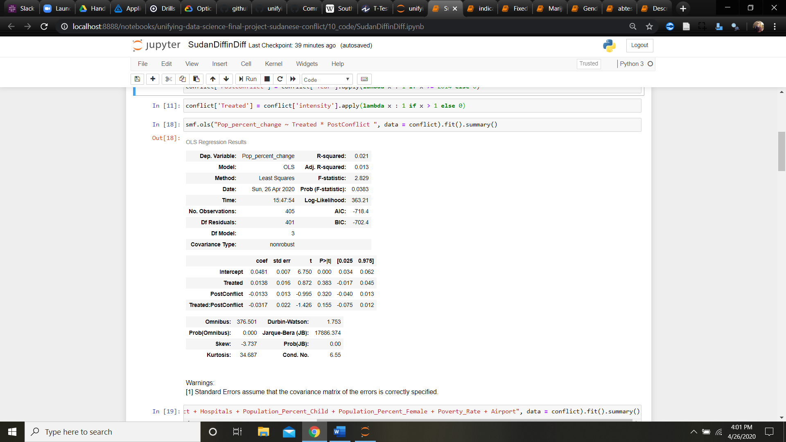

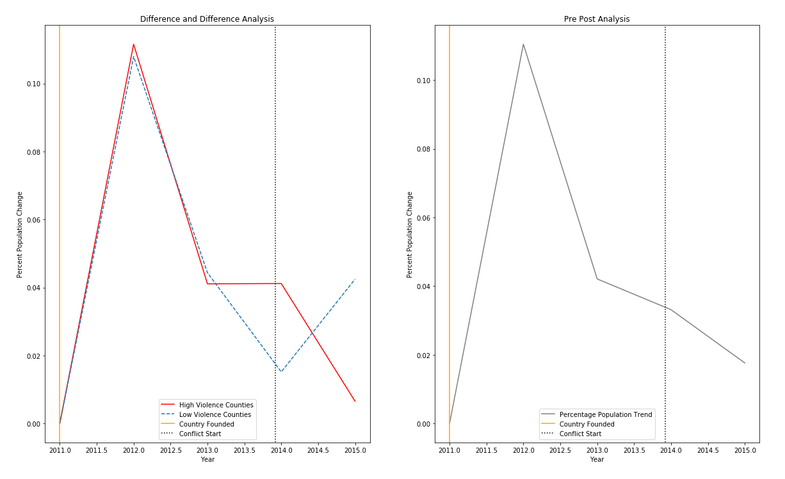

Figure 3: Pre-Post of South Sudan Percent Population Change.

Luckily, due to splitting our counties based off of intensity of conflict by county, we are able to capture the internally displaced persons per county based off of the amount leaving high intensity counties for those of low intensity. With this we see the internal migration from our treatment group to our control be -3.17% overall.

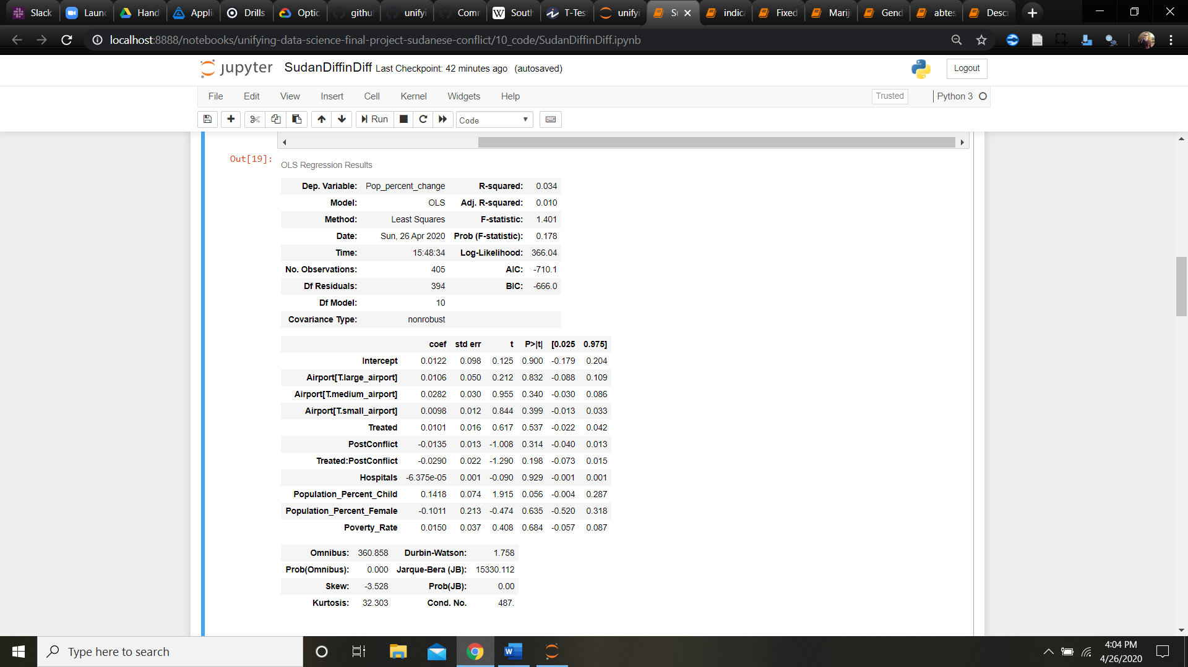

Our variables also paint an interesting picture of factors for people staying in a conflict zone. An increase of one percent (0.01 numerically in our model) in the percentage of population that is female decreases of the population change by over 10 percent (-0.1011 with a 95 percent confidence interval between -0.5020 and 0.318). This is contrary to our findings with children, where a one percent (0.01 numerically in our model) increase in the under 17 population actually saw an increase in the overall population change by 14 percent. (0.1418 with a 95 percent confidence interval between -0.004 and 0.287). Poverty, access to hospitals, and access to transportation saw negligible changes between 1 and 2.8 percent increases in the population change, with high estimates seeing increases to 3.3 to 10 percent on the high end of our confidence interval. This may correlate with urbanization allowing for a certain level of protection and security from the conflict.



Figure 4: Difference in Difference of Percent Population Change versus Intensity of Conflict

When controlling for counties themselves, only 6 of the counties saw a positive percent of population change. These counties are Aweil Centre, Baliet, Longochuk, Mundri West, Rumbek Centre. The remaining counties all saw a decrease in percent of their population through the war. Since this correlation is the highest with this account, compared to the other factors previously observed and tested, we are led to believe there are other untested factors that most likely explain why people migrated during this conflict. Given much of the writing with regards to the civil war revolves around sectarian violence between the two main ethnic groups, population density of these ethnic groups may play a strong role into why people migrated.

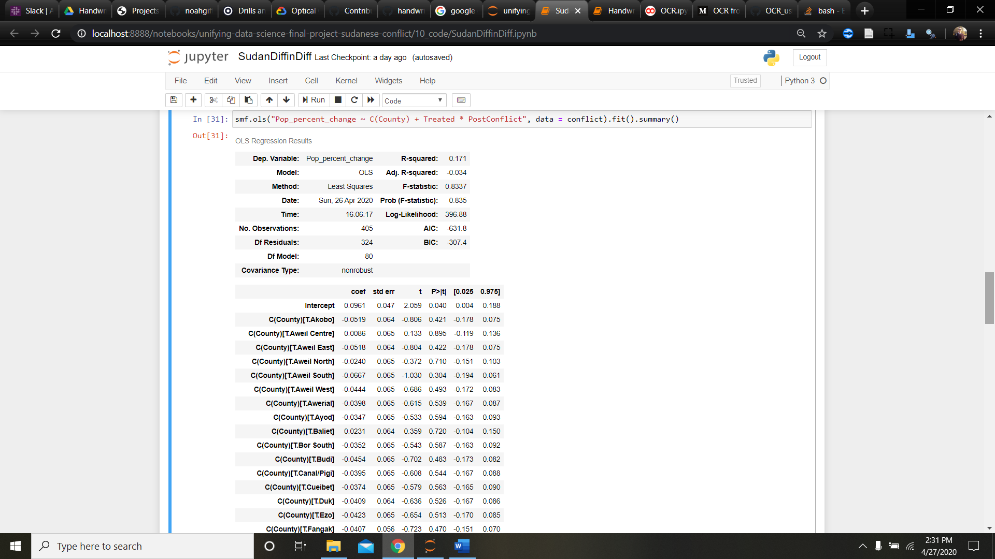

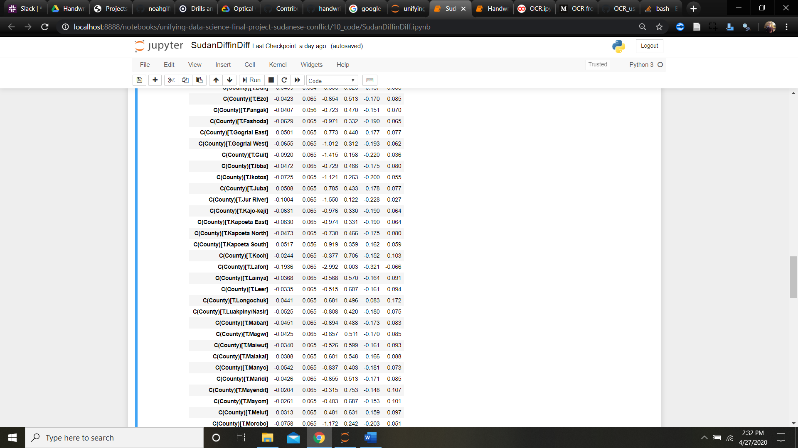

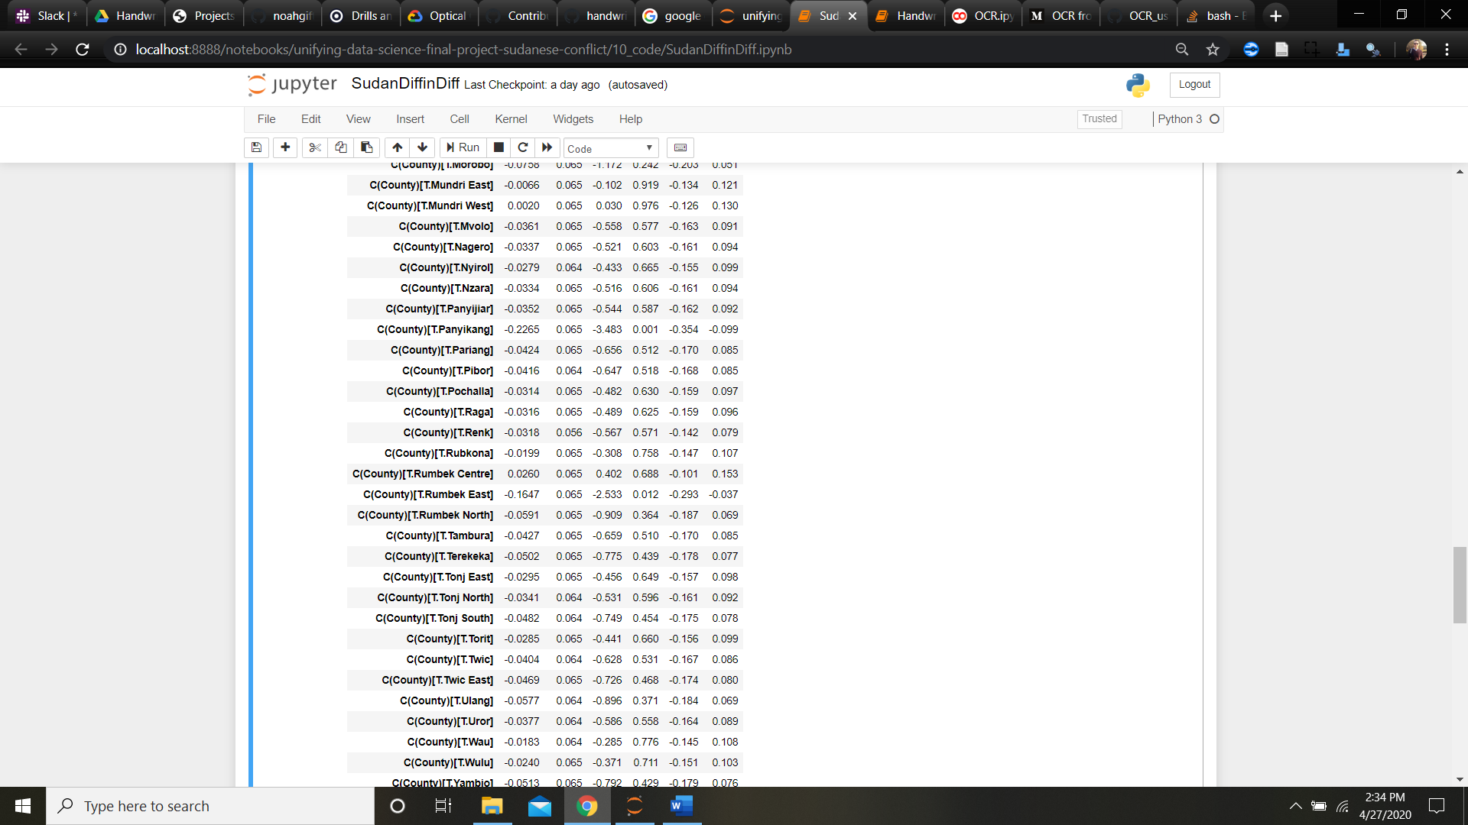

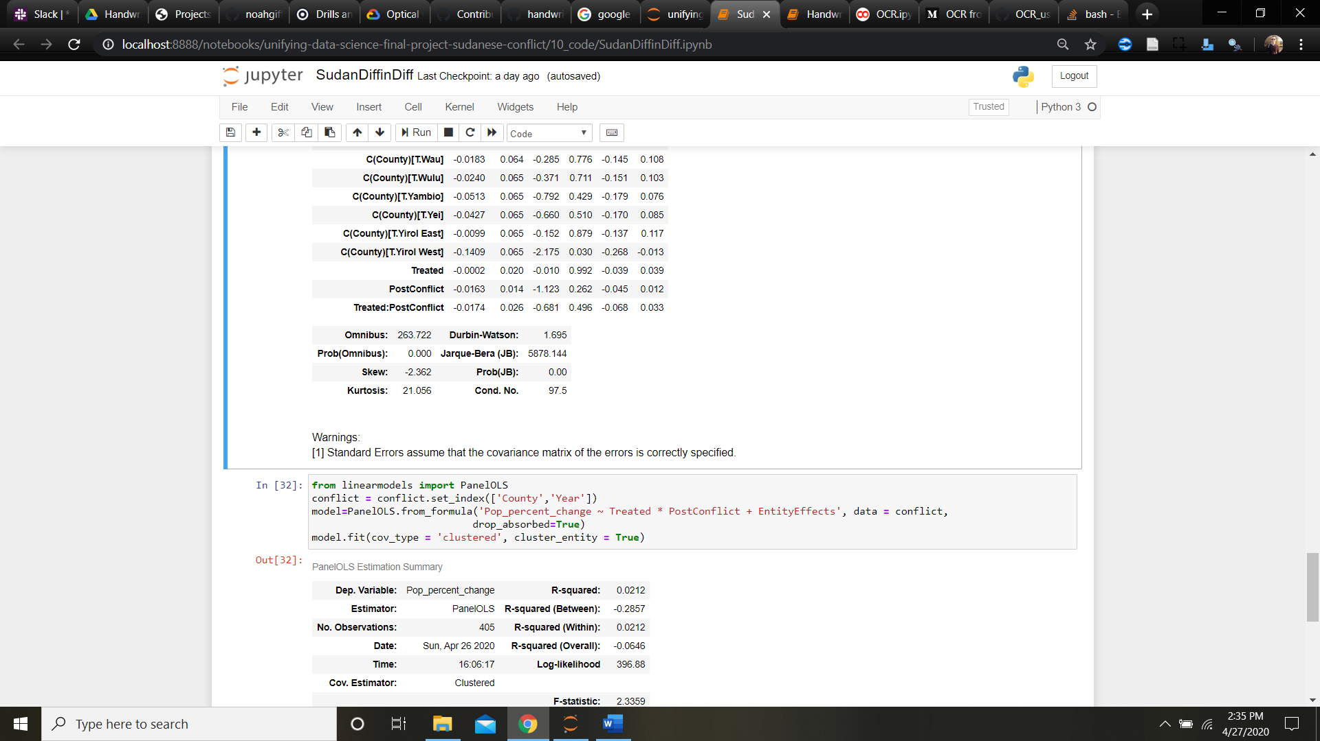

**Conclusion:**

Through our testing and research, we’ve found various factors, to include gender and age demographics, urbanization, and ethnicity are likely compounding factors to migration caused by violence and conflict. Unfortunately due to limited data, we were not able to get into greater detail on some of the other factors that we believed to be present in an individual’s calculus for becoming a refugee or seeking asylum, we believe that these first steps are important to understanding these factors, to ultimately better support the conflicts and humanitarian crisis’s through planning around them.

**References:**

[1]