**SEng 310 – Assignment 4 by Derek Roberts (v00698880)**

**Cognitive Walkthrough**

**Role: Physics 122 Instructor**

**Task: Share Resource.pdf with the class**

**Step 4: Click Add New Resource**

When *the Add New Resource* popup appeared the user said “I wish things opened in the middle,” and then dragged the popup from the top left of the screen to the centre. Although not severe enough to stop the user or cause confusion it added an extra step and contributes to a worsened user experience. Windows should open either in the centre of the screen or at least over the already open window.

**Step 7: Enter Description**

When presented with a field labelled *Description* and a text box large enough to accommodate 14 lines of text before needing the scrollbar the user said “but I don’t want to enter anything!” This is far too large and prominent for an optional field and appears to require a significant amount of text. It should be renamed from *Description:* to *Comments (Optional):* and the text field made much smaller.

**Step 8: Notify Recipients**

Although selecting checkboxes for *Students, Teaching Assistants* and *Instructors* was straightforward there was no mention of how they will be notified. Further explanation through either a question mark button or clearer labels would help. *Notify Recipients* could instead say *Notify by Email*. Adding notification options, like *By Email* or *At Next Login* should help as well.

**Step 9: Click Submit**

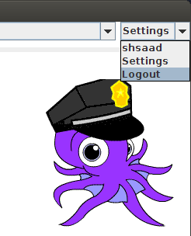After clicking submit button the user asked, “How do I know it went through?” There was no feedback and the final GUI is intended to simply add it to the on-screen list of resources. A successful addition is not apparent, so a notification of some kind should be added. Either present the new addition more prominently (bold, outline or highlight) or use a popup confirmation like “resource added successfully.”

**Step 10: Logoff**

*Logoff* and *Settings* are accessed by a combobox under a combobox showing the user’s name. A more explanatory title, like *Settings and Sessions*, would help. Rather than a combobox a recognizable icon, like a gear, or pull-down menu would be more appropriate.

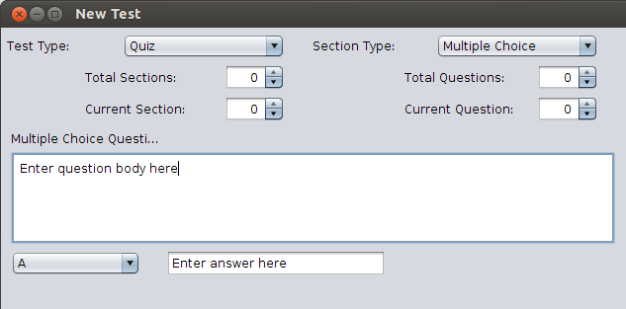**Role: Physics 122 Instructor**

**Task: Create a quiz**

**Step 5: Enter a question**

The use of number boxes reading Total Sections, Current Section, Total Questions and Current Question is unclear. Instead, use clear buttons like Add Question and Add Section. Simplify navigation with buttons like Next/Previous Question and Next/Previous Section.

**Step 6: Enter an answer**

Multiple choice answers are filled-in by taking a single combobox and changing it from one answer to the next. Instead all answers A-Z, should be listed in a row, with simple controls, like Add or Remove.

**Step 8: Click Submit**

After clicking submit button the user asked “I need to see that I actually created a test.” Once again there was no clear feedback. A popup showing the title of the quiz, when it will become available, for how long it will be available, who will receive it and how they will be notified should be presented. It’s starting to look like feedback in this prototype is a real point.

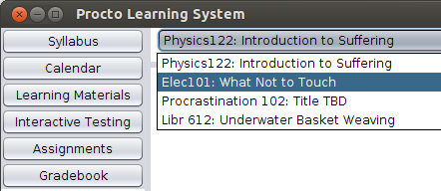

**Role: Elec100 Student**

**Task: Take test #3**

**Step 2: Change class combobox to Elec100**

The user spent at least 30 seconds navigating through the accordion (at left) and after finding the current class (top centre) navigates between classes said “I expected that to be in the accordion, like everything else.” Since the most navigational elements are in that area the class navigation should either be in or just above the accordion.

**Step 4: Click on Test #3**

The option to take a test is small and hidden under Interactive Testing in the accordion. The user likely found test #3 because the task was to take and find this test. Has this not been the case a test could easily have gone unnoticed, so the site should notify the user immediately after login that there is a test waiting. An email should also be sent when or before that test is made available.**Usability Inspection for PRTO#3**

**Visibility of System Status**

Since this is a web site and requires internet connectivity a green/red light or other way to show connection would be helpful.

**Match Between System and the Real World**

On the first screen after logging in as a student shows Modules as the most prominent table, but what are modules? Tests 4 and 5 are listed under Inactive Tests, but what does that mean? Have they not been completed? Are they complete, but not yet available to students?

**User Control and Freedom**

Revising and revisiting tests was simple and straightforward. Undo/redo in text fields worked properly.

**Consistency and Standards**

Latin text aside, everything was easy to find prominently placed and made sense.

**Error Prevention**

Not quite enough functionality to test this thoroughly, but looking good!

**Recognition rather than Recall**

All content is prominently displayed making navigation and recognition easy. Well done!

**Flexibility and Efficiency of Use**

On login screen tab moves between username and password fields, but pressing enter does not begin login. Instead login button must be pressed or navigated to using tab and then pressing enter. This is inconsistent, which might be worse than preventing keyboard navigation entirely. All else is good.

**Aesthetic and Minimalist Design**

Dislike the colours, but the layout is great!

**Help Users Recognize, Diagnose and Recover from Errors**

Clicking *Add New Test* without first entering a title prompts with “Alert: Please enter a test title.” Incorrect login name or passwords receive similar alerts. Excellent!

**Help and Documentation**

Not currently present.