**Name – Ekaansh Sahni**

**Registration no. – 11903816**

**Roll no – A15, Group – A Section – K19RD**

Question no. 3 – Colour mapping of Temperature Scalar field using MATLAB/C++/C/Python.

Solution –

I have used Python language for this question. As I have been given the temperature data of various countries, I used that data to plot the World map with different ranges of colours.

For making the world map, I have used a python library called PyGal. It makes the task very easy for mapping and plotting graphs.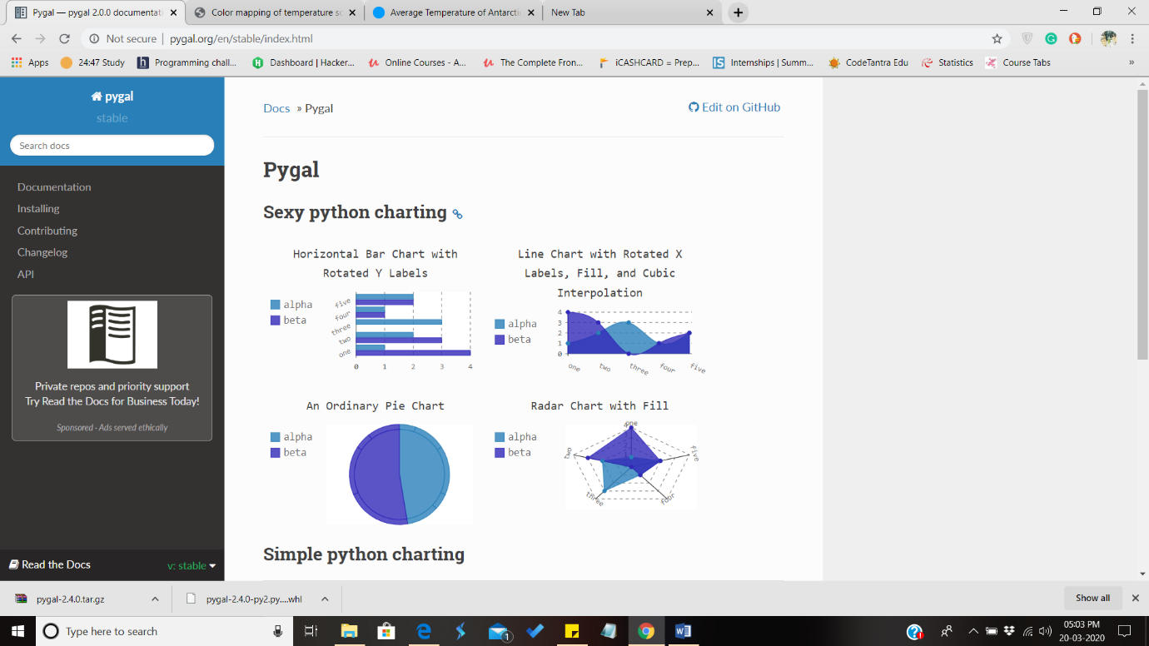

With this, I have created the perfect colour mapped world map of annual temperatures.

Here’s my code –

*import pygal*

*worldmap_chart = pygal.maps.world.World()*

*worldmap_chart.title = 'Color mapping of temperature scalar field on March 20'*

*worldmap_chart.add('below 0 Degrees', {*

*'ca': -5.35,'gl': -10,'mn':-0.7,'aq':-20,'ru': -5.1*

*})*

*worldmap_chart.add('Above 0 and below 15', {*

*'af': 12.6,'al': 11.4,'ad': 7.6,'tj':2,'ua':8.3,'ar': 14.8,'ee': 5.1,'cn': 6.95,'am': 7.15,'az': 11.95,'by': 6.15,'be': 9.55,'bt': 7.4,*

*'bo': 21.55,'at':6.35,'bg': 10.55,'ch':5.5,'cl':8.45,'cz':7.55,'de':8.55,'dk':7.5,'ee':5.1,'es':13.3,'fi':1.7,'fr':10.7,*

*'gb':8.45,'ge':5.8,'hr':10.4,'hu':9.75,'ie':9.3,'is':1.75,'it':13.45,'jp':11.15,'kg':1.75,'kr':5.7,'kp':11.5,'kz':6.4,*

*'li':5.65,'lt':6.2,'lu':8.65,'lv':5.6,'mc':13.55,'md':9.45,'me':10.55,'mk':9.7,'nl':9.25,'no':1.25,'np':8.25,'nz':10.55,*

*'pl':7.85,'pr':15,'rs':10.55,'ro':8.8,'tr':11.1,'se':2.1,'us':8.55,'si':8.1,'sk':6.7,'uz':12.05,'sm':11.85*

*})*

*worldmap_chart.add('Above 15 and below 25', {*

*'in': 23.5,'br': 24.95,'vn':24.45,'tw':20,'tz':22.23,'uy':17.55,'ug':22.8,'pt':15.15,'py':23.55,'rw':17.86,'bf': 20,*

*'co': 24.95,'eg': 22.1,'au': 21.65,'sa':24.85,'bd': 25,'bi':19.8,'bw':21.5,'cd':24.55,'cf':24.9,'cg':24,'ci':20,'cr':24.8,*

*'cv':23.4,'cy':18.45,'do':24.55,'dz':22.5,'tm':15.1,'tn':19.2,'ec':21.85,'gr':15.4,'gt':23.4,'hk':20,'hn':23.5,'ht':24.9,'id':23,*

*'il':19.4,'iq':21.4,'ir':17.25,'jm':24.95,'jo':18.3,'ke':24.75,'lb':16.4,'ly':21.8,'ma':17.1,'mg':22.65,'mu':22.35,'mt':19.2,*

*'mw':21.19,'mx':21,'mz':23.8,'ni':24.9,'pe':19.6,'pk':20.5,'ye':23.85,'zm':24.1,'zw':21,'st':23.75,'sy':17.75*

*})*

*worldmap_chart.add("Above 25", {*

*'bn': 26.85,'pg':25.5,'tg':27.15,'ph':25.85,'th':26.3,'tl':25.25,'ve':25.35,'sc':27.15,'pa':25.4,'my':25.4,'cm':26.6,*

*'cu': 25.2,'sn':27.85,'sd':26.9,'sr':25.7,'so':27.05,'ga': 25.1,'gw': 26.75,'bz': 25.3,'bj': 27.55,'ae': 27,'bh': 27.15,*

*'cm':26.6,'dj':28,'er':25.5,'gh':27,'gm':27.7,'gn':25.7,'gu':26,'gy':26,'kw':25.35,'lk':26.95,'ml':28,'mr':27.65,'mv':27.65,*

*'ne':27.15,'ng':26.8,'sg':26.45,'sl':26.05*

*})*

*worldmap_chart.render_to_file('map.svg')*

It’s hard to understand on a word document so I am giving the screenshot also with this –

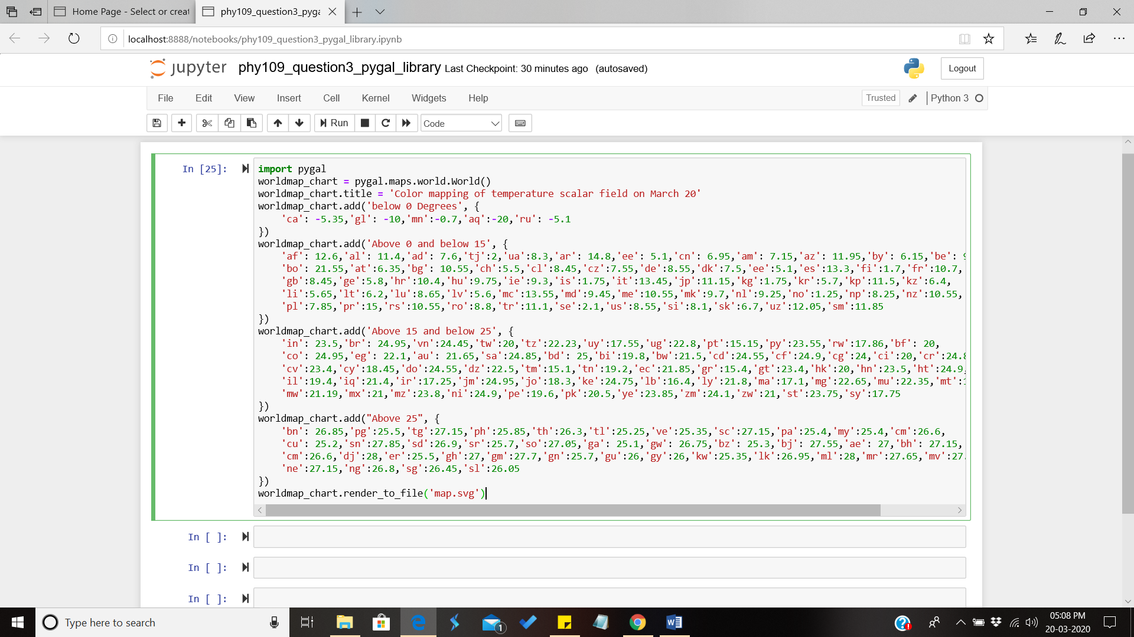

Let me explain the code line by line now, first I have imported the library then I have made a world map chart by initializing it. Then I added the title for the map, then I went on to put the required data. Finally I rendered the world map to a .svg file extension. Now let me tell you how I put the data, I used the given temperature data and coded it with their respective country codes as shown in the code.

This is the csv file of temperature-

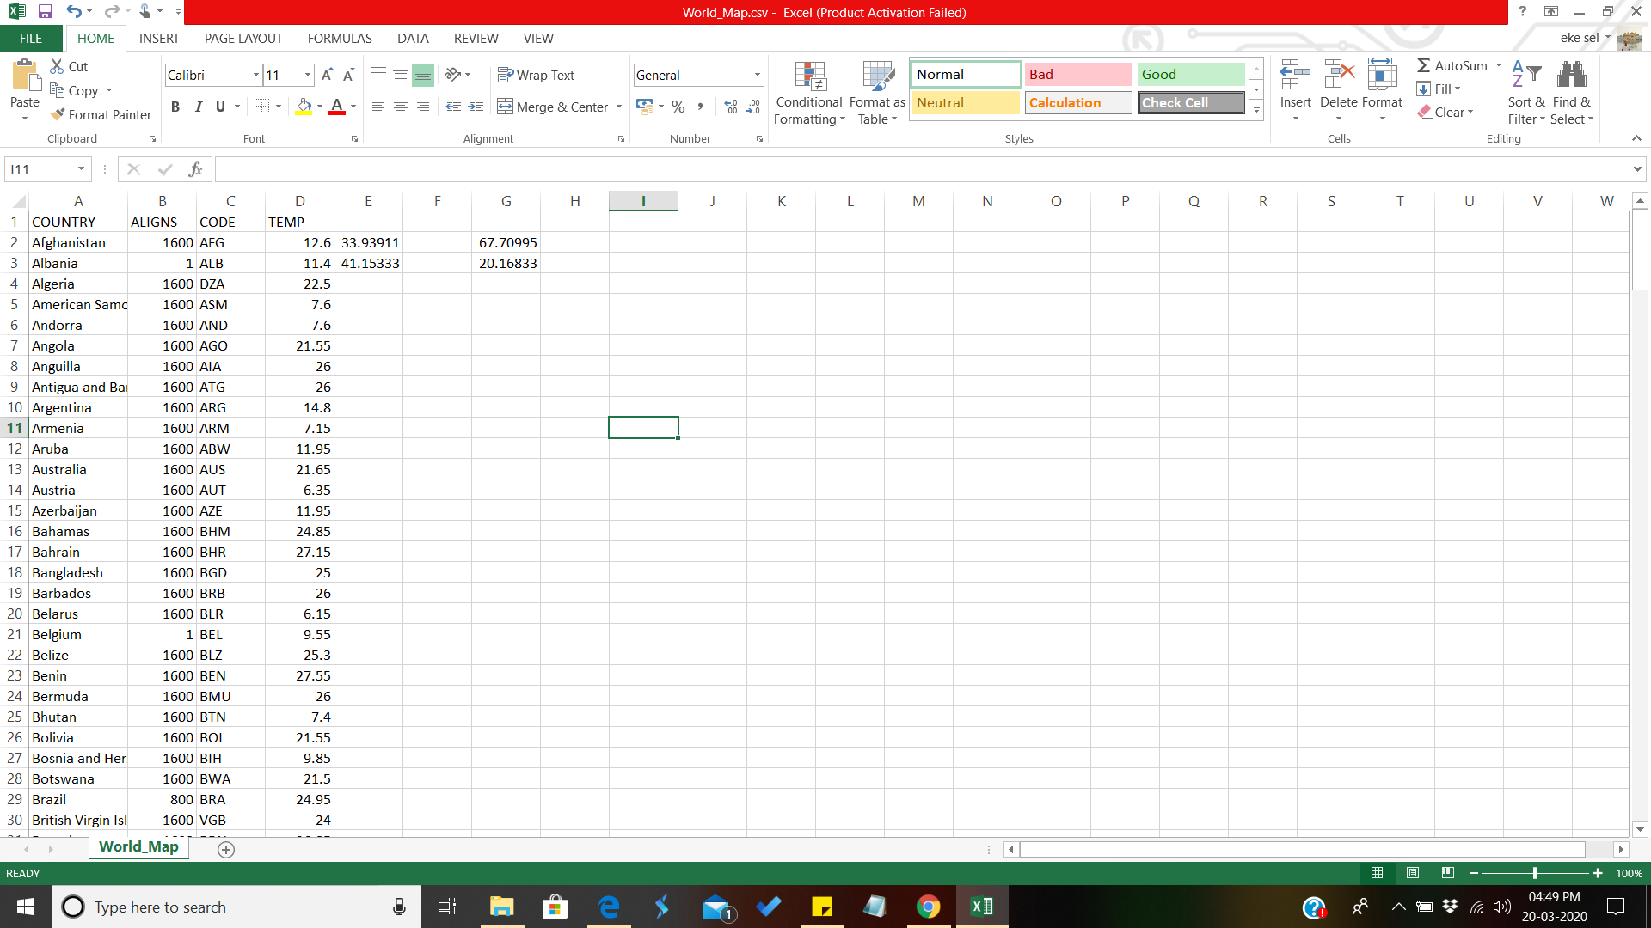

This is the respective country codes given in library’s documentation site 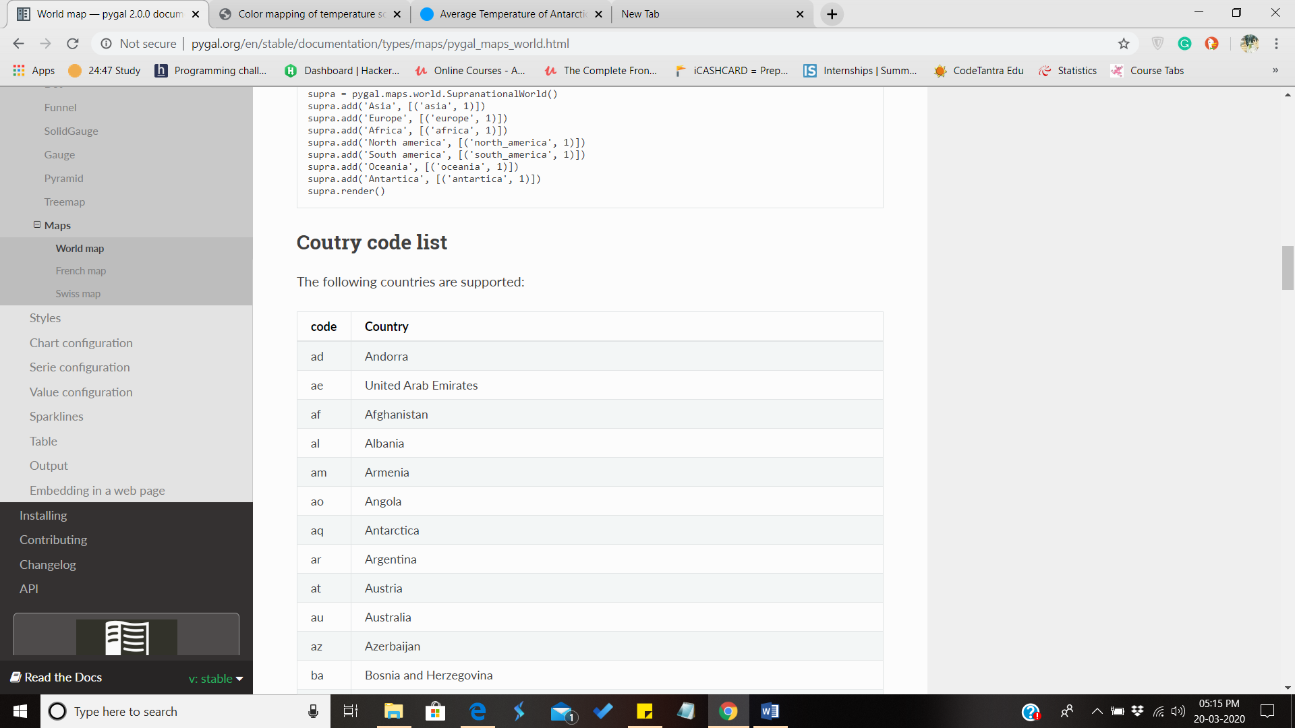–

Now let me show you the output –

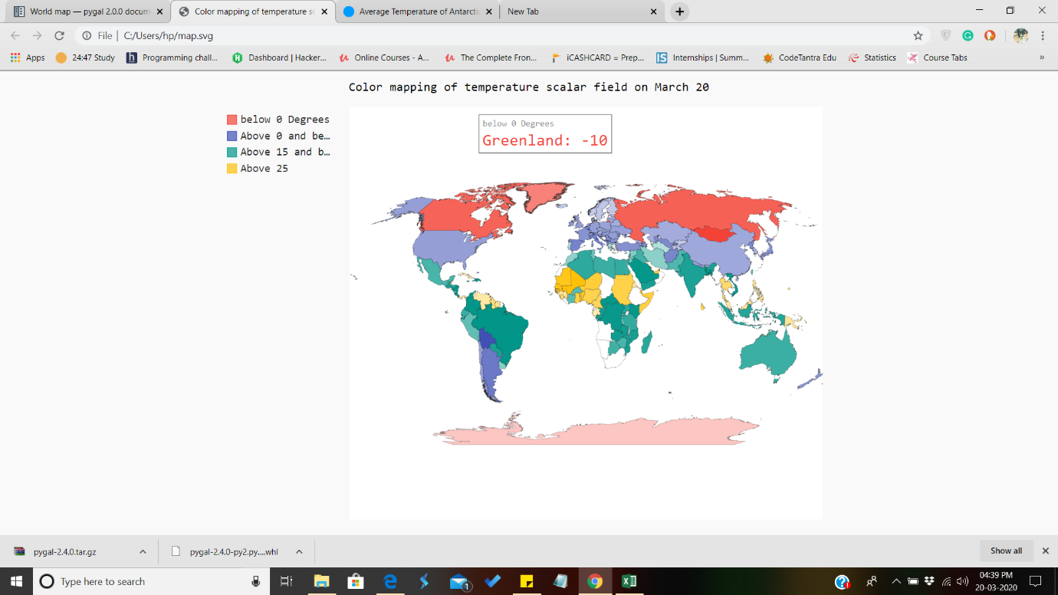

Now, people might be wondering why the output in the python ide isn’t there only. It’s because I rendered it to a file and moreover I rendered it to a svg file. The best benefit of svg file is that it’s not a normal image file. It an Html image file. I can hover up to countries and they will show their temperatures which was given as input. Just like in the image, I have hovered up to Greenland and its showing its respective temperature. Similarly there are some white areas also in the output, that’s because their data was not present in the csv file. I have differentiated countries with below 0 degrees, above 0 and below 15 degrees, above 15 and below 25 and finally above 25. The colouring is done automatically by the library PyGal.

One more image of Output showing India –

