BlockChain Modelling
Description:
- this is a BlockChain model to demostrate the basic mechanism of BlockChain concept.
- written in java

Demonstration:
If we initialize the blockchain model with 3 transaction statements:
1. Derek sende me 10 bitcoin
2. I send 20 bitcoins to sunny
3. Sunny send 40 bitcoins to derek

it will return 3 blocks of unique hash code number highlighted in the console.
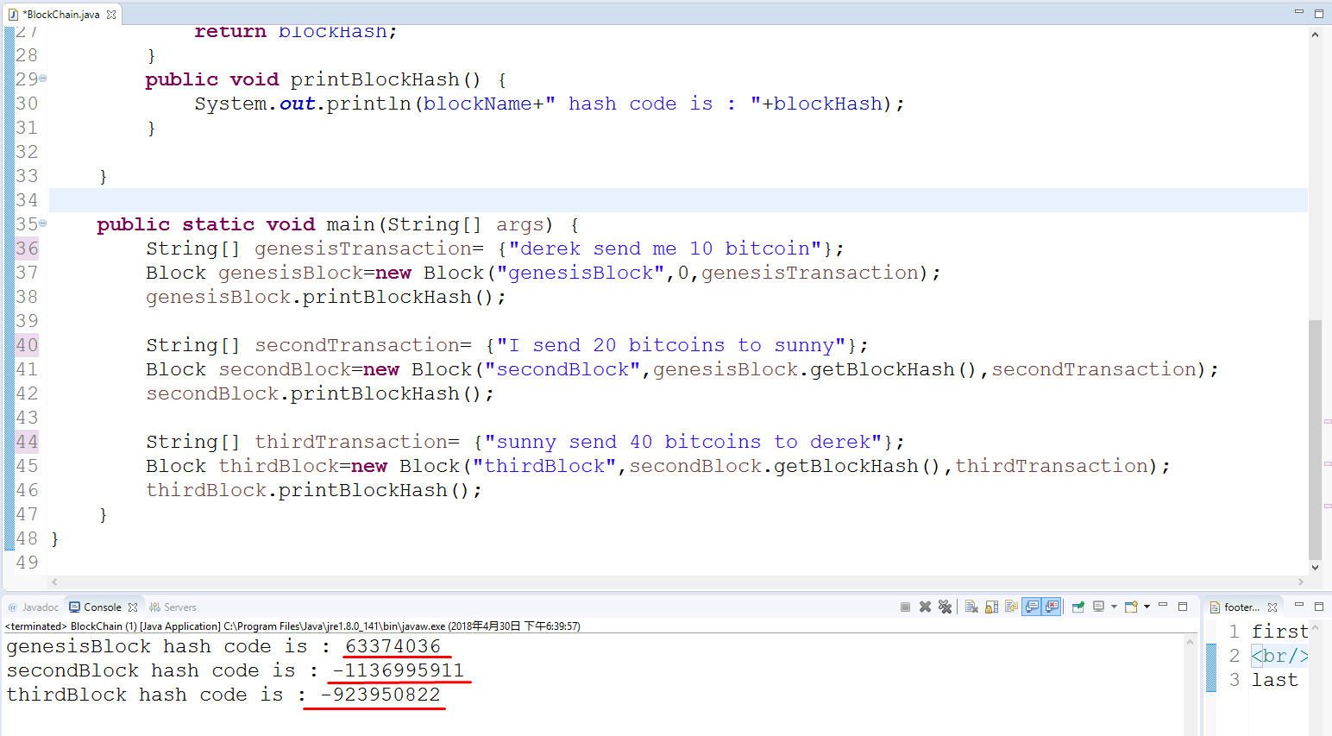

If we modify any one of the blockchain statement , then the hash code returned will be entirely different:
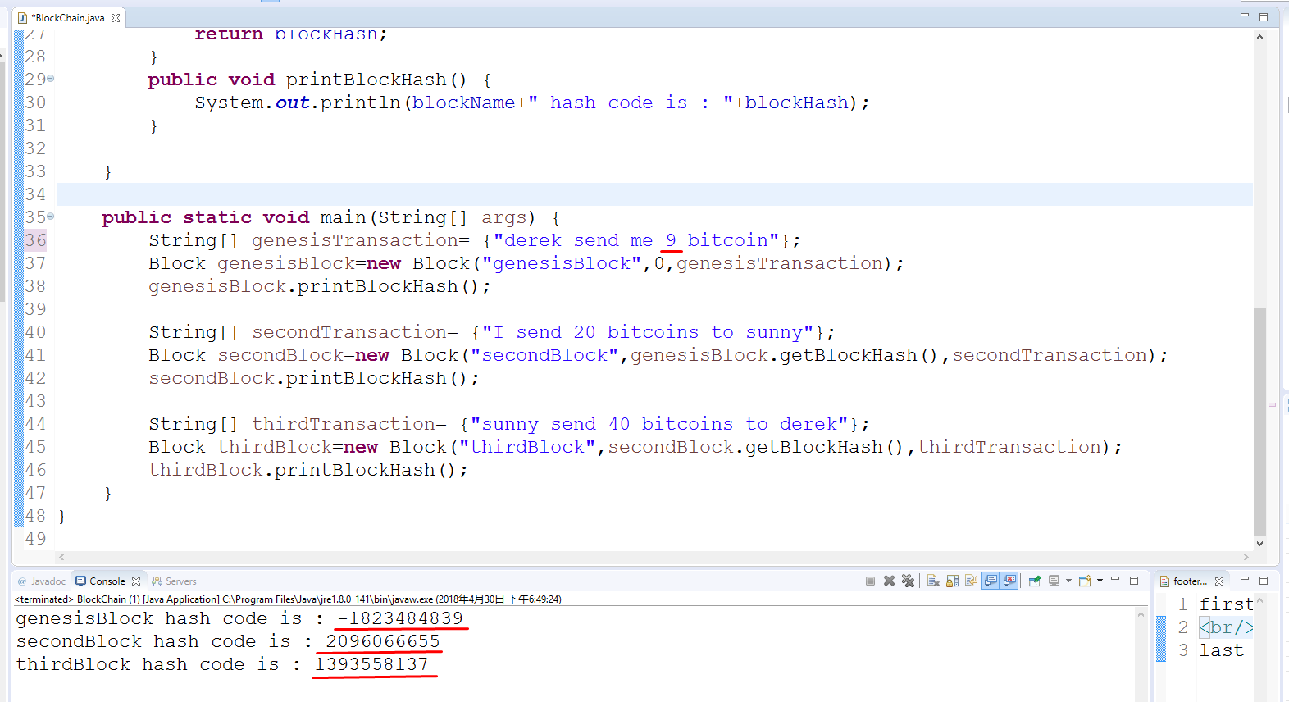

Explain:
Because it implements linked-list datastructure:
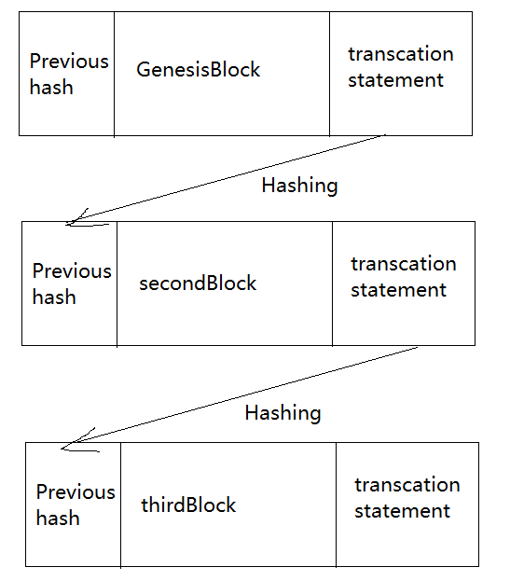
this makes BlockChain a secured system.

Model Project UML:
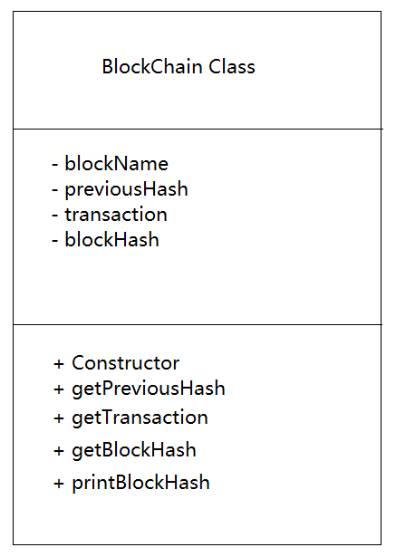

Project Source Code:

import java.util.Arrays;

public class BlockChain {

public static class Block{
private String blockName;
private int previousHash;
private String[] transaction;
private int blockHash;

public Block(String blockName,int previousHash,String[] transaction) {
this.blockName=blockName;
this.previousHash=previousHash;
this.transaction=transaction;
Object[] contents= {Arrays.hashCode(transaction),previousHash};
this.blockHash=Arrays.hashCode(contents);
}
public int getPreviousHash() {
return previousHash;
}
public String[] getTransaction() {
return transaction;
}
public int getBlockHash() {
return blockHash;
}
public void printBlockHash() {
System.out.println(blockName+" hash code is : "+blockHash);
}

}

public static void main(String[] args) {
String[] genesisTransaction= {"derek send me 9 bitcoin"};
Block genesisBlock=new Block("genesisBlock",0,genesisTransaction);
genesisBlock.printBlockHash();

String[] secondTransaction= {"I send 20 bitcoins to sunny"};
Block secondBlock=new Block("secondBlock",genesisBlock.getBlockHash(),secondTransaction);
secondBlock.printBlockHash();

String[] thirdTransaction= {"sunny send 40 bitcoins to derek"};
Block thirdBlock=new Block("thirdBlock",secondBlock.getBlockHash(),thirdTransaction);
thirdBlock.printBlockHash();
}
}

