SmartCoin Demo Project
Description:
- this is a Demo project for simulate the basic transaction process in cyptocurrency like Bitcoin.
- It’s written in solidity which is a programming language supported by Ethereum.

Function:
- Once the the project is published on Ethereum platform ,it’s able to have View balance and Give coin function.So that it can interact with other sender and receiver.

Project UML:
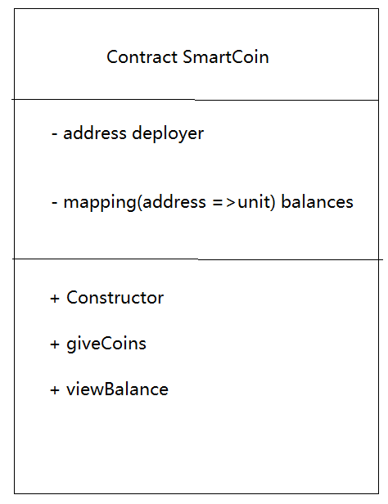

Project Source Code:

pragma solidity ^0.4.0;

contract SmartCoin{

address deployer; //the address of person who deploy this contract
mapping(address=>uint) balances; //give address will return number of balance

function SmartCoin(){ //constructor function
deployer=msg.sender; //initialize the deployer address when this contract is constructed
}

function giveCoins(uint amount,address receiver){ //function for give coins
if(msg.sender==deployer){ //if the person calling this function is the deployer of this contract then give coins to receiver
balances[receiver]+=amount;//balance of address receiver
}
else{
throw;
}

}

function viewBalance() returns(uint){
return balances[msg.sender]; //return the balance of the person who is using this function
}
}

