Java服务器和客户端即时通讯程序
- 程序功能:
1.Swing GUI组件提供 用户交互窗口
2.Socket API建立 服务器和客户端网络通信链接和流数据传输
3.IO API提供 文本和流数据的转换

- 程序效果:
建立链接
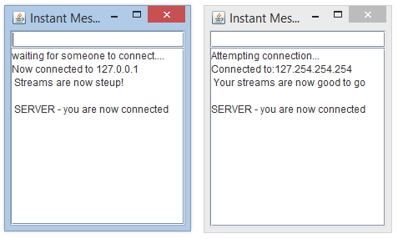
//需先运行Server.java再运行Client.java

结束链接
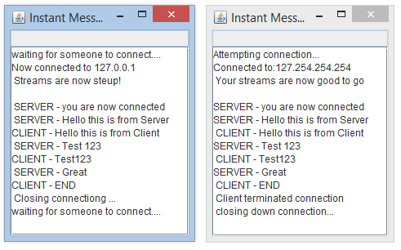
//任意一方输入 “END” 链接结束

- 代码:
Server.java
import java.io.*;
import java.net.*;
import java.awt.*;
import java.awt.event.ActionEvent;
import java.awt.event.ActionListener;
import javax.swing.*;

public class Server extends JFrame{
private JTextField userText;
private JTextArea chatWindow;
private ObjectOutputStream output;
private ObjectInputStream input;
private ServerSocket server;
private Socket connection;

public Server() {
super("Instant Messenger : Server");
userText=new JTextField();
userText.setEditable(false);//cannot type message when not connected to any client
userText.addActionListener(
new ActionListener() {
public void actionPerformed(ActionEvent event) {
sendMessage(event.getActionCommand());
userText.setText("");
}
});
add(userText,BorderLayout.NORTH);
chatWindow=new JTextArea();
add(new JScrollPane(chatWindow));
setSize(300,150);
setVisible(true);
}

//set up and run the server
public void startRunning() {
try {
server=new ServerSocket(6789,100);
while(true) {
try {
waitForConnection();
setupStreams();
whileChatting();
}catch(EOFException eofException) {
showMessage("\n Server ended the connection!");
}finally {
closeStuff();
}
}
}catch(IOException ioException) {
ioException.printStackTrace();
}
}

private void waitForConnection() throws IOException{
showMessage("waiting for someone to connect.... \n");
connection =server.accept();
showMessage("Now connected to "+connection.getInetAddress().getHostName());
}

private void setupStreams() throws IOException{
output =new ObjectOutputStream(connection.getOutputStream());
output.flush();
input =new ObjectInputStream(connection.getInputStream());
showMessage("\n Streams are now steup! \n");
}

private void whileChatting() throws IOException{
String message="you are now connected";
sendMessage(message);
ableToType(true);
do {
try {
message=(String) input.readObject();
showMessage("\n"+message);
}catch(ClassNotFoundException classNotFoundException) {
showMessage("\n idk what that user send");
}
}while(!message.equals("CLIENT - END"));//break loop when client side user enters "END"
}

private void closeStuff() {
showMessage("\n Closing connectiong ... \n");
ableToType(false);
try {
output.close();
input.close();
connection.close();
}catch(IOException ioException) {
ioException.printStackTrace();
}

}

protected void sendMessage(String message) {
try {
output.writeObject("SERVER - " + message);
output.flush();
showMessage("\n SERVER - "+message);
}catch(IOException ioException) {
chatWindow.append("\n Error: I canot send that message");
}

}

private void showMessage(final String text) {
SwingUtilities.invokeLater(
new Runnable() {
public void run() {
chatWindow.append(text);
}
}
);
}

private void ableToType(final boolean tof) {
SwingUtilities.invokeLater(
new Runnable() {
public void run() {
userText.setEditable(tof);//set weather user can type or not
}
}
);
}

public static void main(String[] args) {
Server myserver=new Server();
myserver.setDefaultCloseOperation(JFrame.EXIT_ON_CLOSE);
myserver.startRunning();
}
}

Client.java
import java.io.*;
import java.net.*;
import java.awt.*;
import java.awt.event.ActionEvent;
import java.awt.event.ActionListener;
import javax.swing.*;

public class Client extends JFrame {
private JTextField userText;
private JTextArea chatWindow;
private ObjectOutputStream output;
private ObjectInputStream input;
private String message="";
private String serverIP;
private Socket connection;

public Client(String host) {
super("Instant Messenger : Client");
serverIP=host;
userText=new JTextField();
userText.setEditable(false);
userText.addActionListener(
new ActionListener() {
public void actionPerformed(ActionEvent event) {
sendMessage(event.getActionCommand());
userText.setText("");
}
}
);
add(userText,BorderLayout.NORTH);
chatWindow=new JTextArea();
add(new JScrollPane(chatWindow),BorderLayout.CENTER);
setSize(300,150);
setVisible(true);
}

public void startRunning() {
try {
connectToServer();
setupStreams();
whileChatting();
}catch(EOFException e) {
showMessage("\n Client terminated connection");
}catch(IOException ioException) {
ioException.printStackTrace();
}finally {
closeStuff();
}
}

private void connectToServer() throws IOException{
showMessage("Attempting connection... \n");
connection= new Socket(InetAddress.getByName(serverIP),6789);
showMessage("Connected to:"+connection.getInetAddress().getHostName());
}

private void setupStreams() throws IOException{
output=new ObjectOutputStream(connection.getOutputStream());
output.flush();
input=new ObjectInputStream(connection.getInputStream());
showMessage("\n Your streams are now good to go \n");
}

private void whileChatting() throws IOException{
ableToType(true);
do {
try {
message=(String)input.readObject();
showMessage("\n"+message);
}catch(ClassNotFoundException e) {
showMessage("\n I dont know that object type");
}
}while(!message.equals("SERVER - END"));//break loop when server side user enters "END"
}

private void closeStuff() {
showMessage("\n closing down connection...");
ableToType(false);
try {
output.close();
input.close();
connection.close();
}catch(IOException e) {
e.printStackTrace();
}
}

private void sendMessage(String message) {
try {
output.writeObject("CLIENT - "+ message);
output.flush();
showMessage("\n CLIENT - "+message);
}catch(IOException e) {
chatWindow.append("\n something messed up");
}
}
private void showMessage(final String m) {
SwingUtilities.invokeLater(
new Runnable() {
public void run() {
chatWindow.append(m);
}
}
);
}

private void ableToType(final boolean tof) {
SwingUtilities.invokeLater(
new Runnable() {
public void run() {
userText.setEditable(tof);//set weather user can type or not
}
}
);
}

public static void main(String[] args) {
Client myclient;
myclient=new Client("127.254.254.254");
myclient.setDefaultCloseOperation(JFrame.EXIT_ON_CLOSE);
myclient.startRunning();
}
}

