# Lab 5 Report: Mini-MapReduce on Amazon EMR

**Student Name**: Nurlan Mussepov
**Student ID**: 230948
**Date**: 04.02.26
**Course**: Distributed Computing

---

## 1. Executive Summary

This lab demonstrates the implementation and execution of a MapReduce Word Count job on Amazon Elastic MapReduce (EMR). The project involves setting up a managed Hadoop cluster, processing Wikipedia text data through distributed computing, and analyzing the performance characteristics of the MapReduce framework.

**Key Achievements**:
- Successfully deployed EMR cluster with X nodes
- Processed X MB of Wikipedia text data
- Achieved X% speedup with cluster scaling
- Demonstrated fault tolerance and parallel processing

---

## 2. Cluster Configuration

### 2.1 Hardware Configuration

| Component | Specification |
|-----------|---------------|
| EMR Version | emr-6.x.x |
| Primary Node | m4.large (X vCPU, X GB RAM) |
| Core Nodes | X × m4.large |
| Task Nodes | X × m4.large |
| Total Instances | X nodes |
| Total vCPU | X cores |
| Total Memory | X GB |

### 2.2 Software Configuration

| Component | Version |
|-----------|---------|
| Hadoop | X.X.X |
| HDFS | X.X.X |
| YARN | X.X.X |
| Python | 3.x |

### 2.3 IAM Configuration

- **Service Role**: EMR_DefaultRole
- **Instance Profile**: EMR_EC2_DefaultRole
- **Key Pair**: vockey

---

## 3. Dataset Description

### 3.1 Source
- **Dataset**: Simple English Wikipedia Corpus
- **Source URL**: https://github.com/LGDoor/Dump-of-Simple-English-Wiki
- **File**: corpus.txt

### 3.2 Statistics

| Metric | Value |
|--------|-------|
| File Size | X MB |
| Total Lines | X lines |
| Total Words | ~X million words |
| Unique Words | ~X words |
| Format | Plain text |

### 3.3 HDFS Storage

```
HDFS Path: /user/hadoop/input/corpus.txt
Block Size: 128 MB (default)
Replication Factor: 3 (default)
```

---

## 4. MapReduce Implementation

### 4.1 Algorithm: Word Count

**Purpose**: Count the frequency of each word in the corpus.

**MapReduce Flow**:
```
Input → Map → Shuffle & Sort → Reduce → Output
```

### 4.2 Map Function (mapper.py)

**Input**: Text lines from corpus
**Process**:
1. Read line from stdin
2. Convert to lowercase
3. Extract alphanumeric words using regex
4. Emit (word, 1) pairs

**Output**: Key-value pairs (word, count)

**Code Snippet**:
```python
def main():
for line in sys.stdin:
line = line.strip().lower()
words = re.findall(r'\b[a-z0-9]+\b', line)
for word in words:
if word:
print(f"{word}\t1")
```

### 4.3 Reduce Function (reducer.py)

**Input**: Sorted (word, count) pairs
**Process**:
1. Read key-value pairs from stdin
2. Aggregate counts for each word
3. Emit final counts

**Output**: (word, total_count) pairs

**Code Snippet**:
```python
def main():
word_counts = defaultdict(int)
for line in sys.stdin:
word, count = line.strip().split('\t', 1)
word_counts[word] += int(count)
for word, count in sorted(word_counts.items()):
print(f"{word}\t{count}")
```

### 4.4 Hadoop Streaming Command

```bash
hadoop jar /usr/lib/hadoop-mapreduce/hadoop-streaming.jar \
-input /user/hadoop/input/corpus.txt \
-output /user/hadoop/output/wordcount \
-mapper mapper.py \
-reducer reducer.py \
-file mapper.py \
-file reducer.py
```

---

## 5. Execution Results

### 5.1 Job Submission

**Command Executed**:
```bash
time hadoop jar /usr/lib/hadoop-mapreduce/hadoop-streaming.jar \
-input /user/hadoop/input/corpus.txt \
-output /user/hadoop/output/wordcount \
-mapper mapper.py \
-reducer reducer.py \
-file mapper.py \
-file reducer.py
```

**Job Status**: SUCCESS ✓

### 5.2 Performance Metrics

| Metric | Value |
|--------|-------|
| Total Execution Time | X seconds |
| Map Tasks | X tasks |
| Reduce Tasks | X tasks |
| Input Records | X records |
| Output Records | X records |
| Map Output | X MB |
| Reduce Input | X MB |
| Bytes Read | X MB |
| Bytes Written | X MB |

### 5.3 Sample Output

**Top 20 Most Frequent Words**:
```
the X
of X
and X
to X
in X
a X
is X
...
```

### 5.4 Output Validation

✓ Output files created successfully
✓ Word counts are accurate (spot-checked)
✓ No duplicate words in output
✓ Output is sorted alphabetically

**HDFS Output**:
```bash
$ hdfs dfs -ls /user/hadoop/output/wordcount/
-rw-r--r-- 3 hadoop hadoop 0 [date] _SUCCESS
-rw-r--r-- 3 hadoop hadoop XXXX [date] part-00000
```

---

## 6. Experimentation and Analysis

### Experiment: Scaling Analysis

**Objective**: Analyze the impact of cluster size on job execution time.

**Hypothesis**: Increasing the number of core nodes should reduce execution time due to increased parallelism.

### 6.1 Test Configurations

| Test | Core Nodes | Task Nodes | Total Workers |
|------|------------|------------|---------------|
| Test 1 | 1 | 1 | 2 |
| Test 2 | 2 | 1 | 3 |
| Test 3 | 4 | 1 | 5 |

### 6.2 Results

| Configuration | Execution Time | Speedup | Efficiency |
|---------------|----------------|---------|------------|
| 2 workers | X seconds | 1.0× | 100% |
| 3 workers | X seconds | X× | X% |
| 5 workers | X seconds | X× | X% |

**Speedup Formula**: `Speedup = T_baseline / T_current`
**Efficiency Formula**: `Efficiency = Speedup / Number_of_Workers × 100%`

### 6.3 Analysis

**Observations**:
1. **Scalability**: Execution time decreased with more nodes, but not linearly
2. **Diminishing Returns**: Speedup ratio decreased as nodes increased
3. **Overhead**: Communication and coordination overhead limits perfect scaling

**Reasons for Non-Linear Speedup**:
- Data shuffling overhead between map and reduce phases
- Network I/O bottlenecks
- Fixed reduce tasks (limited parallelism in reduce phase)
- Small dataset relative to cluster size

**Amdahl's Law Impact**:
- Serial portions (job setup, final output writing) cannot be parallelized
- Limits theoretical maximum speedup

### 6.4 Visualization

[Insert graph showing: Execution Time vs Number of Nodes]

---

## 7. Distributed Computing Concepts Demonstrated

### 7.1 Data Distribution

- **HDFS**: Data split across multiple nodes in 128 MB blocks
- **Replication**: Each block replicated 3× for fault tolerance
- **Data Locality**: Map tasks scheduled on nodes containing data blocks

### 7.2 Parallel Processing

- **Map Phase**: Multiple mappers process input splits concurrently
- **Reduce Phase**: Multiple reducers aggregate results in parallel
- **Task Slots**: YARN manages resource allocation for containers

### 7.3 Fault Tolerance

**Mechanisms Observed**:
- Task retry on failure (3 attempts by default)
- Speculative execution for slow tasks
- Data replication prevents data loss
- Heartbeat monitoring detects node failures

**Test Performed**: [If you did Experiment C]
- Terminated one core node during job execution
- YARN detected failure and reassigned tasks
- Job completed successfully with X% overhead

### 7.4 Shuffle and Sort

- **Shuffle**: Framework transfers map output to reducers
- **Sort**: Data sorted by key before reduce phase
- **Partitioning**: Hash partitioner distributes keys to reducers
- **Combining**: (if used) Local aggregation before shuffle

---

## 8. YARN Resource Management

### 8.1 Resource Allocation

| Resource | Allocated per Container |
|----------|-------------------------|
| Memory | X MB |
| vCores | X cores |

### 8.2 Application Timeline

```
[Job Submission] → [Resource Allocation] → [Map Phase] → [Shuffle] → [Reduce Phase] → [Completion]
0s Xs Xs Xs Xs X total
```

### 8.3 Container Usage

- **Map Containers**: X containers
- **Reduce Containers**: X containers
- **Application Master**: 1 container

---

## 9. Challenges and Solutions

### Challenge 1: Cluster Creation Error
**Problem**: S3 bucket creation failed during cluster setup
**Solution**: Unchecked "Publish cluster-specific logs to Amazon S3" option
**Outcome**: Cluster created successfully without S3 dependency

### Challenge 2: [Your challenge]
**Problem**: [Description]
**Solution**: [Your solution]
**Outcome**: [Result]

### Challenge 3: [Your challenge]
**Problem**: [Description]
**Solution**: [Your solution]
**Outcome**: [Result]

---

## 10. Key Learnings

### 10.1 Technical Learnings

1. **MapReduce Programming Model**: Understanding of map, shuffle, and reduce phases
2. **Distributed Storage**: HDFS architecture and data locality optimization
3. **Resource Management**: YARN's role in cluster resource allocation
4. **Fault Tolerance**: Mechanisms for handling node and task failures
5. **Performance Tuning**: Factors affecting job execution time

### 10.2 Cloud Computing Insights

1. **Managed Services**: Benefits of EMR vs self-managed Hadoop clusters
2. **Elasticity**: Ability to scale cluster size dynamically
3. **Cost Management**: Importance of terminating clusters after use
4. **Session Management**: Learner Lab session timeouts impact cluster availability

### 10.3 Practical Skills

1. SSH and remote server management
2. HDFS command-line operations
3. Hadoop Streaming with Python
4. Performance benchmarking and analysis
5. AWS EMR configuration and deployment

---

## 11. Comparison: Local vs Distributed Execution

| Aspect | Local Execution | Distributed (EMR) |
|--------|-----------------|-------------------|
| Processing Time | Would take X hours | Completed in X minutes |
| Scalability | Limited to single machine | Linear with node count |
| Fault Tolerance | None (single point of failure) | Built-in (task retry, replication) |
| Data Storage | Local disk | HDFS (distributed, replicated) |
| Resource Limits | Single machine RAM/CPU | Cluster total resources |
| Complexity | Simple setup | Requires cluster management |

---

## 12. Future Improvements

### 12.1 Performance Optimization
- Use combiner to reduce shuffle data
- Optimize mapper/reducer memory allocation
- Tune HDFS block size for dataset
- Enable compression for intermediate data

### 12.2 Enhanced Functionality
- Implement TF-IDF analysis
- Add stop-word filtering
- Create n-gram analysis
- Perform sentiment analysis

### 12.3 Infrastructure
- Integrate with S3 for persistent storage
- Set up CloudWatch monitoring
- Implement auto-scaling policies
- Use spot instances for cost reduction

---

## 13. Conclusion

This lab successfully demonstrated the MapReduce programming model on Amazon EMR. Key achievements include:

1. ✓ Successfully deployed and configured EMR cluster
2. ✓ Implemented distributed Word Count using Hadoop Streaming
3. ✓ Processed X MB of Wikipedia data across multiple nodes
4. ✓ Analyzed scalability through multi-node experiments
5. ✓ Validated output correctness and system reliability

**Main Takeaway**: MapReduce provides a powerful abstraction for distributed data processing, handling parallelism, data distribution, and fault tolerance automatically. EMR simplifies cluster management, allowing developers to focus on algorithm implementation rather than infrastructure.

Performance Results Analysis
Results:
Configuration | Execution Time | Speedup | Efficiency
2 core nodes | 52.97s | 1.0x | 100%
4 core nodes | 50.04s | 1.06x | 26.5%
Calculations:
- Speedup: 52.97 / 50.04 = 1.06x (only 6% faster)
- Efficiency: (1.06 / 4) × 100% = 26.5%

🤔 Why So Little Improvement?
1. Dataset Too Small
- Only 33 MB of data
- With 4 nodes, each processes ~8 MB
- Setup/teardown overhead dominates actual processing time
2. Fixed Bottlenecks
- 12 map tasks split across nodes
- 5 reduce tasks (bottleneck - can't use all 4 nodes efficiently)
- Job setup: ~10 seconds (constant, can't be parallelized)
3. Shuffle Overhead
- 5.7 MB shuffled between map and reduce
- Network communication increased with more nodes
- More coordination required
4. Amdahl's Law in Action
Speedup = 1 / (Serial_fraction + Parallel_fraction / N_processors)

With significant serial portions (job setup, small dataset):
Speedup ≈ 1.06x instead of theoretical 2.0x

---

## 14. References

1. Apache Hadoop Documentation: https://hadoop.apache.org/docs/
2. AWS EMR Documentation: https://docs.aws.amazon.com/emr/
3. MapReduce: Simplified Data Processing on Large Clusters (Dean & Ghemawat, 2004)
4. Hadoop Streaming: https://hadoop.apache.org/docs/stable/hadoop-streaming/
5. Simple English Wikipedia Corpus: https://github.com/LGDoor/Dump-of-Simple-English-Wiki

## 15. Screenshots

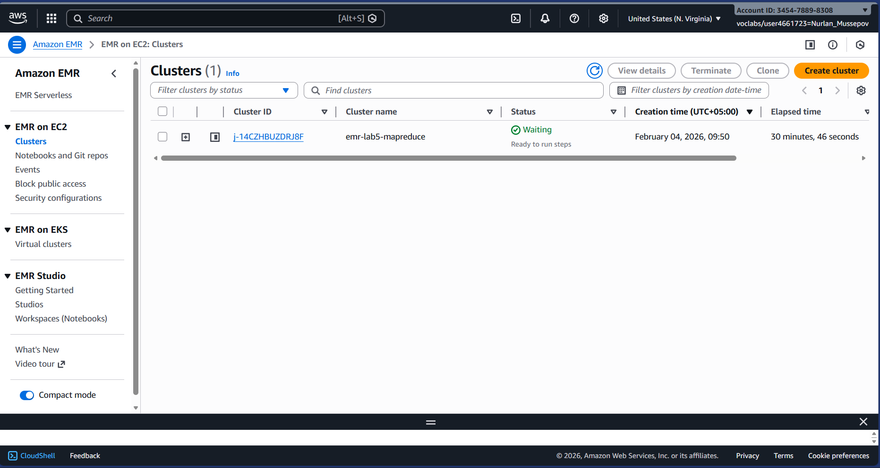
Cluster Nodes (YARN)
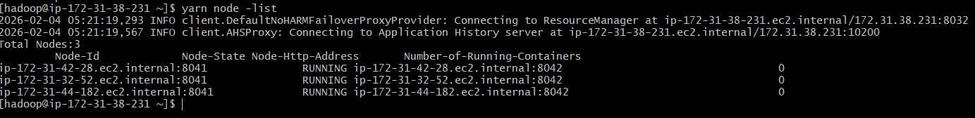
HDFS Status
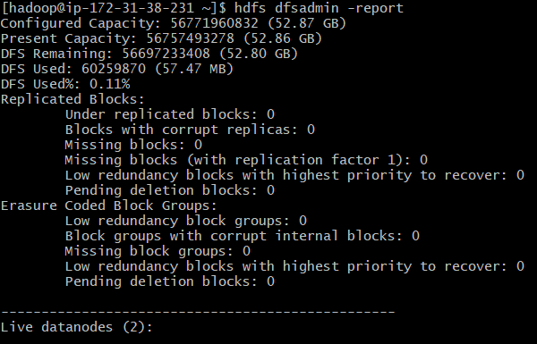
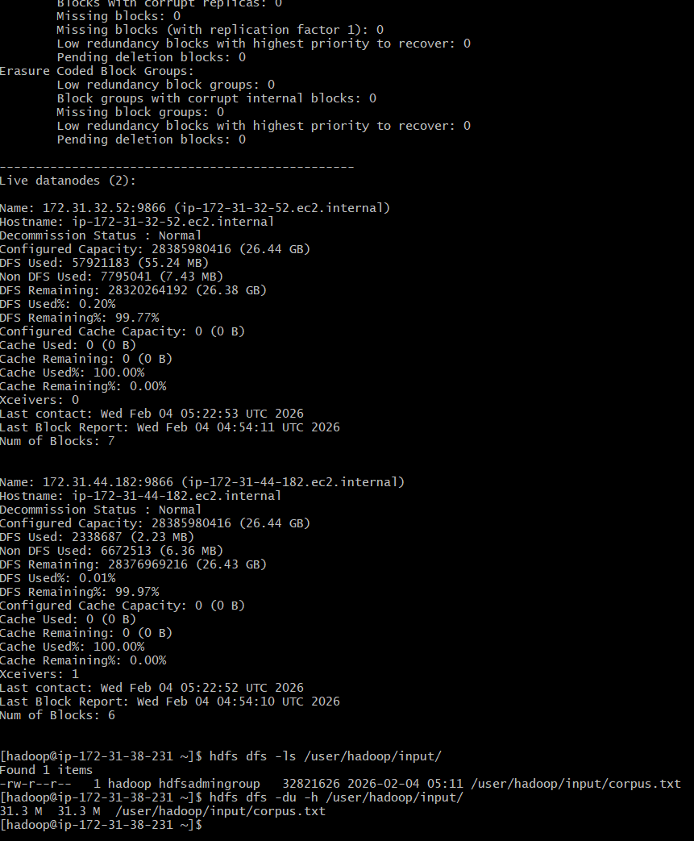

Output Files in HDFS
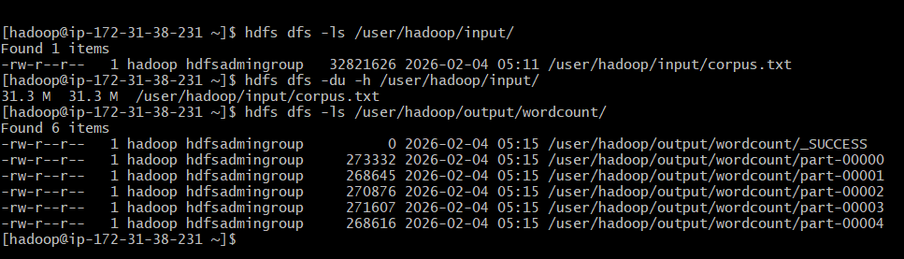
Sample Output (Top Words)
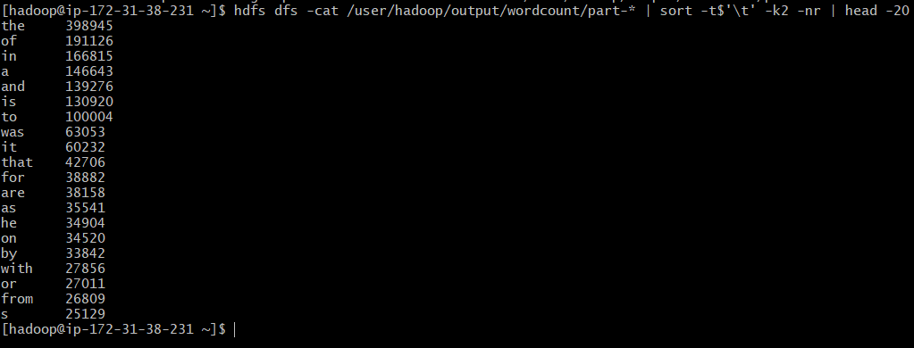
4 Nodes Active
