Part 1: WEDE5020
Bakes by MK- Bakery Website
Tshepang Matsepe
ST10360501
Project Information

Project Title: Bakes by MK website
Project Type: Website development project
Part: Part 1- Building the foundation
Organisation: Bakes by MK
Location: Groblersdal/ Centurion, South Africa
Subject: WEDE5020
Student Name: Tshephang Matsepe
Student Number: ST10360501
Group: 15
Academic Year: 2026

Project Overview
Bakes by MK is a real small bakery business based in two locations from Groblersdal, Limpopo and Centurion, Gauteng which started out as a brother and sister just having the love for baking muffins for the family almost every weekend. The kitchen became a place of solace and felt that their words would mostly be understood through their love for baking. The idea for Bakes by MK started as an experiment to see whether people would be audacious to try out their baking skills embedded with love and care. As the business is in its 2nd year of operation, its gained massive traction on TikTok and it has gained followers along with orders.
The purpose of this project is to design and develop a professional website that establishes an online presence for Bakes by MK and provides customers with an easy way to discover products, learn about the organisation and submit enquiries instead of only having to rely on WhatsApp messaging which can easily be forgotten.
The website is being developed in three parts as a web development project. Part 1 focuses on establishing the foundation of the website through project planning, content research, website structure, file organisation and HTML development.
Part 2 will focus primarily on CSS styling, responsive design and improving the visual appearance of the website. Part 3 will introduce JavaScript functionality, interactivity, validation and additional website enhancements.
The final website will aim to be responsive, user friendly, accessible, well structured and suitable for viewing on desktop and mobile devices.

Organisation Overview
About Bakes by MK
Bakes by MK is a real small business that provides freshy baked products for everyday enjoyment and special occasions. The bakery offers the following:
- Cakes
- Cupcakes
- Brownies
- Celebration Cakes
- Custom cake designs
- Pastries
The business is designed around the idea of providing customers with attractive, fresh and high quality baked products while making the enquiry process convenient. The bakery currently relies primarily on social media and word-of-mouth recommendations. The proposed website will provide a primary online location where customers can access information about the bakery and its products.
Mission:
The mission of Bakes by MK is to provide freshly prepared high quality baked goods that bring people together and make everyday moments and special celebrations more memorable.
Vision:
The vision of Bakes by MK is to become a trusted local bakery known for quality products, creative designs, reliable service and customer satisfaction.
Target Audience:
- Individuals looking for cakes and baked goods.
- Families purchasing products for celebrations.
- Customers looking for birthday cakes.
- Customers planning weddings and anniversaries.
- Customers organising parties and events.
- Businesses requiring baked products for events.
- Customers looking for customised celebration cakes.
The website will be designed to accommodate users who access the website from computers, tablets and mobile phones.

Website goals and objectives:
The main goal of this website is to establish a professional online presence for Bakes by MK. The website aims to:
- Increase awareness of the bakery.
- Present the bakery's products in an organised format.
- Provide customers with information about available products.
- Generate enquiries for custom orders.
- Make contact information easy to locate.
- Provide information about collection and delivery.
- Improve customer confidence through a professional online presence.
- Provide a foundation for future online ordering functionality.
- Create a platform that can be expanded during Parts 2 and 3.
Key performance indicators:
KPI | Purpose
Website visits | Measures website traffic.
Product page views | Measures interests in bakery products.
Enquiry submission | Measures potential customer leads.
Contact interactions | Measures customer engagement .
Call to action interactions | Measures how effectively visitors are encouraged to enquire.
Mobile usability | Measures accessibility across mobile devices.
Navigation success | Determines whether users can easily find information.

Website features and functionality:
The website will have 5 pages:
- Home
- About
- Products
- Enquiry
- Contact
Home:
The homepage will introduce visitors to Bakes by MK. It will contain:
- Business logo.
- Navigation menu.
- Hero image.
- Main headline.
- Short business introduction.
- Featured products.
- Call-to-action buttons.
- Footer.

The primary call-to-action will encourage visitors to explore the available products or make an enquiry.
About
The About page will provide information about the organisation. It will contain:
- Organisation history.
- Mission statement.
- Vision statement.
- Business values.
- Introduction to the bakery.
Products
The Products page will provide an organised overview of the bakery's products. Products will include:
- Cakes.
- Cupcakes.
- Brownies.
- Cookies.
- Pastries.
- Celebration cakes.
Each product will eventually be presented using a product card containing an image, product name, description and enquiry option.
Enquiry
The Enquiry page will provide customers with a form for submitting product and custom-order enquiries. The form will include:
- Full name.
- Email address.
- Phone number.
- Product selection.
- Preferred date.
- Quantity.
- Collection or delivery preference.
- Additional requirements.
- Submit button.
JavaScript validation and enhanced form functionality will be introduced during Part 3.
Contact
The Contact page will provide customers with ways to communicate with Bakes by MK. The page will contain:
- Telephone number.
- Email address.
- Social-media information.
- Operating hours.
- Centurion/Groblersdal service/collection location.
- Centurion and or Groblersdal service/collection location.
- Location/map areas.
The locations will be for the project information and are included to satisfy the website specification requiring more than one location.
Website sitemap
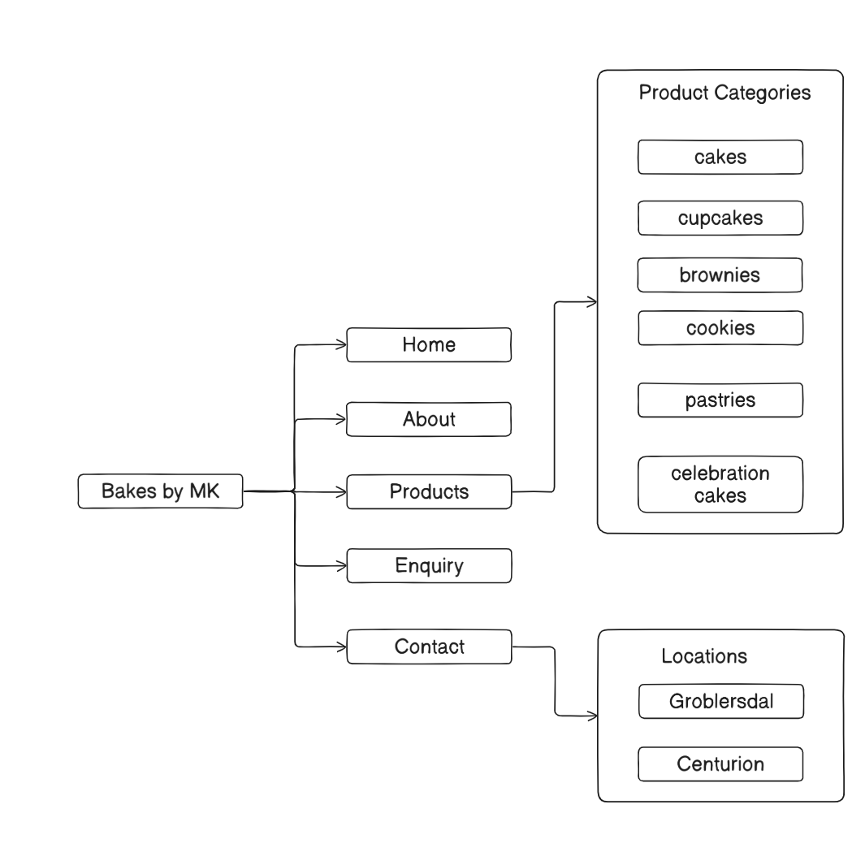
Project file structure

File description
File/Folder | Purpose
Index.html | Website homepage
About.html | Organisation information
Products.html | Bakery product catalogue
Enquiry.html | Customer enquiry form
Contact.html | Contact and location information
Css/style.css | Website styling
Js/script.js | Javascript functionality
Images/ | Website images and visuals
Documents/ | Project documentation and research
README.md | Project documents

Website design
Colour scheme
Here are the proposed colours:
- A
The colours were selected to communicate warmth, creativity, quality and the visual identity commonly associated with bakery products.
The final colours may be refined during Part 2 when the CSS design is implemented.
Typography
The website will use a readable modern font for body content. Along with complementary decorative or elegant font may be used for selected headings and branding elements and readability will remain a priority across desktop and mobile screen sizes.
The typography hierarchy will distinguish:
- Main page headings.
- Section headings.
- Product headings.
- Body text.
- Buttons and navigation.
User experience
The website will be designed around simplicity and ease of use. Important user-experience considerations include:
- Consistent navigation on every page.
- Clear page headings.
- Descriptive links and buttons.
- Readable text.
- Appropriate spacing.
- Accessible colour contrast.
- Alternative text for relevant images.
- Responsive layouts.
- Clear enquiry and contact options.
The navigation system will allow users to move between all five pages without returning to the homepage.
Technical requirements
This project will use these development tools:
HTML5
HTML5 will be used to create the structure and content of each website page.
Semantic elements such as these will be used:
- <header>
- <nav>
- <main>
- <section>
- <article>
- <footer>
CSS3
CSS will be introduced in Part 2 and will be used for:
- Colours.
- Typography.
- Layout.
- Responsive design.
- Navigation styling.
- Product cards.
- Buttons.
- Forms.
- Spacing.
- Visual effects.
Javascript
JavaScript will be introduced primarily during Part 3.
- Potential functionality includes:
- Form validation.
- Interactive navigation.
- Product filtering.
- Dynamic messages.
- User interaction.
- Other interactive website features.
Visual studio code
Visual Studio Code will be used as the primary code editor and it will be used to:
- Create HTML files.
- Create CSS files.
- Create JavaScript files.
- Organise project folders.
- Test and edit website code.

