Computer Organization and Architecture

1 Introduction

***Tongwei Ren***

Sep. 3, 2018



# Computer is Everywhere

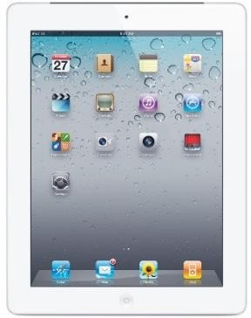

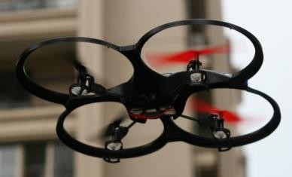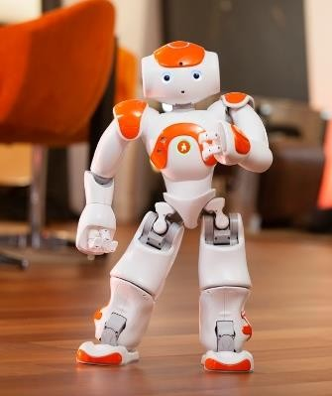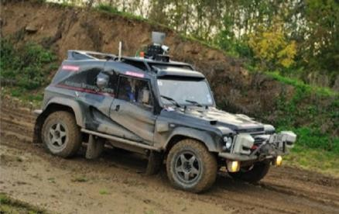

### Change or not?

#### 计算机是指“通用电子数字计算机（general-purpose electronic digital computer ）”

* + 通用：不是一种专用设备
    - 所有计算机在给予足够时间和容量存储器的条件下，都可

以完成同样的计算

* + - 当希望完成新的计算时，不需要对计算机重新设计
  + 电子（非机械）：采用电子元器件
  + 数字（非模拟）：信息采用数字化的形式表示

#### 计算机系统

* + 硬件：处理器、存储器、外部设备
  + 软件：程序，文档
* **Architecture** (visible to programmer)
  + Its attributes have a direct impact on the logical execution of a program
  + Instruction set, the number of bits to represent data types, …
    - E.g.: Is there a multiply instruction?
* **Organization** (opaque/encapsulated to programmer)
  + The operational units and their interconnections
  + Control signals, memory technology, …
    - E.g.: Implement multiply by a hardware unit or repeated addition?

#### First generation: Vacuum tubes (1946-1957)

* + ENIAC (1946-1955): decimal, manually programming

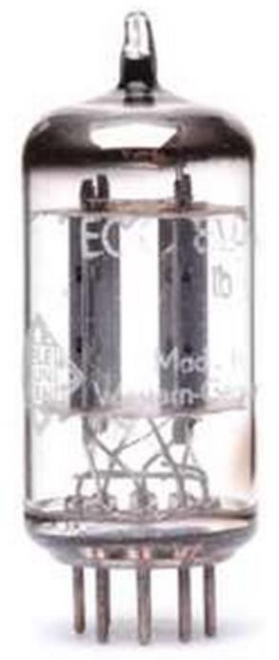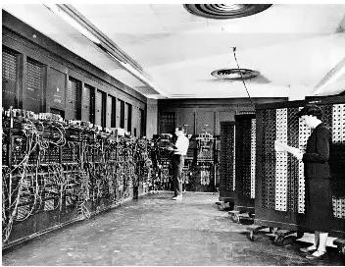

#### First generation: Vacuum tubes (1946-1957)

* + IAS (1946-1952*): binary, stored program

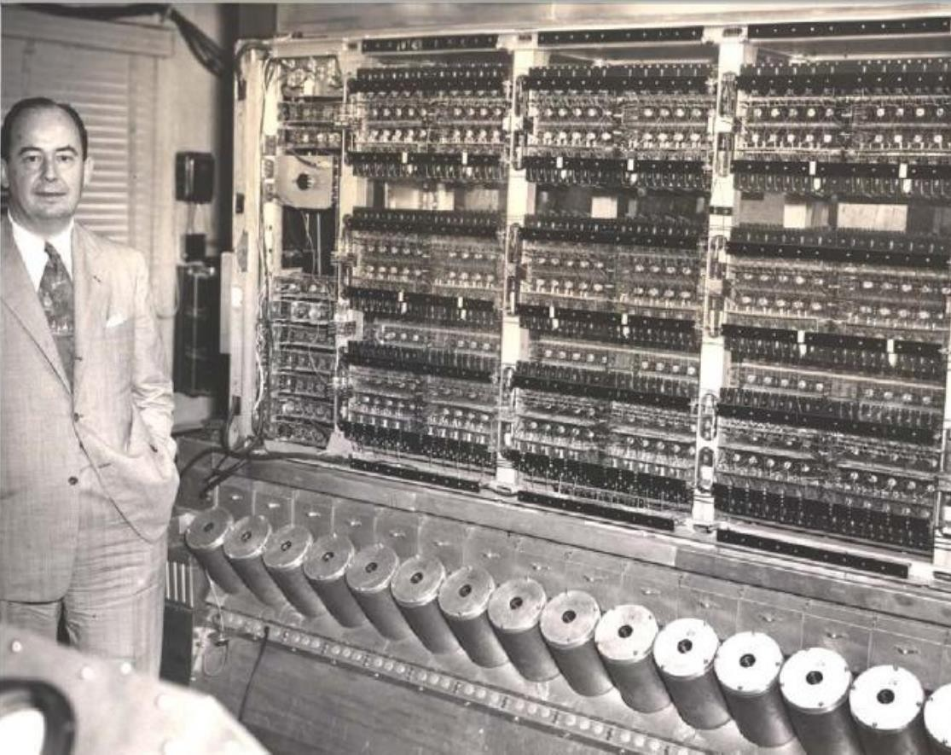

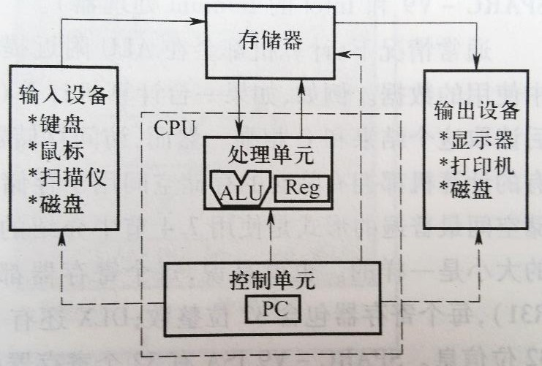

#### 组成部分

* + 存储器：地址和存储的内容
  + 处理单元：执行信息的实际处理
  + 控制单元：指挥信息的处理
  + 输入设备：将信息送入计算机中
  + 输出设备：将处理结果以某种形式显示在计算机外

#### First generation: Vacuum tubes (1946-1957)

* + IAS (1946-1952*): **the von Neumann machine**
    - Idea: main memory stores programs and data
    - Prototype of all subsequent computers
      * Central Arithmetical (CA)
      * 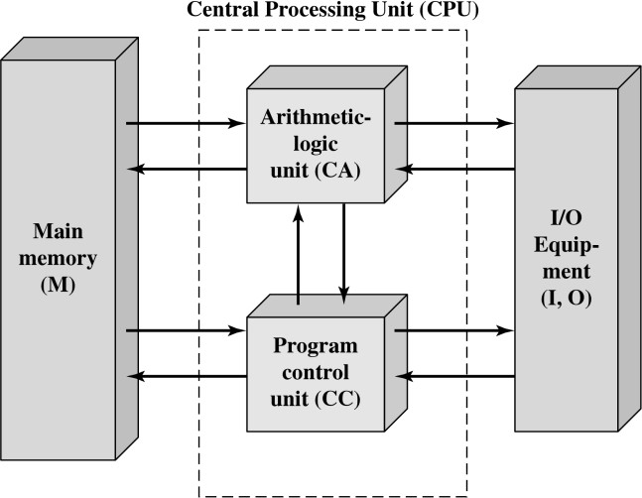Central Control (CC)
      * Memory (M)
      * Input (I) / Output (O)

A Brief History of Computers (cont.)

#### Second generation: Transistors (1958-1964)

* + NCR and RCA, IBM 7000: transistors are smaller, cheaper, and dissipate less heat; they also can be used as same as vacuum tubes
  + Introduction of more complex arithmetic and logic units and control units, the use of high-level programming languages and the provision of system software.

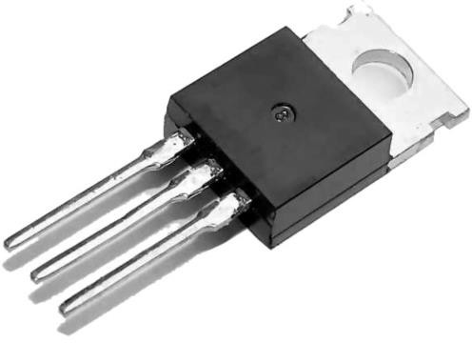

## A Brief History of Computers (cont.)

#### Third to *N* generation: Integrated circuits (1965-now)

* + Idea:
    - fabricate an entire circuit in a piece of silicon rather than assemble discrete components made from separate pieces of silicon
    - These transistors can be connected with

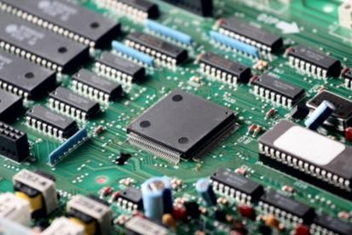a process of metallization to for circuits

* + Scale:
    - small ➔ large ➔ very large ➔ ultra large ...

## A Brief History of Computers (cont.)

* **Moore’s law** (Gordon Moore, 1965)
  + The number of transistors that could be put on a single chip is doubling every year (1965-1969) / 18 months (1970-now)
  + Consequence
    - The cost of computer logic and memory circuitry has

dramatically fallen for the cost of a single chip is unchanged

* + - Smaller size leads to flexibility and probability
    - Increased operating speed for shortened electrical path length
    - Reduction in dependency on power and cooling
    - The interconnections on the integrated circuit are more reliable than solder connections and few interchip connections

## A Brief History of Computers (cont.)

#### Constant function

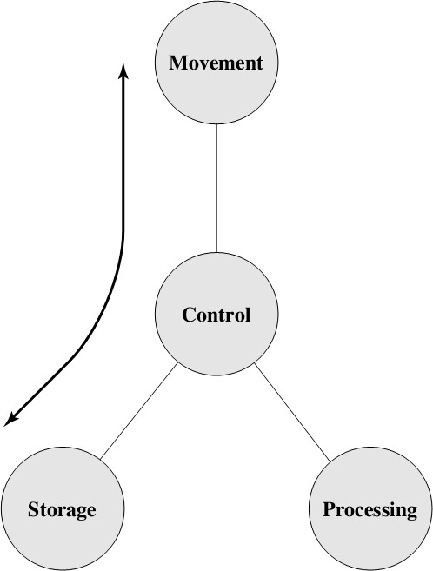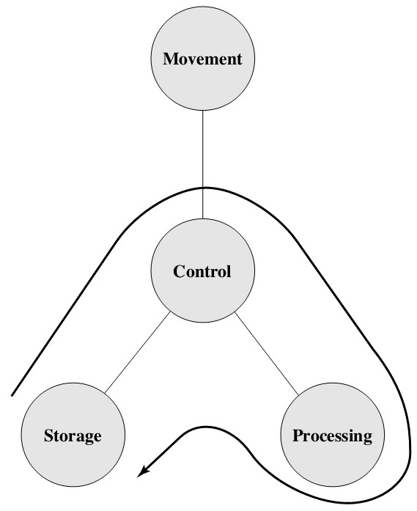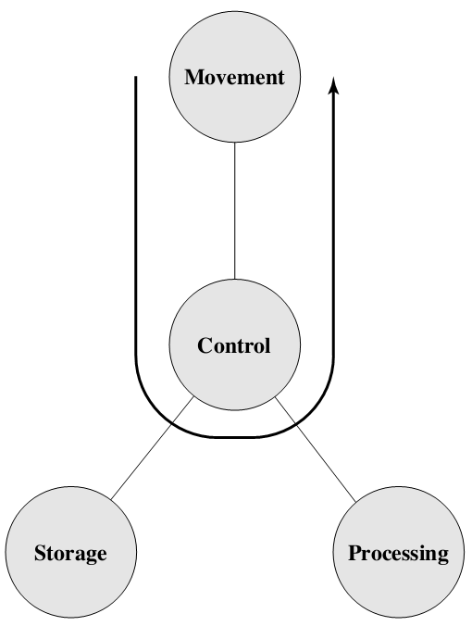

Data processing

Data movement

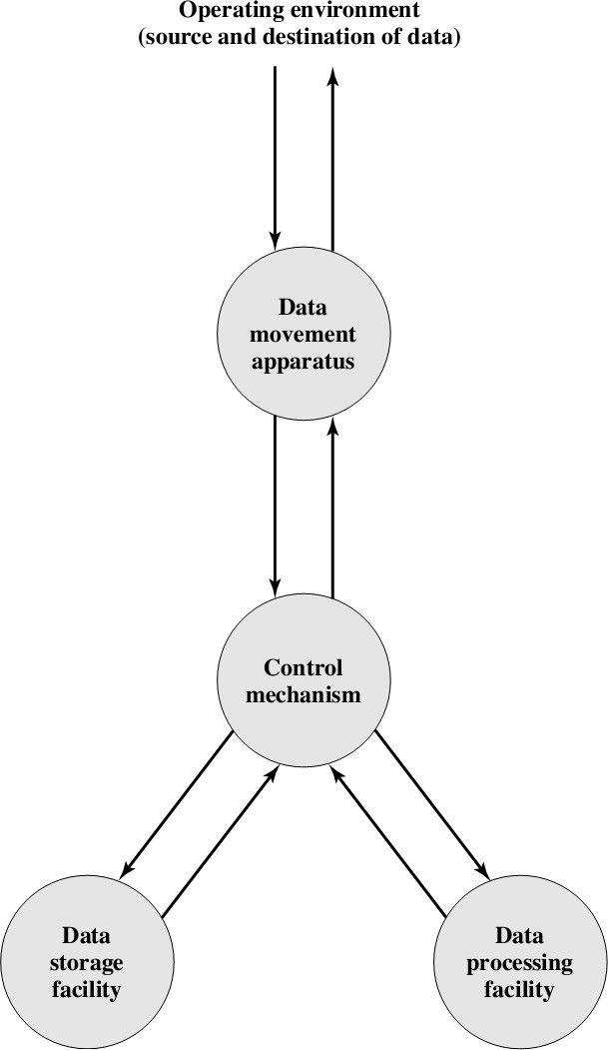

Data storage

## A Brief History of Computers (cont.)

#### Performance improvements

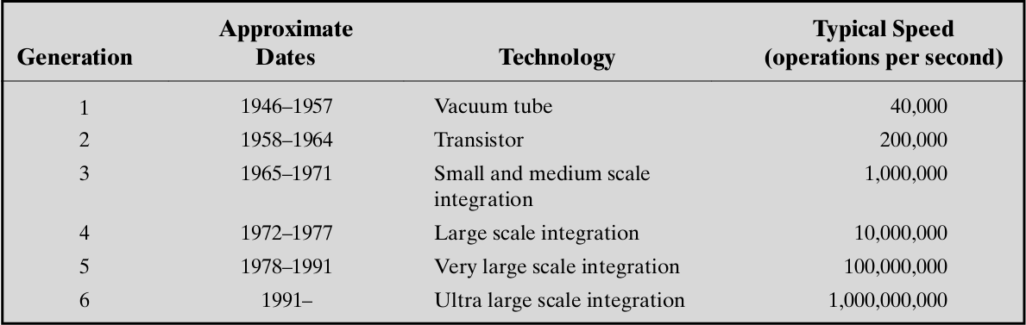

Computer Performance

* One of key parameters of computer
  + Performance, cost, size, security, reliability, power

consumption, …

#### Sample performance evaluation criteria

* + CPU: speed
  + Memory: capacity, speed
  + I/O: speed, capacity

**The main goal / driver is the increase of CPU speed**

CPU Performance

#### System clock

* + Clock rate / clock speed (HZ): fundamental rate in cycles per

second at which a computer performs its most basic operations

* + Clock cycle / clock tick: a single electronic pulse of a CPU
  + Cycle time (s): the time between pulses
    - Sometimes **“clock cycle”**

#### Instruction execution

* + A processor is driven by a clock with a constant frequency 𝑓 or,

equivalently, a constant cycle time 𝑡.

* + Let 𝐶𝑃𝐼𝑖 be the number of cycles required for instruction type 𝑖, and 𝐼𝑖 be the number of executed instructions of type 𝑖 for a given program.
  + The overall can be calculated as follows:

σ𝑛 (𝐶𝑃𝐼𝑖×𝐼𝑖)

σ𝑛

𝐶𝑃𝐼 =

𝑖=1

𝐼𝑐

, 𝐼𝑐 =

𝑖=1 𝐼𝑖

* + Process time to execute a given program:

𝑇 = 𝐼𝑐 × 𝐶𝑃𝐼 × 𝑡

𝑝

𝑇 = 𝐼𝑐 ×

+ (𝑚 × 𝑘)

× 𝑡

**Transfer data between processor and memory**

#### Million Instructions Per Second (MIPS)

𝑀𝐼𝑃𝑆 = 𝐼𝑐

𝑇 × 106

𝑓

#### = 𝐶𝑃𝐼 × 106

* Million Floating Point Operations Per Second (MFLOPS)

𝑀𝐹𝐿𝑂𝑃𝑆 =

𝑁𝑓𝑙𝑜𝑎𝑡𝑖𝑛𝑔−𝑝𝑜𝑖𝑛𝑡 𝑜𝑝

#### 𝑇 × 106

* Benchmarks
  + Measure the performance of systems using a set of benchmark

programs

* + Averaging results:
    - Arithmetic mean: 𝑅

= 1 σ𝑚 𝑅

𝐴

* + - Harmonic mean: 𝑅

𝑚

= 𝑚

𝑖=1 𝑖

𝐻 σ𝑚 1

𝑖=1𝑅𝑖

#### Concepts

* + organization, architecture

#### Computer history

* + The von Neumann machine, Moore’s law

#### Possible computer operations

* Computer performance
  + CPU performance evaluation

Thank You

[rentw@nju.edu.en](mailto:rentw@nju.edu.en)

