We have a sphere with given center and radius. So we can define the area where our sphere located (pic. 1).

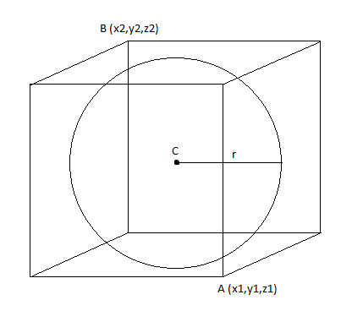

Picture 1- Inscribed sphere in a cube

Where A is start point and B is the end point. The following formulas show us how to find start and end points of massive. Since we have a delta that define the distance between points we need to divide each point by delta to find the index of each dimention.

x1=Cx-r/delta

y1=Cy-r/delta

z1=Cz-r/delta

x2=Cx+r/delta

y2=Cy+r/delta

z2=Cz+r/delta

To hide dots that sphere contain we just use slightly modified sphere equation

(x-a)^2+(y-b)^2+(z-c)^2<=R^2 for each dot in range from A to B.