**DBMS Term Project**

**Spring 2019**

**Derrick Demers**

**Phase 1: Problem Analysis and Requirement Specification (3/25/19)**

A problem statement:

I will be building a database that will address the inventory, employees, and customer orders of an online video game store. This store will mainly specialize in the sales of video games and hardware, but also carry movies as well as CDs. The online store needs a database since they are just starting up, they will need this database built from the ground up to store inventory items, employee names, numbers, and salary, and customer names, email addresses, addresses, order numbers, and order totals. This database will be composed of seven separate tables: one for customers, one for employees, one for inventory, one for hardware, one for games, one for movies, one for music.

Requirements/rules:

1. Employees must have a name (first and last), an employee ID, and a salary in the database
2. Employees can be managers
3. No item must be null
4. Each customer can have multiple orders
5. Only one employee is assigned one salary
6. Each customer must have an email address
7. There can be many of one item in the inventory
8. Each customer has one address
9. Each media (games, music, movies) can have one title, many copies, and an ID

**Phase 2: Database Design (4/6/2019)**

* **Inventory (Total_Amnt, TotHardware_Amnt, TotCD_Amnt, TotGames_Amnt, TotMovies_Amnt)**

This table stores the amount of all products we have by category (hardware, CDs, games, movies). This table carries employee ID information so it can tell who has the authority to edit the data.

* **Employees (Emp_Name, Emp_ID, Emp_Salary, Manager)**

This table stores the information of employees. All attributes are dependent on the Emp_ID

* **Customers (Cust_Name, Cust_OrderNo, Cust_Amnt, Cust_Cost, Cust_Email, Cust_Addr)**

This table stores all the customer information.

* **Hardware (Hardware_Name, Hardware_Make, Hardware_ID, Hardware_Amnt, Hardware_Price)**

This table stores the information of the hardware available in the store. TotHardware_Amnt references the Inventory table, linking the hardware to the inventory

* **Games (Game_Title, Game_Publ, Game_ID, Game_Price, Game_Amount)**

This table stores the information of the games available in the store. TotGames_Amnt references the Inventory table, linking the games to the inventory

* **Movies (Movie_Title, Movie_Studio, Movie_ID, Movie_Price, Movie_Amount)**

This table stores the information of the movies available in the store. TotMovies_Amnt references the Inventory table, linking the movies to the inventory

* **CDS (CD_Artist, CD_Title, CD_RecComp, CD_ID, CD_Price, CD_Amount)**

This table stores the information of the movies available in the store. TotCD_Amnt references the Inventory table, linking the CDs to the inventory.

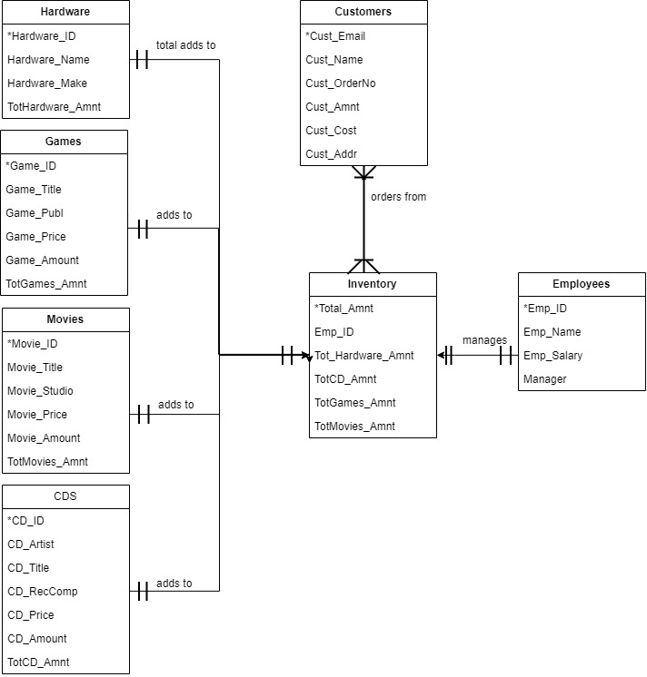

**Phase 3: Updates**

The updates from Phase 2 to Phase 3 include a tidying up of the diagram as well as condensing the business rules. I had set up the tables and their data accordingly as well as implemented four stored procedures centered around the inventory, finding an employee, and finding a customer.

**Phase 3: Internal Model**

CREATE TABLE EMPLOYEES (

EMP_ID VARCHAR(7) NOT NULL,

EMP_NAME VARCHAR(30) NOT NULL,

EMP_SALARY INT NOT NULL,

MANAGER VARCHAR(3) NOT NULL,

PRIMARY KEY (EMP_ID)

);

INSERT INTO EMPLOYEES (EMP_ID, EMP_NAME, EMP_SALARY, MANAGER)

VALUES ('1234567', 'Amara Romanoff', 20.25, 'YES');

INSERT INTO EMPLOYEES (EMP_ID, EMP_NAME, EMP_SALARY, MANAGER)

VALUES ('2365478', 'Laney Zane', 23.25, 'YES');

INSERT INTO EMPLOYEES (EMP_ID, EMP_NAME, EMP_SALARY, MANAGER)

VALUES ('1511244', 'Chad Dylan', 13.25, 'NO');

INSERT INTO EMPLOYEES (EMP_ID, EMP_NAME, EMP_SALARY, MANAGER)

VALUES ('2334543', 'Sarah Flack', 13.25, 'NO');

CREATE TABLE CUSTOMERS(

CUST_NAME VARCHAR(30) NOT NULL,

CUST_ORDERNO VARCHAR(7) NOT NULL,

CUST_AMNT INT NOT NULL,

CUST_COST INT NOT NULL,

CUST_EMAIL VARCHAR(50) NOT NULL,

CUST_ADDRESS VARCHAR(50) NOT NULL

);

INSERT INTO CUSTOMERS (CUST_NAME, CUST_ORDERNO, CUST_AMNT, CUST_COST, CUST_EMAIL, CUST_ADDRESS)

VALUES ('Ricky Remero', '2323234', 1, 200, 'remero@yahoo.com', '327 Journey St');

INSERT INTO CUSTOMERS (CUST_NAME, CUST_ORDERNO, CUST_AMNT, CUST_COST, CUST_EMAIL, CUST_ADDRESS)

VALUES ('Remmy Peterson', '1287356', 2, 120, 'Gamit34@yahoo.com', '224 West Avenue');

INSERT INTO CUSTOMERS (CUST_NAME, CUST_ORDERNO, CUST_AMNT, CUST_COST, CUST_EMAIL, CUST_ADDRESS)

VALUES ('Sydney Blanch', '5643176', 3, 180, 'SBlanch@hotmail.com', '3344 Blackwater Rd');

INSERT INTO CUSTOMERS (CUST_NAME, CUST_ORDERNO, CUST_AMNT, CUST_COST, CUST_EMAIL, CUST_ADDRESS)

VALUES ('Avery Dawn', '2233445', 1, 25, 'NewDawn@gmaiil.com', '782 Cypres PT apt 709');

CREATE TABLE HARDWARE (

HARDWARE_NAME VARCHAR(25) NOT NULL,

HARDWARE_MAKE VARCHAR(25) NOT NULL,

HARDWARE_ID VARCHAR(7) NOT NULL,

HARDWARE_AMNT INT NOT NULL,

HARDWARE_PRICE INT NOT NULL

);

INSERT INTO HARDWARE (HARDWARE_NAME, HARDWARE_MAKE, HARDWARE_ID, HARDWARE_AMNT, HARDWARE_PRICE)

VALUES ('Xbox One', 'Microsoft', '1092367', 40, 250);

INSERT INTO HARDWARE (HARDWARE_NAME, HARDWARE_MAKE, HARDWARE_ID, HARDWARE_AMNT, HARDWARE_PRICE)

VALUES ('Playstation 4', 'Sony', '2097865', 40, 250);

INSERT INTO HARDWARE (HARDWARE_NAME, HARDWARE_MAKE, HARDWARE_ID, HARDWARE_AMNT, HARDWARE_PRICE)

VALUES ('Gaming PC', 'AMD', '1298754', 40, 1200);

INSERT INTO HARDWARE (HARDWARE_NAME, HARDWARE_MAKE, HARDWARE_ID, HARDWARE_AMNT, HARDWARE_PRICE)

VALUES ('DVD Player', 'Panasonic', '4098321', 40, 150);

CREATE TABLE GAMES (

GAME_TITLE VARCHAR(25) NOT NULL,

GAME_PUBL VARCHAR(25) NOT NULL,

GAME_ID VARCHAR(7) NOT NULL,

GAME_PRICE INT NOT NULL,

GAME_AMOUNT INT NOT NULL

);

INSERT INTO GAMES (GAME_TITLE, GAME_PUBL, GAME_ID, GAME_PRICE, GAME_AMOUNT)

VALUES ('Borderlands 3', '2K', '9876345', 100, 60);

INSERT INTO GAMES (GAME_TITLE, GAME_PUBL, GAME_ID, GAME_PRICE, GAME_AMOUNT)

VALUES ('Halo Reach', 'Microsft', '9853216', 100, 60);

INSERT INTO GAMES (GAME_TITLE, GAME_PUBL, GAME_ID, GAME_PRICE, GAME_AMOUNT)

VALUES ('Super Smash Bros.', 'Nintendo', '9654278', 100, 60);

INSERT INTO GAMES (GAME_TITLE, GAME_PUBL, GAME_ID, GAME_PRICE, GAME_AMOUNT)

VALUES ('Devil May Cry V', 'Capcom', '9987656', 100, 60);

CREATE TABLE MOVIES (

MOVIE_TITLE VARCHAR(50) NOT NULL,

MOVIE_STUDIO VARCHAR(50) NOT NULL,

MOVIE_ID VARCHAR(7) NOT NULL,

MOVIE_PRICE INT NOT NULL,

MOVIE_AMOUNT INT NOT NULL

);

INSERT INTO MOVIES (MOVIE_TITLE, MOVIE_STUDIO, MOVIE_ID, MOVIE_PRICE, MOVIE_AMOUNT)

VALUES ('Avengers: Infinity War', 'Disney', '4098765', 25, 100);

INSERT INTO MOVIES (MOVIE_TITLE, MOVIE_STUDIO, MOVIE_ID, MOVIE_PRICE, MOVIE_AMOUNT)

VALUES ('Dispicable Me', 'Paramount', '4765421', 25, 100);

INSERT INTO MOVIES (MOVIE_TITLE, MOVIE_STUDIO, MOVIE_ID, MOVIE_PRICE, MOVIE_AMOUNT)

VALUES ('Saw VI', 'Capstone', '4198342', 25, 100);

INSERT INTO MOVIES (MOVIE_TITLE, MOVIE_STUDIO, MOVIE_ID, MOVIE_PRICE, MOVIE_AMOUNT)

VALUES ('Star Wars VII', 'Lucasfilm', '4124533', 25, 100);

CREATE TABLE CDS (

CD_ARTIST VARCHAR(50) NOT NULL,

CD_TITLE VARCHAR(50) NOT NULL,

REC_COMP VARCHAR(50) NOT NULL,

CD_ID VARCHAR(7) NOT NULL,

CD_PRICE INT NOT NULL,

CD_AMOUNT INT NOT NULL

);

INSERT INTO CDS (CD_ARTIST, CD_TITLE, REC_COMP, CD_ID, CD_PRICE, CD_AMOUNT)

VALUES ('Green Day', 'Revolution Radio', 'Fearless Records', '7665544', 10, 100);

INSERT INTO CDS (CD_ARTIST, CD_TITLE, REC_COMP, CD_ID, CD_PRICE, CD_AMOUNT)

VALUES ('Fall Out Boy', 'Infinity on High', 'Warner Music', '7554421', 10, 100);

INSERT INTO CDS (CD_ARTIST, CD_TITLE, REC_COMP, CD_ID, CD_PRICE, CD_AMOUNT)

VALUES ('All Time Low', 'Love Like War', 'Hopeless Records', '7998865', 10, 100);

INSERT INTO CDS (CD_ARTIST, CD_TITLE, REC_COMP, CD_ID, CD_PRICE, CD_AMOUNT)

VALUES ('Crown the Empire', 'Rise of the Runaways', 'Fearless Records', '7112234', 10, 100);

CREATE TABLE INVENTORY (

TOTAL_AMNT INT DEFAULT 0 NOT NULL,

TOTHARDWARE_AMNT INT DEFAULT 0 NOT NULL,

TOTCD_AMNT INT DEFAULT 0 NOT NULL,

TOTGAMES_AMNT INT DEFAULT 0 NOT NULL,

TOTMOVIES_AMNT INT DEFAULT 0 NOT NULL

);

#Stored Procedures#

CREATE PROCEDURE SelectAllEmployees()

SELECT * FROM EMPLOYEES;

CALL SelectAllEmployees;

CREATE PROCEDURE SelectAllManagers()

SELECT * FROM EMPLOYEES

WHERE MANAGER = 'YES';

CALL SelectAllManagers();

CREATE PROCEDURE SelectAllHardware()

SELECT * FROM HARDWARE;

CALL SelectAllHardware();

CREATE PROCEDURE SelectAllGames()

SELECT * FROM GAMES;

CALL SelectAllGames();

CREATE PROCEDURE SelectAllMovies()

SELECT * FROM MOVIES;

CALL SelectAllMovies();

CREATE PROCEDURE SelectAllCDs()

SELECT * FROM CDS;

CALL SelectAllCDs();

CREATE PROCEDURE HardwareTotal()

INSERT INTO INVENTORY (TOTHARDWARE_AMNT)

SELECT SUM(HARDWARE_AMNT) FROM HARDWARE;

CALL HardwareTotal();

SELECT TOTHARDWARE_AMNT FROM INVENTORY;

CREATE PROCEDURE CDTotal()

INSERT INTO INVENTORY (TOTCD_AMNT)

SELECT SUM(CD_AMOUNT) FROM CDS;

CALL CDTotal();

SELECT TOTCD_AMNT FROM INVENTORY;

CREATE PROCEDURE GamesTotal()

INSERT INTO INVENTORY (TOTGAMES_AMNT)

SELECT SUM(GAME_AMOUNT) FROM GAMES;

CALL GamesTotal();

SELECT TOTGAMES_AMNT FROM INVENTORY;

CREATE PROCEDURE MoviesTotal()

INSERT INTO INVENTORY (TOTMOVIES_AMNT)

SELECT SUM(MOVIE_AMOUNT) FROM MOVIES;

CALL MoviesTotal();

SELECT TOTMOVIES_AMNT FROM INVENTORY;

CREATE PROCEDURE InventoryTotal()

SELECT SUM(TOTHARDWARE_AMNT * TOTCD_AMNT * TOTGAMES_AMNT * TOTMOVIES_AMNT) FROM INVENTORY

AS TOTAL_AMNT;

CALL InventoryTotal();