**Introduction:**

This study explores bacterial resistance patterns in acute myeloid leukemia (AML) patients to refine antibiotic therapy and enhance patient outcomes. Immunocompromised patients, notably those undergoing AML treatment, necessitate improved infection management strategies. By mapping resistance patterns, this research aims to meet this need, opening avenues for enhanced infection management strategies within cancer care. The methodology involved analyzing bacterial genome data from 64 patients, identifying relevant antibiotics, and employing bioinformatics tools to detect resistance genes. The analysis revealed multiple resistance genes across antibiotic classes, with antibiotic efflux being prominent. Notably, genes like MexD, OprM, and ParR in Pseudomonas aeruginosa contribute to resistance through efflux mechanisms. Insights gleaned from resistance gene distribution graphs highlight the extensive resistance of Escherichia coli indicating the need for further genetic studies. Understanding how bacteria, resistance genes, and antibiotics interact is vital for better antibiotic use. This knowledge could shape policies in cancer centers and improve care for patients with weakened immune systems.

**Significance of the study:**

1. By understanding bacterial resistance patterns in AML patients, clinicians can tailor antibiotic therapy more effectively improving patient outcomes.

2. There is a crucial need for better management strategies for infections in immunocompromised patients, particularly those undergoing treatment for cancers like AML. This study addresses this need by mapping resistance patterns which is a step towards more effective infection control and management

3. The data collected and analysed in this study can serve as a valuable resource for future research into bacterial infections and resistance in cancer patients. It may lead to wider studies involving more antibiotics, bacteria and other types of cancer, further expanding knowledge on this crucial issue.

4. The findings of this study could influence policy decisions and guidelines related to the management of cancer treatment centers, enhancing the safety and efficacy of care provided to immunocompromised patients

**Aims**

1. To analyze the resistance patterns of bacterial pathogens in cancer patients, focusing on AML, and assess the impact on treatment outcomes and patient survival.
2. To further establish a relationship between mortality and antibiotic resistance.
3. To provide a dataset for subsequent AML research by schools, organisations and individuals to advance scientific knowledge and foster innovation

**Methodology**  
Bacterial genome data from the specified dataset (SRP417207), encompassing genomes from 64 patients, was acquired through the SRA Explorer website. Three antibiotics - Penicillin(s), Ciprofloxacin, and Aminoglycoside - relevant to treating infections in cancer patients were identified from literature. Utilizing bioinformatics tools, the bacterial genomes were analyzed, and specific pathogens were identified in each of the 64 samples. The genetic sequences of the bacterial isolates were searched for selected resistance genes using tools like BLAST. Subsequently, resistance patterns were analyzed using statistical tools such as R or Python, and correlations or trends were identified.

**Results and Discussion**

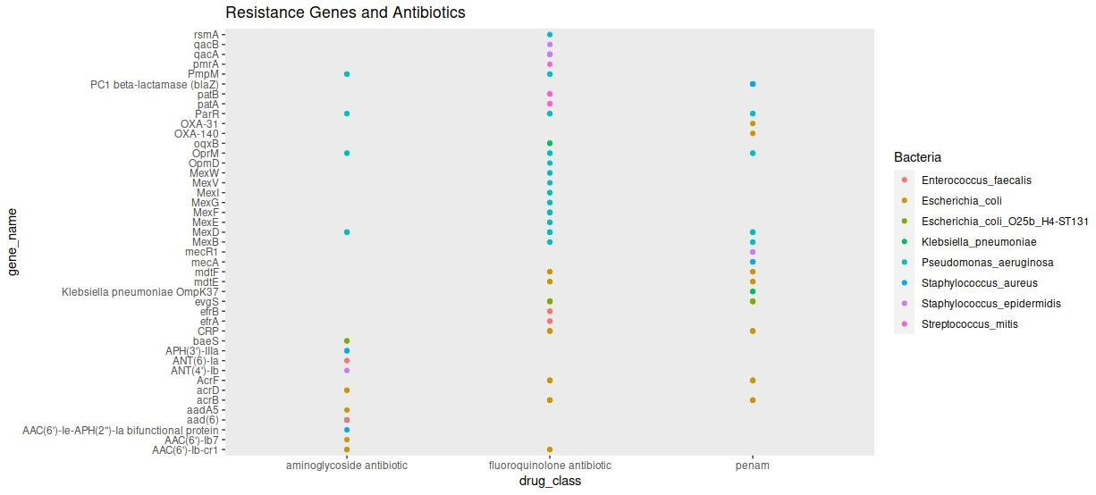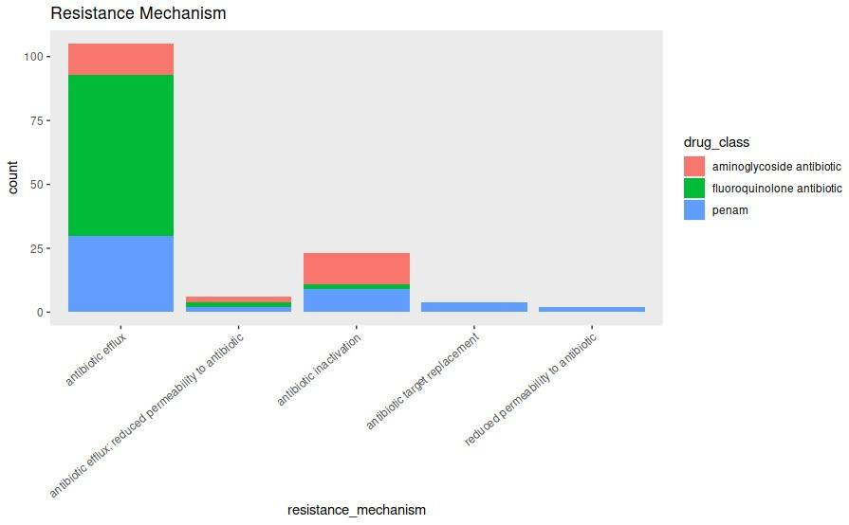

The analysis revealed at least three genes associated with resistance to each antibiotic class. Various resistance patterns were identified, including antibiotic efflux, antibiotic target alteration, antibiotic target protection, antibiotic inactivation, antibiotic target replacement, and antibiotic efflux with reduced permeability to antibiotics. Notably, antibiotic efflux emerged as the most common resistance mechanism. The genes MexD, OprM and ParR, belonging to the resistance-nodulation-cell division (RND) antibiotic efflux pump gene family in Pseudomonas aeruginosa bacteria, confers resistance to the three selected antibiotics (Penicillin, Ciprofloxacin, and Aminoglycoside) through the antibiotic efflux mechanism. MexD and OprM exhibit antibiotic resistance by actively pumping antibiotics and other toxic compounds out of the bacterial cell, thereby reducing their intracellular concentration and rendering them ineffective. ParR in the bacteria exhibits resistance by actively pumping antibiotics out of the cell through efflux pumps while simultaneously reducing the permeability of their cell membranes to incoming antibiotics.