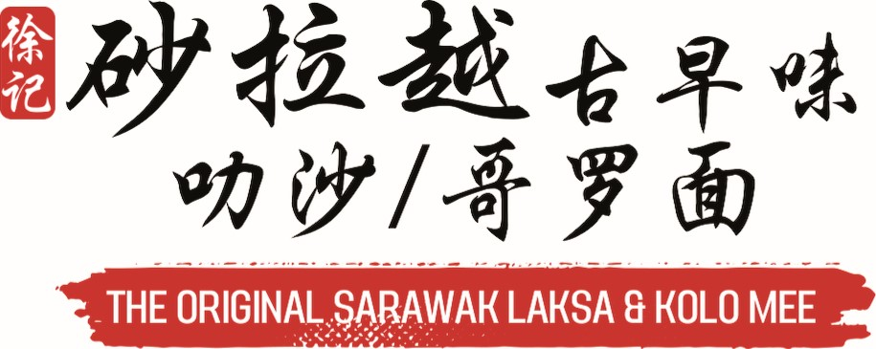
Beverages  Cold
- Coffee 2.00 2.40 2.70
- Oji] Coffee 0 1.80 2.10 2.40
- Coffee C 2.00 2.40 2.70
304 | Teh C | 2.00 | 2.40 | 2.70 | 325C | DRINHME Jin Seng Teh Krisantemum | 4.00
305 | Teh 0 | 1.80 | 2.10 | 2.40 |  | 
306 | Milo | 3.00 | 3.20 | 3.50 | 325D | DRINHME Juice | 4.80
307 | Milk |  | 2.00 |  | 325F | DRINHME Calamansi Fruit Juice | 4.80

308 | g   Teh BungalBarley |  | 1.90 | 2.20 | 326B | iSoya Black Bean | 4.00
309 | Chinese Tea |  | 0.60 | 0.80 | 326C | iSoya Longan Sea Coconut | 4.00
310 | Plain Water |  | 0.50 | 0.70 |  | 
311 | Mineral Water |  | 1.50 | 1.80 | 326D | iSoya Red Dates Snow Fungus | 4.00
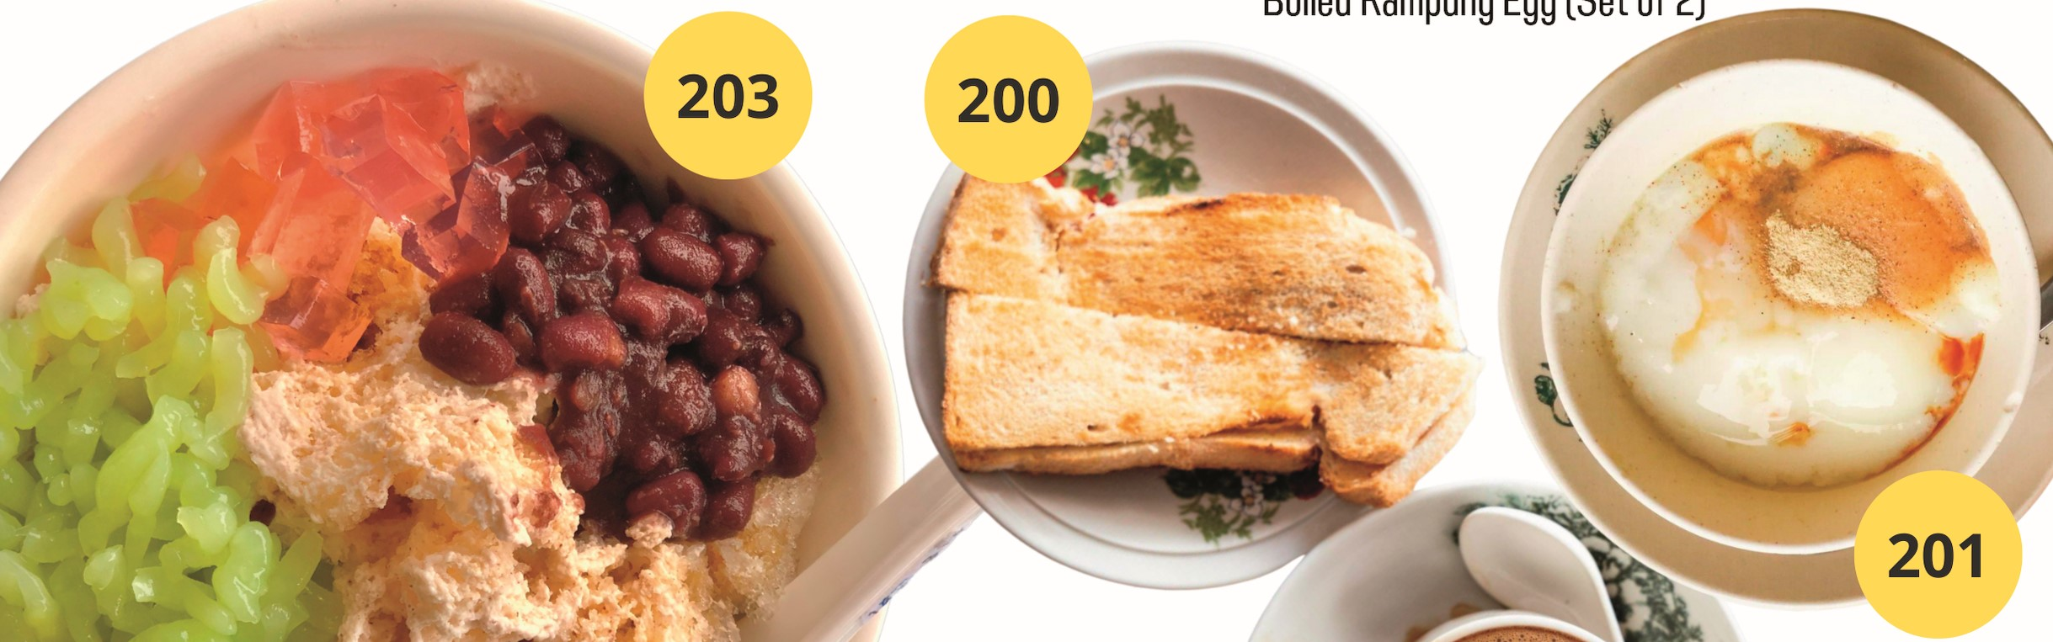
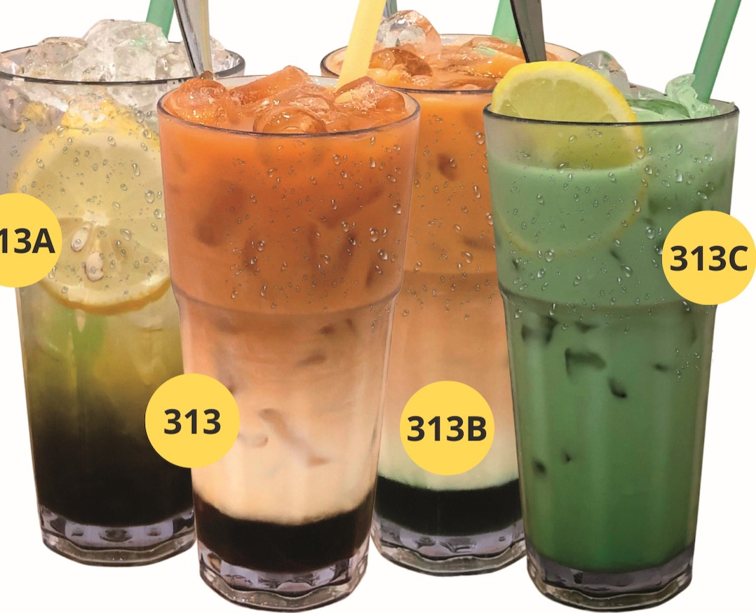

- Teh 2.00 2.40 2.70 325A DRINHME Limau Ais Jeli
Boiled
Kampung
Egg
(Set
of
2)
313A
4.00
 |  |  |  | 3.00
314 |  Limau Asam |  | 3.20 | 3.50 |  Sarawak Beverages
315 | White Coffee |  | 3.00 | 3.30 | 0 313 | 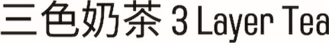 | 4.90
316 | Nescafe | 2.60 | 3.00 | 3.30 | 313A |  Lemon Green Tea | 4.20
317 | Nescafe 0 | 2.30 | 2.70 | 3.00 | 0 313B |  | 4.90
318 | Neslo |  | 3.50 | 4.00 |  | Pandan 3 Layer Tea
319 | Teh 0 Limau |  | 2.50 | 2.80 |  |  | 4.90
320 | Limau |  | 2.20 | 2.50 |  | Wheat Grass C Lemon
321 | Lemon Tea |  | 2.70 | 3.00 | 0 203 | Ice Kacang | 5.90
322 | Coffee Mix Tea C | 2.00 | 2.40 | 2.70 |  |  Toast Eggs
323 | Coffee Mix Tea | 2.00 | 2.40 | 2.70 | 200 |   Toast (Butter Kaye) | 2.80
324 | Coffee Mix Tea 0 | 1.80 | 2.10 | 2.40 | 201 |  | 3.20

312  Canned Drinks

