<https://sprin.io/tools> - Link to download STS

STS – Spring Tool Suite – Eclipse based IDE

IDE – Integrated Development Environment

STS – Is suitable to create Spring Boot based Application

Postgres 12.9/13.5 (recommended version) download link

<https://www.enterprisedb.com/downloads/postgres-postgresql-downloads>

Postgres – support SQL as well as NoSQL db format

|  |  |  |
| --- | --- | --- |
| Sl No | SQL | NO-SQL |
| 1 | Table | Document |
| 2 | SQL is used | JavaScript |
| 3 | Stored in the form of rows & Columns | It is stored as a collection in the form of JSON |
| 4 | CLI, GUI | CLI, GUI |
| 5 | Mysql command line client, MySQL Workbench | MongoDB, Firebase |
| 6 | No cloud version | Cloud version supported |
| 7 | Fixed Schema | Dynamic Schema |

Web Service – It’s a service offered through web (using internet)

ABC bank Customer, You are about to withdraw XXXX Amount from your account.

1. Using ABC bank debit card in ABC bank ATM -- JAVA
2. Using XYZ bank ATM - .Net – debit card number, pin

Person1 English

Person2 Spanish (Don’t know English)

--- Translator

Web Service – XML/JSON – data exchange format.

XML -eXtensible Markup Lang

JSON – JavaScript Object Notation

Web Services types

1. SOAP based (Simple Object Access Protocol) – XML - WSDL
2. REST ful web service (Representational State Transfer – Re-use http methods – simple and effective

WSDL – WebService Definition/Description Language

Web Service – XML/JSON

XML/JSON – Data Exchange Format – is independent of platform/operating System/Programming Lang/Architecture

Public class Employee {

Private int id;

Private String name;

Private String email;

Constructor & getter setters

}

XML Representation

<employees>

<employee>

<id>100</id>

<name> ABC</name>

<email>abc@gmail.com</email>

</employee>

<employee>

<id>101</id>

<name> xyz</name>

<email>xyz@gmail.com</email>

</employee>

<employee>

<id>102</id>

<name> mno</name>

<email>mno@gmail.com</email>

</employee>

</employees>

JSON – Representation

Employees = [

{“id”:100,”name”:”abc”, “email”:”abc@gmail.com”},

{“id”:101,”name”:”xyz”, “email”:”xyz@gmail.com”},

{“id”:102,”name”:”mno”, “email”:”mno@gmail.com”}

];

Parser – It’s a software tool to extract the data from XML/JSON

Parsing – It’s a process of extracting data from XML/JSON using parser

Weather service, Currency Services,

TMDB – The Movie Data base

Web Services – public , private web services

<https://www.themoviedb.org/>

Account & Settings—Settings --- API – Generate API Key – Sample API url – Get data in JSON format

REST API/web Service – Calling a method (can be developed using any programming lang) with the help of an URI and doing CRUD operation on the data.

To Create a Web Service –

1. Any programming Lang
2. Any Database
3. Any System

Spring Boot is the easiest way of creating web service

1. Using Spring boot CLI
2. Using Spring Initializr (start.spring.io) – Using the web browser
3. Using STS – Using the IDE
4. Lang (3 JVM based Lang – JAVA, Kotlin, Groovy)
5. Build Tool ( Maven [xml based] , Graddle [json based])
6. Packaging (jar/war)

JAR – JAVA Archive

WAR – Web Archive

groupId, artifactId, version – uniquely identify the projects – pom.xml file.

groupId – package name – should be in all small, reverse of the company url.

artifactId – projectname –

Creating a spring boot project using STS

Step 1 : Open STS

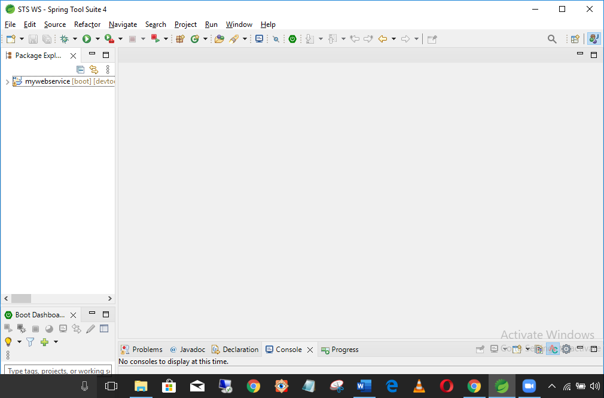

Step 2 : File -> New -> Spring Starter Project option

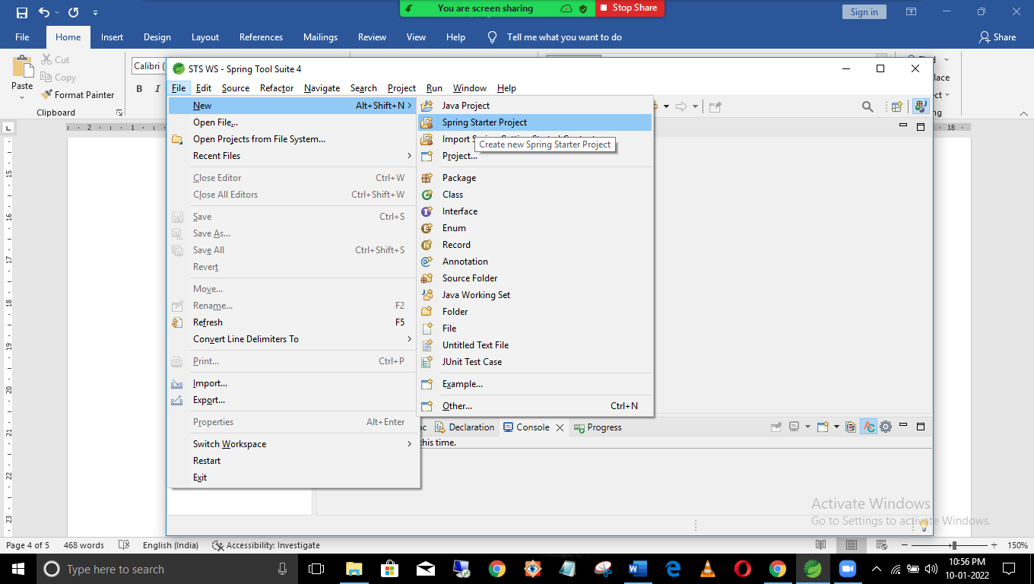

Step 3 : Fill project info as shown below

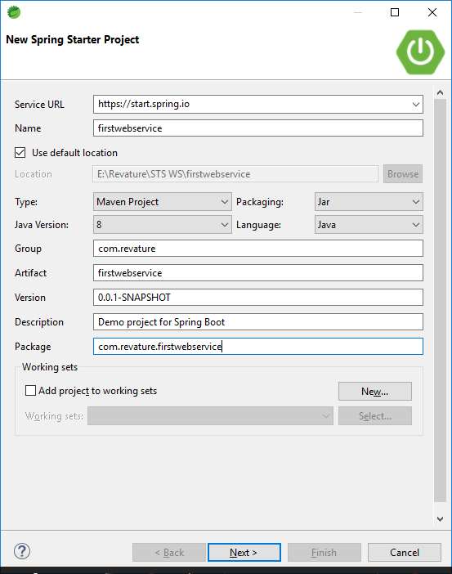

Step 4: select dependencies and spring boot version

Maven Local repo folder location - C:\Users\<Hamshu>\.m2\repository

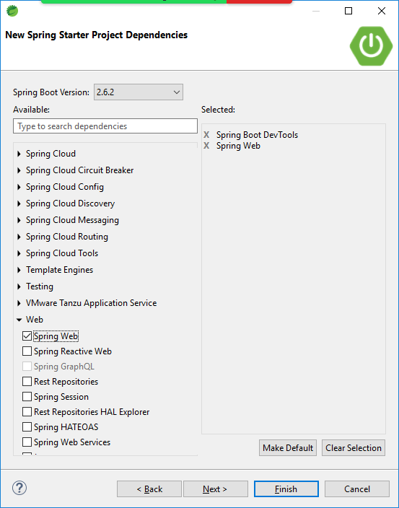

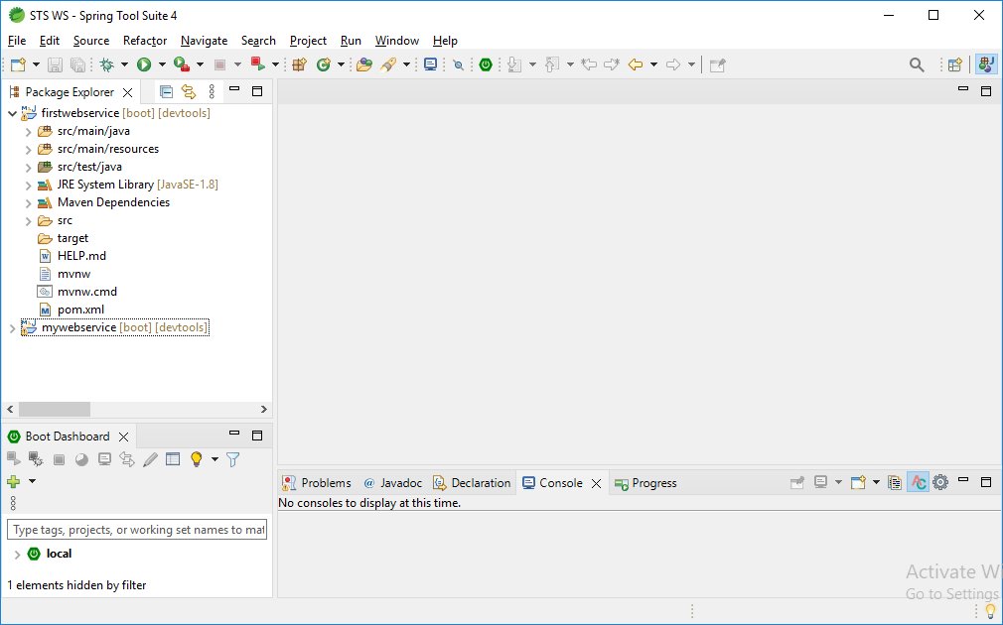

Endpoints – URI with the help of this, we can operate/process data (CRUD)

REST ful web services, the end points are known as Rest End Points

Rest Controller – Controller is a class which controls the flow of data - @RestController

Spring is a very popular java-based framework, it uses the concept of dependency injection & IoC

Two important design patterns which drive spring framework

IoC – Inversion of Control

DI – Dependency Injection.

Spring is also known as Framework of frameworks (It supports struts, hibernate (ORM), thymeleaf (UI) etc.,

Important Annotations used in REST Service Controller

1. @Autowired
2. @SpringBootApplication
3. @RequestMapping – Generic Mapping
4. @GetMapping
5. @PostMapping
6. @PutMapping
7. @DeleteMapping
8. @PathVariable
9. @RequestBody

Endpoints – It’s a URI with the help of that, we can able to get/create/update/delete the data

|  |  |  |  |  |  |
| --- | --- | --- | --- | --- | --- |
| Sl No | Operation | http Method | Method Signature | Arguments | Return Type |
| 1 | Read All | get | findAll() | No | List<Object> |
| 2 | Read By Id | get | findById(int id) | Id in @PathVariable | Object |
| 3 | Create | post | Add(Object obj) | Obj in @RequestBody | Nil |
| 4 | Update | put | Update(id, obj) | Id in path,obj in body | Nil |
| 5 | Delete | delete | Delete(id) | Id in pathvariable | Nil |

Download a Tool – Postman – API Testing tool

<https://chrome.google.com/webstore/detail/postman/fhbjgbiflinjbdggehcddcbncdddomop?hl=en>

@RequestMapping – is a generic @annotation which can be used with any of the rest end points.

@Get/Post/Put/Delete Mapping – Specific mapping

All the Endpoints are case sensitive.