Day 6 – Adv Java (Servlet, WebServer [Tomcat], Servlet Container)

Client – Server Architecture

Hotel / Restaurant

1. Customer place orders – (request) --- Server
2. Server pass the order to kitchen
3. Chef will prepare the food
4. When the food is ready, again server will take it and give it to the corresponding table

Client – Server Arch ---- Request & Response model

Client – [Browser & End user ] will create the request object

Server will receive the request and validate it. If valid, then process it and generates response

Server will send back the response to the respective client’s request

Server is a Software – install anywhere (Tomcat – web server)

Protocol – Set of Rules

http – hyper text transfer protocol

ftp – file transfer protocol

smtp – simple mail transfer protocol

pop – post office protocol

URL – Uniform Resource Locator

<http://www.google.com> -- URL

[protocol://resource_location.service_name.domain_name]

.com

.edu

.net

.org

.gov

.uni

.in

.us

.uk

.sl

.sg

IP address – Internet Protocol Address [IPv4 & IPv6]

IPv4 – [0-255].[0-255].[0-255].[0.255] --- 173.34.78.154

Each resource connected to internet will have a ip address.

Sent the data in the form of packets

http is a stateless protocol – server will never remember about any previous request

session management techniques

1. Session object
2. Hidden Form Fields
3. Cookies
4. URL Re-writing

XML – eXtensible Markup Language (Tag based Lang) – This is case and space sensitive lang. All the tags are user defined.

XML is for representing/ transferring the data from one place to another

JSON – JavaScript Object Notation

Public class Student {

Private int id;

Private String name;

}

XML

<students>

<student>

<id>100</id>

<name>ABC</name>

</student>

<student>

<id>101</id>

<name>DEF</name>

</student>

<student>

<id>102</id>

<name>XYZ</name>

</student>

</students>

JSON format

Students = [

{“id”:100,”name”:”ABC”},

{“id”:101,”name”:”DEF”},

{“id”:102,”name”:”XYZ”}

];

Parsers – It’s a software which will extract data from xml/json [SAX Parser, DOM Parser]

Parsing – It’s a process of extracting data from xml/json file

MySQL – DB Server (Installed Locally) – default port no : 3306 (software / Virtual port)

Tomcat – Web Server (15mb) (Installed Locally) default port no : 8080

Oracle DB – DB Server (Install Locally) default port no : 8080

Servlet – It’s a JAVA class which gets executed in the server

Normal JAVA class gets executed inside the JVM where as Servlets get executed by the Web/Application Server

Tomcat – web Server

GlassFish, JBoss, WebLogic, WebSphere – Application Server

Web server – can handle both servlets, jsp and jsf only

JEE – Servlet, JSP, JSF, EJB, JPA, JMS, Mail Service, JAXB ……

Servlet – It’s a JAVA Class which extends either GenericServlet or HttpServlet

GenericServlet – Protocol independent (http,ftp,smtp,pop…)

HttpServlet – HttpProtocol based

Init()

Service()

Destroy()

http methods

1. Get
2. Post
3. Delete
4. Put
5. Patch
6. Options
7. Trace

Creating New Dynamic Web Project in Eclipse EE

Step 1: Open Eclipse

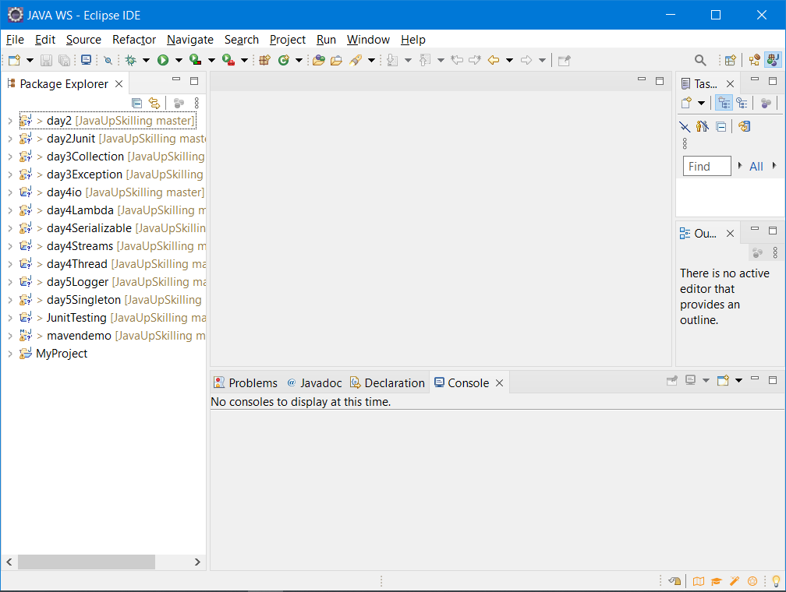

Step 2: File -> New -> Other -> Dynamic Web

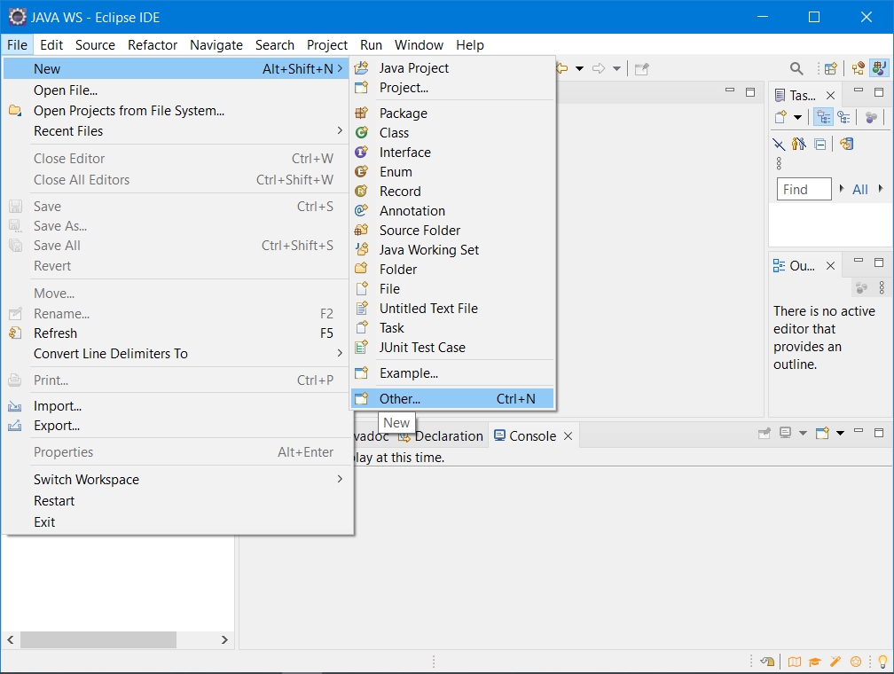

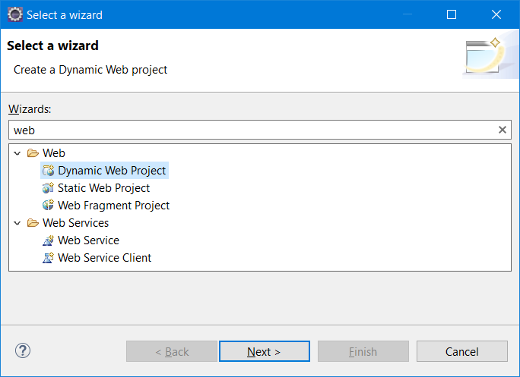

Step 3: Fill all the fields (Name of Project, target Runtime, Dynamic Web Module Version [3.0])

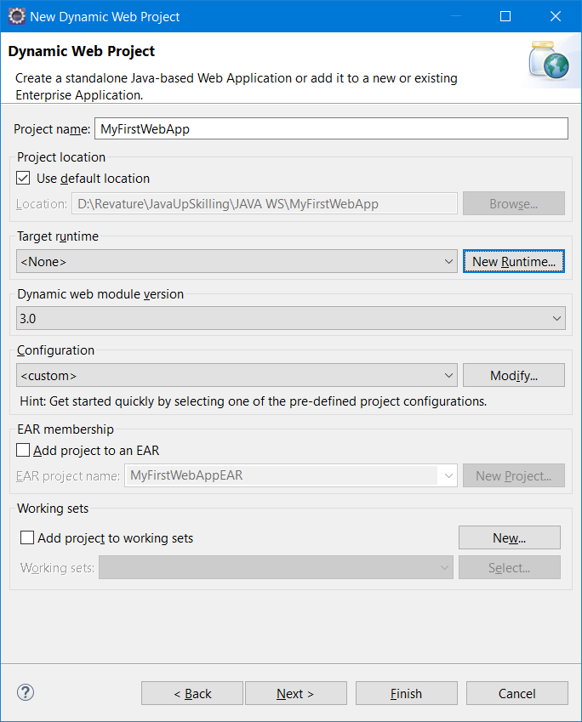

Step 3.1 ) Click on “New Runtime” Button to define a new local tomcat server instance

3.2) select “Apache Tomcat 8.5 server” from the available options and also click the check box “Create a new Local Server”

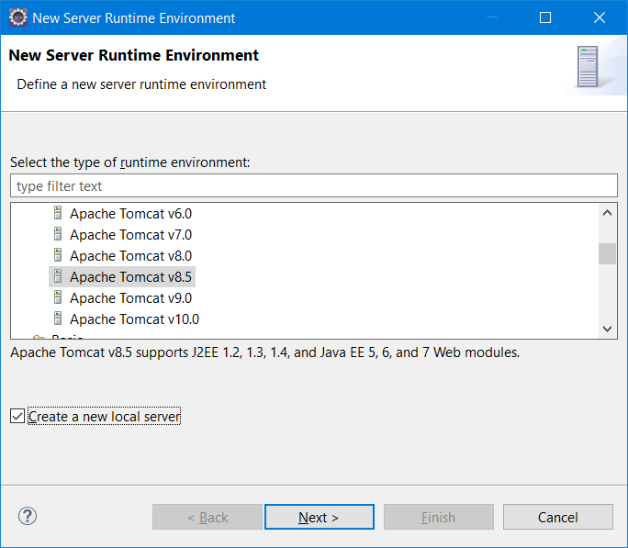

3.3) Click “Next” and choose the location of tomcat server by clicking the “Browse” button

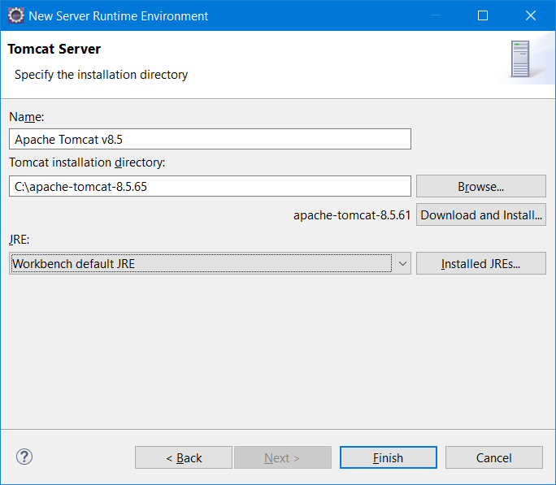

3.4) click Finish

Step 4) Click “Next”

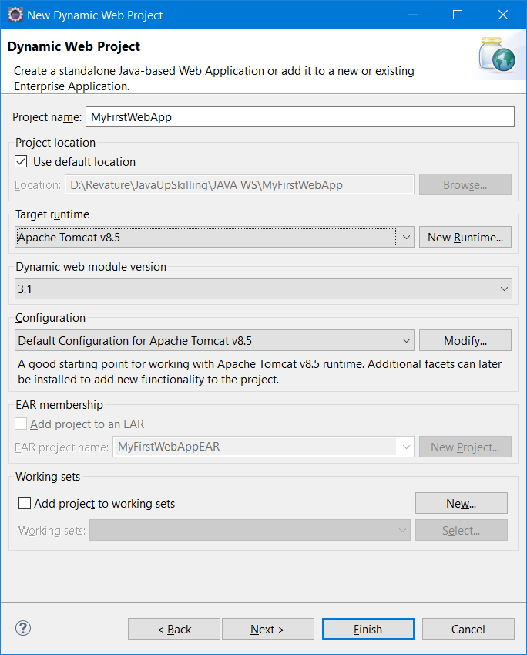

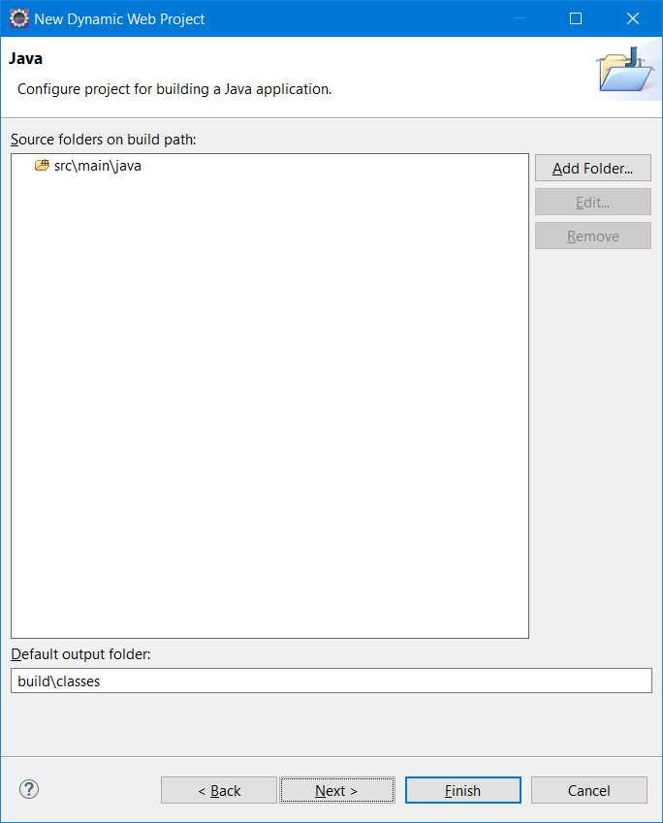

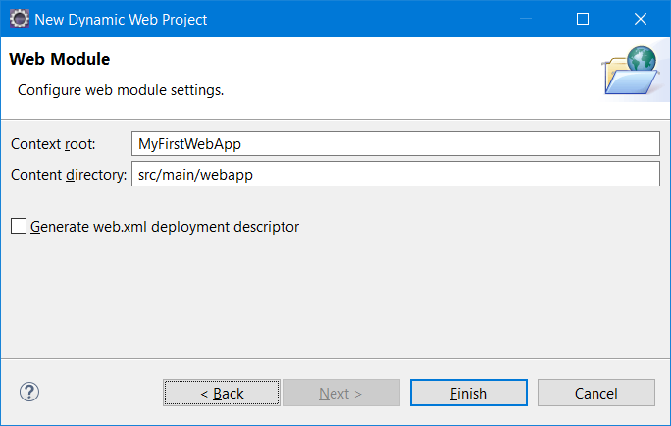

Click “Finish” button

Click on “Open Perspective”

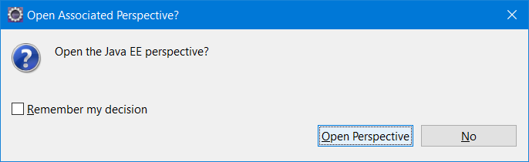

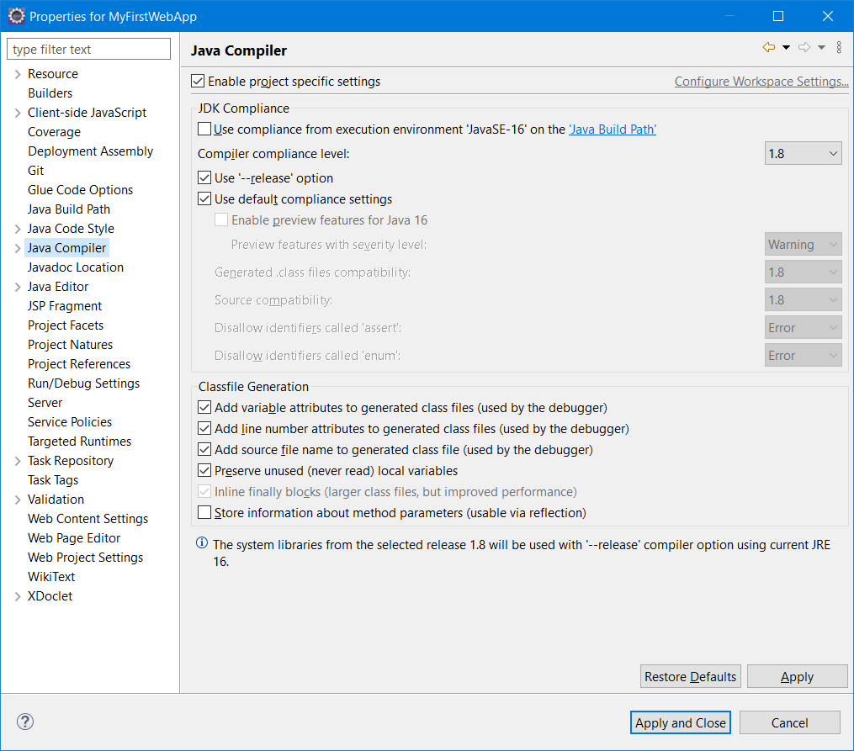

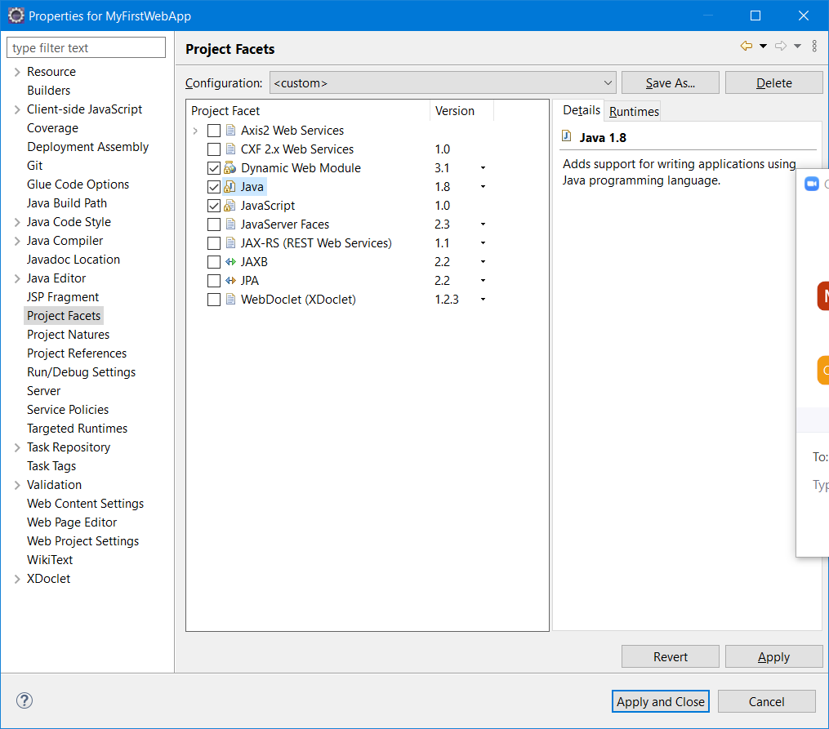

Steps to create a Servlet in dynamic web app

1. Right click project -> Select Servlet

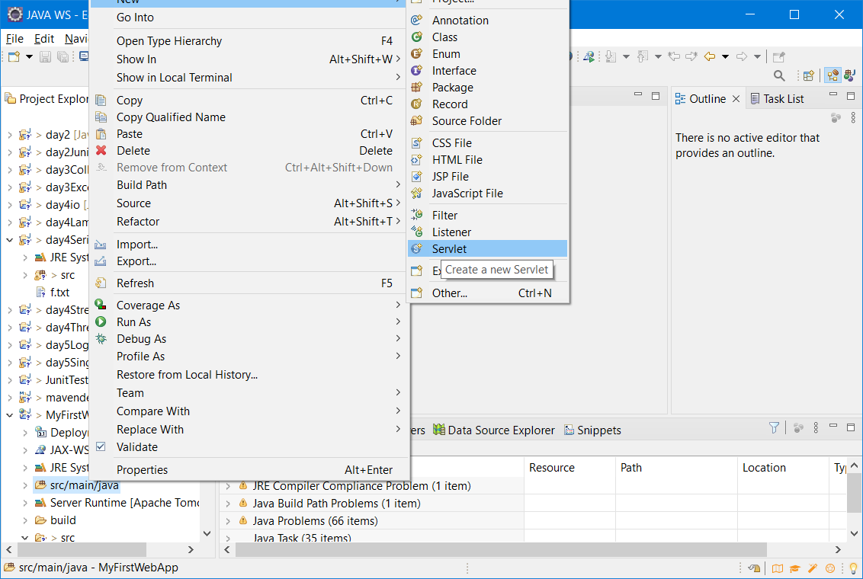

Step 2: Enter the package name and servlet name and click “Next” button

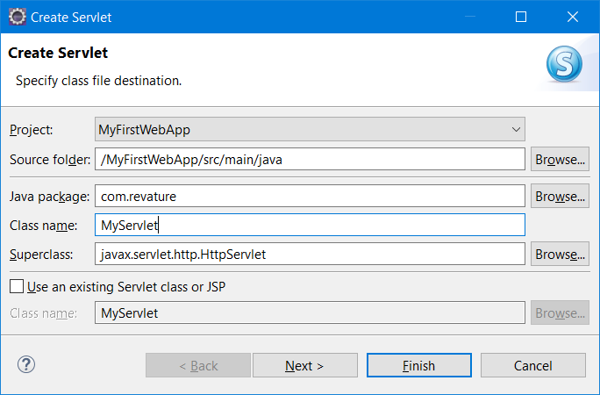

Step 3: accept the default URL Mapping

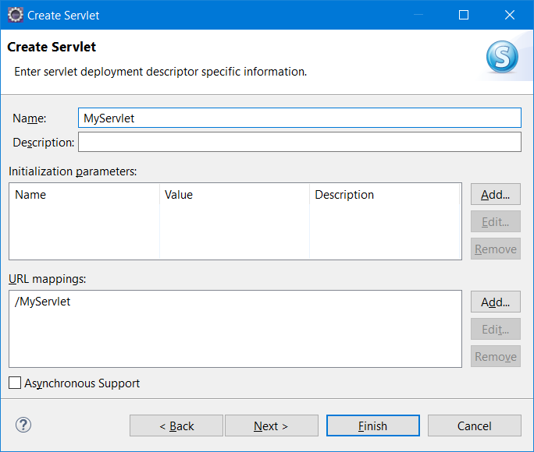

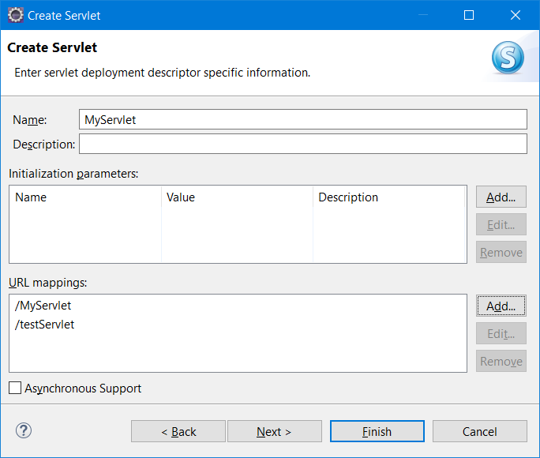

Click “Next”

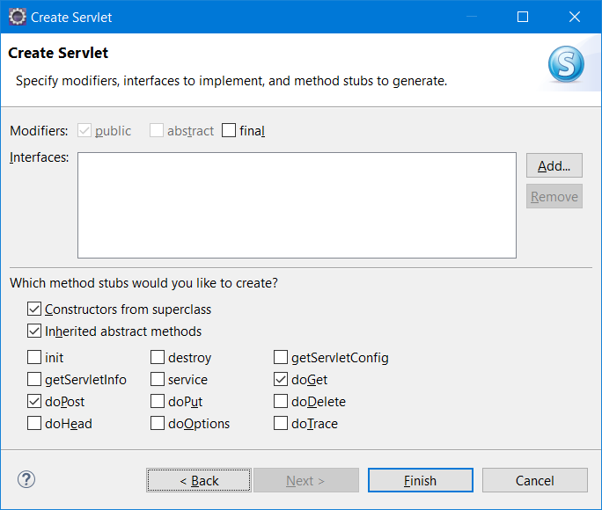

Click Finish.

To Run the application, right click the project, select Run As -> Run on Server

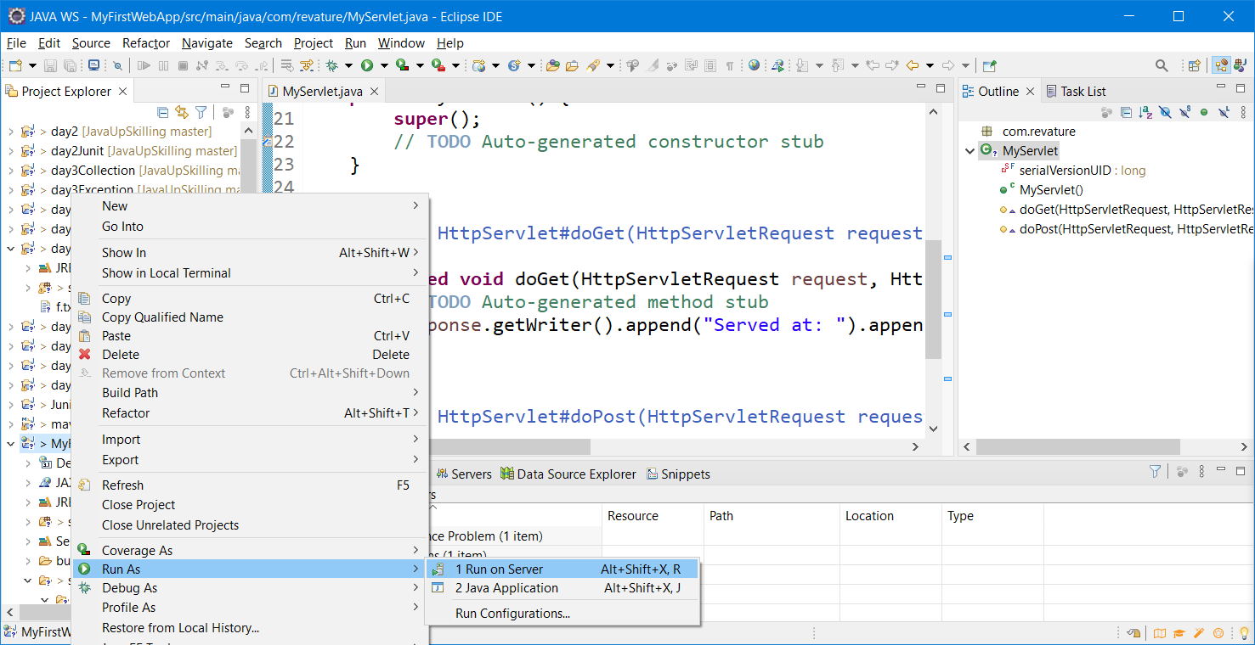

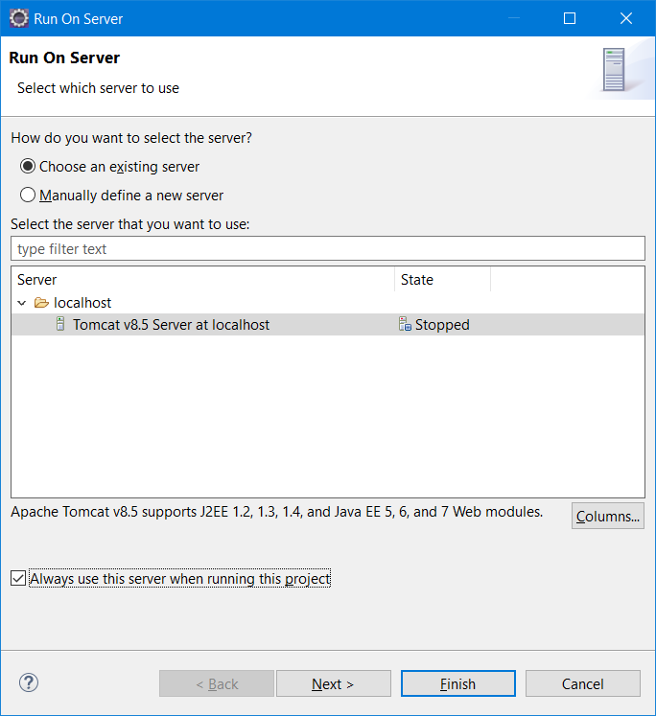

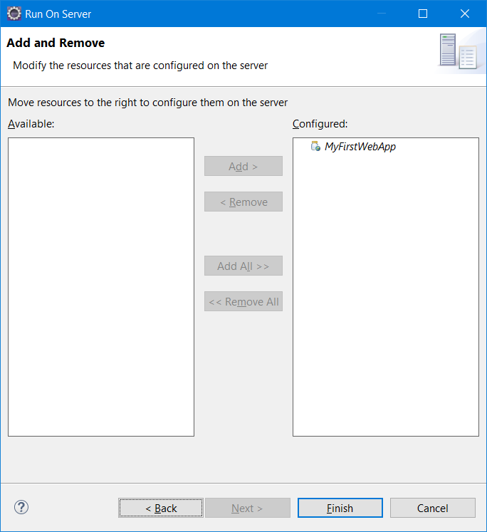

Click finish. In case of “Port Already in use error” double click the “Apache Tomcat server” and update http port number as shown below.

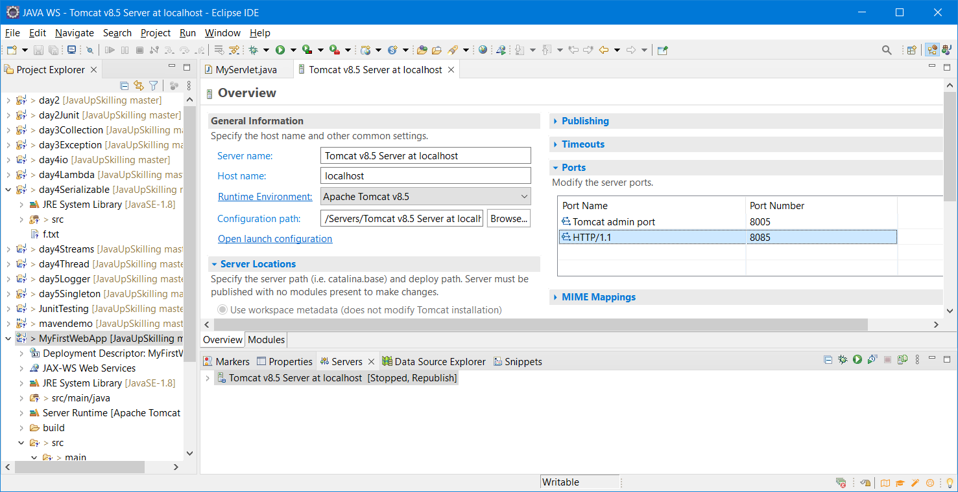

Static Web App – The content will not change with respect to time & to user. – By using just HTML,CSS & JS

Dynamic Web App – The content will change for different user at different time – Gmail, Facebook, LinkedIn – Server Side Coding Technologies (Servlet, JSP, ASP, php, Python, NodeJS, Angular, React)

Build – It is the process of converting source to object (.java -> .class conversion)

Packaging – It is the process of converting all the source code into a single compressed format (jar/war)

Deployment – Executing the compressed java web application in the web server

Deployment Descriptor – It is a xml file (web.xml)

<web-app xmlns="http://xmlns.jcp.org/xml/ns/javaee"

xmlns:xsi="http://www.w3.org/2001/XMLSchema-instance"

xsi:schemaLocation="http://xmlns.jcp.org/xml/ns/javaee

http://xmlns.jcp.org/xml/ns/javaee/web-app_3_1.xsd"

version="3.1">

<servlet>

<servlet-name>servlet1</servlet-name>

<servlet-class>com.revature.MyFirstServlet</servlet-class>

</servlet>

<servlet-mapping>

<servlet-name>servlet1</servlet-name>

<url-pattern>/*</url-pattern>

</servlet-mapping>

</web-app>

Java Introduced annotation in java 1.5 only

If jdk version is >= 1.5 then web.xml file is optional

If jdk version <1.5 – web.xml is compulsory

<https://www.javatpoint.com/servlet-tutorial>

In servlet – we are creating html response

We embed html code inside the java code – servlet