Thank you for trying MeowBit beta, Version 0.3.5179.694
NOTE: You need to have the Namecoin WALLET installed and updated and RUNNING for MeowBit to work. Start Namecoin wallet. Let it update.
First, if you don’t have the Namecoin wallet, get it here (download links are over on the top right of that linked page.) Install it. Allow it to run for 3-5 hours until it’s totally updated.

Howdy kitties!
We’ve been listening to your feedback and doing a lot of beta testing on our own, on many computers. Derrick worked his butt off tonight making an updated version. It works better, and also logs better…that will help us help you if you need help.
(NOTE to users: if you’d installed a previous version, uninstall the old version first. Click on desktop kitty to open MeowBit monitor. Stop Service. Go into system tray. Right-click on kitty, exit MeowBit. Go to Windows Start / Control Panel, Programs and Features / click MeowBit to uninstall. Then you can install new version.)
(Updates from previous version: fixes www./no www. issue. Fixes bug that made some people unable to install. Also has better logging to help us help you.)
(Note to developers: 3/6/14 11:08 PM Wyoming time: the source code on our source page is the last version, Derrick had to go to sleep. We will update the source link tomorrow evening, and put on GitHub with our third roll out.)
New version is at the same download link as the old one, on the Install page, HERE.
If you have questions or issues, please post them on our forum, HERE.
Thank you,
–THE BEASTLICK INTERNET POLICY COMMISSION outreach team.
MeowBit INSTALLATION INSTRUCTIONS
We haven’t heard of any issues, but if you have any Namecoin in your wallet, be SURE to back it up to another hard drive or computer before installing anything that interacts directly with the wallet.
If you were viewing Dot-Bit domains before using the clunky and insecure alternate-DNS servers workaround, change back to your old default DNS servers before installing MeowBit.
Disable (or disable and remove) FreeSpeechMe if you have it installed as a plug-in in Firefox. Restart Firefox. You should NOT be able to surf dot-bit addresses.
Close Firefox and any other browsers.
You need to have the Namecoin WALLET installed and updated. Start Namecoin wallet. Let it update.
First, if you don’t have the Namecoin wallet, get it here (download links are over on the top right of that linked page.) Install it. Allow it to run for 3-5 hours until it’s totally updated.
Depending on your computer’s settings, you may or may not get a Windows firewall warning, when installing Namecoin or when installing MeowBit. If you do, click “Allow Access”, then the “Close” button:
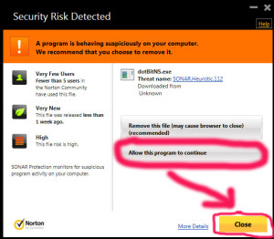
Depending on your firewall settings, you may get no request, you may get one request, or you may get several such requests in a row, one right after the other, or a few moments apart, for several components of the Namecoin wallet and/or MeowBit. You will have to click “Allow Access” for each one you get. If a Windows firewall warning for any of these components ever comes up again, click “Allow Access” again.
In Windows 8, it will likely be the User Account Control instead of Windows Firewall. Hit the “Yes” button to allow.
You have to have the Namecoin wallet running while running MeowBit in order to be able to use Dot-Bit websites.

Download the file. Unzip and extract. Double click on it. Accept the terms, then click “Next.”
(IF NORTON THINKS IT’S A VIRUS BECAUSE IT DOESN’T RECOGNIZE IT, TURN NORTON OFF, AND RE-DOWNLOAD IT, AND LATER TELL NORTON TO ALLOW IT. MeowBit contains no viruses, spyware, adware or malware. It is GNU-licensed, Free Software, source code here, and anyone can vet it. However, the 2014 version of Norton is overly nanny and will delete new programs that aren’t recognized. (Info about this on the Norton site, here.) This is also true of some other anti-virus programs, like AVG.)
Click the kitty cat icon on the desktop:
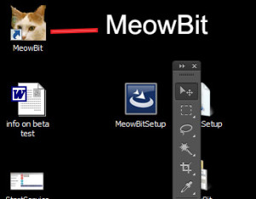
It will install and pop up this window:
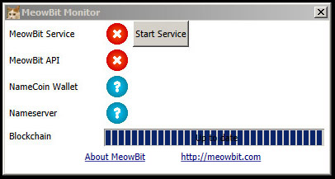
You may have variations of blue and red icons, but none will be green immediately.
If “Install Service” button appears, then press that button.
If “Start Service” button appears, then press that button.
Icons should soon start turning green:
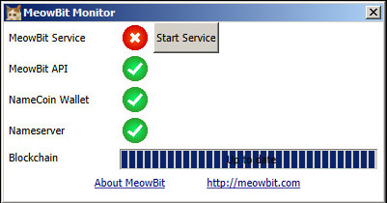
Once the are all green…
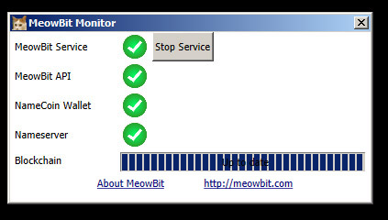
…open any browser and try surfing some Dot-Bit sites. Here are few to try:
https://dot-bit.bit/
http://feens.bit/
Dot-Bit Kitty Pix! – The ONLY Dot-Bit-only kitty pix website in the world! (So far. We need more.)
http://dotbitkittypix.bit/
Dot-Bit whois: http://www.dotbitwhois.bit/
http://www.derrickslopey4towncouncil.bit Dot-Bit-only site of our programmer, who is running for Town Council in Orono, Maine.
http://peacemonger.bit different quote every time you hit “refresh.”
Here’s a page with a long list of more to try. They may not all work (they aren’t always all up) but if some of them work, MeowBit is working.
You can now delete the installer file from your desktop, unless you want to install MeowBit on more computers.
You will be able to access the program monitor through the kitties that the installer sprinkles around your computer. The one on the desktop is to start the program when it’s off:
And there will be one in the task bar when MeowBit is running and you click on certain components:
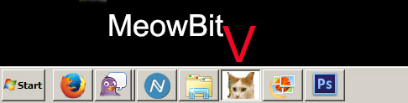
…and then there’s this delightful little fellow in the system tray:
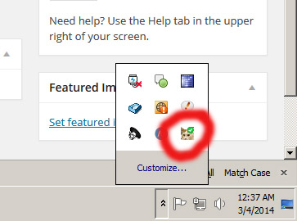
All of these will open the program interface.
GENERAL TIPS AND NOTES ON INSTALLING:
–MeowBit install will require a reboot if Microsoft .Net 4.0 is not already installed
–If you have trouble getting the Namecoin wallet to connect on a new installation of windows; if it seems stuck and won’t update, close the wallet, reboot your computer and restart the wallet, then it should begin updating.
MeowBit auto-starts at Windows start-up, this can be changed using the start-up folder. Info for Windows 7 and 8 here:
http://windows.microsoft.com/en-us/windows/run-program-automatically-windows-starts#1TC=windows-7
To work seamlessly, you’d also have to set Namecoin wallet to start at start-up:
MORE ADVANCED TROUBLESHOOTING, AND TECH SUPPORT FROM US:
Please leave a clear and detailed comment on our help forum if you have any issues with any aspect of running MeowBit. We like bug reports.
If you have problems getting MeowBit to work, please post on the forum or e-mail to us:
–the text in latest log file. The log path might be this:
C:\Program Files (x86)\MeowBit\logs\console
Or
C:\Program Files\MeowBit\logs\console
(Arrange the logs by date, then copy text from most recent file in that folder, and post it to us on the forum, with any additional notes you have about what you did and what happened and what didn’t happen that you expected to happen.)
NOTE: There may be personal info in the logs (i.p. address, operating system, sites you visited, etc.), but unlike the NSA and your ISP, we WILL delete them as soon as we’re done analyzing them. Unless you post them on our forum, which we do encourage, as we can group-source solutions.
–A screenshot or description of icon you see.
And just tell us how it works on your end please.
But we also like to hear from you when things go well and if you enjoy MeowBit! Comments aren’t just for bug reports! And if you enjoy MeowBit, please, TELL TWO FRIENDS!
If you get a message that says “Namecoin config updated. restart wallet”, restart wallet and wait a few minutes.

