Title: COS30045 Lab

Name: Song Jun Cheng

Github Link:

[Derrick1013/COS300045-Lab (github.com)](https://github.com/Derrick1013/COS300045-Lab)

**Lab 1**

**Lab 1.1**

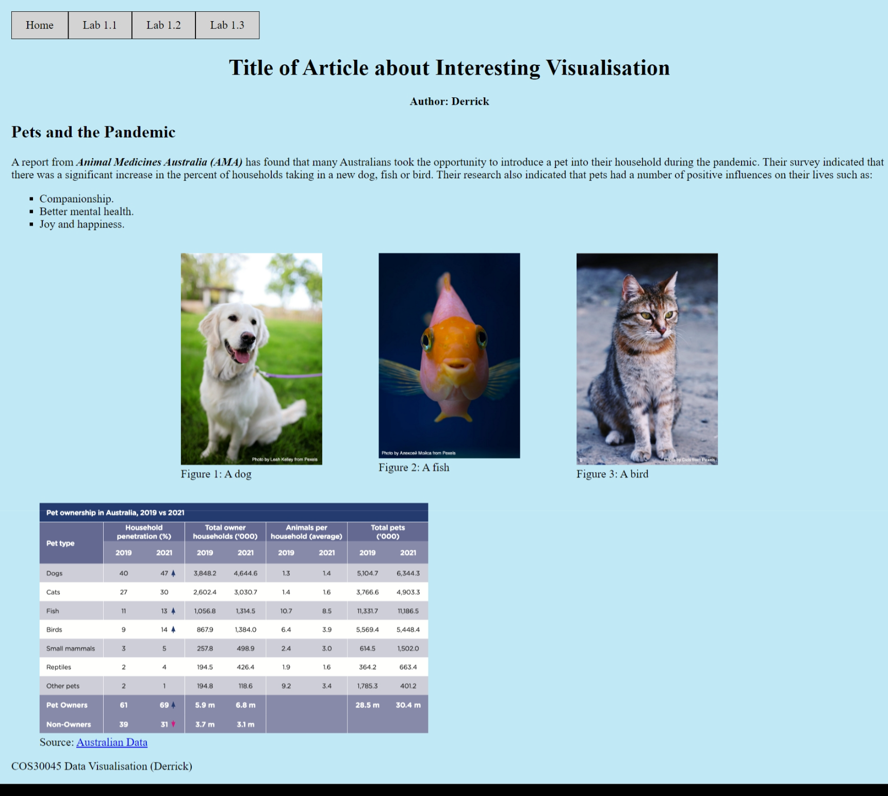

**Lab 1.2**

**Lab 1.3**

**Lab 2**

**Lab 2.1**

**Lab 2.2**

**Lab 2.3**

**Lab 2.4**

