**Demonstration 3**

Song Jun Cheng - 105315725

**Lab 5.1**

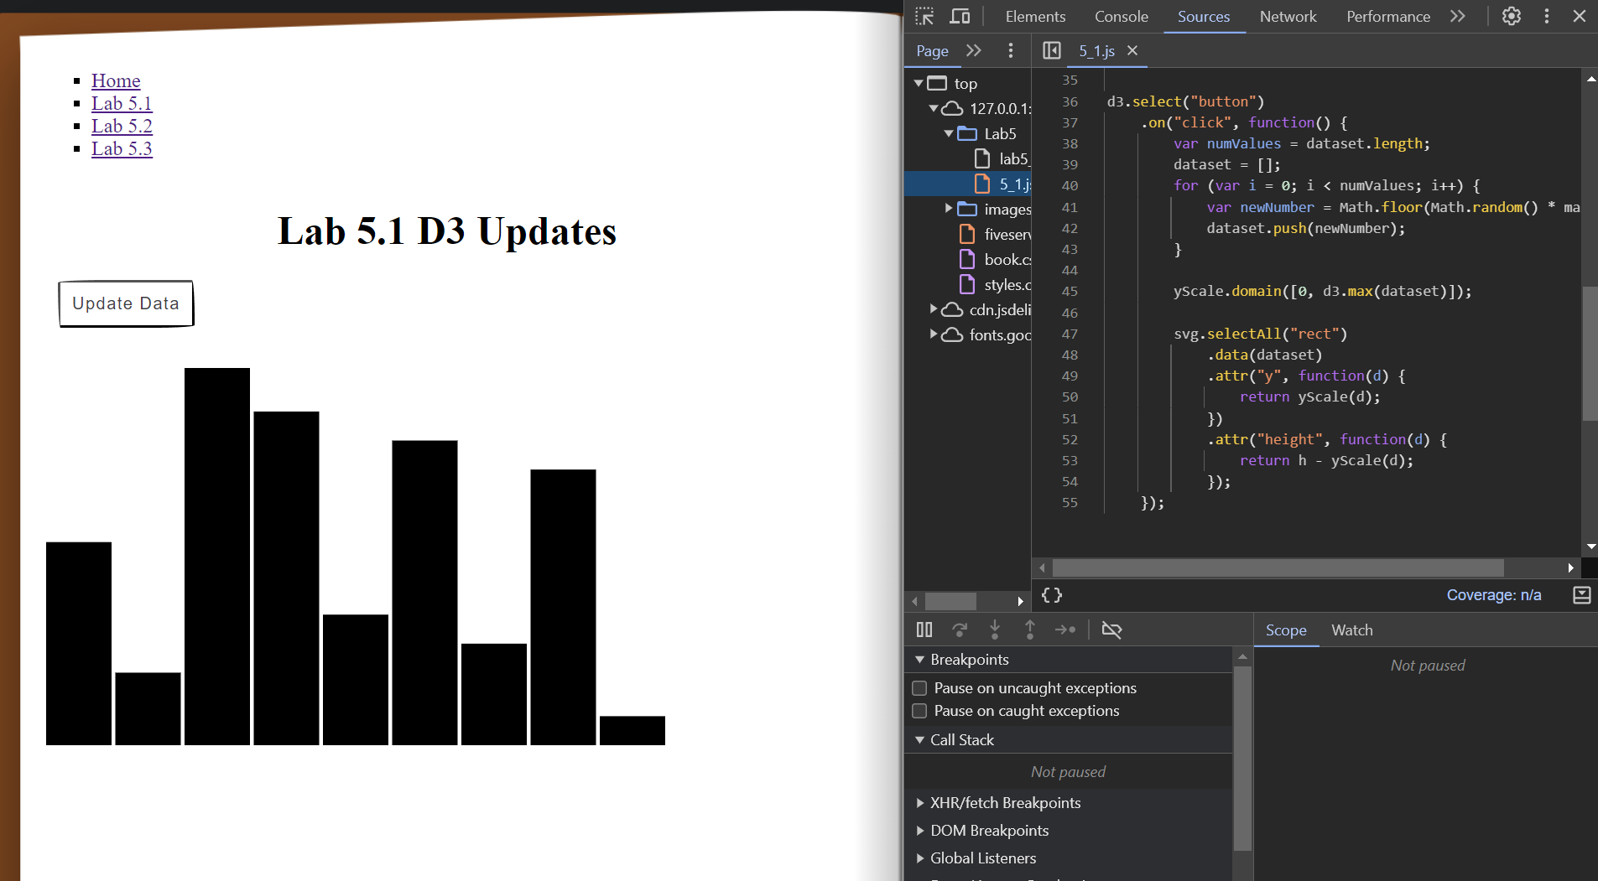

**Lab 5.2**

**Lab 5.3**

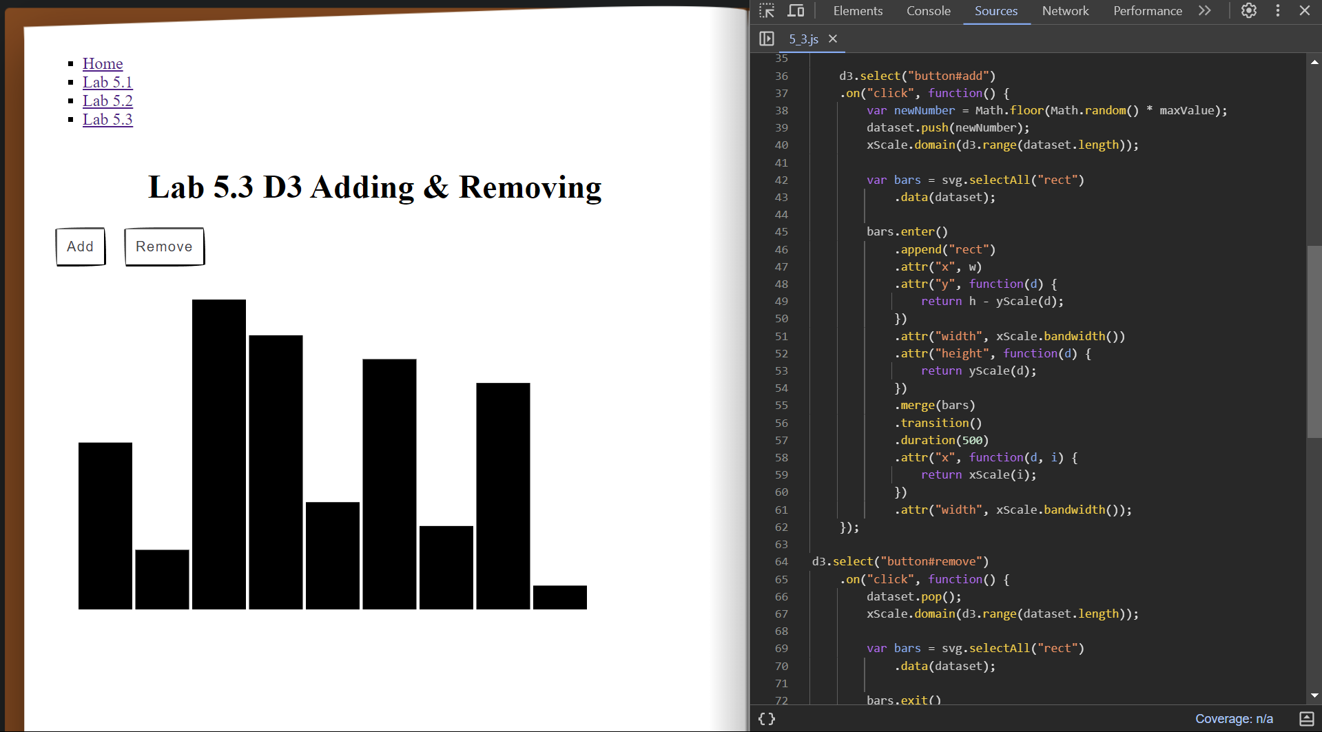

**Lab 6.1**

**Lab 6.2**

