**Stores Sales Prediction**

***Wireframe Document***

-Derrick T

**The UI developed will consist of only one part of the webpage as it was sufficient for the solution designed. There will be no images.**

1. The testing phase of the solution requires user data (unseen data) for the model to work on and generate predictions.
2. To achieve this, a front-end page along with the feature of accepting user input (data) is developed using HTML, CSS and Flask API to establish a connection between the saved models and the entered data.

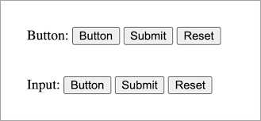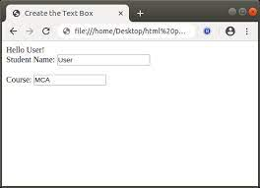The webpage design will be minimal with text boxes and dropdown lists to select options and consist of a submit button

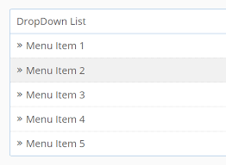

The above was the sample image or an idea, the webpage will be made more appealing, this is how it will look:

