Project Aura Development Guide

Environment Setup:
https://developer.android.com/develop/xr/jetpack-xr-sdk/get-started
- Install Android Studio
- Download and install the latest canary build
  - https://developer.android.com/studio/preview
  - 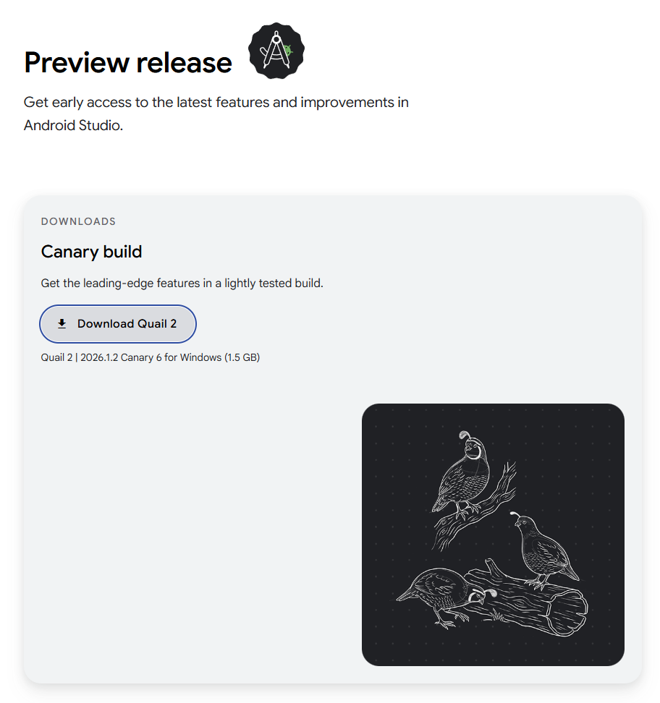
- Install SDK Tools
  - Android SDK Build-Tools
  - Android Emulator (not necessary)
  - Android SDK Platform-Tools
  - Cmake
  - NDK (may need to use version 27)
  - Android SDK Command-line Tools
  - 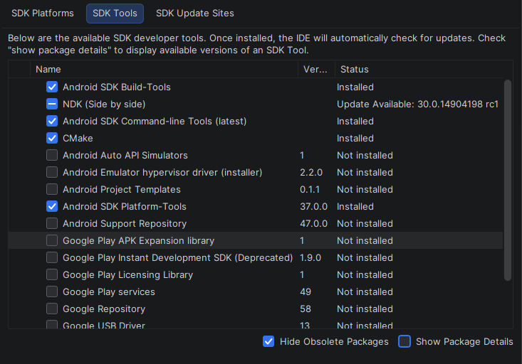

Application Development:

Hello World
- Create New Project.
- Select XR -> Basic Display Glasses Activity -> Next
  - 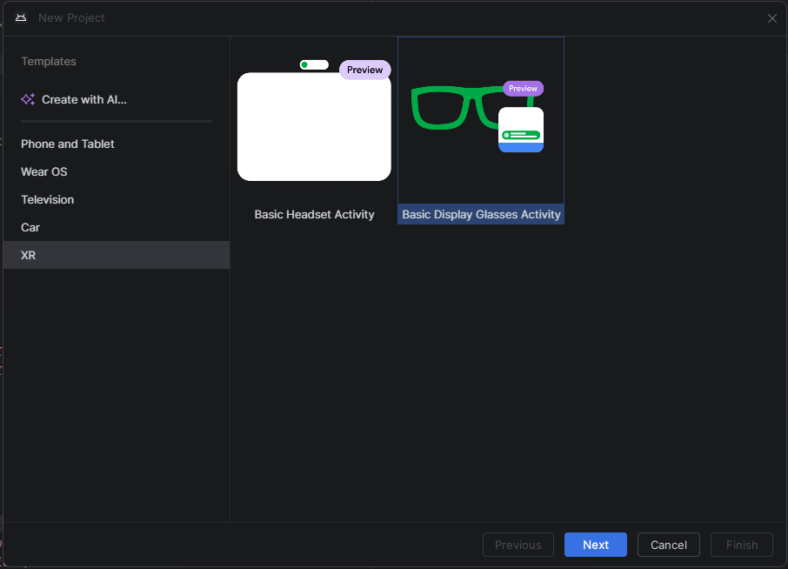
- Make a project name then select Finish.
- You may need to loosen minSdk restraints, I changed to 34
  - 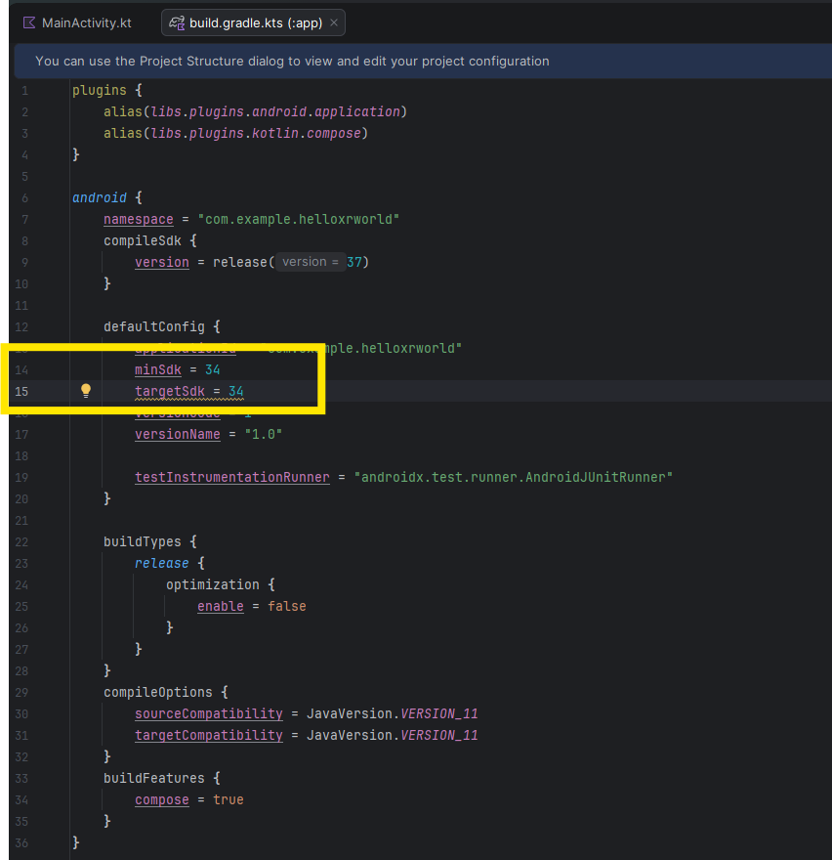
- Build Program

Camera Preview
- Follow setups steps 1-4 from Hello World.
- Add camera permissions to app/main/AndroidManifest.xml
  - 