RESEARCH PROPORSAL
Project Title: MEDICAL APPOINTMENT SYSTEM

By:
CAROL JAMES AROGO
I231/G/4532/22
&
WYCLIFF OKUMU OPELA
I231/G/4538/22

A Project Submitted to the School of Informatics and Innovative System at Jaramogi Oginga Odinga University of Science & Technology
Date of Submission: 14th October 2024

Declaration

This project, as presented in this project proposal, is my original work and has not been presented for any other university award.
Student: WYCLIFFE OKUMU OPELA Registration No: I231/G/4538/22
Sign: Date:
&

Name: AROGO CAROL JAMES Registration No: I231/G/4532/22
Sign: Date:

Dedication

I dedicate this project to my beloved parents for their support towards my academic journey. I also dedicate this project to my best friends

Acknowledgement

First, I want to thank the Almighty god for granting us life to do this project, without him we could have achieved nothing indeed. My second appreciation goes to my counterpart Mr. Opela Wycliffe for dedicating his time and energy to ensure that this project reach this far. I would also like to thank my lectures for their support, motivation as we were doing this project. Indeed it has been pleasure working under your presence, and lastly I want to thank my family and friends for their continuous support toward this project.

Abstract
An appointment policy is established for a specific outpatient system, with the goal of reducing a combination of patients' expected waiting times and doctor's expected overtime. Service times are stochastic, and patients are assumed to be punctual if they show for their appointments. Substantial reductions in waiting times can be obtained over traditional scheduling practices, and the procedure is easily implemented by a naive scheduler once the optimal policy is established. Health care is changing with a new emphasis on patient-centeredness. Fundamental to this transformation is the increasing recognition of patients' role in health care delivery and design. Medical appointment scheduling, as the starting point of most non-urgent health care services, is undergoing major developments to support active involvement of patients. Therefore, the current standard operating procedure in healthcare environment for patient registration and appointment scheduling are time consuming and somehow troublesome. By developing Medical Appointment System, it will reduce the number of calls for an appointment and avoid the morning rush for an urgent appointment. Also, it will potentially reduce the need for extra reception staff, a significant reduction in labor which will enable the appointment process to run effectively, efficiently and profitably.

Table of Contents
By: 1
Declaration 2
Dedication 3
Acknowledgement 4
Abstract 5
Table of Contents 6
List of tables 7
List of Figures 7
Acronyms/Abbreviations 7
CHAPTER 1: INTRODUCTION 8
1.1 Background Information 8
1.2 Problem statement 9
1.3 Objectives 10
1.3.1 Main objective 10
1.3.2 Specific Objectives 10
1.5 Research Questions 10
1.6 Significance of Study 10
1.7 Scope of The project 10
1.7.1 Specific Outcomes 10
1.7.1.1 User Interface 10
1.7.1.2 Database Management 10
1.7.1.3 Notification System 11
1.7.2 Stakeholders 11
1.7.3 Boundaries 11
1.7.4 Timeline 11
1.8 Assumptions 12
1.9 Definition of Terms 12
CHAPTER 2: LITERATURE REVIEW 13
CHAPTER 3: METHODOLOGY 15
3.1 Requirement Gathering 16
3.2 System Design 16
3.2.1 Flowchart 16
3.2.2 Use Case Diagram 18
3.2.3 Sequence Diagram 19
20
3.3 IMPLEMENTATION 20
Functionalities of Implementation 20
CHAPTER 4: CONCLUSION & EXPECTED OUTCOME 21
4.0 Expected Outcome 21
4.1 Conclusion 21
REFFERENCES 22

List of tables
Table 1: Timeline……………………………………………………………………………………………………………….14

List of Figures
Figure 1: Waterfall model…………………………………………………………………………………………………………15
Figure 2: System Flowchart………………………………………………………………………………………………………16
Figure 3: Use case Diagram……………………………………………………………………………………………………….18
Figure 4: Sequence Diagram……………………………………………………………………………………………………..19

Acronyms/Abbreviations
E-Health – Electronic Health
MMAC - Mobile Based Medical Appointment and Consultation
M-Heath – Mobile Health
UML – Unified Modelling Language
NHIS - National Hospital Information System

CHAPTER 1: INTRODUCTION

1.1 Background Information
Health care is changing with a new emphasis on patient-centeredness. Fundamental to this transformation is the increasing recognition of patients' role in health care delivery and design. Medical appointment scheduling, as the starting point of most non-urgent health care services is undergoing major developments to support active involvement of patients as argued by (Kwame & Petrucka, 2021). In order to minimize the patient average waiting time and doctor average idle time, overtime and cost, it is significant to determine how to schedule the number of patient appointments.
Traditionally, medical appointments have been made with schedulers over the telephone or in person according to (Zhao et al., 2017b). These methods are based on verbal communications with real people and allow for maximum flexibility in complicated situations (Hashim, n.d.-a). However, because these traditional methods require the intervention of schedulers, the ability to get a timely appointment is not only limited by the availability of appointment slots, but also by the schedulers and phone lines. Patients’ satisfaction with appointment booking is influenced by their ability to book at the right time with the right health service providers. In this case, if anybody is ill and wants to visit a doctor for a medical check-up, he or she needs to visit the hospital and wait until the doctor is available. The patients also waits in queue while getting appointment. If the doctor cancels the appointment for some emergency reasons then the patient is not able to know about the cancellation of the appointment unless or until he or she visits the hospital (Ferreira et al., 2023). As the mobile communication technology is rapidly developing, therefore one can use mobile application to overcome such problems and inconvenience for the patients.
Medical appointment can be seen as a means of patient booking and securing a particular time with the doctor either for medical checkup or for medical consultation as recorded by (Peter Idowu et al., 2014). Online medical appointment scheduling helps to manage and effectively utilize the time spent at the health center in a way that the patient is assigned a time which is visible for both the patient and the doctor. Large waiting times at hospital outpatient clinics are a cause of dissatisfaction to patients, cause additional stress to hospital staff, increase the risk of contagion and add complications for patients with medical conditions. Reducing waiting times and surgeon idle time improves the quality of service and efficiency of a hospital (Ferreira, D.C. et al. (2023).

With the growing internet penetration, healthcare industry is moving towards the use of an online medical appointment system according to (Ismail et al., 2017). The establishment and improvement of doctor-patient interaction system is a very important requirement, especially now when the mobile communication technology is developing rapidly. With the rise of technology, patients will be able to access healthcare services more easily and conveniently than before. Additionally, the system will be designed to be user-friendly and accessible, ensuring that patients of all ages and abilities can use it with ease (Stoumpos, A.I., Kitsios, F. and Talias, M.A. (2023)

In summery the proposed system will enable flexible doctor-patient interaction by giving patients easy time to book there appointments early and to enable doctor preparedness in terms of medical equipment’s and even other requirements needed for the patient’s medication. Similarly, the system will be efficient and simple to use by the system users since it will offer the variety of languages so that users can be able to interact with the system using their local languages.

1.2 Problem statement
Medical Appointment System lies at the intersection of efficiency and timely access to health services to the patients without any inconveniences. Therefore, the timely access is important for realizing good medical outcomes and good medical services to the patients at large. The current hospital service booking system is inefficient and outdated for both patients and staff, hence it fails to provide effective and timely medical services therefore this has led to poor medical appointment services (Zhao et al., 2017b). This is because it relies on outdated and traditional methods like telephone calls, paper forms and even verbal communication where the patient is needed to visit the hospital and waits in the queue until the doctor is available to get an appointment, this process is very much time consuming and does not provide the efficiency needed by the users. Here are some of the causes that brings a gap within the current appointment system;
The current Medical Appointment System is highly characterized by time wasting according to (Kaplan et al., 2015). There is long waiting time in the queue while the patients are waiting to be attended to as they make an appointment with the doctors. Patients spend excessive time on hold, waiting for appointments, and navigating for complex scheduling processes with unclear certainty of whether they will be able to succeed or not. This situation normally leads to the demoralization of patients and some opt for going back home or seek some other alternative solutions rather than waiting for the long queues for a very long time. This has emerged as one of the major challenge to deal with especially in our public health sector (Ahmad, B.A., Khairatul, K. and Farnaza, A. (2017).
Similarly, poor communication between the doctors and the patients has also emerged as another challenge within the medical setup. The poor communication is caused by the lack of centralized communication channels which leads to confusion and delays in sharing (Zhao et al., 2017) information between patients, staffs and departments. Furthermore, traditional appointment system has led to administrative burden as manual processes consumes a lot of valuable time and hinders the doctors’/staffs’ focus on patient care .(Kwame, A. and Petrucka, P.M. (2021a)
Lastly, manual medical appointment system has often led to missed appointments (Ab & Kn, n.d.) and (Zhao et al., 2017b). Lack of effective reminders leads to missed appointments, wasted resources, and increased healthcare costs. For instance, when a patient has booked an appointment with the doctor maybe to visit the doctor in one week time for further checkup, there is high possibility that either the patient or the doctor may forget that they had an appointment because there is no reminder(Hashim, n.d.-b). This may lead to wastage resource and healthcare cost in case of a scenario when the patient spend the cost on transport only to reach hospital and realize that the doctor isn’t available or the doctor is available but the patient has not turned up. It is also a significance challenge in this point.

1.3 Objectives

1.3.1 Main objective
The primary objective is to develop a Medical Appointment System that streamlines the appointment scheduling process, enhances patient experience, and improves operational efficiency within the hospital.

1.3.2 Specific Objectives
- To Study and understand medical processes involved in the current appointment system.
- To perform system analysis and designed on the Medical Appointment System.
- To implement and test Medical Appointment System.

1.5 Research Questions
The questions that were pertinent in this research are;
- What information system development practices lead to IS failures?
- Is it possible to determine whether or not an information system will fail in the early stages?

1.6 Significance of Study
Administrator: The Admin will no longer exert an extra effort on taking all the appointment of clients since using this system, it will automatically record it without the staffs actions needed. As well as the admins will not be confuse regarding what appointments in that particular time because with the help of the system all the appointments will displays organized.
Clients: Allows them to conveniently and securely book their appointments. This system, also allows them to reschedule/cancel appointments immediately. It will help them to reduce their time on waiting and last they can select the appointment time according to their preference.

1.7 Scope of The project

1.7.1 Specific Outcomes
The specific outcome of this project includes developing;

1.7.1.1 User Interface
This is the portal where the patients will be booking the appointments and the doctors will also be monitoring and managing the schedules. It will also involve the Admin Dashboard where the system operations will be managed.

1.7.1.2 Database Management
This is the database which will store patients information such as name, status age etc. It will also store doctors information such as doctors name, specialization etc. Lastly, it will include appointment record such as date, time, status etc.

1.7.1.3 Notification System
This includes the reminders for the upcoming appointments and also the changes in the appointment status.

1.7.2 Stakeholders
The ley stakeholders of this system will include the following;
i. Patients: These are the users who will book appointments and access their medical history.
ii. Doctors: These are the healthcare providers who will be managing their schedules and patient interactions within the system.
iii. Administrators: These are the personnel responsible for overseeing system operations and user management.

1.7.3 Boundaries
• Developing of mobile applications for appointment scheduling.
• Integration of Medical appointment system with existing healthcare systems such as electronic medical records.
• To provide user training and support documentation.

1.7.4 Timeline

TASK | DURATION | START DATE | END DATE
Requirement Analysis | 2 weeks | 10-02-2026 | 24-02-2026
System Design | 4weeks | 25-02-2026 | 02-03-2026
Development | 5 weeks | 10-03-2026 | 15-04-2026
Testing | 1 week | 16-04-2026 | 23-04-2026
Table 1: Timeline

1.8 Assumptions
It is assumed that both the doctors and the staffs will use the proposed system to schedule appointments.
It is assumed that the current medical appointment management system is done manually and therefore requires automation.

1.9 Definition of Terms
Data mining - data processing using sophisticated data search capabilities and statistical algorithms to discover patterns and correlations in large preexisting databases

CHAPTER 2: LITERATURE REVIEW
This chapter focuses on the previous works which were done by different authors about the Medical Appointment Systems and the existing works or the systems that have already been developed and the related works. We intend to review the existing literatures to identify the work which have been done and the existing gaps of the systems in place. Below are some of the work done by different authors and researchers on this particular field of study.
(AJAYI., et al 2019) proposed a Mobile Based Medical Appointment and Consultation (MMAC) System in Nigeria which provides the establishment and improvement of doctor-patient interaction. This research indicates that mobile web can be made full use of to make up the time and distance gap between doctors and patients and to provide fast and adequate medical services. Through the connection between mobile terminals and specific service, both doctors and patients are able to obtain required data to achieve a better interaction. The mHealth technology has allowed patients to improve and manage their health by gathering information about health symptoms and notifying doctors for appropriate consultation and treatment. With a healthcare mobile app, the patient can schedule appointments directly from their smartphones. However, the research was limited with the services they offer which could not carter fully for the patients’ needs.
(Rinder et al., 2012) proposes a Healthcare Scheduling by Data Mining: Literature review and future directions. The article presents a systematic literature review of the application of industrial engineering methods in healthcare scheduling, the research work defines two categories of healthcare scheduling which are; work/patient scheduling and provider resource scheduling, Patient appointments are scheduled based on the number of appointments slots available. The number of appointments available is established based on the type of work, such as regular visits, follow-up visits, tests and procedures, education sessions, and the number of providers available by hour and day of the week. The paper described application of data modelling technique to improve scheduling in healthcare, and the modelling technique had to be a data mining technique. However, none of the methods modelled no-show and walk-ins patient behavior, also the research work should include more variables related to patient and/or environment.
(Peter Idowu et al., 2014) proposed a dependable online appointment booking system for NHIS outpatient in Nigerian teaching hospitals. The research proposes a web based medical appointment booking. The scope of the research work is to design a web-based appointment booking system where patients can register, login to the system, book an appointment with a doctor and view appointments. The system also includes the doctor logging into the system, cancel an appointment, generate appointment and view appointments. However, the research was limited in that the display of bio-data an X-rays and laboratory results were not included in the system due to technical constrains. And more so, the system was not able to diagnose of prescribe drug for usage.
A Patient eRefferal Booking System by (Muriki et al., 2020) aimed at developing and implementing a web-based electronic referral system in Kenya that enables the patients to chat with their healthcare providers, book appointments and make follow-ups. This system ensures that patients seeks for more advanced medical attention in their healthcare facilities such that if the available facilities cannot be able to sort the patient’s issues, then they can be referred to other healthcare facilities and their movement can be tracked or monitored. The referring facility may need to be updated on the patient’s progress once the patient was referred to a higher level when they come back on a routine checkup. An eRefferal System submits an electronic referral request to clinics and healthcare facilities and the referring provider completes an internet-based form with the patient’s relevant history and the referring provider consult questions. However, the system does not provide the patients with an option of booking an appointment with the healthcare facilities directly or where they can make an appointment with the doctor directly. This makes the system to be less effective.
However, despite all the efforts by the great researchers and innovators to solve the problem of traditional medical booking systems, there still exist a loophole that has not been put into considerations. The existing systems all operates only using English as a language for communication within the system, which means that the researchers used the assumption that all the targeted system users are either all literate or they are familiar with the English which is not the case. It is indeed true that in some communities here in Kenya or in some other parts of the world, education has not seen the light of the day and they use their natural language as a means of communication. If the system is made to accommodate everybody who might be in need to go to seek medical attention to the hospital, it must be able to include their local languages so that even those who cannot speak, understand or talk English can also feel the benefit of using the same system as the people who are literate. Therefore, this having not ben included into the existing systems, then it is a problem that needs to be solve.

CHAPTER 3: METHODOLOGY
This chapter defines the type of methodology that will be used to develop a Medical Appointment System. The type of methodology that will be used in development of this system is Waterfall. Waterfall methodology is a well-established project management workflow where each phase of a project must be completed before the next phase begins. Waterfall methodology works best in projects with well-defined requirements and low uncertainty hence allowing teams to follow a straightforward path from the point of conception to its completion.
Requirement Gathering

System Design

Implementation

Testing

Deployment

Maintenance

Figure 1: Waterfall model

3.1 Requirement Gathering
This is the first face of the system development which involves identifying and understanding the users' needs for the medical appointment system. The main activity in this phase is to conduct surveys and interviews with potential users including patients and medical staff, to gather data on preferences, expectations, and challenges they faced while using the older system. The data is then comprehensively analyzed to formulate precise and specific system requirements that align with user needs and research objectives.

3.2 System Design
System design is systematic wherein it takes into account all related variables of the system that needs to be created, from the architecture, to the required hardware and software, right down to the data and how it travels and transform throughout its travel through the system. It is needed to clarify in more details about the progress of the system flow in order to build an application that suited user requirements and system.

3.2.1 Flowchart
Below is a flowchart that shows the functionality and flow of information in Medical Appointment System.

Start

User Registration

Login

Services
Online doc consultation
Book appointment

Check available doctor
Choose appointment time
Reschedule appointment

Conversation & consultation
Check database

Decision
Decision
Time assigned
Patient need to book appointment
Time not assigned
Patient don’t need to book appointment
End conversation
Logout
Appointment booked

Stop

Figure 2: System flowchart

3.2.2 Use Case Diagram
Use case is a methodology used in system analysis to identify, clarify and organize the system requirements. A use case is a list of actions or event steps, typically defining the interactions between a role (known in the Unified Modeling Language (UML) as an actor) and a system, to achieve a goal. An actor can be a human or other external system. It is used to explain and document the interaction that is required between user and system to accomplish user task. With the main purpose of capturing the dynamic aspect of the system.
List of Actors in Medical Appointment System.
- System Admin
- Doctor
- Patient
List of Use Case
- Login
- Change Account Password
- Manage Appointment
- Manage Schedule
- Manage Patients
- Manage Doctors
- Manage User And Full Specification
- View Related Patient
- Check Appointment
- Provide Feedback
- Request For appointment
- Check Appointment Status
- Cancel the appointment
- Logout
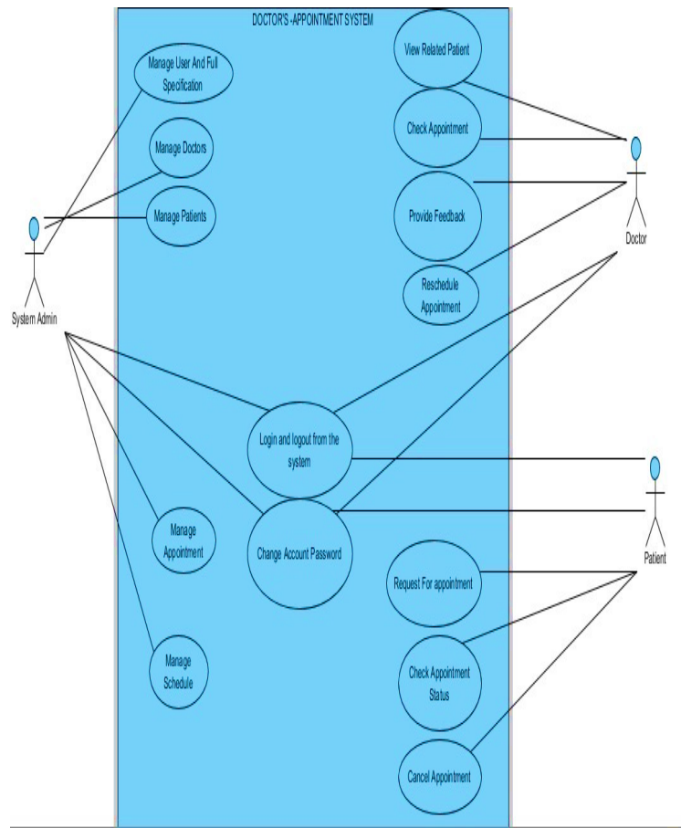
Medical Appointment system

Sys Admin

Figure 3: Use case diagram

3.2.3 Sequence Diagram
Sequence Diagram is another important diagram in UML to describe the dynamic aspects of the system. Sequence Diagrams are interaction diagrams that detail how operations are carried out. They capture the interaction between objects in the context of a collaboration. Sequence Diagrams are time focus and they show the order of the interaction.
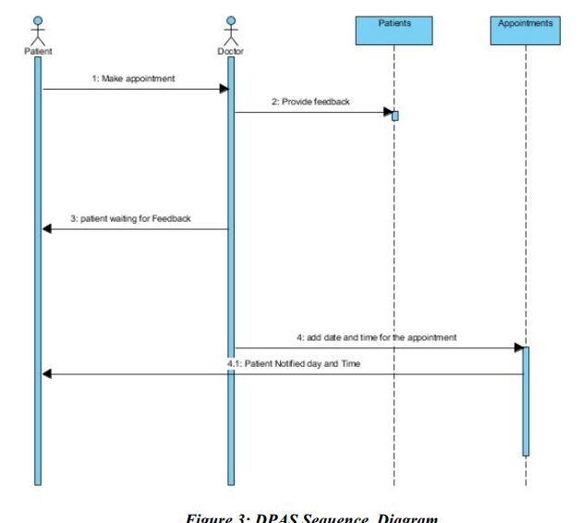

Figure 4: Sequence diagram

3.3 IMPLEMENTATION
System implementation is the realization of the technical specifications or algorithm as a program software component or other computer system through programming and deployment. Implementation may exist for given specification or standard.

Functionalities of Implementation
i. Login: This is the first functionality, the system provides a login page for authentication of the user (Doctor, Patient and Admin) where a user provides username and password and password is encrypted by using MD5 function.
ii. Make Appointment: This functionality enables the Patient to make the appointment to the doctor of His/her interest from the hospital and from the area of specialization.
iii. View Feedback: Also is the functionality which enables the Patient to view the feedback in case the doctor provides the feedback to the one who is interest with.
iv. Cancel the Appointment: This Functionality enables the patient to cancel the appointment after make the appointment and doctor does not provide the feedback.
v. View Appointment: This functionality is for Doctor that enables the doctor to view the appointment and once his/her appointment is received can provide the feedback to the one who make the appointment.
vi. Reschedule the Appointment: This functionality is for doctor also which help the doctor to reschedule the appointment in case the time provided is not fit in the time provided before.
vii. Provide Feedback: This functionality helps Doctor to provide the feedback to the one who make the appointment
viii. Change password: This functionality enabled a Patient and Doctor to change his/her password anytime regarding that the password should be remembered.
ix. Logout: After all this is the last and final functionality for Patient and Doctor which closes the whole session and gets back to Home Page which is Login Page.

CHAPTER 4: CONCLUSION & EXPECTED OUTCOME

4.0 Expected Outcome
- Reduced waiting time in that patients will be able to book appointments at their convenience leading to shorter waiting times.
- Improved secure data handling in that robust security measures will ensure the protection of patient’s data.
- Higher patients’ satisfaction since this will improve patience experience through easy access to services and information.

4.1 Conclusion
In conclusion the Medical Appointment System is a significant step forward in the digital transformation of healthcare services. HealthCare evolves which would be essential for meeting the growing demands and expectations of patients. It aims to provide patients with a convenient and effective way to book appointments and services. Therefore it would be user-friendly and easy process for healthcare appointment service.

REFFERENCES
Vanden Bosch, Peter M., and Dennis C. Dietz. “Minimizing Expected Waiting in a Medical Appointment System.” IIE Transactions 32, no. 9 (September 1, 2000): 841–48. https://doi.org/10.1023/A:1007635012421.

Zhao, Peng, Illhoi Yoo, Jaie Lavoie, Beau James Lavoie, and Eduardo Simoes. “Web-Based Medical Appointment Systems: A Systematic Review.” Journal of Medical Internet Research 19, no. 4 (April 26, 2017): e134. https://doi.org/10.2196/jmir.6747.

Ismail, Noorsyahira, Shahreen Kasim, Yusmadi Yah Jusoh, Rohayanti Hassan, and Ayu Alyani. “MEDICAL APPOINTMENT APPLICATION.” Acta Electronica Malaysia 1, no. 2 (November 1, 2017): 05–09. https://doi.org/10.26480/aem.02.2017.05.09.

Hashim, M Jawad. “Patient-Centered Communication: Basic Skills,” n.d.

Open Resources for Nursing (Open RN) (no date) 2.3 communicating with patients, Nursing Fundamentals 2e. Available at: https://wtcs.pressbooks.pub/nursingfundamentals/chapter/2-3- communicating-with-patients/ (Accessed: 14 October 2024).

Hashim, M Jawad. “Patient-Centered Communication: Basic Skills,” n.d.

Zhao, Peng, Illhoi Yoo, Jaie Lavoie, Beau James Lavoie, and Eduardo Simoes. “Web-Based Medical Appointment Systems: A Systematic Review.” Journal of Medical Internet Research 19, no. 4 (April 26, 2017): e134. https://doi.org/10.2196/jmir.6747.

Ferreira, Diogo Cunha, Inês Vieira, Maria Isabel Pedro, Paulo Caldas, and Miguel Varela. “Patient Satisfaction with Healthcare Services and the Techniques Used for Its Assessment: A Systematic Literature Review and a Bibliometric Analysis.” Healthcare 11, no. 5 (February 21, 2023): 639. https://doi.org/10.3390/healthcare11050639.

Ferreira, Diogo Cunha, Inês Vieira, Maria Isabel Pedro, Paulo Caldas, and Miguel Varela. “Patient Satisfaction with Healthcare Services and the Techniques Used for Its Assessment: A Systematic Literature Review and a Bibliometric Analysis.” Healthcare 11, no. 5 (February 21, 2023): 639. https://doi.org/10.3390/healthcare11050639.

Kaplan, G., M.H. Lopez, and J.M. McGinnis. Transforming Health Care Scheduling and Access: Getting to Now, 2015. https://doi.org/10.17226/20220.

Ab, Azraii, and Kamaruddin Kn. “An Assessment of Patient Waiting and Consultation Time in a Primary Healthcare Clinic” 12, no. 1 (n.d.).

AJAYI, Olusola Olajide et al, International Journal of Computer Science and Mobile Computing, Vol.8 Issue.5, May- 2019, pg. 208-218

Martin Muriki et al, College of Biological and Physical Sciences School of Computing and Informatics University of Nairobi. “Implementing A Patient eRefferal Booking System.”

Rinder, Maria M., Gary Weckman, Diana Schwerha, Andy Snow, Peter A. Dreher, Namkyu Park, Helmut Paschold, and William Young. “Healthcare Scheduling by Data Mining: Literature Review and Future Directions.” Journal of Healthcare Engineering 3, no. 3 (January 2012): 477–502. https://doi.org/10.1260/2040-2295.3.3.477.

Peter Idowu, Adebayo, Olajide Olusegun Adeosun, and Kehinde Oladipo Williams. “Dependable Online Appointment Booking System for Nhis Outpatient in Nigerian Teaching Hospitals.” International Journal of Computer Science and Information Technology 6, no. 4 (August 31, 2014): 59–73. https://doi.org/10.5121/ijcsit.2014.6405.

